Stage 1 Mathematical Methods
Trigonometry Test
Topic 3: Subtopics 3.1, 3.2, 3.3
Total Marks – 44

(Calculator and one A4 page of handwritten notes permitted.)

- (4 marks)

- Find the value of $θ$ in the diagram (not drawn to scale).

8 cm
7 cm
6 cm
θ°

(2 marks)

- Find the value of $x$ in the diagram (not drawn to scale).

11 cm
x cm
8 cm
57°

(2 marks)
- (4 marks)

Find ALL possible values of $θ$ in the diagram (not drawn to scale).

8 m
θ°
50°
10 m

(4 marks)
- (6 marks)

Consider the following diagram (not drawn to scale):
15 cm
A
B
C
D
20 cm
7 cm
x cm
35°

- Find the area of triangle ABD.
(4 marks)

- Find the value of $x$ given that the area of triangle BCD is 75 cm².
(2 marks)
- (6 marks)

A tower 40 metres high, stands on top of a hill. From a point some distance from the base of the hill, the angle of elevation to the top of the tower is 13°. From the same point the angle of elevation to the bottom of the tower is 8°. Find the height of the hill.
(4 marks)
- (2 marks)

- State the period of $y=4\sin\left(\frac{x}{5}\right)$.
(1 mark)

- State the period of $y=\tan\left(3x\right)-1$.
(1 mark)

- (2 marks)

- Find $b$ given that the function $y=\sin\left(bx\right)$ has period $\frac{π}{4}$.
(1 mark)

- Find $b$ given that the function $y=\cos\left(bx\right)$ has period $4$.
(1 mark)

- (4 marks)

Find the cosine functions represented in each of the following graphs:

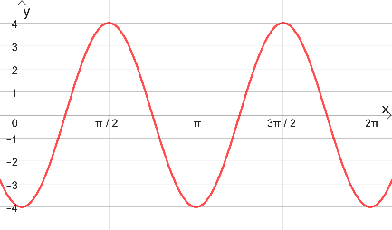 | 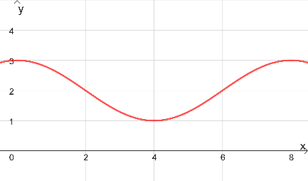

(2 marks) |  |  |  |  |  |  |  |  |  |  |  |  |  |  |  |  |  | (2 marks)
- (4 marks)

Sketch at least one complete cycle of the following graphs:

- $y=\cos\left(x\right)-3$ |  |  |  |  |  |  |  |  |  |  |  |  |  |  |  |  |  | - $y=\cos\left(x-\frac{π}{4}\right)$
(2 marks) |  |  |  |  |  |  |  |  |  |  |  |  |  |  |  |  |  | (2 marks)

- (6 marks)

Solve the following algebraically for $0≤x≤2π$.

- $2\sin\left(x\right)=-1$
(2 marks)

- $2\cos\left(x\right)-\sqrt{2}=0$
(2 marks)

- $\cos\left(2x\right)=\sqrt{3}\sin\left(2x\right)$
(2 marks)

- (6 marks)

An ecologist studying a species of water beetle estimates the population of a colony over an eight week period. If $t$ is the number of weeks after the initial estimate is made, then the population in thousands can be modelled by $P\left(t\right)=5+2\sin\left(\frac{πt}{3}\right)$ where $0≤t≤8$.

- What was the initial population?
(1 mark)

- What was the population after 8 weeks?
(1 mark)

- What was the smallest population and when did it occur?
(2 marks)

- During what time interval(s) did the population exceed 6000?
(2 marks)

