KEY FACTS AND CONCEPTS
Discrete random variables
- A random variable is a number whose value is determined by a process, the outcome of which is open to chance. Usually, capital letters such as $X$ are used to represent random variables.
- Discrete random variables may take only specific values. They are usually characterised by counting.
- Continuous random variables may take any value (often within set limits). They are usually characterised by measuring.

- A probability distribution associates a probability with each possible value of a discrete random variable. It can be represented using a table, column graph, or a probability distribution function.
- If $X$ is a random variable with possible values $\left\{x_{1},x_{2},x_{3},…,x_{n}\right\}$ and corresponding probabilities $\left\{p_{1},p_{2},p_{3},…,p_{n}\right\}$ then:
  - Each probability must be between 0 and 1.
$0≤p_{i}≤1$ for all $i=1,…,n$
  - The sum of all the probabilities must be 1.
$$\sum_{i=1}^{n}{p_{i}}=p_{1}+p_{2}+p_{3}+…+p_{n}=1$$
- For a uniform discrete random variable, each possible value has the same probability of occurring
$p_{i}=\frac{1}{n}$ for all $i=1,…,n$.
- The mode of a discrete probability distribution is the most frequently occurring value of the variable. This is the data value $x_{i}$ whose probability $p_{i}$ is the highest.
- The median of the distribution corresponds to the 50th percentile. If the possible values $\left\{x_{1},x_{2},x_{3},…,x_{n}\right\}$ are listed in ascending order, the median is the value $x_{j}$ when the cumulative sum $p_{1}+p_{2}+…+p_{j}$ reaches 0.5.

- If there are $n$ trials of an experiment, and an event has probability $p$ of occurring in each of the trials, then the number of times we expect the event to occur is $np$.
- If $X$ is a random variable with possible values $\left\{x_{1},x_{2},x_{3},…,x_{n}\right\}$ and corresponding probabilities $\left\{p_{1},p_{2},p_{3},…,p_{n}\right\}$ then the expected value or mean is:
$$E\left(X\right)=μ=\sum_{i=1}^{n}{{x_{i}p}_{i}}=x_{1}p_{1}+x_{2}p_{2}+…+x_{n}p_{n}$$
- The expected value can be interpreted as a long-run sample mean.
- The principle purpose of the expected value is to be a measurement of the centre of the distribution.
- If $X$ is a random variable with possible values $\left\{x_{1},x_{2},x_{3},…,x_{n}\right\}$ and corresponding probabilities $\left\{p_{1},p_{2},p_{3},…,p_{n}\right\}$ then the standard deviation is:
$$σ\left(X\right)=\sqrt{\sum_{i=1}^{n}{x_{i}^{2}p_{i}}-μ^{2}}=\sqrt{x_{1}^{2}p_{1}+x_{2}^{2}p_{2}+…+x_{n}^{2}p_{n}-μ^{2}}$$
- The principle purpose of the standard deviation is to be a measurement of the spread of the distribution.

- For a random variable, $X$, and any constants $a$ and $b$:
  - $E\left(aX+b\right)=aE\left(X\right)+b$
  - $σ\left(aX+b\right)=\left|a\right|σ\left(X\right)$

- A Bernoulli trial is an experiment which only has two possible outcomes: “success” if some event occurs or “failure” if the event does not occur.
- A Bernoulli random variable $X$ is the number of successes in a single Bernoulli trial.
We define $p$ as the probability of success, so $P\left(X=1\right)=p$, and $P\left(X=0\right)=1-p$, where $0≤p≤1$.
  - $E\left(X\right)=p$
  - $σ\left(X\right)=\sqrt{p\left(1-p\right)}$

- A binomial random variable $X$ is the number of successes in $n$ identical independent Bernoulli trials with probability of success $p$.
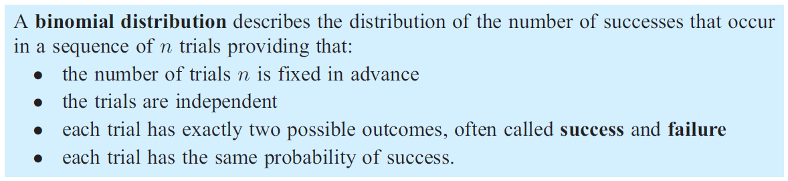
The distribution of $X$ is called the binomial distribution and we write $X\sim B\left(n,p\right)$.
  - The probability distribution of $X$ is
$P\left(X=k\right)=\left({n \atop k}\right)p^{k}{\left(1-p\right)}^{n-k}$ where $k=0,1,…,n$
  - $E\left(X\right)=np$
  - $σ\left(X\right)=\sqrt{np\left(1-p\right)}$

