VECTORS
KEY FACTS AND CONCEPTS
5A VECTORS IN SPACE
- The position vector of $P$ from $O$ where $P=\left(x,y,z\right)$ is
$\vec{OP}=\left({x \atop \begin{aligned}y \\ z\end{aligned}}\right)=x\underline{i}+y\underline{j}+z\underline{k}$.
- The magnitude or length of the vector $\underline{a}=\left({a_{1} \atop \begin{aligned}a_{2} \\ a_{3}\end{aligned}}\right)$ is
$\left|\underline{a}\right|=\sqrt{a_{1}^{2}+a_{2}^{2}+a_{3}^{2}}$.
- Two vectors are equal if they have the same magnitude and direction. If $\underline{a}=\left({a_{1} \atop \begin{aligned}a_{2} \\ a_{3}\end{aligned}}\right)$ and $\underline{b}=\left({b_{1} \atop \begin{aligned}b_{2} \\ b_{3}\end{aligned}}\right)$, then
$\underline{a}=\underline{b}⇔a_{1}=b_{1}, a_{2}=b_{2}, a_{3}=b_{3}$.

5B OPERATIONS WITH VECTORS IN SPACE
- Operations with vectors:
- $\underline{a}+\underline{b}=\left({a_{1}+b_{1} \atop \begin{aligned}a_{2}+b_{2} \\ a_{3}+b_{3}\end{aligned}}\right)$
- $\underline{a}-\underline{b}=\left({a_{1}-b_{1} \atop \begin{aligned}a_{2}-b_{2} \\ a_{3}-b_{3}\end{aligned}}\right)$
- $k\underline{a}=\left({ka_{1} \atop \begin{aligned}{ka}_{2} \\ {ka}_{3}\end{aligned}}\right)$ for any scalar $k$

5C VECTOR ALGEBRA
- Properties of vectors:
  - $\underline{a}+\underline{b}=\underline{b}+\underline{a}$ {commutative property}
  - $\left(\underline{a}+\underline{b}\right)+\underline{c}=\underline{a}+\left(\underline{b}+\underline{c}\right)$ {associative property}
  - $\underline{a}+\underline{0}=\underline{0}+\underline{a}=\underline{a}$ {additive identity}
  - $\underline{a}+\left(-\underline{a}\right)=\left(-\underline{a}\right)+\underline{a}=\underline{0}$ {additive inverse}
  - $k\left(\underline{a}+\underline{b}\right)=k\underline{a}+k\underline{b}$ {distributive property}
  - $\left|k\underline{a}\right|=\left|k\right|\left|\underline{a}\right|$ where $k\underline{a}$ is parallel to $\underline{a}$
  - $\left|\underline{a}+\underline{b}\right|≤\left|\underline{a}\right|+\left|\underline{b}\right|$ {triangle inequality}

5D THE VECTOR BETWEEN TWO POINTS
- If $A\left(a_{1},a_{2},a_{3}\right)$ and $B\left(b_{1},b_{2},b_{3}\right)$ are two points in space then the position vector of $B$ relative to $A$ is
$\vec{AB}=\vec{OB}-\vec{OA}=\left({a_{1}-b_{1} \atop \begin{aligned}a_{2}-b_{2} \\ a_{3}-b_{3}\end{aligned}}\right)$.
- Distance $AB=\left|\vec{AB}\right|$.

5E PARALLELISM
- If $\underline{a}$ is parallel to $\underline{b}$, then there exists a scalar $k$ such that
$\underline{a}=k\underline{b}$.
- If $\underline{a}=k\underline{b}$ for some scalar $k$, then $\underline{a}$ is parallel to $\underline{b}$, and $\left|\underline{a}\right|=\left|k\right|\left|\underline{b}\right|$.
- The unit vector (length 1 unit) in the direction of $\underline{v}$ is $\frac{1}{\left|\underline{v}\right|}\underline{v}$.
- $A$, $B$, and $C$ are collinear if $\vec{AB}=k\vec{BC}$ for some scalar $k$.
5F THE SCALAR PRODUCT OF TWO VECTORS
- If $\underline{a}=\left({a_{1} \atop \begin{aligned}a_{2} \\ a_{3}\end{aligned}}\right)$ and $\underline{b}=\left({b_{1} \atop \begin{aligned}b_{2} \\ b_{3}\end{aligned}}\right)$, the scalar product of $\underline{a}$ and $\underline{b}$ is defined as $\underline{a}•\underline{b}=a_{1}b_{1}+a_{2}b_{2}+a_{3}b_{3}$.
- Properties:
  - $\underline{a}•\underline{b}=\underline{b}•\underline{a}$
  - $\underline{a}•\underline{a}={\left|\underline{a}\right|}^{2}$
  - $\underline{a}•\left(\underline{b}+\underline{c}\right)=\underline{a}•\underline{b}+\underline{a}•\underline{c}$
  - $\left(\underline{a}+\underline{b}\right)•\left(\underline{c}+\underline{d}\right)=\underline{a}•\underline{c}+\underline{a}•\underline{d}+\underline{b}•\underline{c}+\underline{b}•\underline{d}$

5G THE ANGLE BETWEEN TWO VECTORS
- The angle $θ$ between two vectors $\underline{a}$ and $\underline{b}$ can be found using
$\cos{θ}=\frac{\underline{a}•\underline{b}}{\left|\underline{a}\right|\left|\underline{b}\right|}$.
- For non-zero vectors $\underline{a}$ and $\underline{b}$:
$\underline{a}•\underline{b}=0⇔\underline{a}$ and $\underline{b}$ are perpendicular.
- $\underline{a}•\underline{b}=\left|\underline{a}\right|\left|\underline{b}\right|⇔\underline{a}$ and $\underline{b}$ are non-zero parallel vectors.

5H PROOF USING VECTOR GEOMETRY

5I THE VECTOR PRODUCT OF TWO VECTORS
- If $\underline{a}=\left({a_{1} \atop \begin{aligned}a_{2} \\ a_{3}\end{aligned}}\right)$ and $\underline{b}=\left({b_{1} \atop \begin{aligned}b_{2} \\ b_{3}\end{aligned}}\right)$, the vector product of $\underline{a}$ and $\underline{b}$ is defined as $\underline{a}×\underline{b}=\left|\begin{matrix}\underline{i} & \underline{j} & \underline{k} \\ a_{1} & a_{2} & a_{3} \\ b_{1} & b_{2} & b_{3}\end{matrix}\right|=\left(\begin{matrix}a_{2}b_{3}-a_{3}b_{2} \\ a_{3}b_{1}-a_{1}b_{3} \\ a_{1}b_{2}-a_{2}b_{1}\end{matrix}\right)$.
- Properties:
  - $\underline{a}×\underline{b}$ is a vector which is perpendicular to both $\underline{a}$ and $\underline{b}$
  - $\underline{a}×\underline{a}=\underline{0}$ for all $\underline{a}$
  - $\underline{a}×\underline{b}=-\underline{b}×\underline{a}$ for all $\underline{a}$ and $\underline{b}$
  - $\underline{a}×\left(\underline{b}+\underline{c}\right)=\left(\underline{a}×\underline{b}\right)+\left(\underline{a}×\underline{c}\right)$
  - $\left(\underline{a}+\underline{b}\right)×\left(\underline{c}+\underline{d}\right)=\left(\underline{a}×\underline{c}\right)+\left(\underline{a}×\underline{d}\right)+\left(\underline{b}×\underline{c}\right)+\left(\underline{b}×\underline{d}\right)$
  - The direction of $\underline{a}×\underline{b}$ is determined by the right hand rule
  - The length of $\underline{a}×\underline{b}$ is $\left|\underline{a}×\underline{b}\right|=\left|\underline{a}\right|\left|\underline{b}\right|\sin{θ}$ where $θ$ is the angle between $\underline{a}$ and $\underline{b}$
  - If $\underline{u}$ is a unit vector in the direction of $\underline{a}×\underline{b}$ then $$\underline{a}×\underline{b}=\left|\underline{a}\right|\left|\underline{b}\right|\sin{θ}\underline{u}$$
  - For non-zero $\underline{a}$ and $\underline{b}$, $\underline{a}×\underline{b}=\underline{0}⇔\underline{a}$ is parallel to $\underline{b}$
  - $\underline{a}•\left(\underline{b}×\underline{c}\right)=\left|\begin{matrix}a_{1} & a_{2} & a_{3} \\ b_{1} & b_{2} & b_{3} \\ c_{1} & c_{2} & c_{3}\end{matrix}\right|$ is called the scalar triple product

VECTOR APPLICATIONS
KEY FACTS AND CONCEPTS
6A AREA
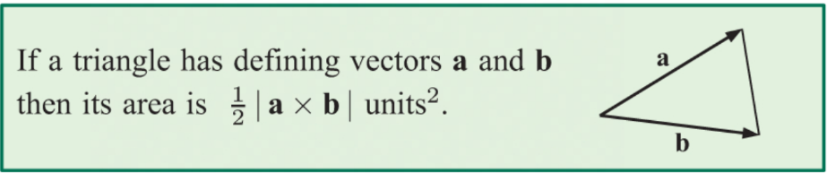
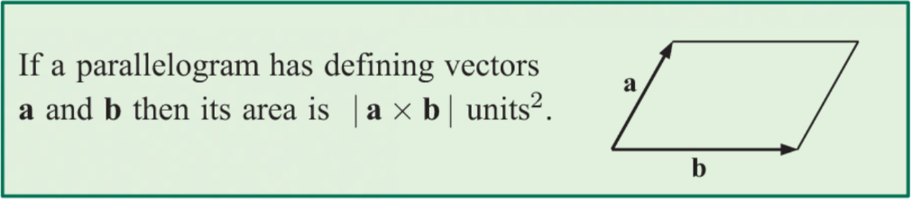

6B LINES IN 2 AND 3 DIMENSIONS
- If a straight line passes through the point with position vector
$\underline{a}=\left[a_{1},a_{2},a_{3}\right]$ and has direction vector $\underline{b}=\left[b_{1},b_{2},b_{3}\right]$ then:
- Its vector equation is $\underline{r}=\underline{a}+λ\underline{b}$
- Its parametric equations are $\left\{\begin{aligned}x=a_{1}+λb_{1} \\ y=a_{2}+λb_{2} \\ z=a_{3}+λb_{3}\end{aligned}\right.$
- Its Cartesian equations are $\frac{x-a_{1}}{b_{1}}=\frac{y-a_{2}}{b_{2}}=\frac{z-a_{3}}{b_{3}}$

6C THE ANGLE BETWEEN TWO LINES
- The acute angle between two lines with direction vectors ${\underline{b}}_{1}$ and ${\underline{b}}_{2}$ is
$$θ=\cos^{-1}\left(\frac{\left|{\underline{b}}_{1}•{\underline{b}}_{2}\right|}{\left|{\underline{b}}_{1}\right|\left|{\underline{b}}_{2}\right|}\right)$$
- The two lines are parallel if ${\underline{b}}_{1}=k{\underline{b}}_{2}$ for some scalar $k$
- The two lines are perpendicular if ${\underline{b}}_{1}•{\underline{b}}_{2}=0$
6D CONSTANT VELOCITY PROBLEMS
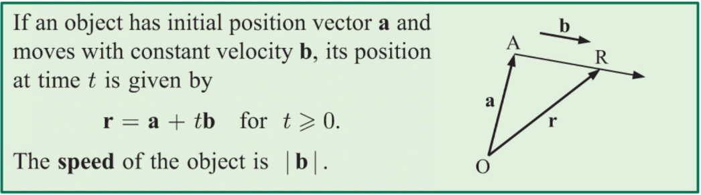

6E THE SHORTEST DISTANCE FROM A POINT TO A LINE
- You can find the shortest distance from the point with position vector $\underline{p}$ to the line with equation $\underline{r}=\underline{a}+λ\underline{b}$ using the following method:
- Find the value of $λ$ which solves $\left(\underline{r}-\underline{p}\right)•\underline{b}=0$
- Substitute this value of $λ$ into the equation of the line to find the coordinates of the point on the line, $N$, which is closest to $P$
- Calculate $\left|\vec{PN}\right|$

6F INTERSECTING LINES
- Vector equations of two intersecting lines can be solved simultaneously to find the point where the lines meet.

6G RELATIONSHIPS BETWEEN LINES
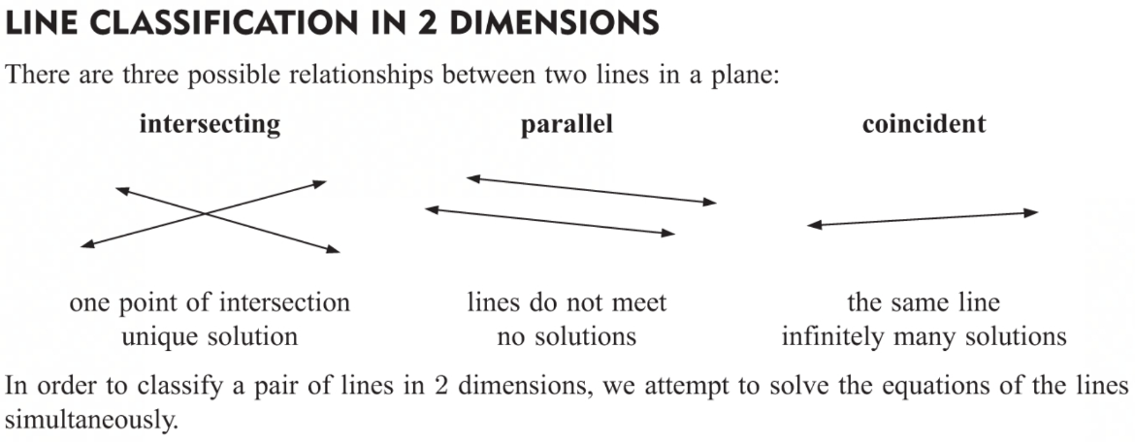
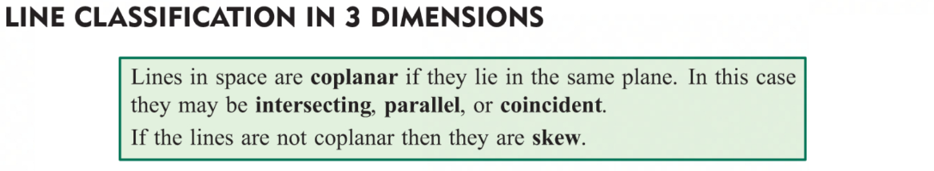
- To find the shortest distance between parallel lines, choose any point on one of the lines and find the shortest distance to the other line using the method outlined in section 6E above.
- To find the shortest distance between skew lines follow this method:
- We need to find two points $A$ and $B$, one on each line, so that $\vec{AB}$ is perpendicular to both skew lines. So, if the direction vectors of the lines are $\underline{v}$ and $\underline{w}$ respectively, then $\vec{AB}∥\underline{v}×\underline{w}$
- Write $\vec{AB}$ in terms of the parameters for the two lines, then use $\vec{AB}=k\left(\underline{v}×\underline{w}\right)$ to write a set of three equations in three unknowns. Solve these simultaneously to find the points $A$ and $B$
- The shortest distance between the lines is $\left|\vec{AB}\right|$

6H PLANES
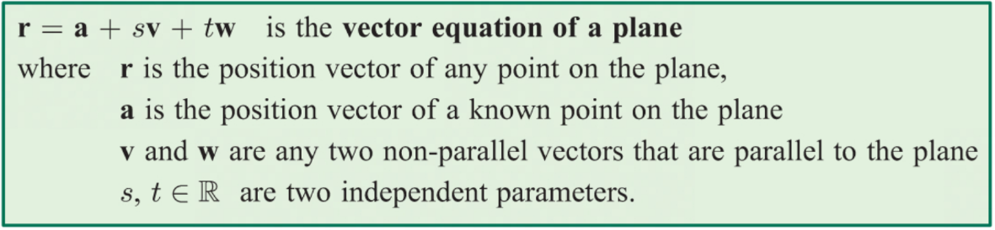
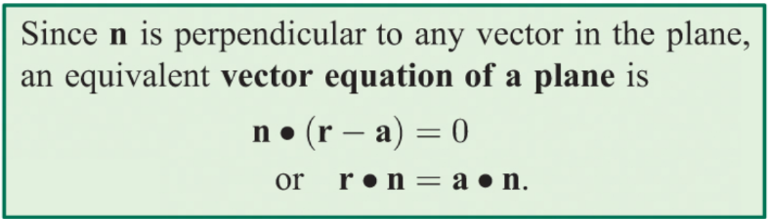
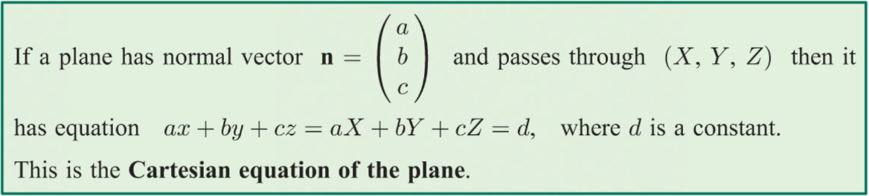
- The distance from a point $\left(x_{1},y_{1},z_{1}\right)$ to a plane $Ax+By+Cz+D=0$ is $d=\frac{\left|Ax_{1}+By_{1}+Cz_{1}+D\right|}{\sqrt{A^{2}+B^{2}+C^{2}}}$

6I ANGLES IN SPACE
- The acute angle, $ϕ$, between a line with direction vector, $\underline{d},$ and a plane with normal vector, $\underline{n}$, is $ϕ=\sin^{-1}\left(\frac{\left|\underline{n}•\underline{d}\right|}{\left|\underline{n}\right|\left|\underline{d}\right|}\right)$
- The acute angle, $θ$, between two planes with normal vectors, ${\underline{n}}_{1}$ and ${\underline{n}}_{2}$ is $θ=\cos^{-1}\left(\frac{\left|{\underline{n}}_{1}•{\underline{n}}_{2}\right|}{\left|{\underline{n}}_{1}\right|\left|{\underline{n}}_{2}\right|}\right)$

6J SOLVING 3 × 3 LINEAR SYSTEMS
- Write the system in augmented matrix form $\left[\begin{matrix}a_{1} & b_{1} & c_{1} \\ a_{2} & b_{2} & c_{2} \\ a_{3} & b_{3} & c_{3}\end{matrix} | \begin{matrix}d_{1} \\ d_{2} \\ d_{3}\end{matrix}\right]$
- Use row operations to reduce it to echelon form $\left[\begin{matrix}a & b & c \\ 0 & e & f \\ 0 & 0 & h\end{matrix} | \begin{matrix}d \\ g \\ i\end{matrix}\right]$
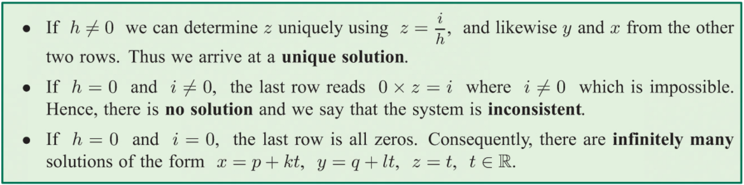

6K INTERSECTING PLANES
