INTEGRATION
KEY FACTS AND CONCEPTS
4A ESTIMATING THE AREA UNDER A CURVE
- The area under the curve $y=f\left(x\right)$ between $x=a$ and $x=b$ can be estimated using lower and upper rectangles.
- Using more rectangles improves the accuracy of the estimate.
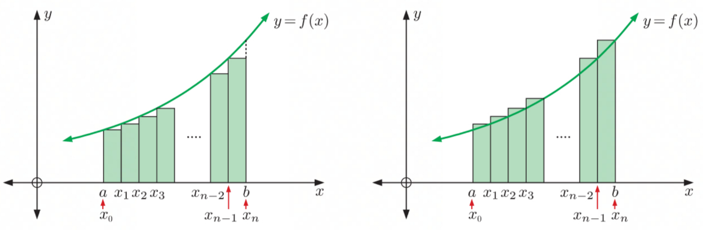

4B ANTIDIFFERENTIATION
- The process of finding $y$ from $\frac{dy}{dx}$, or $f\left(x\right)$ from $f'\left(x\right)$ is the reverse process of differentiation and is called antidifferentiation.
- If $F\left(x\right)$ is a function where $F'\left(x\right)=f\left(x\right)$ we say that:
  - The derivative of $F\left(x\right)$ is $f\left(x\right)$ and
  - The antiderivative of $f\left(x\right)$ is $F\left(x\right)$

4C THE FUNDAMENTAL THEOREM OF CALCULUS
- If $F\left(x\right)$ is the antiderivative of $f\left(x\right)$ then the signed area function from $x=a$ to $x=b$ is $\int_{a}^{b}{f\left(x\right)}dx=F\left(b\right)-F\left(a\right)$
- The following properties of definite integrals can be deduced from the Fundamental Theorem of Calculus:
  - $\int_{a}^{a}{f\left(x\right)dx}=0$
  - $\int_{b}^{a}{f\left(x\right)dx}=-\int_{a}^{b}{f\left(x\right)dx}$
  - $\int_{a}^{b}{f\left(x\right)dx}+\int_{b}^{c}{f\left(x\right)dx}=\int_{a}^{c}{f\left(x\right)dx}$
  - $\int_{a}^{b}{f\left(x\right)±g\left(x\right)dx}=\int_{a}^{b}{f\left(x\right)dx}±\int_{a}^{b}{g\left(x\right)dx}$
  - $\int_{a}^{b}{kdx}=k\left(b-a\right)$ {$k$ is a constant}
  - $\int_{a}^{b}{kf\left(x\right)dx}=k\int_{a}^{b}{f\left(x\right)dx}$ {$k$ is a constant}

4D INTEGRATION
- If $F'\left(x\right)=f\left(x\right)$ then $\int{f\left(x\right)dx}=F\left(x\right)+c$ where $\int{f\left(x\right)dx}$ is the indefinite integral of $f\left(x\right)$ with respect to $x$.
- $\int{kf\left(x\right)}dx=k\int{f\left(x\right)}dx$
- $\int{f\left(x\right)+g\left(x\right)dx}=\int{f\left(x\right)dx}+\int{g\left(x\right)dx}$

4E RULES FOR INTEGRATION
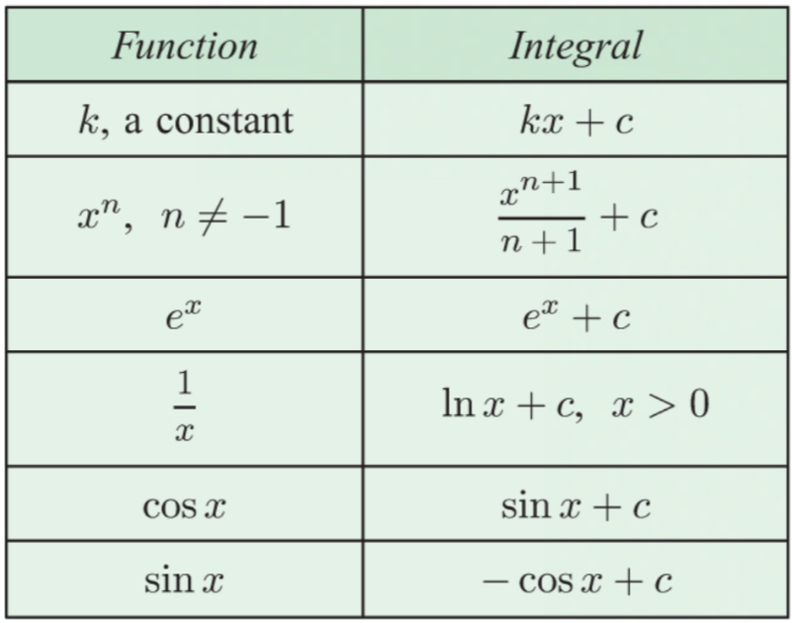

4F INTEGRATING $f\left(ax+b\right)$
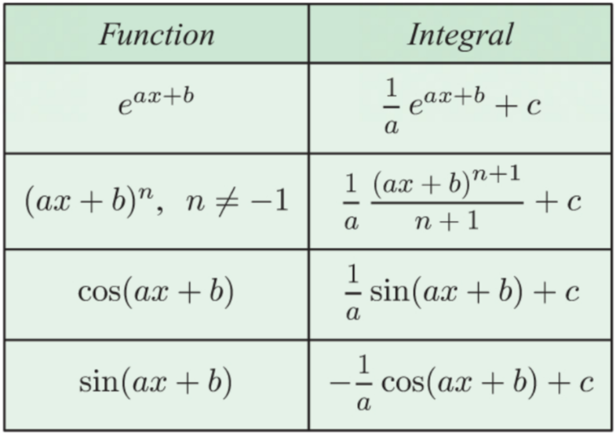

4G DEFINITE INTEGRALS
- If $F\left(x\right)$ is the antiderivative of $f\left(x\right)$ then the definite integral on the interval $a≤x≤b$ is $\int_{a}^{b}{f\left(x\right)}dx={\left[F\left(x\right)\right]}_{a}^{b}=F\left(b\right)-F\left(a\right)$

APPLICATIONS OF INTEGRATION
KEY FACTS AND CONCEPTS
5A THE AREA UNDER A CURVE
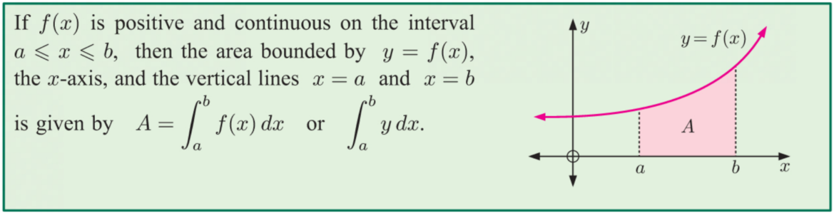

5B THE AREA BETWEEN TWO FUNCTIONS
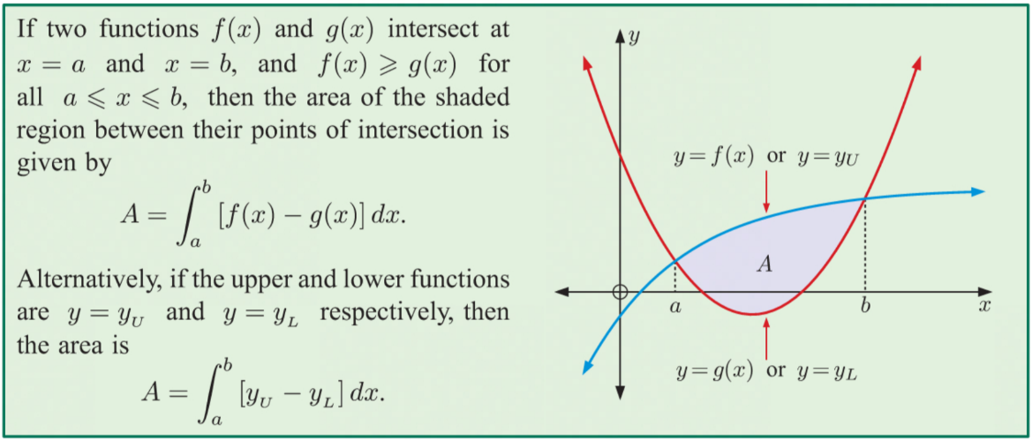

5C KINEMATICS
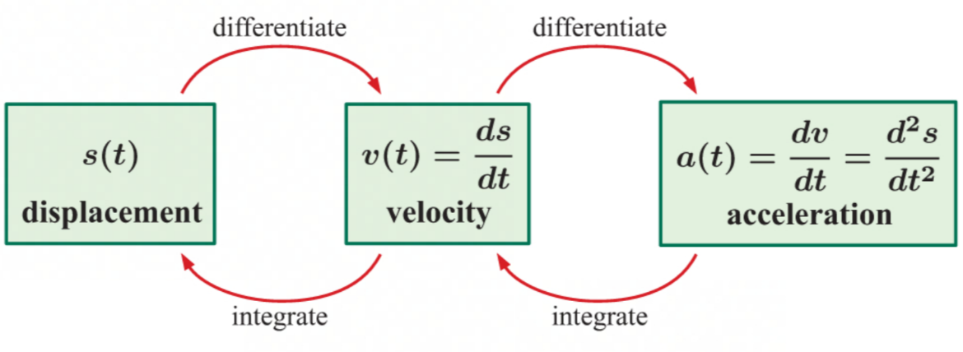
- $\text{Displacement}=\int_{a}^{b}{v\left(t\right)}dt$
- $\text{Distance}=\int_{a}^{b}{\left|v\left(t\right)\right|}dt$

5D PROBLEM SOLVING BY INTEGRATION
- In practical situations it is often easier to measure the rate of change of a variable, and then use integration to find a function for the quantity concerned.
- If $Q'\left(t\right)$ is the rate at which quantity $Q\left(t\right)$ is changing at time $t$:
  - $Q\left(t\right)=\int{Q'\left(t\right)}dt$
  - $\int_{a}^{b}{\int{Q'\left(t\right)}}dt$ gives the change in $Q\left(t\right)$ over the interval $a≤t≤b$

