Stage 2 Mathematical Methods
Integration Test
Topic 1: Subtopics 3.1, 3.2, 3.3, 3.4
Total Marks – 37

(Calculator and one A4 page of hand written notes permitted)

- (10 marks)

Integrate the following expressions: (there is no need to simplify your answers.)

- Find $\int{{\frac{1}{2}e}^{x}-\frac{1}{{\left(3-2x\right)}^{2}}dx}$
(3 marks)

- Find $\int{\frac{1-4\sqrt{x}}{x}dx}$
(3 marks)

- (i) Differentiate ${\left({9-x}^{2}\right)}^{\frac{3}{2}}$
(2 marks)

(ii) Hence find $\int{x\sqrt{9-x^{2}}dx}$
(2 marks)

- (8 marks)

Algebraically find the exact value of $k$ in each case:

- $k=\int_{-1}^{0}{\left(\frac{1}{1-x}\right)}dx$
(4 marks)

- $\int_{0}^{k}{\left(e^{-2x}\right)dx}=-3$
(4 marks)

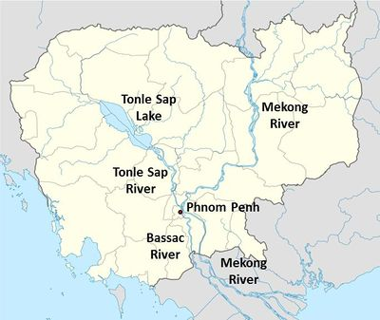
- (9 marks)

In the central plains of Cambodia, at the end of a tributary linking it to the mighty river Mekong, lies a lake named Tonlé Sap. It is not a particularly impressive lake during the dry season, little more than a reedy swamp, but when the monsoon rains begin Tonlé Sap is filled by the flow of a unique reversing river.

During the wet season the water level in the lake rises from just a metre to 10 times that depth. At the same time, the surface area more than quadruples to cover 15,000 km². The increase in water is caused by a remarkable hydrological phenomenon driven by the Mekong, one of the world’s largest rivers. When the south-west monsoon season begins in June, the Mekong suddenly swells into a raging torrent. Its water level rises so fast that not all of the water can escape to the sea.

Instead, some of the floodwater runs into the Tonlé Sap river, which joins the Mekong at Phnom Penh.

The force of water causes the river’s current to be reversed, north towards Tonlé Sap lake. For the next four or five months, the river flows upstream instead of down. Since it is the lake’s only outlet, the water has nowhere else to go, so the lake fills.

The rate of water flow, $R$, along the river can be modelled by $R\left(t\right)=21.4\cos\left(\frac{2π}{12}\left(t-8.5\right)\right)-21.4\cos\left(\frac{5π}{12}\right)$.
$R$ is the rate at which water is flowing into (or out of) the Tonlé Sap lake in km³ per month and $t$ is the number of months that have passed since 1st January in any given year.

A graph of $R$ against $t$ is shown below:

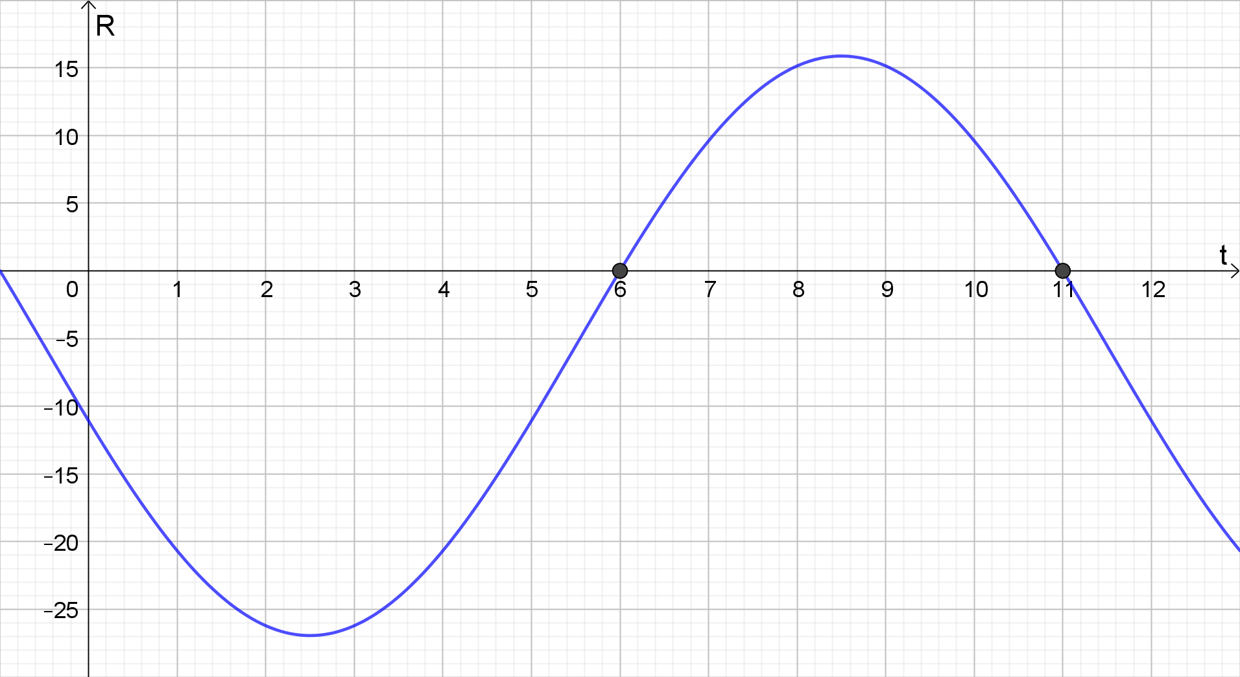

- Mark the graph with W (wet season) to indicate the time intervals when the Tonlé Sap river is filling the Tonlé Sap lake. Mark the graph with D (dry season) to indicate the time intervals when the Tonlé Sap river is draining the Tonlé Sap lake.
(1 mark)

- Determine the volume of water drained from the Tonlé Sap lake by the Tonlé Sap river during the dry season. You may assume that $R$ has roots of 6 and 11.
(3 marks)

- Determine the net volume of water drained from the Tonlé Sap lake by the Tonlé Sap river over the course of a year.
(2 marks)

- Determine the average volume of water flowing along the Tonlé Sap per month.
(3 marks)

- (10 marks)

A particle travels in a straight line with a velocity $v\left(t\right)=10-e^{t}$ metres per second. The particle is initially 2 metres to the right of the origin.

- Determine the initial velocity of the particle
(1 mark)

- Determine when the particle changes direction
(2 marks)

- Find an algebraic expression for the position (or displacement) of the particle, $s\left(t\right)$
(3 marks)

- Calculate the distance travelled by the particle in the first 5 seconds
(2 marks)

- Show mathematically that the particle never travels at a constant velocity
(2 marks)

