INTEGRATION TECHNIQUES AND APPLICATIONS
KEY FACTS AND CONCEPTS
7A RULES FOR INTEGRATION
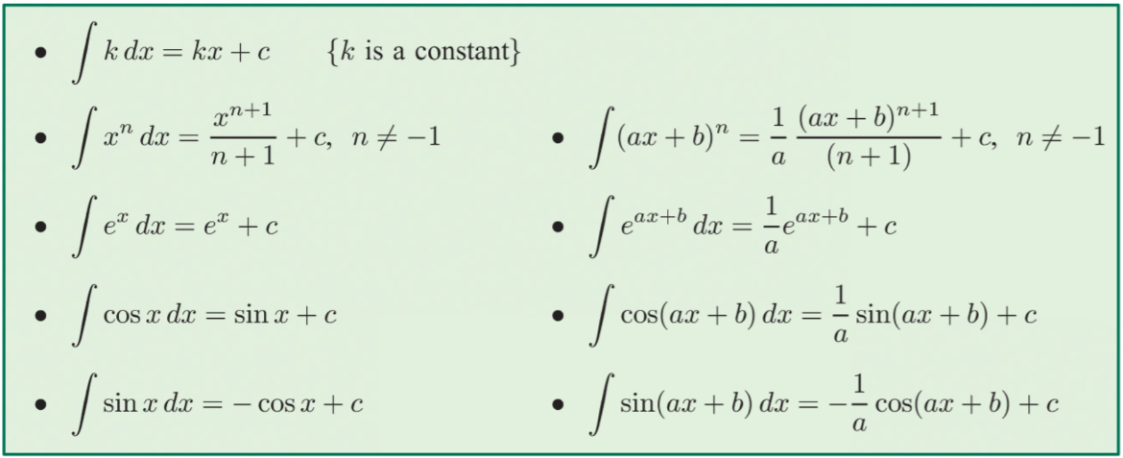

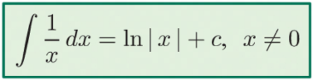
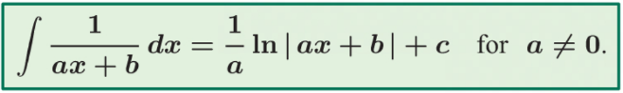

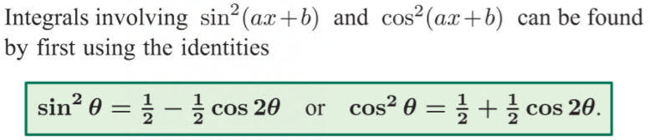

7B INTEGRATING $\frac{±1}{\sqrt{a^{2}-x^{2}}}$ AND $\frac{a}{a^{2}+x^{2}}$
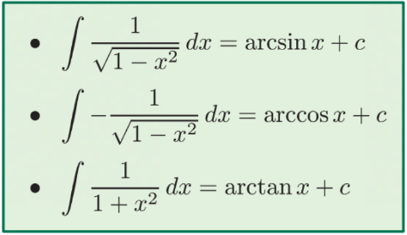

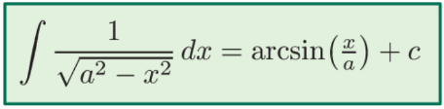
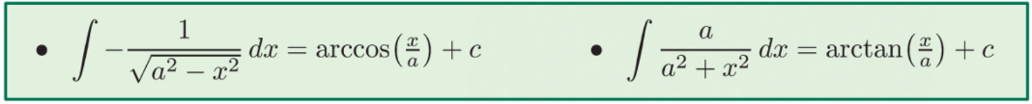

7C INTEGRATION BY SUBSTITUTION
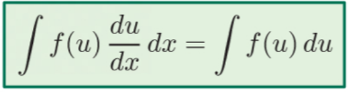

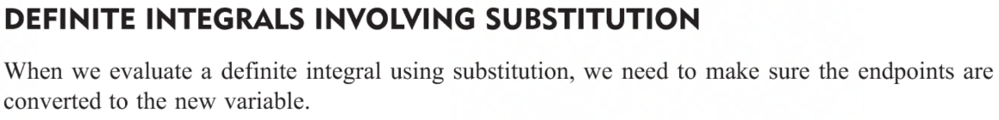

7D INTEGRATION BY PARTS
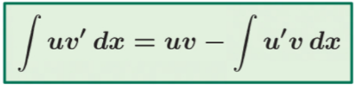

7E THE AREA BETWEEN TWO FUNCTIONS
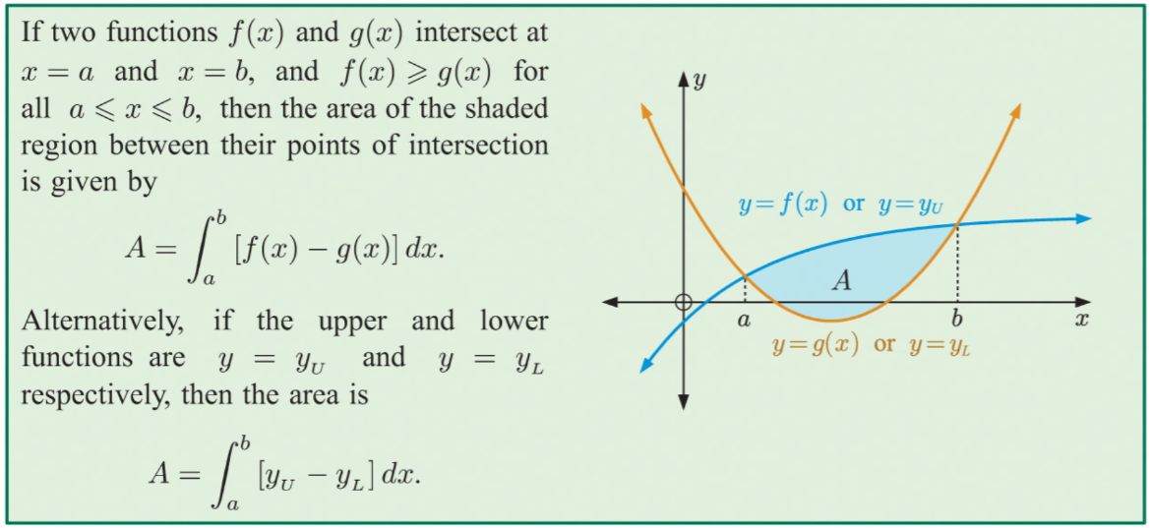

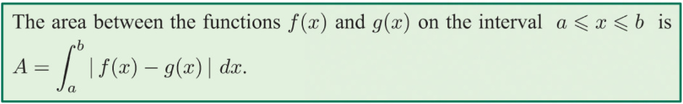

7F SOLIDS OF REVOLUTION
