**Mitochondria**

Respiration (chemical and word equations)

Key: take sugar (made by plants, etc.) and convert it into useful energy form cells can use

**C6H12O6** + 6 **O2** 🡪6 **CO2** + 6 **H2O** + **ATP**

glucose oxygen carbon water energy

gas dioxide gas

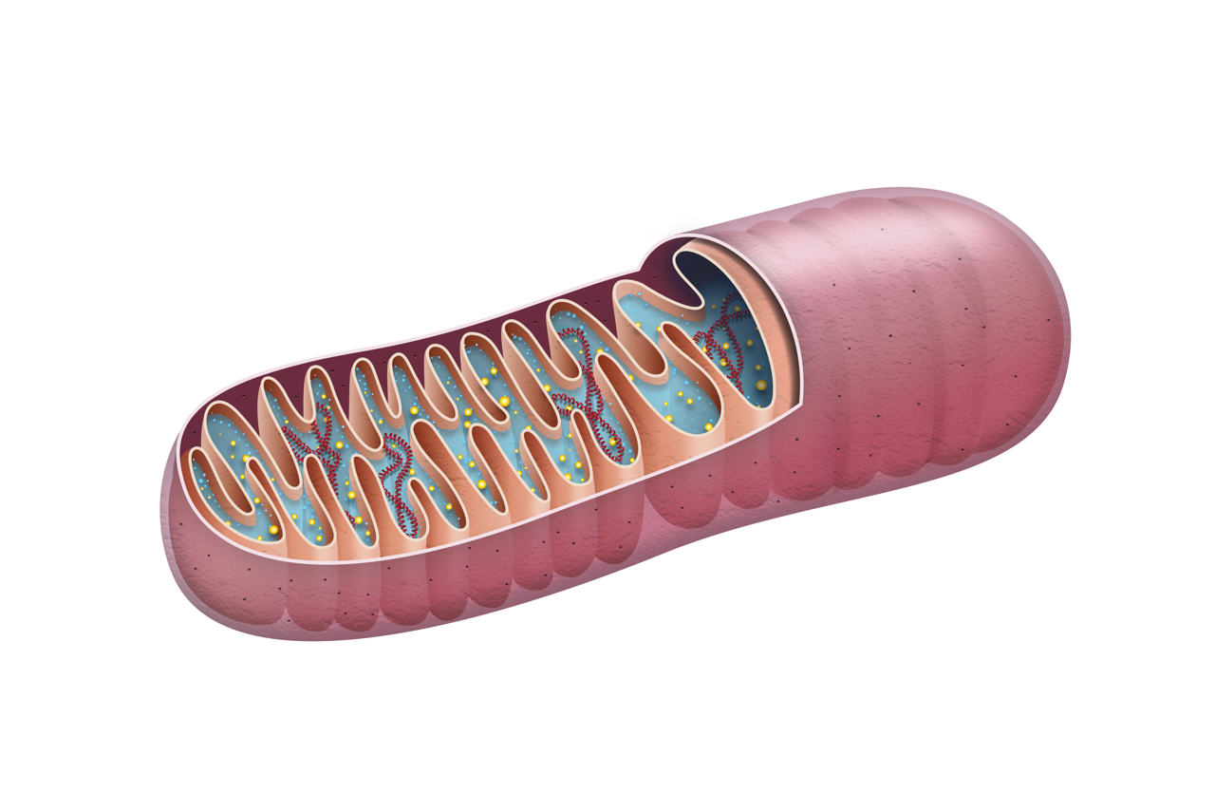

**Chloroplast**

Photosynthesis (chemical and word equations)

Key: make sugar (autotrophic) rather than ingest it; sugar then used for respiration by mitochondria

sunlight

6 **CO2** + 6 **H2O** 🡪  **C6H12O6** + 6 **O2**

carbon water glucose oxygen

dioxide gas gas

