Meal Planning Suggestions
Year 11 Boys Camp – Glenelg River

Breakfast (no cooking – only hot water)
- Up&Go
- bread/wraps with jam, peanut butter, etc
- cereals
- fruit

Lunch (no cooking; packed into Ziploc bags for kayaking)
- rolls & chips
- sandwiches (all types)
- cheese/crackers
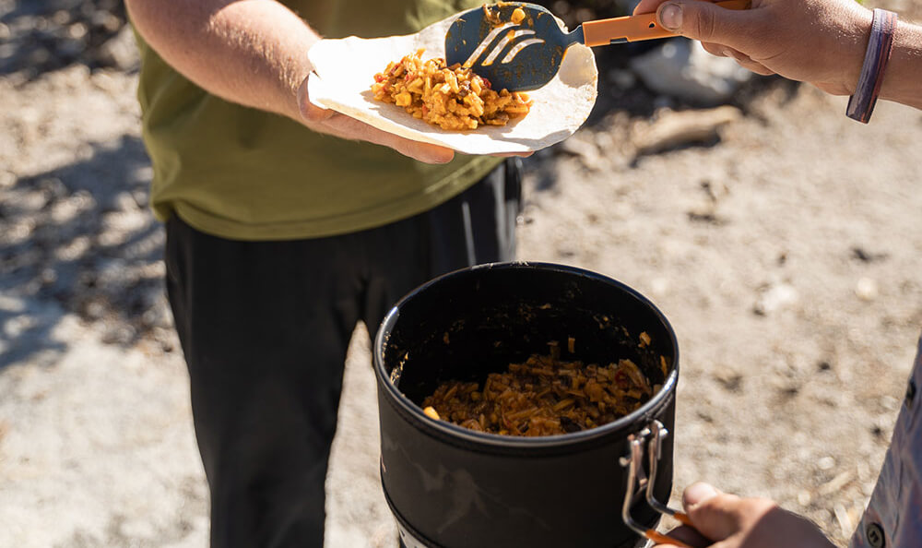
- fruit

Snacks
- lollies
- beef jerky
- muesli bars
- cheese/crackers
- trail mixes
- dried fruit
- chocolate
- chips

Dinner
- frozen pre-cooked meals (freeze in ice-cream container, or similar)
  - spaghetti bolognaise
  - curries + rice
- Mexican – Doritos covered in mince, and other Mexican toppings; Mexican wraps
- packet pastas
- fried rice
- ravioli
- canned meals
  - stews
  - soups
- canned vegetables
- desserts – pies, cakes, muffins, tin fruit, custard, etc.

