Heritage College
A Christadelphian School
Adelaide, Australia

Stage 2 Biology
FORMATIVE SACE Test

Topic: DNA & Proteins (1.1-1.5)
Section A: Multiple-Choice Questions (1 mark each)

1. Refer to the following diagram, which shows a molecule of foetal haemoglobin (HbF) consisting of two alpha and two gamma polypeptide chains:

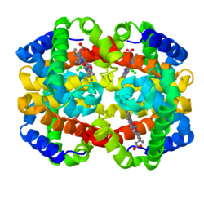

Using only the diagram, it is not possible to determine the

J primary structure of HbF.
K secondary structure of HbF.
L tertiary structure of HbF.
M quaternary structure of HbF.

2. Monozygotic twins develop when a single fertilized egg splits in two and two embryos are formed. These twins exhibit differences in phenotype for the expression of syndromes such as Fragile X because they are

J genetically identical but epigenetically different.
K genetically and epigenetically identical.
L genetically different and epigenetically identical.
M genetically and epigenetically different.

3. Refer to the following diagram, which shows the process of protein synthesis:
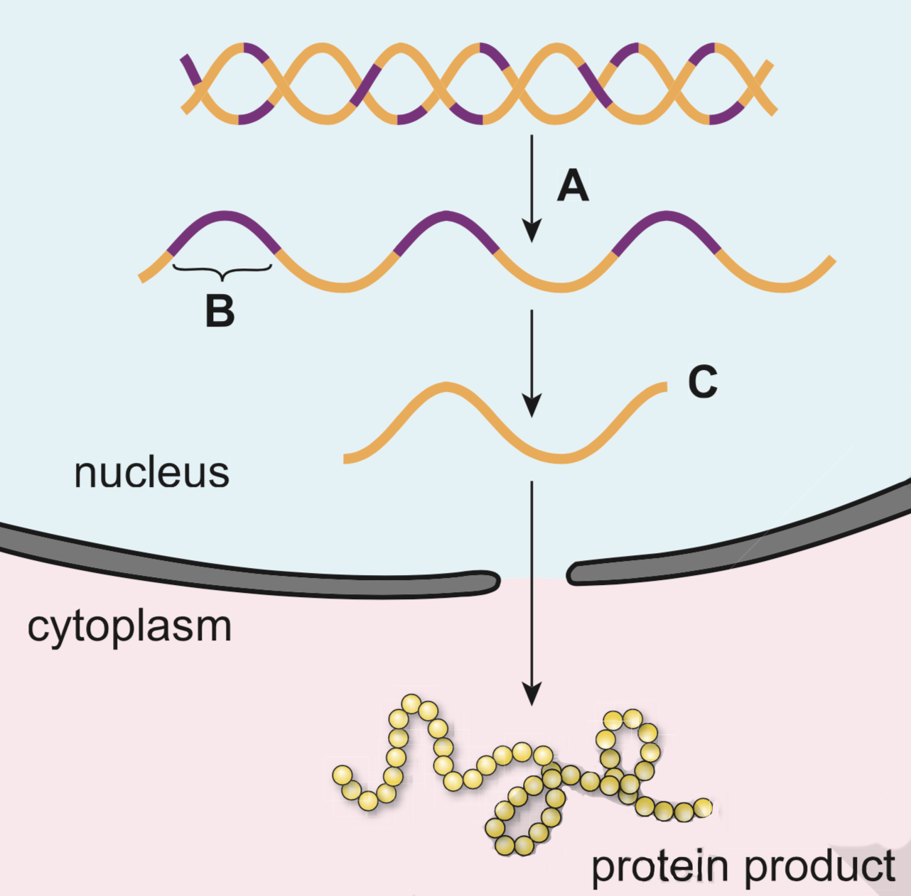

Which one of the following combinations of process A, segment B, and molecule C is correct?

 | Process A | Segment B | Molecule C
J | translation | intron | DNA
K | transcription | intron | RNA
L | translation | exon | DNA
M | transcription | exon | RNA

4. Refer to the following diagram, which shows two electropherograms of a segment of a gene that codes for a particular protein. Sequence A shows the nucleotide sequence for five amino acids in a person who has a normal gene. Sequence B is the same sequence in a person who has a mutated gene.

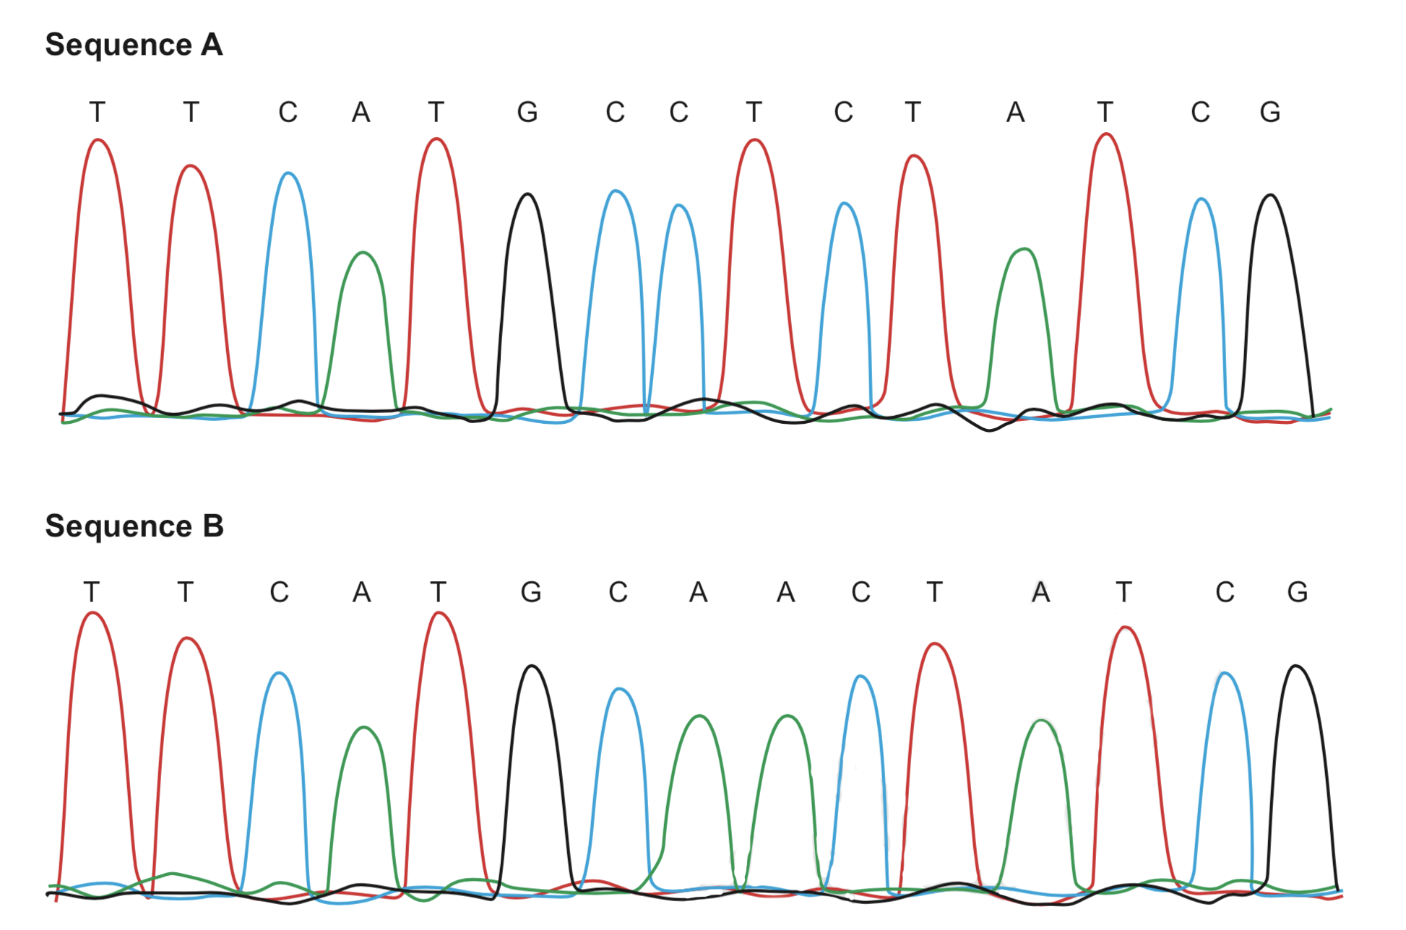

The table below shows selected DNA codons and their corresponding amino acids.

DNA Codon | Amino acid
ATG | methionine
CAA | glutamine
CCT | proline
CTA | leucine
TCG | serine
TTC | phenylalanine

Using the information in the two electropherograms and the table, you can tell that the mutation shown

J may result in a change in one amino acid in the protein.
K will result in a change in one amino acid in the protein.
L may result in a change in two amino acids in the protein.
M will result in a change in two amino acids in the protein.

5. The statement ‘All chromosomes are double stranded and linear’ is

J always true
K not true for eukaryotes or for prokaryotes
L true for prokaryotes but not for eukaryotes
M true for eukaryotes but not for prokaryotes

6. Below is the section of a target DNA strand which is to be copied. It is 17 bases in length. It is put through the PCR thermocycler with the addition of chain terminating (ddNTP) base Cytosine.

It is true to say that many cycles of PCR will produce DNA strands that are

J only 17 bases long.
K a maximum of 16 bases long.
L either 6, 13, 14, 16 or 17 bases long.
M a maximum of 6 bases long.

Section B: Short Answer

1. Refer to the following diagram, which shows three different models of DNA replication (A, B, and C). The blue strands are the original DNA from a parent cell and the yellow strands are the newly synthesized DNA.

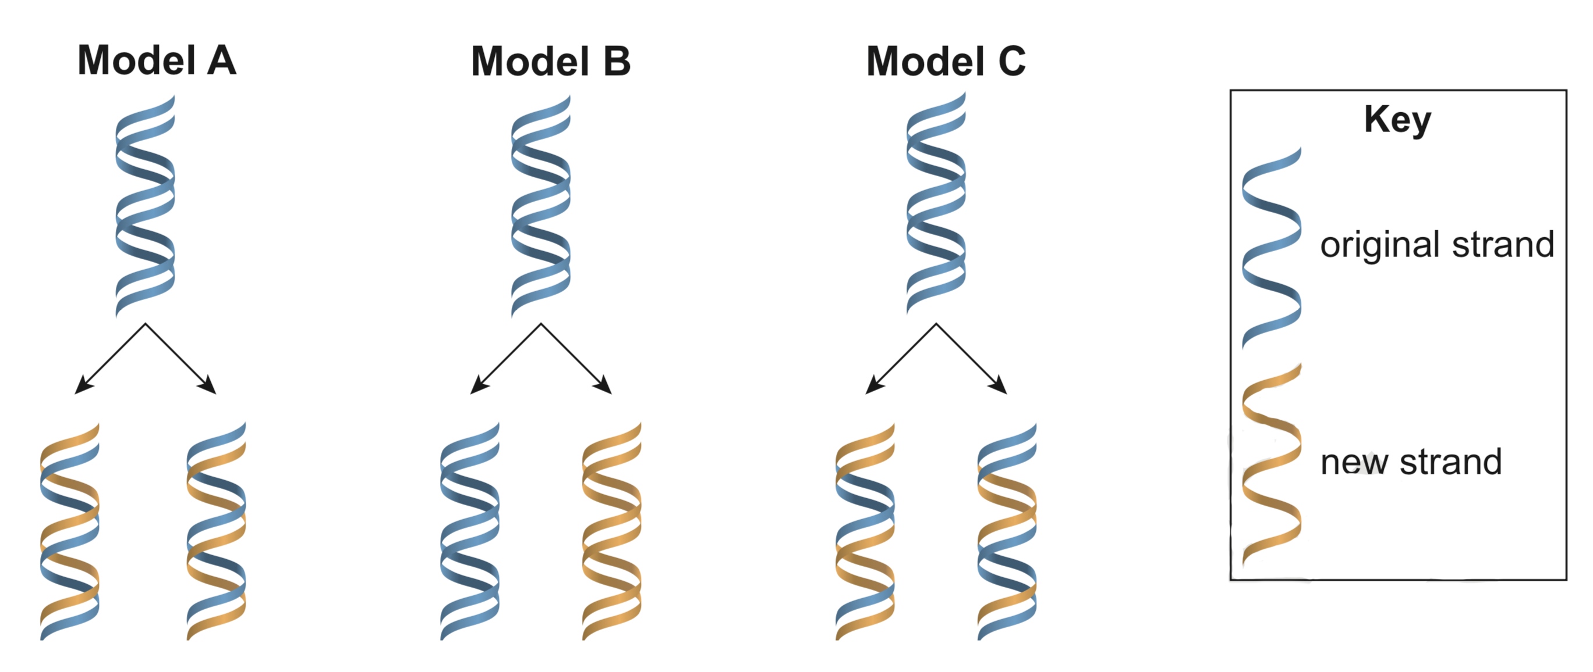

- Write the letter of the model that represents DNA replication in eukaryotes.

(1 mark)

- Describe DNA replication in eukaryotes with reference to the original DNA strands and the newly synthesized DNA strands.
______________________________________________________________________________________________________________________________________________________________________________________________________________________________________________________________________________________________________________________________________________________________________________________________________________________________________________________________________________________________________________________________________________________________________________________________________________________________________________________________(4)

(c) State one environmental factor that could change the base sequence of DNA.
______________________________________________________________________________________________________________________________________________________________(1)

(d) Explain the difference between the potential consequences of mutations in germ cells and
the potential consequences of mutations in somatic cells.
______________________________________________________________________________________________________________________________________________________________________________________________________________________________________________________________________________________________________________________________________________________________________________________________________________________________________________________________________________________________________________________________________________________________________________________________________________________________________________________________________________________________________________________________________________________________________________________________________________________________(4)

2. An enzyme catalyses the following reaction:

(a) According to the induced-fit model for enzyme action, explain how this enzyme helps facilitate the breakdown of Chymotrypsinogen in human cells.
______________________________________________________________________________________________________________________________________________________________________________________________________________________________________________________________________________________________________________________________________________________________________________________________________________________________________________________________________________________________________________________________________________________________________________(3)

(b) In some cases, the creation of byproducts in cellular chemical reactions can alter the rate of the reaction itself. Propose how this could be the case for the reaction above.
______________________________________________________________________________________________________________________________________________________________________________________________________________________________________________________________________________________________________________________________________________________________________________________________________________(2)

(c) Draw a graph with an explanation that illustrates how the rate of this reaction would be affected by increasing the reactant concentration while keeping the level of Trypsin the same.
(4 marks)

3. A crime was committed which resulted in a fight between two people. A small amount of blood was found at the crime scene, but for scientists to locate the perpetrator of the attack, they will need to perform DNA profiling to identify blood that does not belong to the victim.

(a) A key step in this investigation will be to use PCR on the DNA from the blood at the crime scene.

i) Why is PCR needed in this forensics case?
____________________________________________________________________________________________________________________________________________________________________________________________________________________________________________(2)

ii) Briefly outline the key steps of a typical PCR cycle.
____________________________________________________________________________________________________________________________________________________________________________________________________________________________________________________________________________________________________________________________________________________________________________________________________________________________________________________________________________________________________________________________________________________________________________________________________________________________________________________________(4)

(b) After DNA has been cut into fragments by restriction enzymes, samples are placed into the electrophoresis gel and an electrical current applied. This process separates the fragments.

What are the two properties of the DNA fragments that allow them to be separated?
____________________________________________________________________________________________________________________________________________________________________________________________________________________________________________________________________________________________________________________________(2)

(c) Gel electrophoresis can also be used to sequence unknown fragments of DNA. Briefly explain the role of chain terminating nucleotides that are used in this process.
____________________________________________________________________________________________________________________________________________________________________________________________________________________________________________________________________________________________________________________________________________________________________________________________________________________________________________________________________________________________(3)

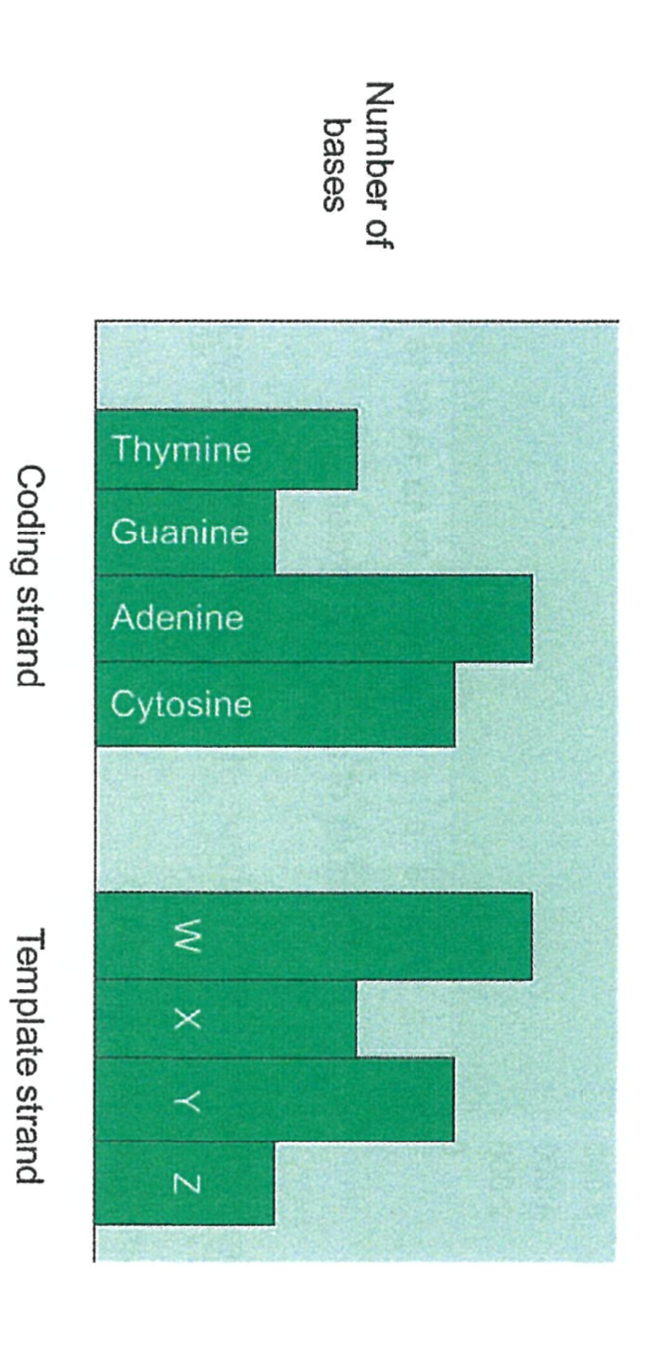
4. A DNA molecule is composed of two polynucleotide strands, a coding strand and a template strand.

(a) The graph shows the number of bases found in the coding and template strands of a small DNA molecule

Identify the base represented by each of the letters.

W: ___________________ X: ___________________ Y: ___________________
(3 marks)

(b) State why the total number of bases in the coding and template strands are identical in DNA.
____________________________________________________________________________________________________________________________________________________________(1)

(c) Explain which strand of the DNA determines the primary structure of a protein, and why.
________________________________________________________________________________
____________________________________________________________________________________________________________________________________________________________________________________________________________________________________________________________________________________________________________________________(2)

(d) mRNA is transcribed from DNA.

State two reasons why the total number of bases in the DNA of a gene is different from the number of bases in the mRNA molecule that undergoes translation.
________________________________________________________________________________
____________________________________________________________________________________________________________________________________________________________________________________________________________________________________________________________________________________________________________________________(2)

Section C: Extended Response

When answering this question you should:
- Communicate your knowledge clearly and concisely
- Use biological terms correctly
- Present information in an organised and logical sequence
- Only include information that is relevant to the question.
Note: 1 well stated point = 1 mark; (total = 6 marks)

- One form of DNA profile is a pattern composed of a series of bands corresponding to DNA fragments of different sizes. Creating DNA profiles has become standard practice in some countries in order to keep records for applications such as forensics. This provides a unique genetic identification for each individual but brings with it potential ethical and economic implications.

In the space below discuss the genetic basis for why each individual will be able to have a unique DNA profile even when similar segments of the human genome are used. Also discuss, with possible examples, why collection of these profiles may cause some to have legitimate concerns.

(6)

Extended Response Answer Sheet

