Chromosome Numbers – background for Mitosis and Meiosis

Interphase DNA = mostly as chromatin

Mitosis/Meiosis DNA grouped/condensed as chromosomes

‘Single’ chromosome:
- One chromatid (with centromere) – this is complete chromatid/chromosome
- They come in pairs – like matching sets (homologous)
- Humans = 23 pairs (so 46)

But when DNA has been replicated in S phase (interphase) – there is two sets of DNA, so there should be double chromosomes when they condense for division:

‘Double’ chromosome:
- Two identical chromatids joined together at centromere (called sister chromatids)
- One is the exact copy of the other (DNA from replication in S phase)
- Look like X shape
- Still part of a homologous pair X X
- 23 pairs = 46 (in duplicate form)

Humans – DIPLOID
- When you have 23 pairs (duplicated or not)

Humans – HAPLOID
- When you have only one from each pair set – ie. 23

Single
chromosomes
(chromatids)
Duplicated
chromosomes

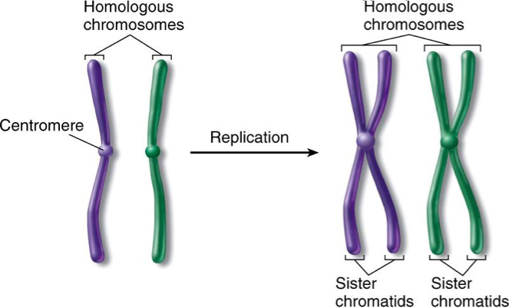

Note: just one of the pair (purple or green) can be called a homologue (singular)

