Stage 2 Biology
FORMATIVE SACE Test

Topic: Cells (2.1-2.5)
Heritage College
A Christadelphian School
Adelaide, Australia

Section A: Multiple-Choice Questions

1. The diagram below illustrates the effects on a plant cell which has been placed in a solution for 10 minutes.

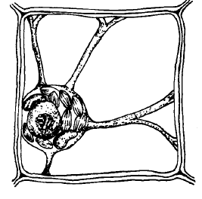
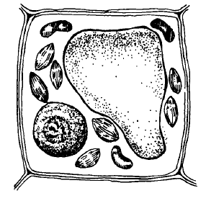

Which statement is true regarding the plant cell?

J It has gained turgor pressure.
K It has experienced lysis.
L It has experienced plasmolysis.
M It was placed in a hypotonic solution.

2. The diagram below illustrates a substance being transported across a cell a phospholipid bi-layer.

The transport shown in the diagram…

J is simple diffusion
K is against the concentration gradient
L is endocytosis
M is facilitated diffusion

3. Refer to the following diagram, which shows an event that occurs during meiosis:

The diagram shows

J crossing over of non-homologous chromosomes.
K independent assortment of homologous chromosomes.
L independent assortment of sister chromosomes.
M crossing over of non-sister chromatids.

4. Refer to the following diagram of cubes, which represent different sized cells, A, B, and C:

Which one of the following statements identifies the relative efficiency of these cells in the exchange of materials?

J Cell A is more efficient than cell B, but less efficient than cell C.
K Cell B is less efficient than cell A, but more efficient than cell C.
L Cell A is less efficient than cell B and cell C.
M Cell C is less efficient than cell A and cell B.

5. The antibiotic oligomycin prevents the production of ATP in actively respiring muscle cells. The addition of oligomycin to actively respiring muscle cells would

J increase the rate of exocytosis.
K decrease the rate of osmosis.
L increase the rate of diffusion.
M decrease the rate of protein synthesis.

6. Refer to the following metabolic pathway, which shows the intermediate compounds in the synthesis of the haem molecule that forms part of haemoglobin. The enzymes that catalyse the reactions at each step are also shown.

Porphyrias are diseases that result when a person has a defective gene that codes for an enzyme in the haem metabolic pathway.

The deficiency of a specific enzyme results in a particular disease, as shown in the table below:

Diagnosis is often made when abnormal amounts of one or more intermediate compounds are found in the patient’s blood, urine, or faeces.

The urine samples of a person with variegate porphyria would be likely to contain an abnormally high amount of

J intermediate compound Z and an abnormally low amount of haem.
K intermediate compound Z and an abnormally low amount of intermediate compound Y.
L intermediate compound Y and an abnormally high amount of intermediate compound X.
M intermediate compound Y and an abnormally high amount of intermediate compound Z.

7. Which one of the following lists identifies some components of the cell membrane?

J phospholipids, aquaporins, and carrier proteins.
K phospholipids, channel proteins, and hormones.
L antibodies, tRNA, and cholesterol.
M phospholipids, receptor proteins, and glucose.

8. The movement of chloroplasts within the cytoplasm of some green plant cells maximizes the exposure of the chloroplasts to sunlight.
Which one of the following cell structures enables this movement of chloroplasts to occur?

J Endoplasmic reticulum
K Cytoskeleton
L Golgi body
M Cell membrane

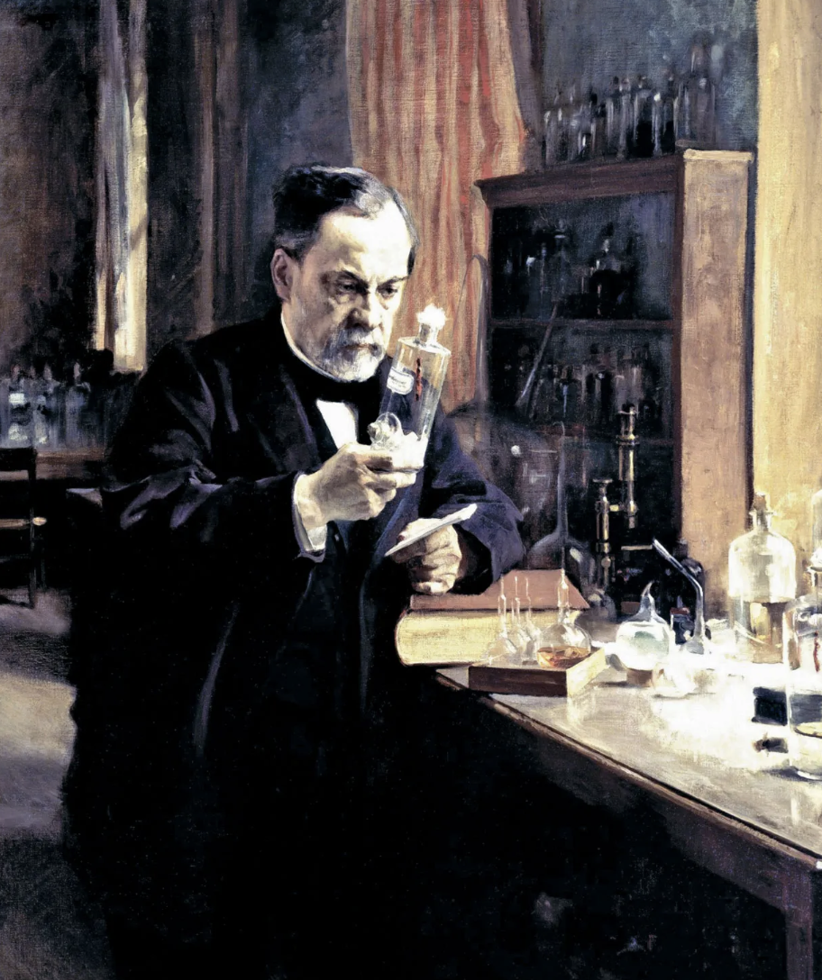
9. In in the nineteenth century Louis Pasteur showed that fermentation by bacteria can contaminate wine.
Louis himself, up to his usual brilliant experimenting! Legend! Without him, we have no ‘pasteurised’ milk!

*Yes, this picture was totally unnecessary and utterly distracting. But now you know what he looks like. Now get on with your test – smash it like Louis would smash that glass flask he is holding!

The process of fermentation in bacteria occurs in the

J mitochondria in the absence of oxygen.
K cytoplasm in the presence of oxygen.
L mitochondria in the presence of oxygen.
M cytoplasm in the absence of oxygen.

10. In an experiment, yeast cells were placed in a glucose solution in a closed container and grown under anaerobic conditions.

Which one of the following would not have been released by the respiring yeast cells?

J Lactic acid
K Ethanol
L Heat
M Carbon dioxide

Section B: Short Answer

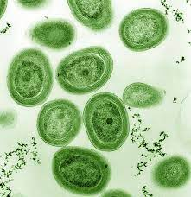
Question 1
The image opposite is a TEM (transmission electron micrograph) of a section through some Prochlorococcus cyanobacteria cells.

These single-celled marine microorganisms are considered the most abundant photosynthetic organisms on Earth.

(a) Prochlorococcus synthesizes a light-absorbing molecule they use in photosynthesis.

Name the light-absorbing molecule.
___________________________________________________ (1)

(b) Name two other raw materials required for photosynthesis.
______________________________________________________________________________________________________________________________________________________________(2)

(c) Write the balanced chemical equation for photosynthesis.
____________________________________________________________________________ (2)

(d) Prochlorococcus live in water but cannot survive below depths of 150 meters. State the primary reason for this.
____________________________________________________________________________ (1)

(e) These bacteria do not have the complex structures called chloroplasts, that eukaryotic cells have. Give two reasons why chloroplasts are beneficial for those cell types that do have them.
______________________________________________________________________________________________________________________________________________________________(2)

(f) Prochlorococcus cells use the process of photosynthesis, amongst other things, to provide energy needed for rapid and frequent cell division.

i. State the type of cell division Prochlorococcus undergoes.
_______________________________________________________________________(1)

ii. Explain how the steps of this process lead to genetically identical daughter cells.
_______________________________________________________________________(2)

Question 2
An experiment was conducted to investigate bacterial growth in food products that are stored in packaging in which the oxygen concentration can vary. The results of the investigation are displayed in the graph below. They show the growth rates of four species of bacterium: A, B, C, and D.

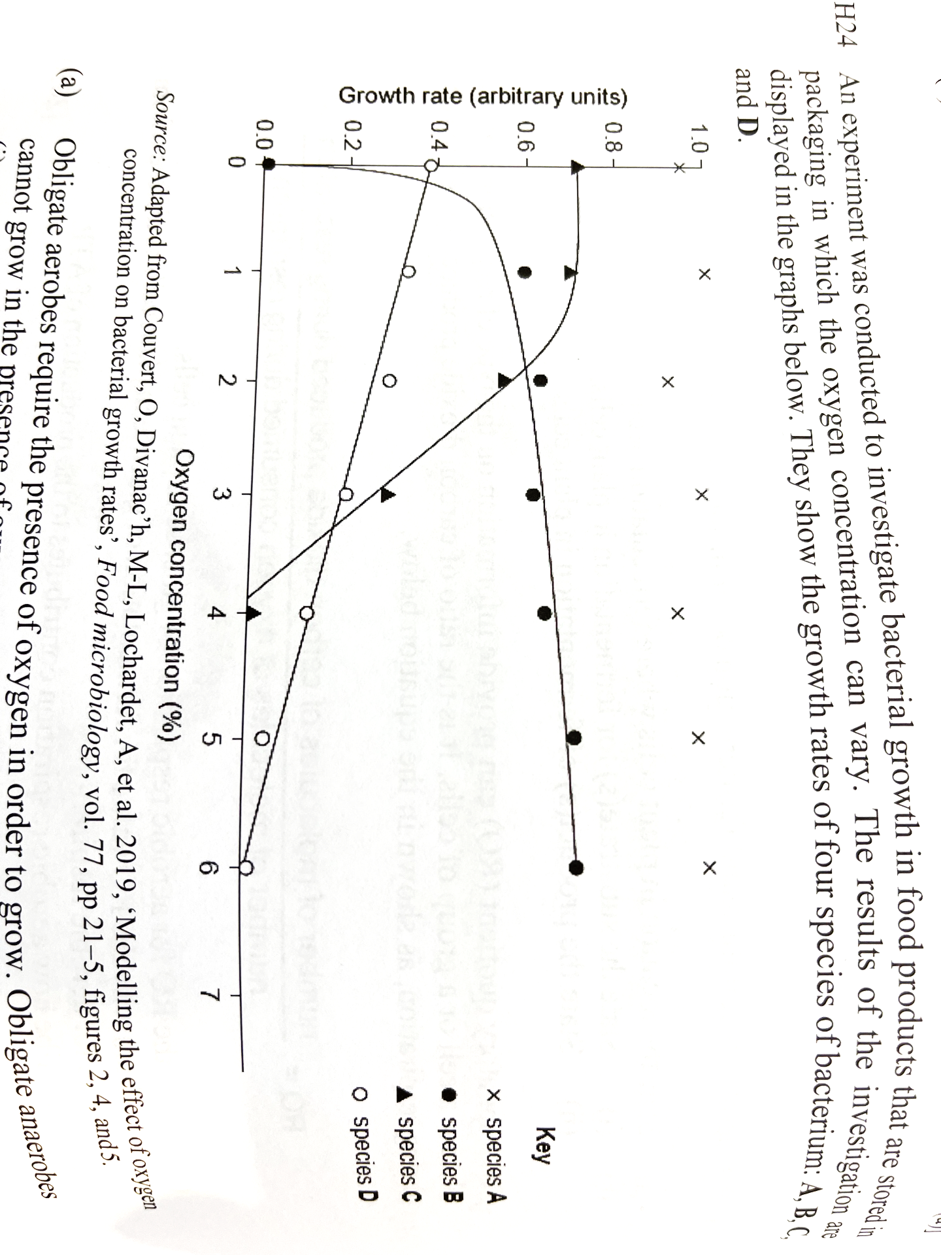

(a) Obligate aerobes require the presence of oxygen in order to grow. Obligate anaerobes cannot grow in the presence of oxygen.

i. Identify which one of the species (A,B,C, or D) is an obligate aerobe.
_______________________________________________________________________(1)

ii. Cyanobacteria are able to photosynthesize. Explain why it is unlikely that species D is a
cyanobacterium.
_________________________________________________________________________
_______________________________________________________________________(2)

(b) Explain how the presence of oxygen affects the efficiency of respiration in eukaryotic cells.
______________________________________________________________________________________________________________________________________________________________(2)

(c) Describe at least two ways in which ATP would be used by bacteria in order to grow/multiply?
___________________________________________________________________________________________________________________________________________________________________________________________________________________________________________________________________________________________________________________________(2)

Question 3
The diagram below shows the very small gap (synaptic cleft) that exists between two nerve cells. Nerve cell 1 passes protein molecules (neurotransmitters) out and across the gap between the two cells. These molecules are then taken in by Nerve cell 2, as it receives the chemical message.

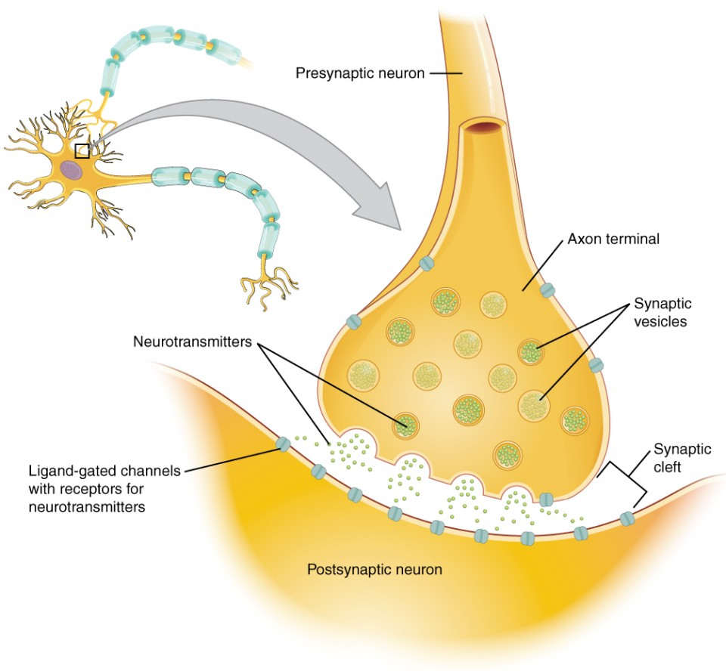
Nerve cell 1
Nerve cell 2

(a) Describe the process by which Nerve cell 1 releases acetylcholine into the synapse, as shown in the diagram above.
______________________________________________________________________________________________________________________________________________________________________________________________________________________________________________(3)

(b) List the key organelles, in order, that would likely be involved from the protein neurotransmitter being synthesized, to it being sent to the synaptic cleft.
______________________________________________________________________________________________________________________________________________________________________________________________________________________________________________________________________________________________________________________________(4)

(c) What factors would determine which method of transport would be used to get the neurotransmitter across the cell membrane?
______________________________________________________________________________________________________________________________________________________________________________________________________________________________________________(2)

Question 4
The molly is a type of fish, that are popular with aquarium hobbyists. Numerous species of molly live near the Gulf of Mexico. The sailfin molly (Poecilia latipinna) and the Atlantic molly (Poecilia Mexicana) reproduce sexually.
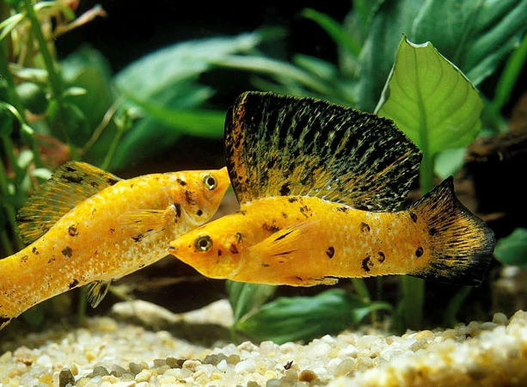
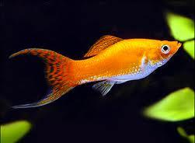

latipinna
mexicana

(a) Name the type of cell division in a molly that produces gametes from diploid cells.
______________________________________________________________________________(1)

(b) Describe the process that results in gamete cells of a molly, which contain a single set of chromosomes.
______________________________________________________________________________________________________________________________________________________________________________________________________________________________________________________________________________________________________________________________________________________________________________________________________________(4)

(c) Explain why the DNA in a somatic cell of a molly doubles before the cell divides.
______________________________________________________________________________________________________________________________________________________________________________________________________________________________________________(2)

(d) Explain why the degree of genetic variation in a species of molly is different from the degree of genetic variation in a species of bacterium.
______________________________________________________________________________________________________________________________________________________________________________________________________________________________________________________________________________________________________________________________(3)

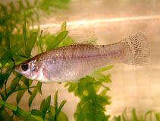
Sailfin mollies and Atlantic mollies can interbreed to produce offspring. These hybrid offspring are called Amazon mollies (Poecilia formosa) and are all female. Amazon mollies are not able to produce normal gametes, but instead produce diploid eggs. These egg cells develop into adult Amazon mollies that are genetically identical to their mother.
formosa

(e) Explain why the offspring of Amazon mollies are genetically identical to their mother.
______________________________________________________________________________________________________________________________________________________________________________________________________________________________________________________________________________________________________________________________(3)

Section C: Extended Response

When answering this question you should:
- Communicate your knowledge clearly and concisely
- Use biological terms correctly
- Present information in an organised and logical sequence
- Only include information that is relevant to the question.
Note: 1 well stated point = 1 mark; 2 marks will be given for communication

1. The cell cycle is controlled by various internal and external factors. These factors combine to oversee whether or not a cell will enter the next phase of the cell cycle, and also how fast it will do so (if at all).

Discuss two examples of external factors that may affect the cell cycle.

Discuss the role of Cdks as an internal factor for the cell cycle.

Explain how cancer is a disruption of the cell cycle and use examples to support your explanation.
(9)

Rough planning space:

Extended Response Answer Sheet

