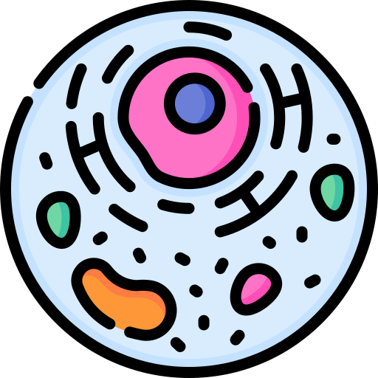
Stage 1 Biology
Cells Learning Intentions

J K L I can represent the structure & function of the 4 major macromolecules

J K L I can state the Cell Theory

J K L I can evaluate whether something is ‘alive’ using the 7 Characteristics of Living Things

J K L I can compare and contrast:
- Prokaryotic Cells vs Eukaryotic Cells (esp DNA)
- Plant vs Animal Cells

J K L I can identify and explain key cell organelles – their structure and function

J K L I can compare and contrast the process/steps of binary fission and mitosis

J K L I can explain the difference between sister chromatids and homologous chromosomes

J K L I can state the balanced equations for photosynthesis and respiration (anaerobic &
aerobic)

J K L I can describe the ATP-ADP cycle

J K L I can evaluate the efficiency of diffusion in relation to cell size using SA:V ratio

J K L I can draw the key parts of ‘fluid mosaic model’ of the cell membrane
- (eg. Plasma membrane; Phospholipid bi-layer)

J K L I can describe the function of the cell membrane in controlling what enters/exits cell

J K L I can compare and contrast the different types of transport across cell membrane:
- Passive – Simple diffusion; Osmosis; Facilitated Diffusion (channel & carrier)
- Active – Ion Pumps; Endocytosis; Exocytosis

J K L I can predict what will happen to a plant or animal cell when placed in any of the
following
solutions:
- Hypotonic/Hypertonic/Isotonic

J K L I can describe, recognize and sketch the cellular conditions of:
- plasmolysis; flaccid; gain/loss of turgor pressure; lysis

J K L I can sketch and explain the process of transcription and translation
- DNA ---- mRNA ---- protein

J K L I can describe the role of the following RNA molecules:
- mRNA, tRNA, rRNA (this is the ribosome itself)

