Cells Unit – Key Terms
Stage 1 Biology
Macromolecule
Polymer
Monomer
Carbohydrate
Simple sugar
Complex sugar
Nucleic acid (DNA/RNA)
Nucleotide
Amino acid
Protein
Lipid
Fats/oils

Chemical energy

7 characteristics of life
Prokaryotic
Eukaryotic
Spontaneous generation

Organelles *know structure/function

Multicellular
Unicellular
Phospholipid (bi-layer)
Fluid Mosaic Model
Plasma membrane
Semipermeable
Cholesterol
Glycolipids
Glycoproteins
Peripheral vs integral proteins
Surface area
Volume
SA:V ratio

Passive transport
Facilitator proteins
- Carrier vs channel
Diffusion
Osmosis
Concentration gradient

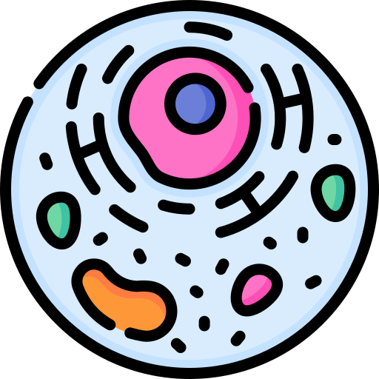
Isotonic
Hypotonic
Hypertonic
Solvent / Solute
Flaccid
Plasmolysis
Lysis
Turgor pressure

Active transport
Exocytosis
Endocytosis
Phagocytosis
Pinocytosis

Respiration
Aerobic respiration
Anaerobic respiration
- Alcohol fermentation
- Lactic acid fermentation
- ATP / ADP

Photosynthesis
Catabolic reaction
Anabolic reaction

Mitosis (PMATC)
Cell cycle stages
Binary fission

Protein synthesis

Transcription
Template strand
mRNA
RNA polymerase

Translation
rRNA (ribosome)
tRNA
codon
anticodon
polypeptide

