Stage 2 Biology Organisms
Communication Assignment

- Outline two key differences between a typical nervous response and a typical endocrine (hormonal) response to a stimulus.
(2)

- Explain how the nervous system is often linked to the endocrine system in bodily communication. Use an example to help explain.
(4)

- Contrast how a peptide vs a steroid hormone typically triggers a desired response in a given cell.
(4)

- Examine the diagram of a typical synapse (where two nerve cells meet).

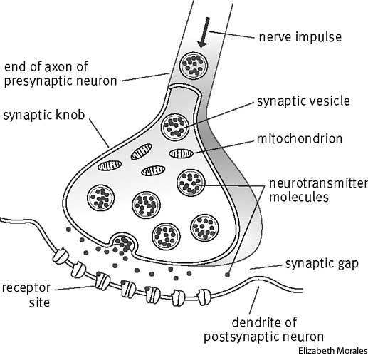

- Identify and describe the steps of the process whereby the neurotransmitter molecules are released into the synapse.
(4)

- Give two clear reasons why there is a higher than normal concentration of mitochondria in this part of the nerve cell.
(4)

- Explain how the neurotransmitter molecules came to find themselves within the synaptic vesicles.
(4)

- Using the diagram as an aid, explain how a pain killing type of drug may work at a molecular level by interrupting nerve impulses. Be specific in your explanation.
(4)

