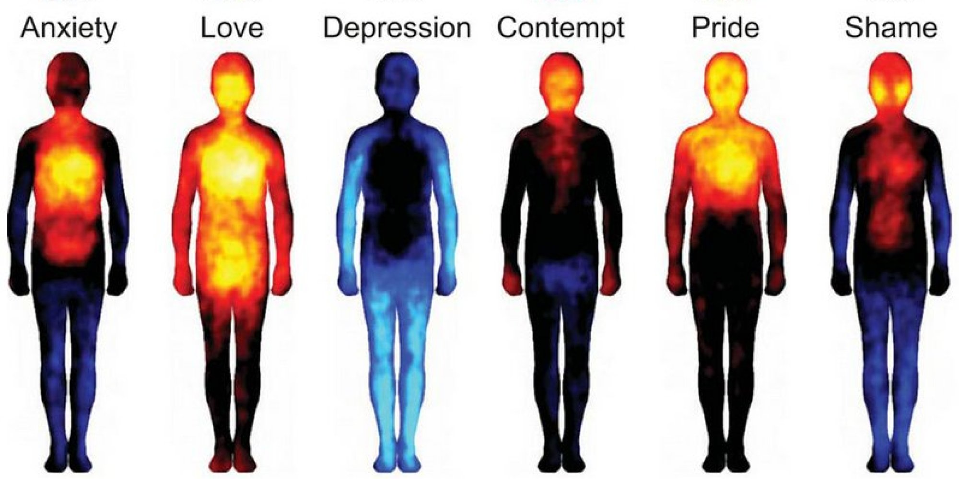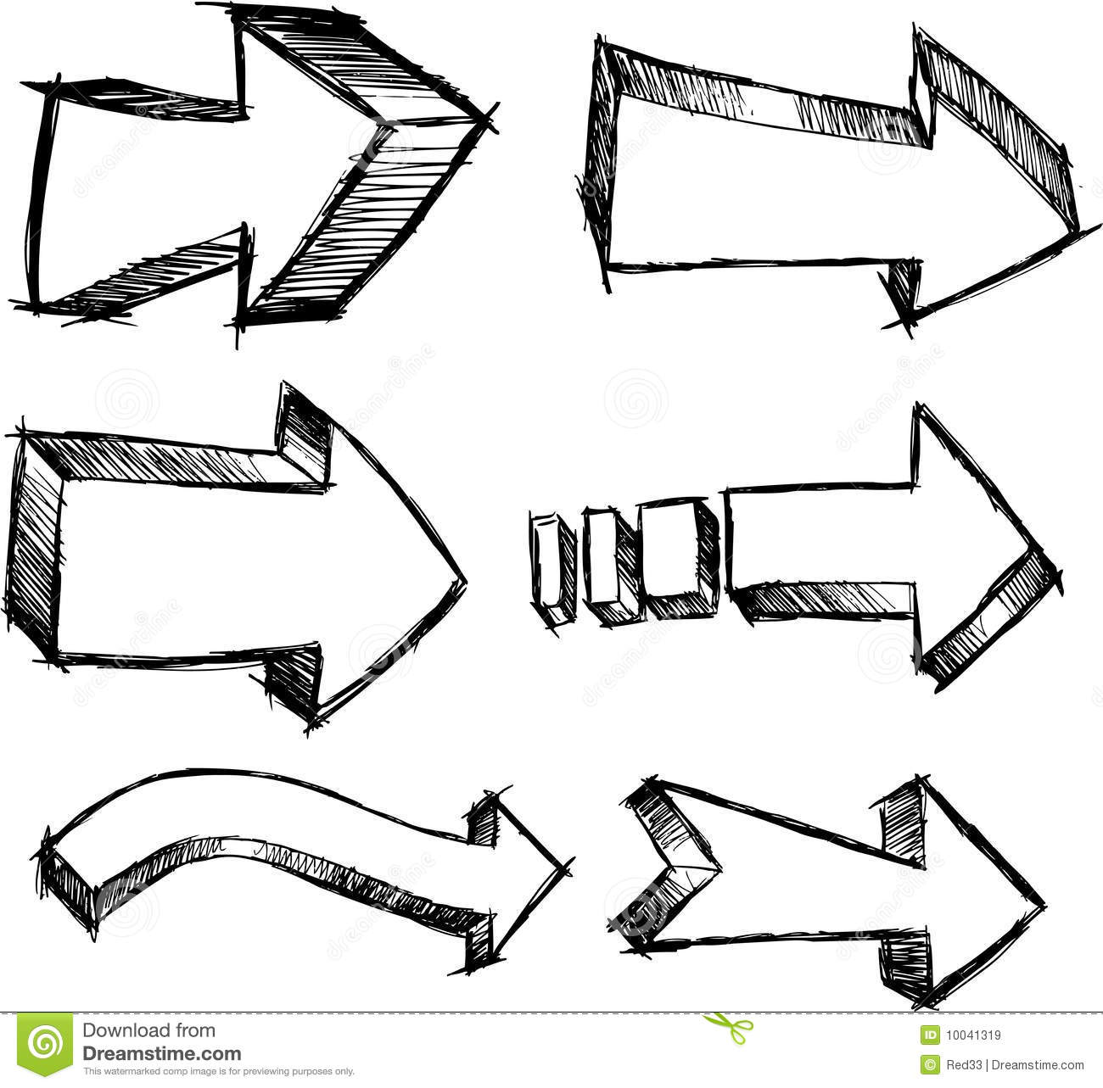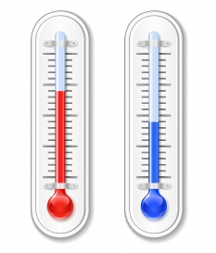

**Involuntary:**



**Voluntary:**



**Involuntary:**



**Voluntary:**



Body

Temperature

(Thermoregulation)

**Normal**

**Body**

**Temperature**

**Normal**

**Body**

**Temperature**

**Sensed by:**

Negative Feedback

(cooling)

Negative Feedback

(warming)

Nerves

and

Hormones

Nerves

and

Hormones

**Sensed by:**

**Increase Body**

**Temperature**

**Decrease Body**

**Temperature**