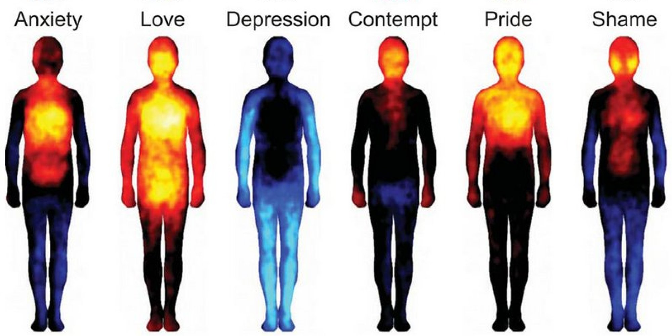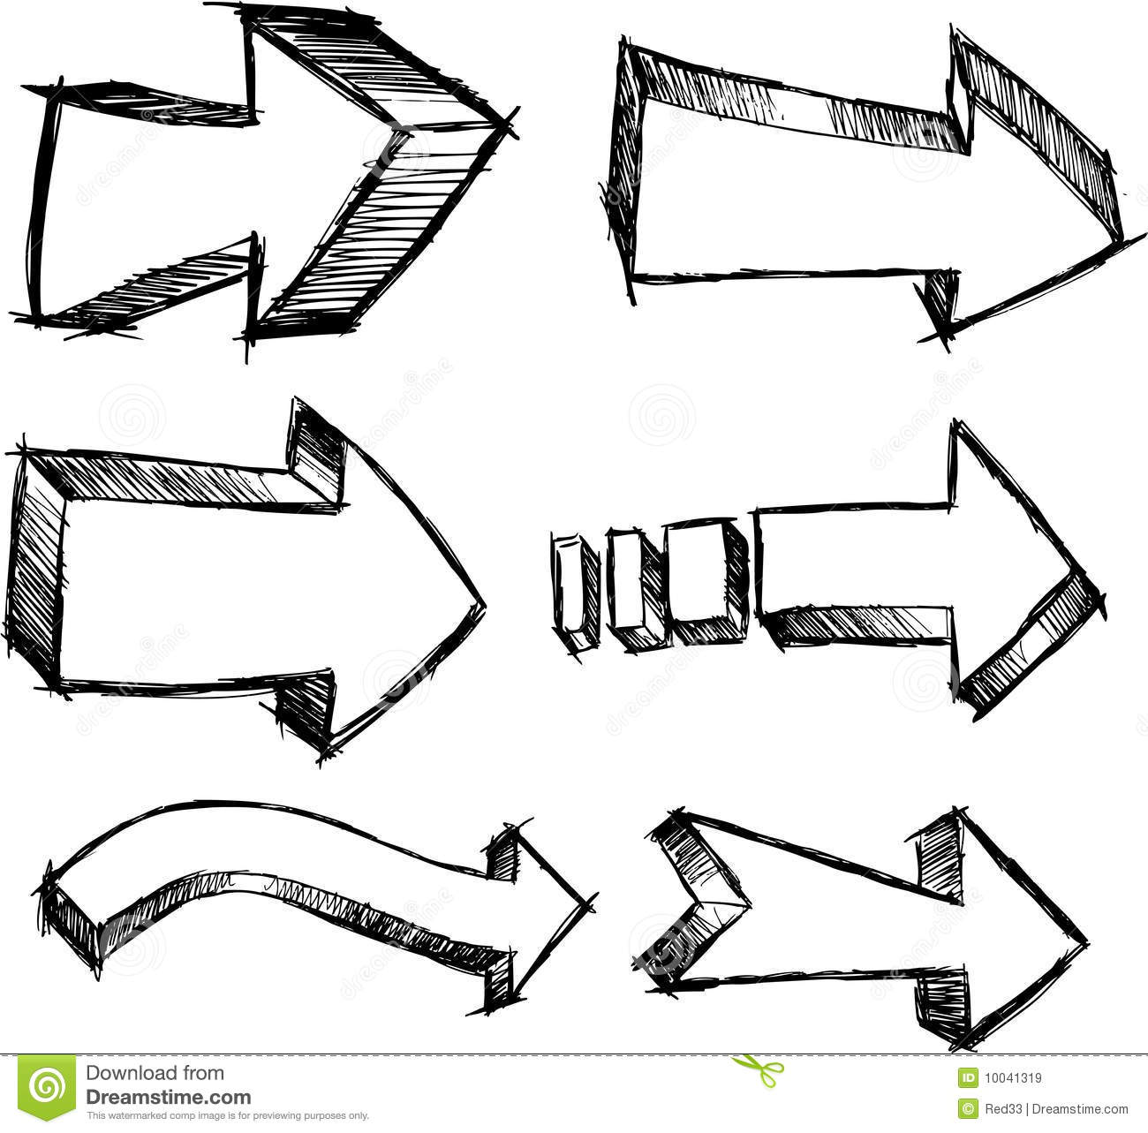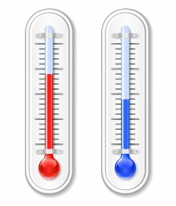

**Involuntary:**

* Shivering (N)
* Vasoconstriction (N)
* Hair stands up (N)
* Increase thyroxine & metabolism

**Voluntary:**

* Put on beanie
* Huddle up
* Rub hands/skin

**Involuntary:**

* Sweating (N)
* Vasodilation (N)
* Hair flattens (N)
* Reduce thyroxine & metabolism

**Voluntary:**

* Cooling with fan
* Ice on head
* Seek shade

Body

Temperature

(Thermoregulation)

**Normal**

**Body**

**Temperature**

**Normal**

**Body**

**Temperature**

**Sensed by:**

Negative Feedback

(cooling)

Negative Feedback

(warming)

Nerves

and

Hormones

Nerves

and

Hormones

**Sensed by:**

**Increase Body**

**Temperature**

**Decrease Body**

**Temperature**