Nephron
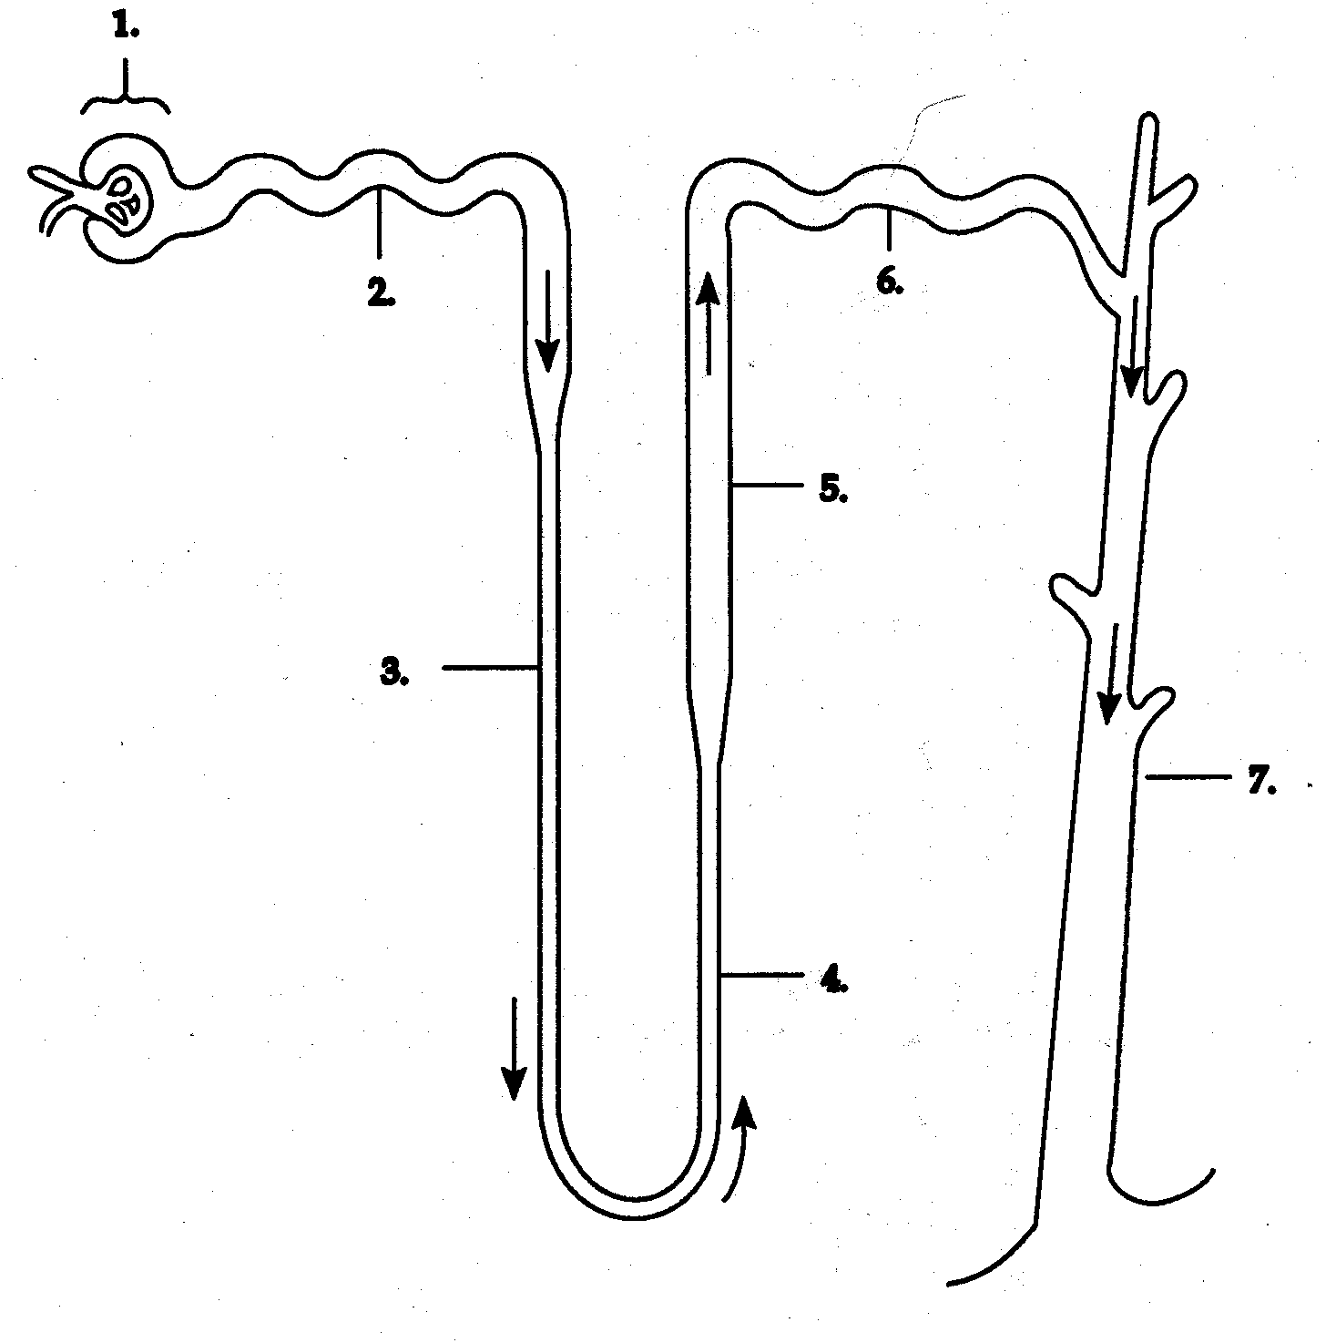
Functional Unit of the Kidney

