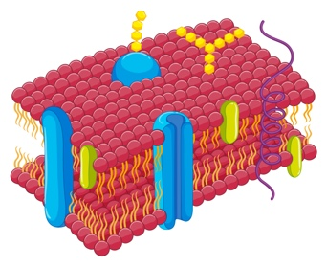
Stage 1 Biology
Cell Membrane Structure
LI: I can identify the structure and function of different parts of the cell membrane.

Task 1: Watch it
Review the provided videos that focus on the cell membrane. You can watch them in any order. As you do jot down or quickly sketch key points and ideas in a Word document or in your notebook. At the end you will have a set of point form notes on the key aspects of the cell membrane.

Title | URL
Structure of the Cell Membrane (Nucleus Biology) | https://www.youtube.com/watch?v=RT61MUjogRo
The Plasma Membrane and the Fluid Mosaic Model (Richochet Science) | https://www.youtube.com/watch?v=CNbZDcibegY
Discovery of the Cell Membrane (TedEd) | https://www.youtube.com/watch?v=yAXnYcUjn5k
Cell Membranes are Way More Complicated than You Think! (TedED) | https://www.youtube.com/watch?v=nsklF1w4eok
Inside a Cell Membrane (Amoeba Sisters) | https://www.youtube.com/watch?v=qBCVVszQQNs

Task 2: Draw it
Using an A3 piece of paper (landscape) draw a large cross section of a typical cell membrane in 2D. You can use crayons, etc. to add detail.

You must annotate your drawing with labels and brief dot points that help the structure/function.
You must include the following terms as a minimum:

Hydrophobic  Hydrophilic  Phospholipids  Integral Proteins  - Channel proteins  - Carrier proteins | Peripheral proteins  Cholesterol  Glycoproteins  Glycolipids

