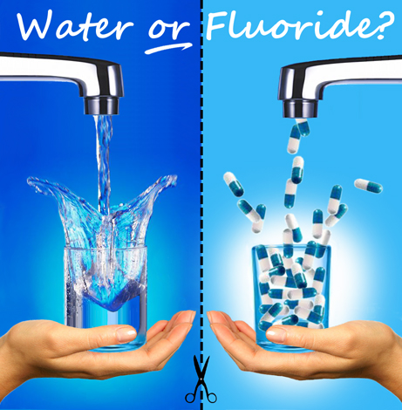
Year 8 Science
The Issue of Fluoridating our Water

Task Brief:
Your task is become informed on the fluoridation of water debate. You will then compose a letter to the SA Government arguing either for or against the fluoridation of water in South Australia. In your letter you need to justify your position and use scientific facts and reasons as much as possible.

Step 1: Watch the ABC Catalyst Video on the Issue as a Class

ABC Catalyst Video
http://www.abc.net.au/catalyst/stories/3821248.htm

***Editor's note: The broadcast incorrectly states that Townsville is “the only place in all of Qld that had fluoridated water”. However, Townsville, Bamaga, Dalby, Mareeba and Moranbah councils provide water fluoridation.***

The Video is also on Haiku – 8 Science/Chemistry/Fluoridation.

Step 2: Class Discussion

- Bias here? (ie. is one view presented above another because of who made the video?)
- What is the science data to support doing it?
- What is the science data to oppose doing it?
- What further questions could be asked and researched?

Step 3: Research and Take a Position with Critical Thinking

Your task is to complete further research on the issue of mandatory water fluoridation, which you will use to write a letter to the Government of SA with your recommendation regarding this issue. *Find your local MP and address to them (search online for who yours is).

As a starting point, see ‘Further Research Websites’ list on the next page.

Step 4: Write your Letter to SA Government Local MP
Your letter must include
- An introduction to yourself (30 words)
- a clear explanation of the scientific evidence that supports your position on this issue. (200 words)
- Justify your position with references to various sources and the facts from those sources. *note you do not need a reference list but do refer specifically to your sources of information in your letter.
Do a draft version and get a peer to read and review!
- demonstrate your ability to critically and insightfully evaluate the claims on this issue and refer to science knowledge on the topic.
(250 words)
- LENGTH – 400 - 500 Words
Assessment Criteria

 | A | B | C | D | E
HE2 | Clear and well considered explanation of how evidence has led to an improved understanding of a scientific idea | A thought out explanation of how evidence has led to an improved understanding of a scientific idea | An explanation of role of evidence in the development of a scientific idea | Some statements about the application of science knowledge to real-world and/or contemporary problems | Little or no reference to the use of science relating to real world problems
IS8 | Critical and insightful evaluation of claims in secondary sources with logical links to science knowledge | Logical evaluation of claims in secondary sources with clear reference to science knowledge | Evaluation of claims in secondary sources with some level of scientific understanding | Identifies claims made by others | Identifies secondary sources

Further Research Websites:

National Health and Medical Research Council
https://www.nhmrc.gov.au/sites/default/files/documents/attachments/water-fluoridationqa.pdf
- Pdf document – lots of great information here (read through)

SA Health Website
https://www.sahealth.sa.gov.au/wps/wcm/connect/public+content/sa+health+internet/public+health/water+quality/fluoride+in+water
- Look around website for links and further information

University of Adelaide – information pamphlet
https://health.adelaide.edu.au/arcpoh/dperu/ua/media/482/pamphlet-water-fluoridation.pdf

Wikipedia – Fluoridation in Australia
https://en.wikipedia.org/wiki/Water_fluoridation_in_Australia

Australian Dental Journal Article
https://fluoridealert.org/wp-content/uploads/do-2020.australia.guidelines.pdf

Mark Aldridge Website
http://www.markmaldridge.com/FLUORIDE-THE-SIMPLE-TRUTH.html

National Museum Australia
https://www.nma.gov.au/defining-moments/resources/introduction-of-fluoride

Fluoride Alert Organization
https://fluoridealert.org/articles/50-reasons/

Truth About Fluoride – lots of links/info
http://www.nofluoride.com

