Stage 2 Biology Completion Practical

Factors Affecting Fermentation Practical

**Submission:**

**Draft Submission**

* Lab report (1 week before final due date)

**Final Submission**

**Max 1500 word report** (or 10 min oral presentation);

Word count includes: *Introduction; Aim; Hypothesis, Variables; Analysis; Evaluation; Conclusion*

* Use report guidelines

**Instructions:**  Refer to Lab background and instruction sheet (attached)

**Assessment Conditions:** Supervised 90 minute lesson

Collaborative groups of 2-3

Performance Standards: **IAE 2,3,4; KA 1, 4**

**Submission:** **Max 1500 word report** (or 10 min oral presentation);

Word count includes: *Introduction; Aim; Hypothesis, Variables; Analysis; Evaluation; Conclusion*

Draft – *due 1 week before final due date.*

**Background:**

Yeast is a type of fungus which will undergo anaerobic respiration in the absence of oxygen. Specifically, this is alcohol fermentation acting on sugar (in the case below this is glucose):

C6H12O6 🡪 2 C2O5OH + 2CO2 + energy

Sugar 🡪 alcohol + carbon dioxide + energy

**Aim:**

You are going to test the effect of temperature on the rate of anaerobic respiration in baker’s yeast. You will collect your data and write a report with analysis and evaluation of the results.

**Lab Safety:**



Hot glass – beware of hot beakers and hot water



Delicate gas collecting apparatus – these can break easily. Inform teacher and place all broken glass in glass receptacle.

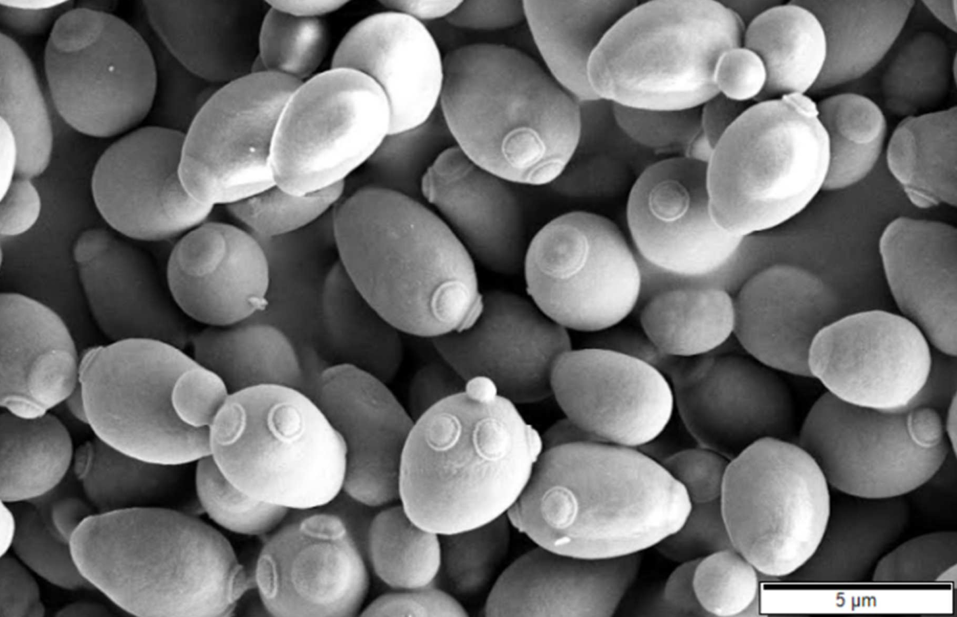

Baker’s Yeast (electron micrograph)

***Saccharomyces cerevisiae***

*https://en.wikipedia.org/wiki/Saccharomyces_cerevisiae*

**Materials per Group:**

* Defiance Instant Dry Yeast – 2 boxes of 12 packets (each packet = 8g)

*\*Note: Important to buy this fresh from the shops for optimal yeast activity.*

* Granulated sucrose (table) sugar
* Thermometer (may need a couple)
* Timer
* Kettle for hot water
* 2x Stirring rods
* 4x 100ml measuring cylinder
* Syringes
  + 1x 10ml
  + 1x 100ml
* Beakers
  + 2x 250ml
  + 4x 600ml beaker (or larger)
* 1x Orange lab tub (in prep room – these are filled 2/3 with water and used for submerging and inverting 100ml measuring cylinders
* Retort stand and clamp for holding measuring cylinder inverted
* CO2 gas collecting apparatus – in prep room yellow trays. *\*Note: These are very delicate and the tips that are turned up sometimes break during use. There should be plenty of spares. If not, just use file to break off tip, smooth end by rotating in flame of Bunsen burner, and then heat to bend tip up again.*
* 4x Large 50ml test tube *\*Note: some rubber bungs on the CO2 collectors are very tight and one or two may not fit well. If this is the case the teacher should help, or just use another one. Be careful not to force them too much.*

**Method – Initial Setup:**

A. Set up gas collection water tub:

1. Fill orange lab tub 2/3 full of water.
2. Fully submerge 4x 100ml measuring cylinders and ensure that no air bubbles are trapped inside.
3. Lift the measuring cylinders so that it is inverted and the open end is still submerged in the water. The cylinders should be full of water with no air bubbles.
4. Attach a clamp to a retort stand and fasten the clamp so that it holds each measuring cylinder in an upright inverted position.

B. Make up warm yeast suspension:

1. 150ml warm water (35˚C) in a 250ml beaker
2. One 8g packet of dry yeast.
3. Stir well. Set aside.

C. Make up 10% sucrose solution (standard):

1. 100ml warm water (35˚C) in a 250ml beaker
2. 10g of sucrose.
3. Stir well. Set aside.

D. Prepare warm water baths:

1. Fill each 600ml beaker (or larger) 2/3 full with water.
2. This will provide a bath for the test tube (once prepared) to rest in to help maintain its warm temperature for the yeast reaction.
3. Set up each of the 4 beakers so that you can maintain a chosen temperature in each. Temperatures are: Tap water (about 17˚C); Warm water (about 40˚C) and Hot water (about 55˚C) and really hot water (about 70˚C). Use thermometers to check. *CHANGE to suit method you used
4. NOTE: *Throughout the lab you should maintain the temperature of the water bath as close to the set temperatures as you can – do this by taking out water and adding warm tap water using a large syringe, and monitoring with a thermometer.*

**Method – Gas Collection**

1. Using small syringe, put 20ml sucrose solution into the 4 test tubes and gently place in respective water baths.
2. **Stir yeast suspension** and suck up 10ml with syringe. Add 10 ml of yeast suspension to each to the test tube with sucrose solutions. Keep the test tub resting in the water bath.
3. Attach gas collecting apparatus to test tube, and fit under cylinder. Make sure the bent up glass tip is correctly under the measuring cylinder – but do not let the cylinder rest directly on it, or it may break. *\*Note: attach to test tube first, before putting tip under cylinder – this makes it less likely that the tip will break off.*
4. Wait and measure amount of gas produced against time (every minute or so). Ensure the water bath temperature is maintained. *\*Note: some of the froth of the yeast suspension may move through the gas collecting tubes. This does not matter.*
5. Record your data carefully for 30-40 min. When complete, calculate that rate of reaction with the following:

Rate of gas production =

Volume of gas / time (eg. 20 min, etc.)

**HINT:** collect your data for gas volume every minute. Then examine your data and find the longest time that you have good solid data for every temperature.

**Collect data from all groups to calculate class average.**

**Example Method Setup:**

**Special Clean up note:**

Make sure that the gas collecting apparatus is clean before putting away. To clean, gently force warm water from syringe into the rubber bung end of the collecting apparatus to rinse out any yeast residue. You may need to repeat a few times.

**Assessment**

**Stage 2 Summative Lab Report Guide – Fermentation**

|  |  |
| --- | --- |
| **Section of the Report** | **Requirements/Indicators** |
| **Introduction** | * Relevant biological Information presented that relates specifically to the practical being investigated. The information relates to the aim of the experiment. * Own words; refer to lab to get ideas * May include the following terms/ideas in the intro (as a guide):   + Respiration (aerobic/anaerobic)   + Fermentation   + Affect of temperature   + Enzymes   + Kinetic energy   + Metabolism / metabolic pathway   + Reactants / products   + Energy / ATP |
| **Aim** | * Indicates the purpose of the experiment |
| **Hypothesis** | * Has the correct format- is not in the form of a question. * Links the independent and dependent variable and is a prediction. |
| **Materials &**  **Method** | * Copy from lab handout * List materials used (dot point form) |
| **Variables** | List each type of variable (with units) with brief explanation – use a subheading for each type:  **Independent** (the thing you change; what is on the x-axis)  **Dependent** (the thing you measure as results; what is on the y-axis)  **Controlled** (the things you keep the same to make it fair; should have 3-4)  **Uncontrolled** (the things you could not really control that may have impacted results; should have 2-3) |
| **Safety/Ethical Audit** | * Detailed analysis of the potential risks, hazards and how they are managed, and the precautions taken in the classroom. Any relevant ethical considerations. |
| **Results** | * Include all data tables from lab * **Tables** have the correct format (title; units at top of column; etc.) * **Table 1: _____________** * Data is represented in an appropriate manner- all data is shown * Significant figures are correct * **Graph** is drawn appropriately- axis are labelled, appropriate scale used, title, size, correct format; lines/curves of best fit * X axis = independent variable * Y axis = dependent variable   Average of Class Results compared to results from your group |
| **Discussion**  **Analysis**  **Evaluation** | * Explains all the data obtained – why are you getting these results based on your bio knowledge * Provides reasoning based on the data for supporting or rejecting the hypothesis * Identify any trends and discuss; if none – say so; explain * Explain various parts of the curve/line of best fit * Link/discuss results to biological concepts/background * Any overall comparisons to the class average curve/line; with any explanations * Identifies potential sources of random and systematic error specifically & their impact on data **(to what degree and justify!)**; sources of uncertainty * States and justifies to what degree the data is reliable, etc. * Discusses the data’s reliability, precision, accuracy and validity with justification!!! *(explain your thinking) * Evaluates the experimental method and suggests possible relevant improvements to the design and how it would impact data accuracy or reliability.   **Further Help for Critical Evaluation of Data**   * Compare your group to the class average in relation to accuracy, reliably, precision, etc.; to what degree are they similar/different? Why – justify your thinking and reasoning.   Critical evaluation of procedures and data can determine the meaningfulness of the results.   * Identify sources of **uncertainty**, including: * **random** and **systematic** errors * **uncontrolled factors.** * Evaluate **reliability**, **accuracy**, and **validity** of results, by discussing factors including: * sample size * precision (are results all close the best fit? Why or why not?; to what degree? * random error * systematic error * uncontrolled factors.   KEY: determine ‘TO WHAT DEGREE’ the data is reliable, accurate, or valid – AND GIVE JUSTIFCATION FOR WHY YOU THINK SO.  Example sentence stems:  “…this would impact the results by causing…”  “… this would affect the validity of the data because…”  “This is a valid result because…”  “Changing this would increase the accuracy of the data by…”  “This reveals the precision of the data is low because…”  “This must have had a major impact on the reliability of the data, because…”  “This would have had negligible or no impact on the validity of the data because…” |
| Conclusion | * Indicates whether the aim of the experiment has been met with justification; * Briefly restates the overall trend of the experiment. * Any overall limitations of the study pointed out with justification |
| Communication | * Use of appropriate biological terms and conventions; **3rd person** |

**Stage 2 Biology**

**Summative Lab Report - Performance Standards Marksheet**

|  |  |  |  |
| --- | --- | --- | --- |
| **Specific features** | | **Grade** | **Comments** |
| IAE2 | *Obtaining, recording, and representing data* |  |  |
| IAE3 | *Analysis and interpretation of data and other evidence;*  *formulate and justify conclusions* |  |  |
| IAE4 | *Evaluation of procedures and their effect on data* |  |  |
| KA1 | *Demonstration of knowledge and understanding of biological concepts* |  |  |
| KA4 | *Communication of knowledge and understanding of biological concepts and information using appropriate terms conventions and representations* |  |  |