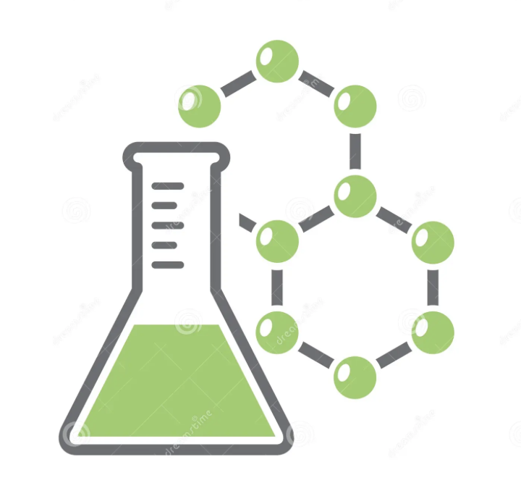**Year 8 Science Chemistry**

**Learning Intentions**

Indicate your relative confidence with the following:

• • • = *Very confident* • • = *Okay* • = *Not confident*

*I can…*

|  |  |
| --- | --- |
| **Identify** the three key **properties** of matter | • • • |
| **Distinguish** between mass and volume and their units |  |
| **Compare** the **states** of matter using the particle model of matter |  |
| **Describe** the arrangement of particles in solids, liquids and gases |  |
| **Deduce** how much energy and temperature matter has by the movement of particles |  |
| **Predict** what will happen to matter when energy is added or subtracted |  |
| **Construct** a model of matter using the particle theory |  |
| **Calculate** mass, volume and density and explain how they are related |  |
| **Calculate** the volume of irregular shaped objects |  |
| **Predict** whether an object will float or sink in water based on density |  |
| **Evaluate** evidence to determine if a chemical or physical change has occured |  |
| **Identify** and **describe** the three parts of an atom |  |
| **Calculate** the number of neutrons in an atom |  |
| **Arrange** electrons in their ‘shells’ (K,L,M) around the nucleus |  |
| **Compare** and **contrast** a molecule of an element and a molecule of a compound |  |
| **Count** the number of atoms and elements in a molecule – eg. Ba(OH)2 |  |
| **Read** and **understand** the information on the Periodic Table |  |
|  |  |

**NOTE:**

You should be able to locate the following resources on the learning intentions above:

1 – Your notes taken in class.

2 – Your handouts and assignments used and completed in class.

3 – Sections in your text book that cover these topics.