

Stage 2 Biology

FORMATIVE SACE Test

**Topic: Cells (2.1 – 2.6)**

**Heritage College**

A Christadelphian School

*Adelaide, Australia*

|  |
| --- |
|  |
|  |

**ANSWERS**

**Section A: Multiple-Choice Questions**

1 = L 2 = L 3 = M 4 = M 5 = M

6 = J 7 = L 8 = K 9 = K 10 = M

**Section B: Short Answer**

**Question 1**

1. Correct balanced equation for photosynthesis
2. Respiration (catabolic reaction)
3. DNA synthesis in S phase; protein synthesis for development of enzymes needed
4. In order to pass on a complete set of DNA to the two new identical daughter cells.
5. i) Telophase; nuclei start to reform, chromosomes start to decondense,

ii) vesicles are used to store and transport materials around inside the cell for more efficient transport; they are used in the process of exocytosis to transport materials to the outside of the cell

1. i) they are all genetically identical so they are more prone to pathogens; all individuals are likely to be lacking the disease resistant genes so all are at risk

ii) The food source which the people depended on was lost which led to starvation/malnutrition

1. i) increases crop yields; increases profits; reduces wastes

ii) sexually reproducing organisms have greater potential for genetic diversity (through crossing over, independent assortment, and random fertilization) and passing on different combinations of genes – some of these may turn out, with the help of mutation, to give the plant disease resistance. Asexually reproducing plants will not have the ability to have such genetic variation as they are identical and so will be less likely to develop resistance.

**Question 2**

1. Because there is such a large amount of biochemical reactions taking place here the organelle needs many proteins to make enzymes. Having its own DNA means it can make its own proteins and rRNA on site for rapid and efficient use.
2. 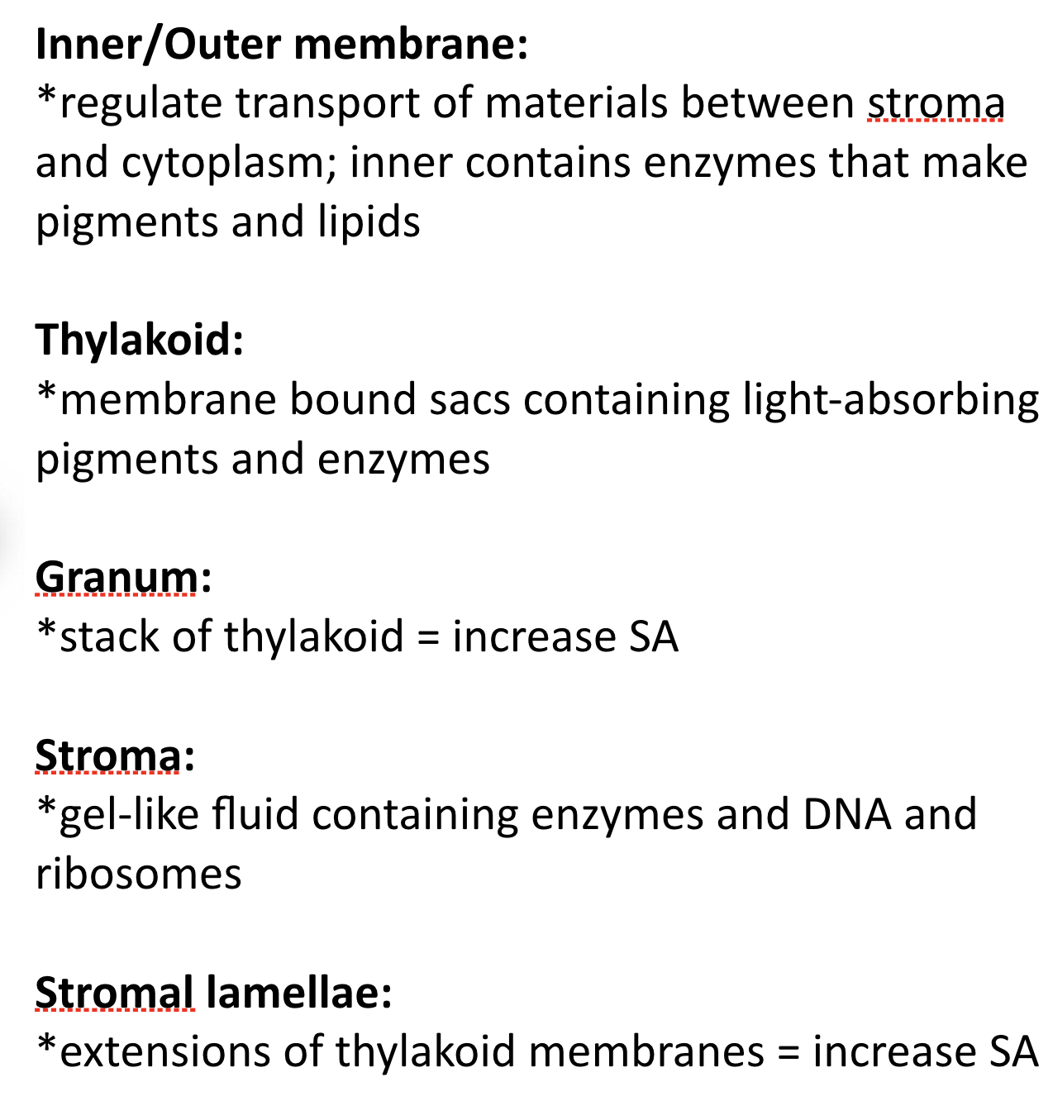Any of the following:
3. Glucose production in the cells relies on light penetrating the cell. With all of the parenchymal cells stacked upright you can increase the amount of cells receiving the sunlight as light shines down them. In this way no cell is blocking other cells, and the efficiency and amount of photosynthesis is greatly increased.
4. The phloem cells will use glucose to make ATP. If the sugar is actually in sucrose form this will prevent or slow the phloem cells from using up the sugar to make ATP as it moves down to the roots where it is needed.

**Question 3**

1. If the haemoglobin proteins were dissolved in the blood this would increase the overall solute concentration in the blood. With a greater solute concentration in the blood it would be more hypertonic compared to the tissue cells, and water would leave the tissue cells by diffusion into the blood. The result could be that they turn flaccid.
2. Continuous flow of blood ensures that there is always a concentration gradient (difference) maintained between the blood and surrounding cells. This is needed for diffusion. If they blood stopped the concentration gradient would eventually even out and no transport would take place in or out of the blood.

**Section C: Extended Response**

Firstly, a sample of living kidney tissue would need to be **physically** dissected using **sharp tools** from the liver tissue of the monkey. This process would need to be done in **sterile** conditions to prevent contamination. This sample of cells would then need to be **chemically** dissected using an **enzyme** solution. The enzyme would be used to break up the **extracellular matrix** which holds the cells together.

Without growth hormones in culturing process the dissected kidney cells will not **divide and grow** in the way they need to for effective cell culture. Various growth hormones may be used as an **external factor**, at stages in the culturing, to ensure that the kidney cells continue to grow and **behave** like kidney cells, preventing them from becoming either **undifferentiated** or behaving like some other type of cell. Without the hormones the cells may even stop **dividing** altogether because it fails to receive the right signals to keep the **cell cycle** progressing.

One possible limitation of vaccine development using **in-vitro** cultured cells is that they may behave or **respond differently** to the vaccine when they are part of a full organ in the living organism that they are from. Cells do not **express proteins** in the lab conditions as they may do when interacting with other tissues in their normal environment. This may lead to inaccurate results in the testing phase, which may cast doubt on how the vaccine would work on humans. Another possible limitation is that studying the **effects of vaccines on targeted culture cells** of one type does not always identify all of the effects this vaccine may have on **all the other cells types** of the organism it may be used on in the future. This may lead to uncertain results and risks when it is used on an organism such as a human.