**Tables and Graphs in Excel**

**Create your Table:**

* First column – list your ‘independent variable’ or ‘groups’
* Second column list your ‘dependent variable’ (results) – do this for each trial
* Do not leave any blank columns in your table.
* Do not put any units in the cells with numbers – just put units in column headings

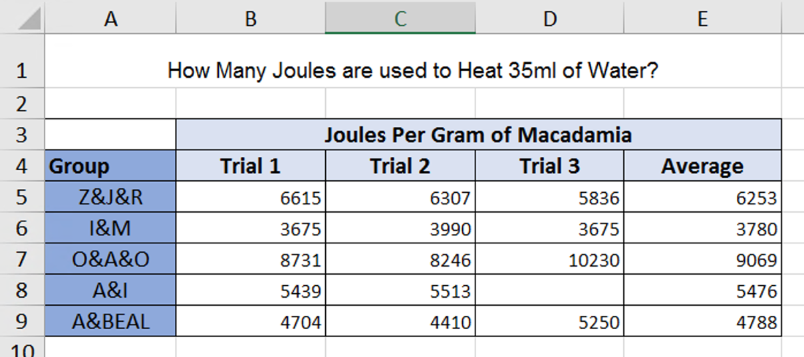

Dependent Variable

(results)

Independent Variable

Or

Groups

**We want to create a graph/chart that looks like this….**

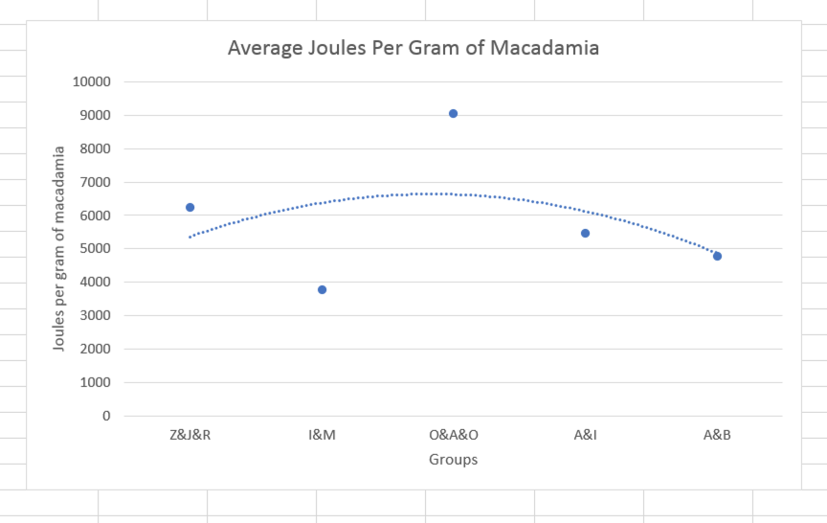

**Create your Graph/Chart:**

|  |  |
| --- | --- |
| Table  Description automatically generated1. **SELECT DATA:**  Highlight the column(s) you want to graph  (in this case it is the ‘Average’ column) | 5. **HORIZONTAL (x) AXIS LABLES:**  Ensure your x-axis labels are correct by right clicking on the x-axis.  Choose ‘Select Data’.    Under **Horizontal Axis** Labels, click ‘Edit’    Use your mouse to drag over and select the cells that should be used as x-axis labels. Then click ok, and ok. **DO NOT select the column heading. |
| 2. **INSERT A LINE GRAPH:**  Graphical user interface, application, Word  Description automatically generatedSelect ‘Insert’ and choose Line Chart (use ‘Line with markers’ type) . |
| 3. **TO REMOVE the LINE:**  Click on the **line** and under the formatting pane (on the right of the screen).  Select ‘No line’. |
| 4. **ADD A TRENDLINE:**  Right click on one of your data points.  Select ‘Add trendline’ | 6. **ADD AXIS LABELS:**  Click on the + symbol at top right of graph, and choose Axis Titles. |