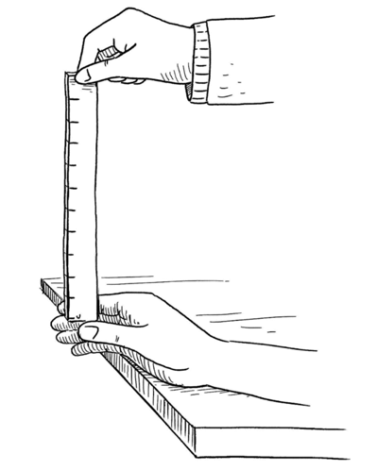**Year 8 Science**

**Reaction Times – Collecting and Analysing Primary Data**

**Purpose**

To determine your reaction time using observation skills.

To use excel to analyse the data.

**Hypothesis**

How long do you think it takes for you to react –

a second, half a second or less?

Keep fingers 5cm apart.

Visual – _____________________________________________

Auditory – _____________________________________________

Tactile – _____________________________________________

**Materials**

* 30cm ruler
* Access to a calculator

**Observation Table**

|  |  |  |  |  |  |  |  |
| --- | --- | --- | --- | --- | --- | --- | --- |
| **Experiment** | **Distance ruler dropped (cm) – trails**  **1 2 3 4 5** | | | | | **Average ruler drop** *d* **(cm)** | **Average reaction time** *t* **(s)** |
| **Visual - sight** |  |  |  |  |  |  |  |
| **Auditory - hear** |  |  |  |  |  |  |  |
| **Tactile – tap/touch** |  |  |  |  |  |  |  |

**Reaction time: $t=\sqrt{d/490}$**

*d* = average ruler drop (cm)

490 is the acceleration of the ruler due to gravity.

**Any Outliers?**

**Possible Mistakes (list)**

* *Explain how these might have affected the data*

**Possible Errors (list)**

* *Explain how these might have affected the data*

<https://backyardbrains.com/experiments/reactiontime>

The average **reaction time** for **humans** is 0.25 seconds to a visual stimulus, 0.17 for an audio stimulus, and 0.15 seconds for a touch stimulus.

Reaction times are important for conducting many sit