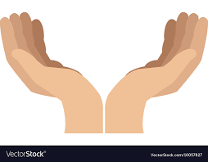

**Strengthening Our Hands in God**

Things to pray for together:



**Strengthening Our Hands in God**

Things to pray for together:

**Strengthening Our Hands in God**

Things to pray for together: