YEAR 8 WOODEN TOY CAD TUTORIAL

TASK:
This task is designed to help develop creative thinking and problem-solving skills using Computer aided Design software. The following is a step-by-step guide to creating a simple wooden toy design using Fusion 360.
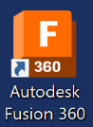
- Open Fusion if you don’t have an account your teacher can help.

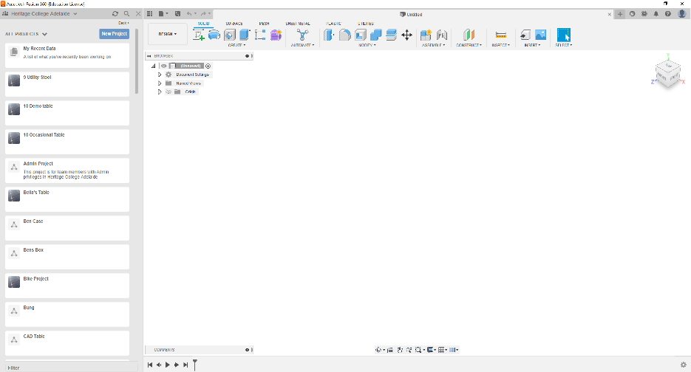
- Your screen will look something like this but will have no project folders.

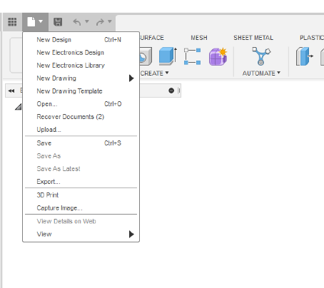
- Select file – New Design

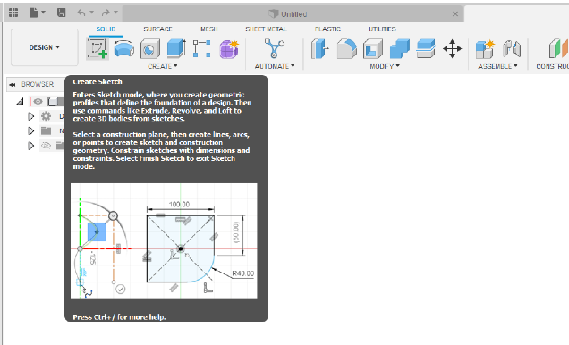
- Select Sketch (notice the drop-down box giving information about the tool selected)

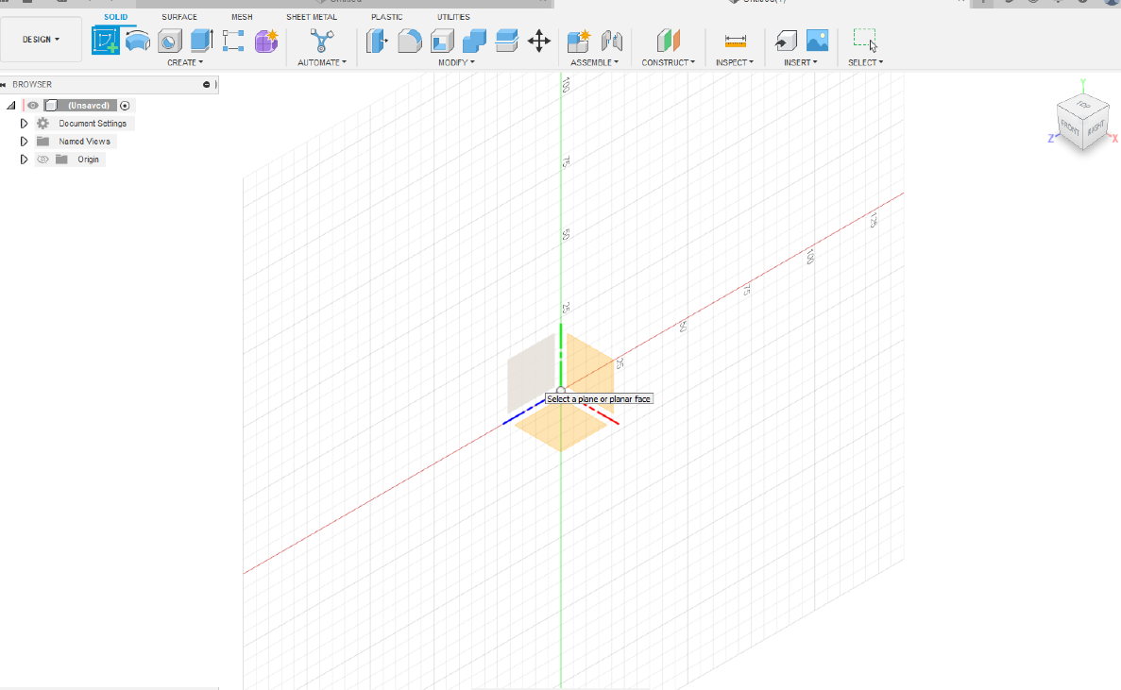
- your drawing space will appear with a set of planes a navigation cube and a browser on the left. (Note how the X,Y&Z are oriented on the planes and cube).
Navigation Cube
X,Y,Z Planes
Browser

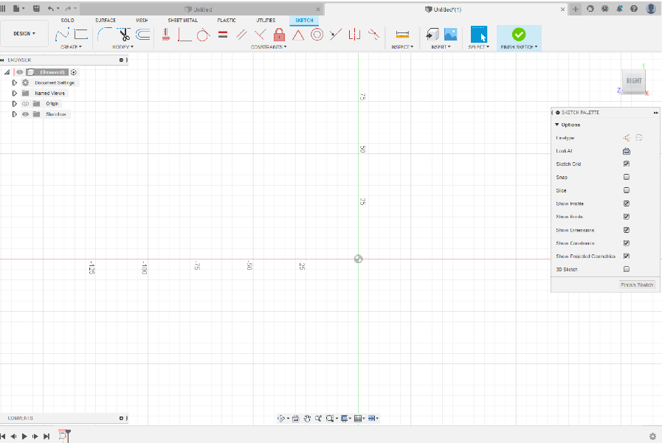
- Once you select a plane your screen will open in sketch mode (Note the navigation cube, the history at the bottom of the screen and the drawing tools on the top ribbon).

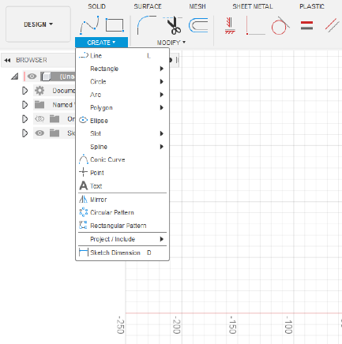
- Click on Create and a palette of tools will appear, you can click on any of these to create a shape or line.

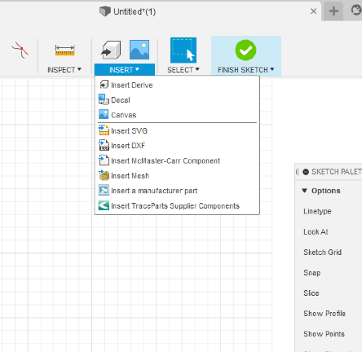
- At this point you can create your own design or copy an existing design. If you bring in a design, you will need to choose a side view image and save it to a folder that you can access. To bring it into your drawing space select Insert – Canvas.

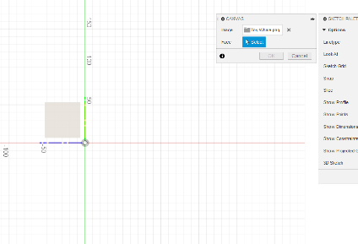
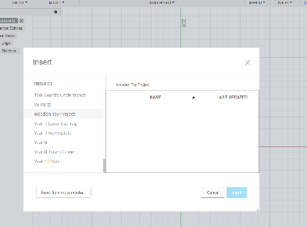

Select the face

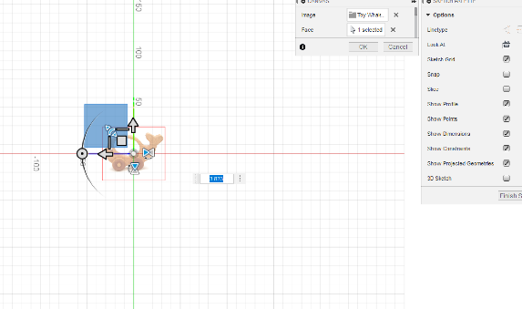
- Use the handles to move and size your image to suit the 300 x 200 mm constraints given

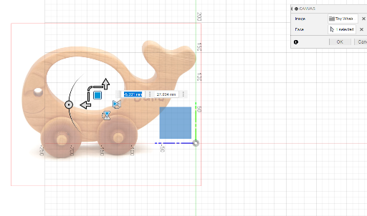
- Place the design over the rulers on the screen to provide a guide to the size.

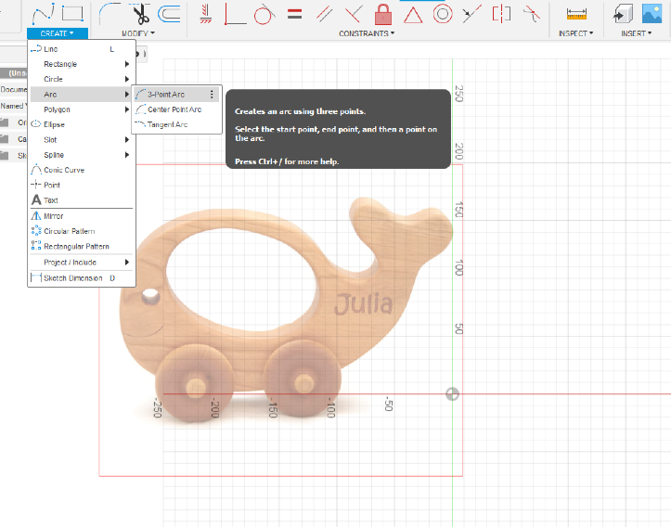
- Choose your drawing tools, in this case we will use the 3-point arc tool to draw the curved whale shape.

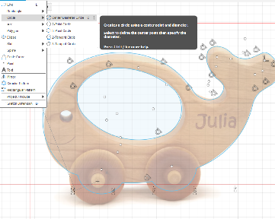
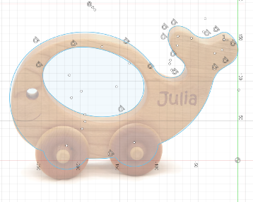
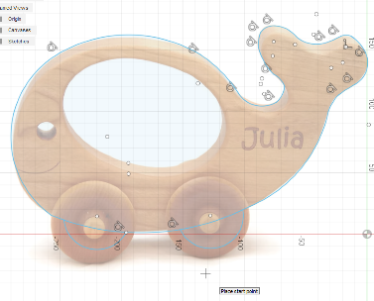
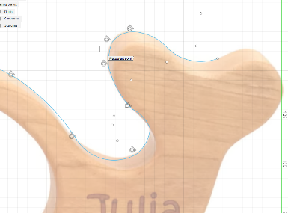
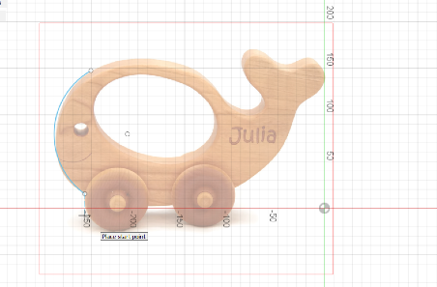
Use the centre point circle for the axle holes 6mm diameter.

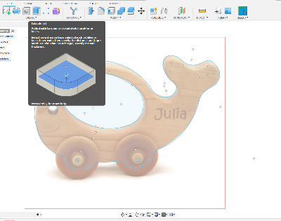
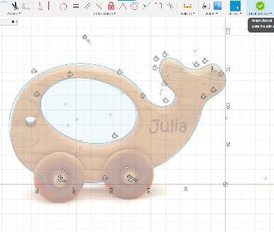
- At this point you have completed your shape, select Finish Sketch. The workspace and ribbon now allow us to create 3D shaping of our design.

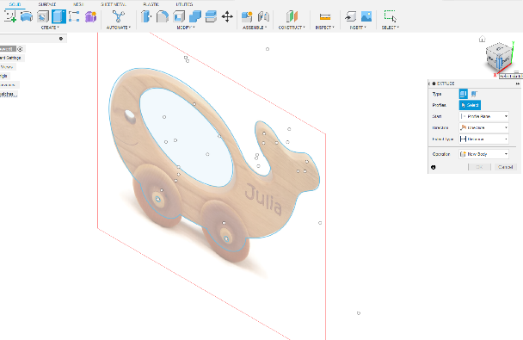
- Extrude your design 45mm. You can make this step a little easier by using the cube to turn the design allowing the extrusion to be viewed.

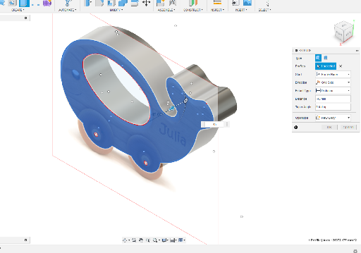

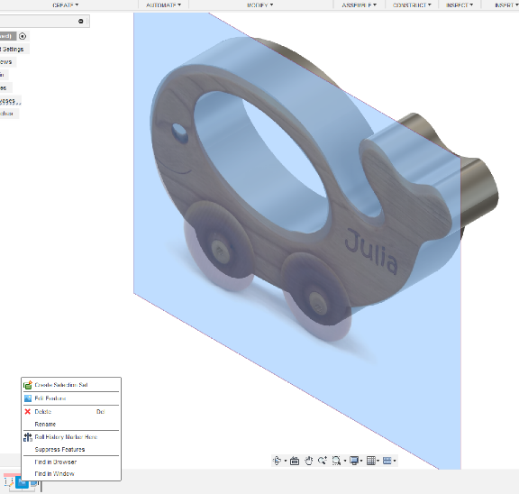
- The image used can now be deleted by right clicking on the image icon in the bottom history ribbon.

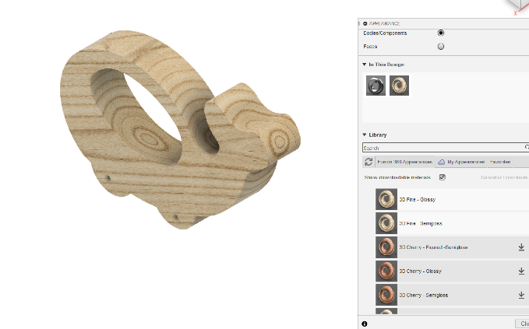
- The Appearance of the design can now be changed by right clicking and selecting Appearance. The first time this is done will result in a small download which will take a moment or two.

- The last step is to complete the task by handing in a drawing. Present your design side on and select Design – Drawing - From Design.
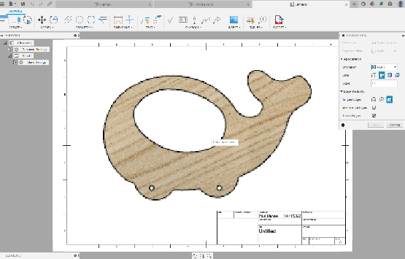
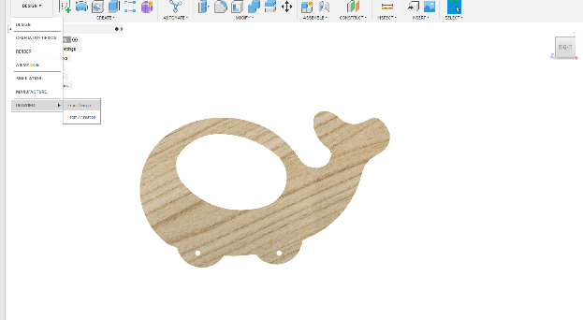

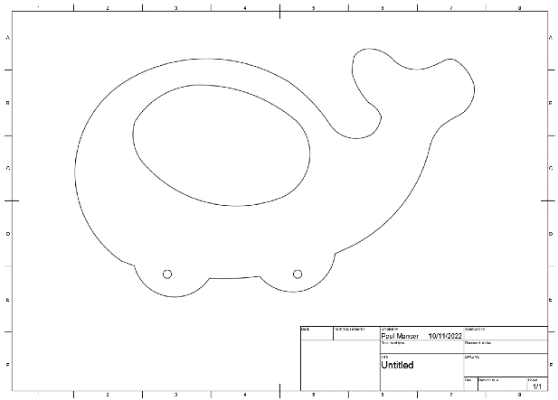
Print your design and submit it for assessment. This page can also be used as a template for cutting the design.

