 | Heritage College Adelaide
Design and Technology Year 8
Materials: Wooden Toys
 | Australian Curriculum Outcomes | Weighting
- Generate, develop, test and communicate design ideas, plans and processes for various audiences using appropriate technical terms and technologies including graphical representation techniques (ACTDEP036)  - Select, justify, and use suitable materials, components, tools, equipment, skills and processes to safely make designed solutions (AC9TDE8P03) |  | 20%

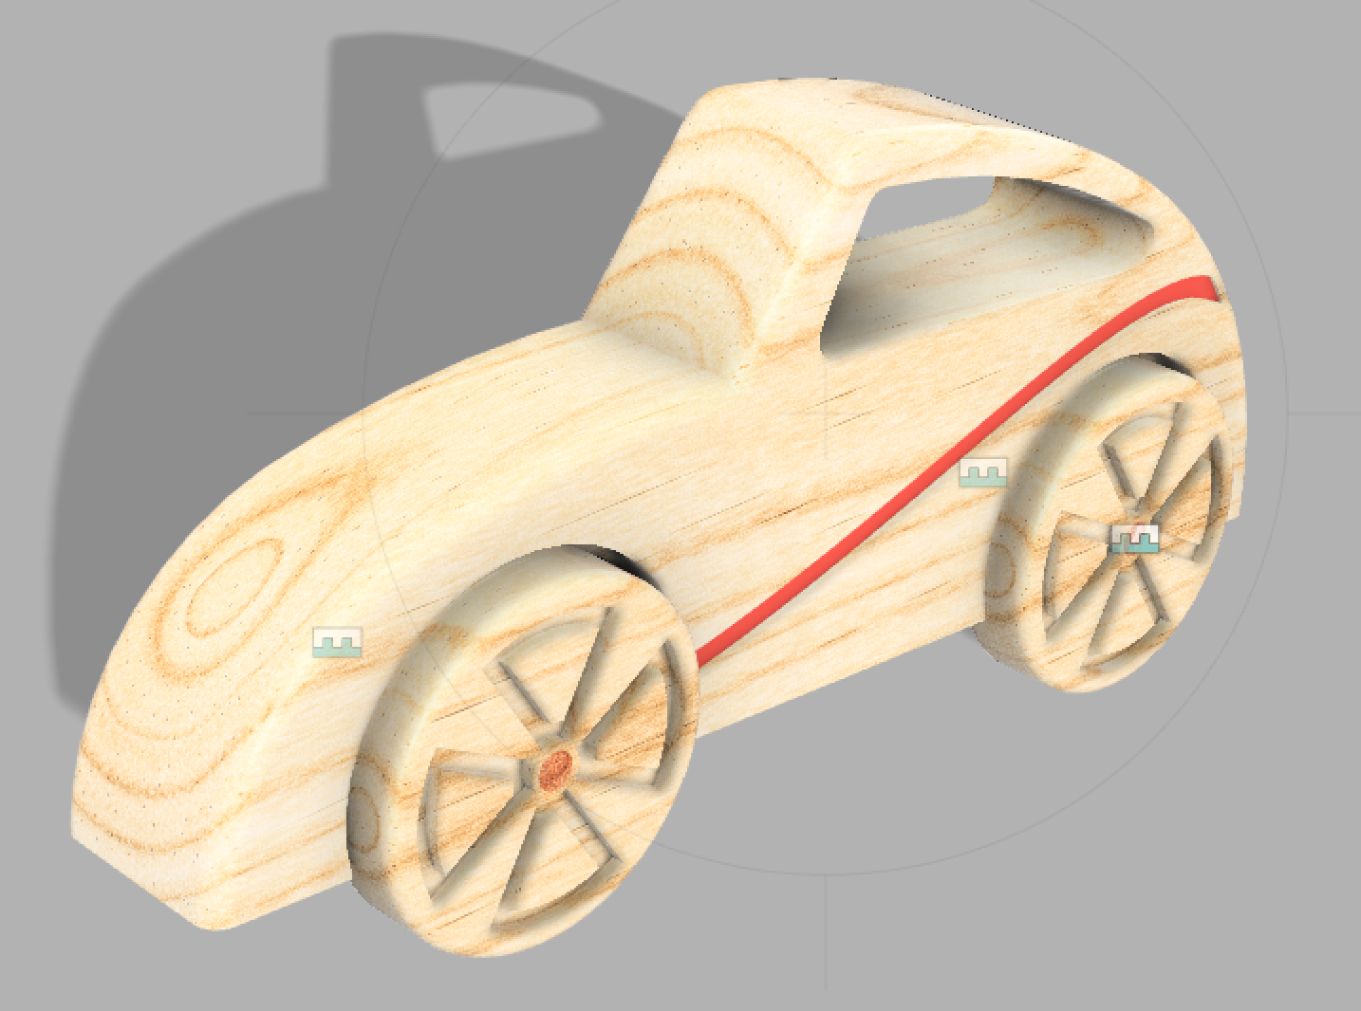

TASK:
You have been chosen to design and create a wooden toy that can be used by children from the age of 2 years old. Traditionally these toys are simple and consist of one piece of timber which may have wheels attached. This toy will be made of timber but could be complimented with other materials if safe and necessary.
Constraints:
- Must be no larger than 300 x 90x90 mm
- Construction must utilise timber
- Designs can be Painted, or Laser engraved
- Must be safe for children 2-10 years old

Design Process:
Analyse existing designs.

Design 1

Pros:

Cons:

Design 2

Pros:

Cons:

Design 3

Pros:

Cons:

Design Sketches (Ideation)

Design Drawing : Orthographic Projection

Dimension in Millimetres, you can use CAD for this section. (Using CAD will make scaling and creating views much easier)

Top | Isometric
Side | Front

*Remember, using a ruler to create guidelines between views will help you create your drawings.
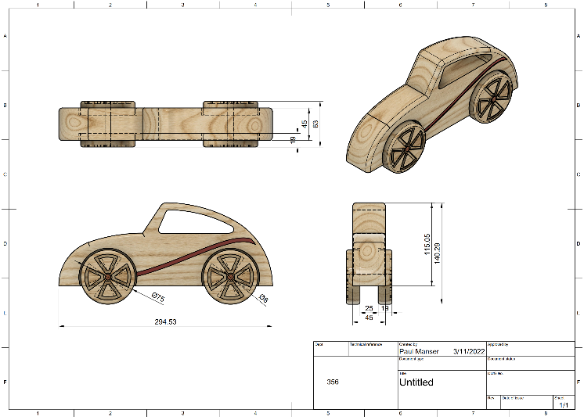
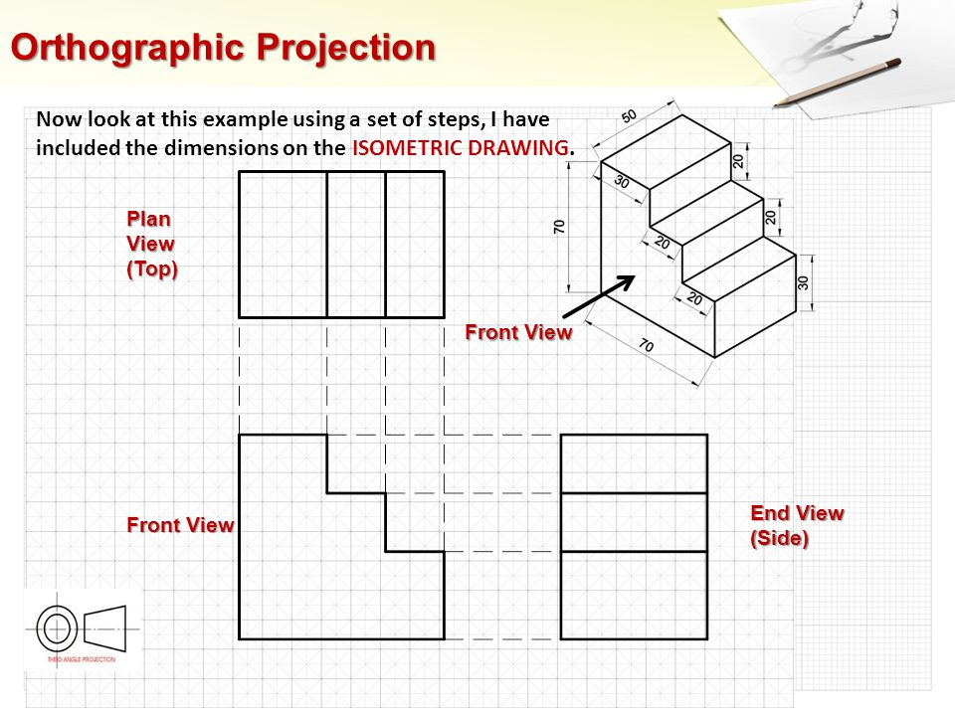

Evaluate your finished Product

