Year 9
Design & Technology
Workbook
2023

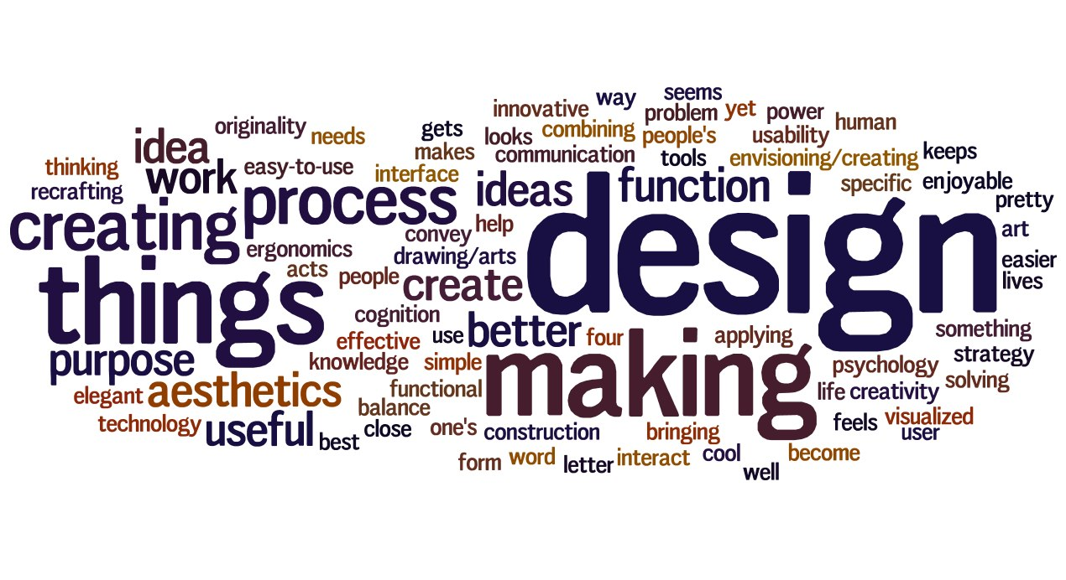

This year you will be working through a safety training course online. Your teacher will help you login to the course and complete the training required.
You can enter the course by clicking on the link on the /Sentral page. Once your training is complete you can print a certificate and keep a copy for your training record.
Time to get started…..
This is how your training looks, you will read sections of information and answer some multiple choice questions.
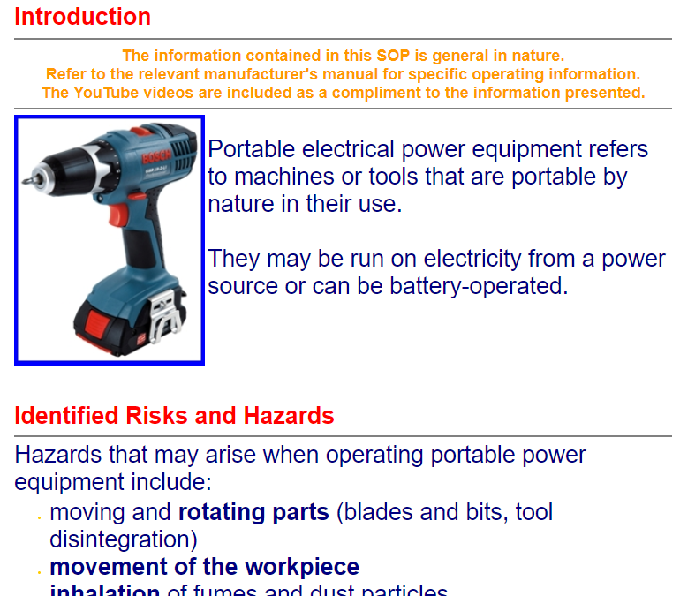

SAFE Work Review Sheet
In Design and Technology, you will learn about the correct and safe use of tools materials and machinery for specific processes that are necessary to construct a project.
Learning Intention
Students demonstrate safe practices in the use of materials, tools and equipment in the context of producing design and technology projects.
Activity: The Safe use of Machines
Use the word bank to complete the following statements:
Distance | Safety guards | Instruction | Protection | Distracted
Cleared | Machine | Unattended | Teacher | Switched Off

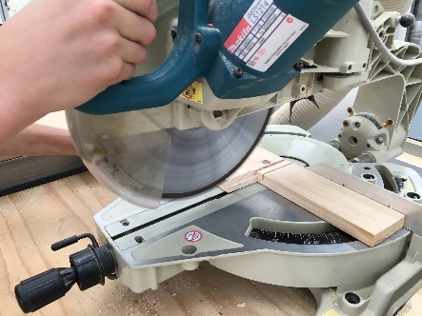
- Do not operate a _____________________ unless you have received thorough
_________________________ and fully understand how the machine should be used. When using machinery that is fitted with___________________ __________________, ensure that they are fitted correctly. When appropriate wear eye and ear _________________________ and restrain long hair.
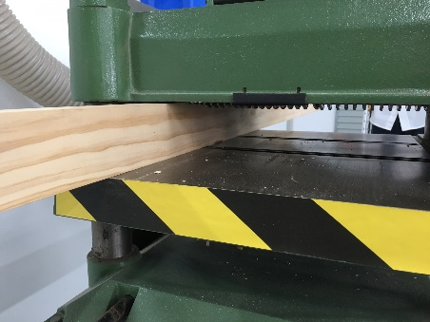
- Keep a safe ______________________ between your hands and any moving parts of the machinery. When making adjustments to the machine ensure the power is ______________________ _________. Ensure that you operate a machine by yourself, and do not leave a machine ______________________________ while it is running. Give your machine your full attention and do not look away or talk to others while using a machine. Operators of machinery should not be _________________________.
- Never Lean on machines. If any part of the machine is broken or malfunctions notify your _____________________ immediately. After using machines, the work area should be _____________________ of scrap material and machine tools and accessories.

Year 9, Materials Folio Rubric
Content Description | Critically analyse factors, including social, ethical and sustainability considerations, that impact on designed solutions for global preferred futures and the complex design and production processes involved (ACTDEK040) | Explain how products, services and environments evolve with consideration of preferred futures and the impact of emerging technologies on design decisions (ACTDEK041) | Investigate and make judgments on how the characteristics and properties of materials, systems, components, tools and equipment can be combined to create designed solutions (ACTDEK046) | Critique needs or opportunities to develop design briefs and investigate and select an increasingly sophisticated range of materials, systems, components, tools and equipment to develop design ideas (ACTDEP048) | Develop, modify and communicate design ideas by applying design thinking, creativity, innovation and enterprise skills of increasing sophistication (ACTDEP049) | Evaluate design ideas, processes and solutions against comprehensive criteria for success recognising the need for sustainability (ACTDEP051)
A | Detailed independent investigation of the sustainability considerations of materials used | Detailed explanation of effects of applicable materials and their impacts on the environment, economy and design decisions | Detailed independent evaluation and testing of suitable materials for project design | Uses dimensioned and annotated digital drawing to generate design ideas | Independently develop criteria for success, and comprehensively evaluate project against criteria | Independently plans and applies project management. Identifies risks and plans to avoid them
B | Independent investigation of the sustainability considerations of materials used | Explanation of effects of applicable materials and their impacts on the environment, economy and design decisions | Comprehensive collaborative evaluation and testing of suitable materials for project design | Uses dimensioned and annotated scale drawings to generate design ideas | Collaborative development of criteria for success, and clearly evaluate project against criteria | Collaboratively plans and applies project management. Identifies risks and plans to avoid them
C | Collaborative investigation of the sustainability considerations of materials used | Some explanation of effects of applicable materials and their impacts on the environment, economy and design decisions | Collaborative evaluation and testing of suitable materials for project design | Uses dimensioned and annotated sketches to generate design ideas | Some collaborative development of criteria for success, and project evaluation against criteria | Some collaborative planning and application of project management. Some identification of risks and avoidance plans
D | Limited investigation of the sustainability considerations of materials used | Limited explanation of effects of applicable materials and their impacts on the environment, economy and design decisions | Limited evaluation and testing of suitable materials for project design | Uses sketching to generate design ideas | Limited collaborative development of criteria for success, and project evaluation against criteria | Limited planning and application of project management. Some identification of risks and avoidance plans
E | No investigation of the sustainability considerations of materials used | No explanation of effects of applicable materials and their impacts on the environment, economy and design decisions | No evaluation and testing of suitable materials for project design | Fails to use sketching to generate design ideas | No development of criteria for success, and project evaluation against criteria | No planning and application of project management. No identification of risks or plans avoid them

Australian Curriculum Content Descriptor | Work flexibly to effectively and safely test, select, justify and use appropriate  technologies and processes to make designed solutions (ACTDEP050)
A | Demonstrates refined technical skills while using production skills independendently while producing quality designed solutions. | Consistently uses safe work practices and procedures to reduce risk during production of designed solutions
B | Refining technical skills and using production skills with independence to produce quality designed solutions. | Follows safe work practices and procedures to reduce risk during production
C | Refining technical skills and using production skills with independence to produce quality designed solutions. | Follows safe work practices and procedures to reduce risk during production
D | Refining technical skills and using production skills with independence to produce quality designed solutions. | Follows safe work practices and procedures to reduce risk during production
E | Did not demonstrate necessary technical skills while using production skills and required significant help while producing designed solutions. | Follows safe work practices and procedures to reduce risk during production

Design and Technology Product Rubric
Comments:
____________________________________________________________________________________________________________________________________________________________________________________________________________________________________________________________________________________________________________________________________________________________________________________________________________________________________________________________________________________________________________________________________________________________________________________________________________________________________________________________________________________________________________________________________________________________________________________________________________

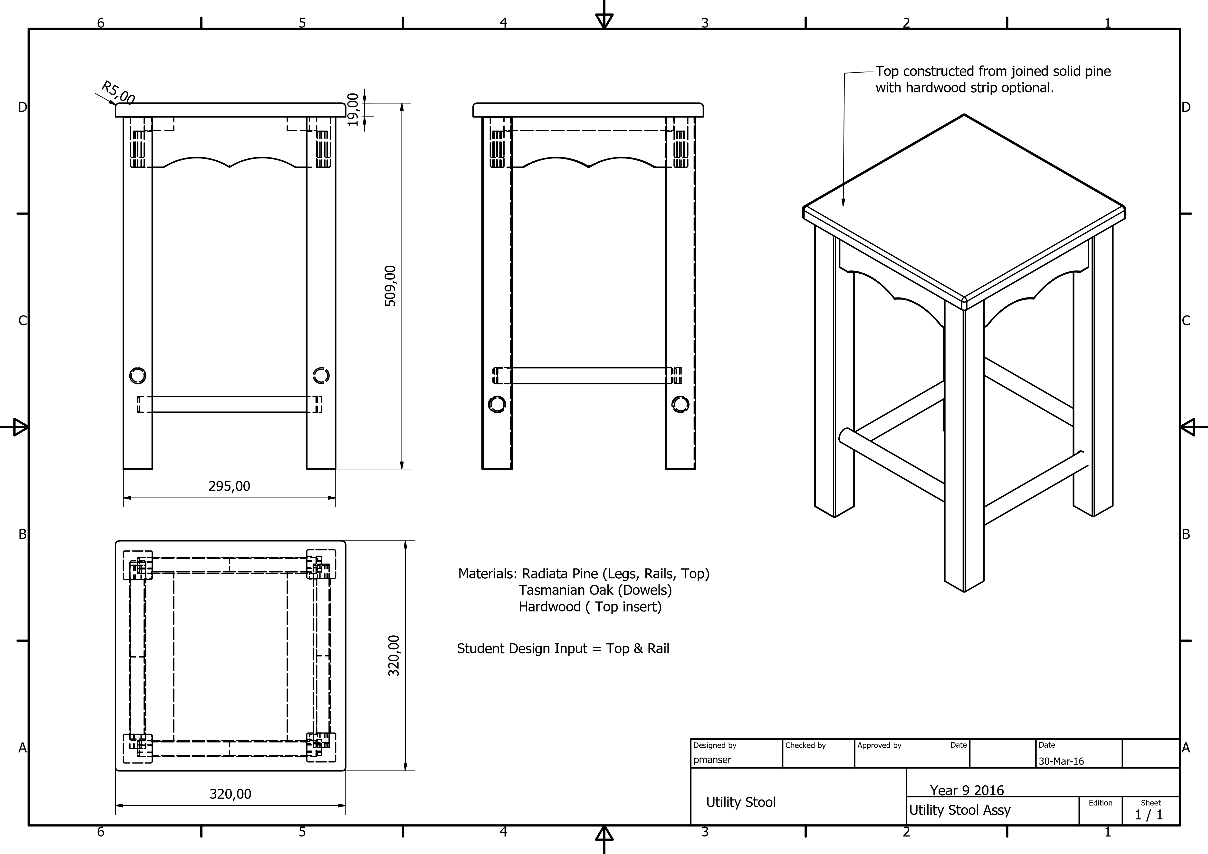
Heritage College Design and Technology
Year 9 Mortise and Tenon Joints

How to Make Mortise and Tenon Joints
Step1: The first is to mark out the mortise or tenons using a sharp pencil. Start with the tenons. To mark out the tenon you need to start by drawing a line around the entire piece of wood using a try square to mark the length of the tenon.
The tenon length is usually about 2/3rds the depth of the piece of timber it is being inserted into. Now you must mark your tenon width and it should be around 1/3rd the thickness of the timber.
Check to see if the tenon matches the closest size chisel or mortising drill bit and if it doesn’t modify the lines to match the chisel or mortising drill bit.
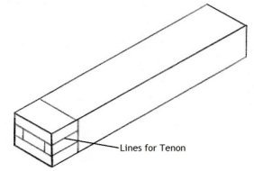

Step2 Cut the tenon and there are two methods of doing this the first is with a tenon saw. Put the piece of timber in a vice on a slight angle to create a neater and straighter cut and then carefully cut along the lines.
Next put the timber back upright in the vice and mark around 5 millimetres in from each end although it can be slightly more with larger tenons.
Now cut straight down where you marked to create small cut outs on both sides of the tenon, the reason you do this is to create a neater and more flush joint but it also hides any gaps you may have from your mortises if they are cut slightly too wide.
The second method of cutting tenons is with a radial arm saw and band saw and all you have to do is cut the depth on the radial arm saw and trim out with the band saw.
This method is usually better because the band saw has a guide rail making the cuts quicker and more accurate. Remember to cut the shoulders of your tenons first so that you do not cut to far later on.
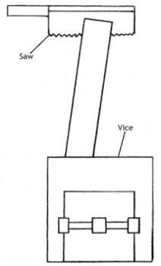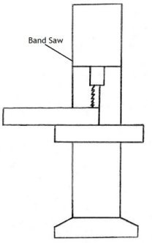
Step3: Marking out the mortise and the first things you need to do is decide where you want to position the joint.
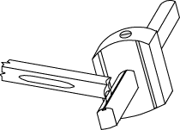
Next you can use your recently cut tenon as a guide for the width of your mortise and you do this by resting it across the timber that will have the mortise and drawing lines along the two edges of the tenon. A Mortise gauge can be set to the correct measurement to allow accurate marking out without the need to re measure and mark each joint.
Mortising Gauge

After you have the width set you must put two more lines in between the ones you have already drawn to mark the thickness of your mortise.
The thickness will be the same as the tenons thickness and you can use it again as a template if you need to but remember to measure the space on each side of the mortise to ensure it is centre.
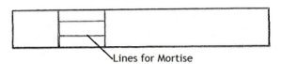
Step4: Now you must cut the mortise and once again there are two methods and the first involves a mallet and chisel.
If you use the first method, you need to put some timber in a vice to rest your timber against and then clamp the two pieces of timber together to hold them steady but make sure to put some scrap timber in between the clamp so that it does not mark your timber.

Next get the chisel and hammer it straight into the wood with your mallet. Apply some pressure away from the chisel bevel and repeat this on the other side of the mortise to create a V shape.
Work from the centre to the outside of the mortise and be patient meaning do not remove too much timber at once also remember to stop at a depth that is the same as the length of your mortise.
The second method involves the mortising machine and what you must do is set the width and depth before you use it. Once they are set simply drill into your mortise bit by bit to remove the timber.

This method is also the faster more accurate one but remember not to drill too much at once and make sure the gap in the drill bit is facing the empty space of the mortise so the excess timber can escape when it is removed.
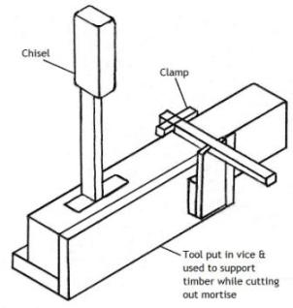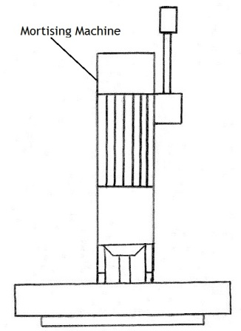
Step5: After you have completed the mortise and tenon check to see if they interlock neatly. If your tenon won’t fit you can shave a minimal amount of timber off with a chisel but ensure that you do it to both sides.
If the tenon does not fit properly with the mortise you may have to remove some timber from the mortise. Do not use excessive force or the mortised timber may split.

Step6: Once you are happy with the joint and it fits flush and neat you can now bond it together with clamps and an adhesive.
Always dry clamp first to ensure everything fits and always keep checking for squareness while clamping plus remove the excess glue with a damp cloth or you will have glue spots which are hard to remove later.

Heritage College Design and Technology
Year 9 Timber Joint Knowledge
Mortise and Tenon
Mortise and tenon joints provide a stable and strong joint which can be used in framing construction. This joint can be fixed with adhesive and is stable due to the mortise to tenon fit and the square shoulders of the joint which provide stability.
Answer the following questions which refer to the “How to make mortise and tenon joints” document:
- Name 4 different marking out tools that should be used when marking out a m&t joint
- _______________________________
- _______________________________
- _______________________________
- _______________________________

- The tenon length is usually __________ the depth of the piece it is fitting in to.

- The tenon width is equal to __________ of the thickness of the timber.

- When cutting a tenon by hand use a __________ saw and ensure that your work is clamped securely in a ___________.

- Tenons can be cut using another type of saw, name this machine _________________________________.

- When marking the mortise, the width should be equal to the width of the _______________.

- Mortises can be created with a __________________ and mallet or with the ______________________ ___________________.

- To ensure a perfect fit we can remove small shavings of timber from the tenon using a __________________

- Always fit joints together without glue to check the fit before gluing, this is called a _________ _________.

Heritage College Design and Technology
Year 9 Materials Technology
Adhesives
When you manufacture a product using woods it will soon be necessary to join parts together. This can be done using fixings such as screws, nails and pins OR through the use of glues. Modern glues are very strong and if the product advertising claims are to be believed, joints made with glues can be stronger than the wood itself.
Traditional Glues - Glues were once made from natural materials such as animal hides and bones. They were boiled to produce a brownish coloured jelly which slowly solidified. This was called ‘scotch glue’ and it could be warmed up later and used as a liquid glue.
Modern Glues - P.V.A. (Polyvinyl Acetate) Glues are very popular as they do not need preparation. These glues are supplied in a plastic container and can be used straight away. Examples of these types of glues are product such as Aquadhere and Titebond.
Research Questions
- PVA glues come in two types, generally identified by the different colour of the glue itself. What are the two types?

- ___________________________________
- ___________________________________
- PVA glues are the most popular wood glues available but there are a number of different adhesives that are suited to use in woodworking. Name 2 other types and provide a brief explanation of why they are different from PVA.

- ______________________________________________________________________________________________________________________________________________________________________________________________________________________________
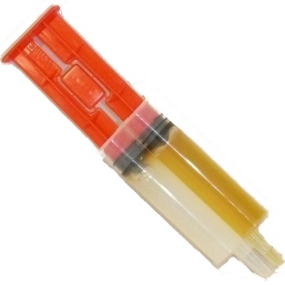
- ______________________________________________________________________________________________________________________________________________________________________________________________________________________________
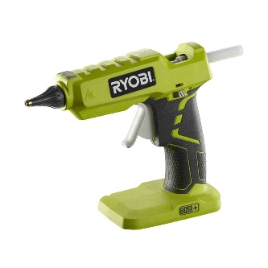
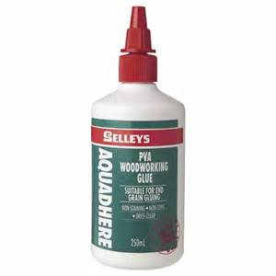
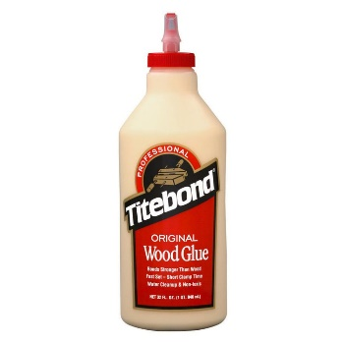
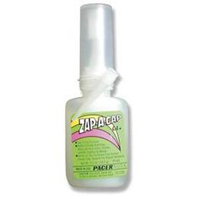

Heritage College Design and Technology
Year 9 Abrasives

Abrasives come in a vast number of types for use on differing materials. In Our workshop we have abrasives that are used with timber, plastics and metals. Most of these abrasives are applied to papers that allow us to “sand” materials to a smooth finish. Abrasive paper is coated with different abrasive materials such as garnet, emery, aluminium oxide and even diamonds which provide a medium which can cut or abrade the surface of a material. The common name sandpaper has remained common despite the fact that sand has not been used as an abrasive coating for hundreds of years.
Abrasive papers should be used with a sanding block for most operations in woodworking. Power sanders should only be used on flat surfaces using the correct grit pad.
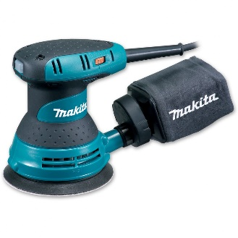
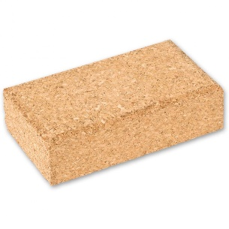
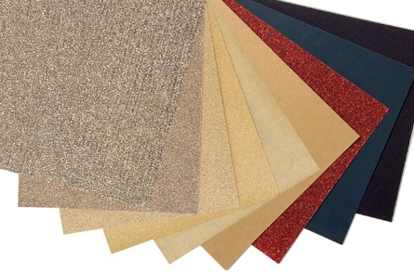

In woodwork we use a range of abrasive papers that are listed in a table below. The task is for you to match the abrasive grit number to the operation that you will complete.
Grit | Common Name | Uses
40-60 | Coarse | Heavy sanding and stripping, roughing up surfaces including removing heavy coatings.
80-120 | Medium | Smoothing of surfaces, removing smaller imperfections and marks.
150-180 | Fine | Final sanding before finishing the timber with polish or coating.
220-240 | Very Fine | Sanding between coats of sealer or polish.
280-320 | Extra Fine | Removing dust spots of marks between finish coats.
360-6000 | Super Fine | Removal of fine surface blemishes or reduction of gloss where needed.

Task
Insert the grit number of the paper you will use for the following operations.
- Removing working marks, putty and pencil lines from your work

- Preparing your project for its first coat of sanding sealer

- Once the sanding sealer is applied and before application of polish

- After one coat of polish is applied the project will be sanded with

Materials Technology Project Evaluation.

This term you have been given the task of producing a project that you have designed. As part of this project you have learnt new skills and worked with materials and tools that have allowed you to complete your project.
The last step in this project is to reflect on what you have done and evaluate the project you have completed.

- Describe the project and provide a list of tools and processes that you had to work through in making this project.
______________________________________________________________________________________________________________________________________________________________________________________________________________________________________________________________________________________________________________________________________________________________________________________________________________________________________________________________________________________________________________________________________________________________________________________________________________________________________________________________________________________________________________________________________________________________________________________________________________________________________________________________________

- Some of the steps in this project are simple and others difficult, what did you find easy and which process did you find most difficult?
__________________________________________________________________________________________________________________________________________________________________________________________________________________________________________________________________________________________________________________________________________________________________________________________________________________________________________________________________________________________________________

- Describe your design and explain why you chose the design you completed.
____________________________________________________________________________________________________________________________________________________________________________________________________________________________________________________________________________________________________________________________________________________________________________________________________________________________________

- If you had the opportunity to start this project again what would you change and why?
__________________________________________________________________________________________________________________________________________________________________________________________________________________________________________________________________________________________________________________________________________________________________________________________________________________________________________________________________________________________________________

Heritage College Design and Technology
Year 9 Metals Research

Metals come in a number of forms that produce differing qualities. At the extreme ends of this spectrum we have liquid metal, Mercury and the extremely hard metal alloy Carbon Steel. The different qualities of metals and their alloys allow us to apply metals to many different applications.
Research the Ferrous and Non Ferrous metals listed and provide some uses for them.
Ferrous Metals mostly contain Iron. They have small amounts of other metals or elements added, to give the required properties. Ferrous Metals are magnetic and give little resistance to corrosion.
Non Ferrous Metals do not contain Iron, are not magnetic and are usually more resistant to corrosion than ferrous metals.
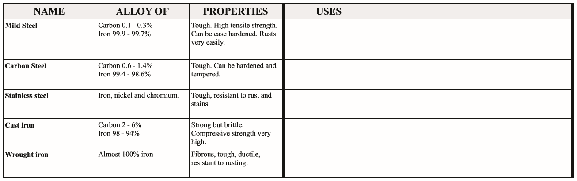
Ferrous Metals
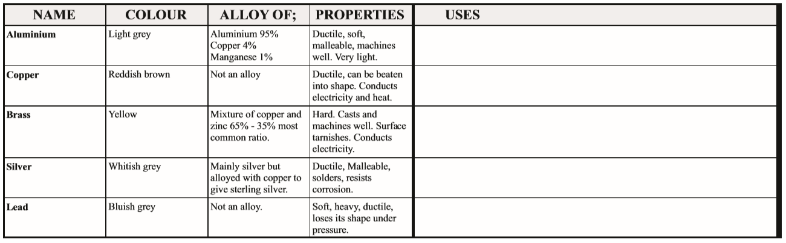
Non Ferrous Metals

Materials Technology; METAL
Year 9: Assessment Activity 1. Date Given:

TOOL CARRY ALL

Learning Intention
In this task you will be expected to:
- Understand and apply safe work practices in practical environments.
- Use a range of materials, tools and techniques in the production of a practical project.
- Communicate effectively using a range of verbal, graphical and written methods.

Project details:
Due Date: Week 9 Term 2 Weighting: 20%
Project requirements:
This introductory sheet metal project will allow you to gain an appreciation of the metal workshop facilities and associated WHS regulations. You will produce a tool carryall and document the process in a project report.

Criteria:
In this task you will be expected to:
- Apply safe work practices in the production of your project.
- Produce a quality project.
- Complete a project report which includes:
  - A Safe Operating Procedure (SOP) for the equipment used.
  - A Safe Work Statement (SWMS) and cutting list.
  - A Safety advisory poster highlighting a possible workshop hazard.
- Complete a self-assessment and evaluation sheet based on your completion of the task.

Learning Intentions - Assessment guidelines

Description | Performance criteria
Applies safe work practices | You will be assessed on how well you follow safety guidelines and make decisions about safe work practices whilst completing your project.
Completed project | You will be assessed on how well select and use materials, tools and techniques thorough out the production of your project as well as the quality of the completed project.
Project Report | You will be assessed on how well you communicate and document the design and development of your finished project.

Student mark and feedback sheet

Name: Grade:

Description | Experiencing Difficulty | Developing | Competent | Highly Developed

Applies safe work practices

Completed project

Project Report

Comment

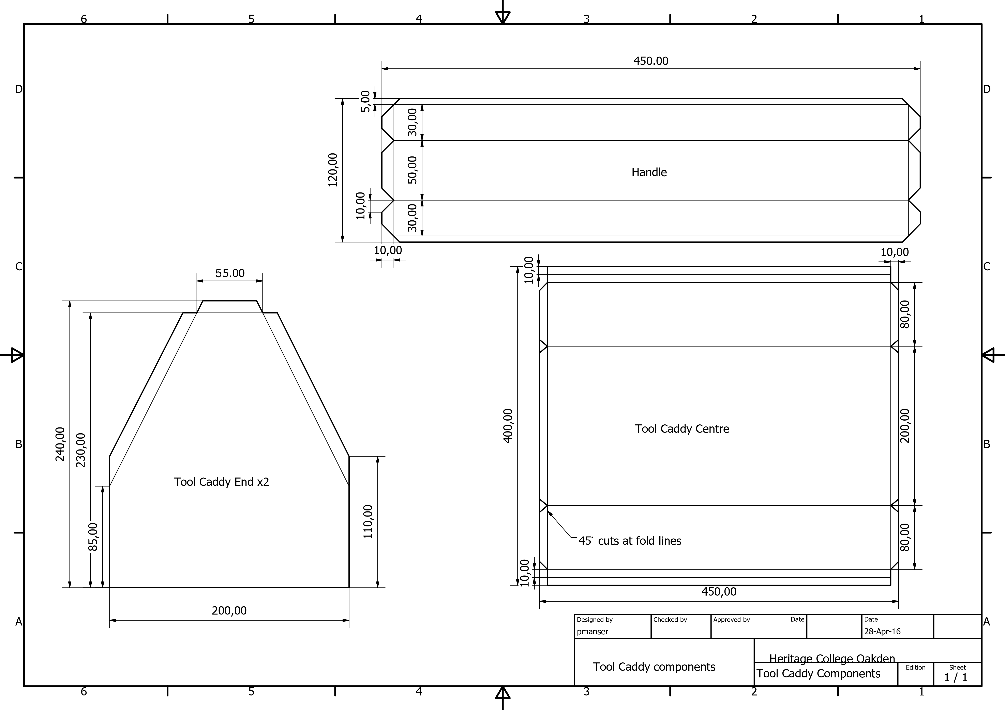
PROCEDURE LIST
Procedure List
The table below is designed to help you understand the steps and processes involved in the production of your project.
This list will provide information that will help you evaluate the project and should include The Materials, Tools and Processes that have been part of your project.
Materials Used | Tools and Equipment | Processes

Year 9 Design and Technology
Design Brief
Metal Craft

DESIGN BRIEF
Metal is a material that can be shaped, bent and twisted into many different shapes and forms. Your brief is to design and make an object using mild steel flat bar that serves to fill a need you may have. This need may be to hold a candle or to hang a pot plant from. If you do not need a functional piece of work you may choose to design a piece of sculpture to decorate your home.
Constraints/Requirements

- The object must serve its designed purpose.

- The object is to be safe.

- Use at least one of the metal forming machines available in the workshop.

- Use less than 2 linear metres of material.

- The following processes must be included in your finished product:

  - Braze/Fusion welding
  - Bending, shaping & joining of mild steel flat bar.
  - Filing of all ends to shape or fit.

- The completed product is to be coated with a black spray painted finish
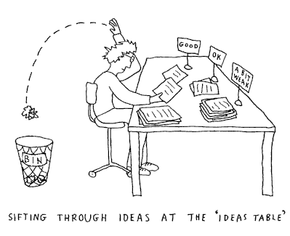

Metal Craft

Critique
The first step in designing any product is to look at existing products that may fill you’re your requirements. Use the resources available to you in the Design and Technology building to view existing products that could be produced with the materials and tools available to you.

Task 1
To begin your critique find pictures of at least 4 different designs that you like and copy them into a Word document with a few notes about what you like or dislike about each one. Remember to copy and paste the web address for each picture below the images (see example below).
When this task is completed you will be ready to move into the design phase of the project.

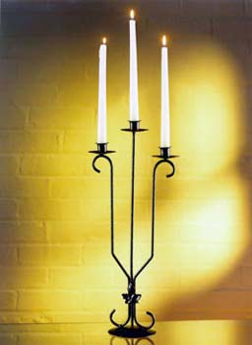

Design Sketches

Design Drawing (Scale drawing)

Notes

Year 9 Design and Technology
Procedure List

Metal Craft

Materials | Tools and Machinery | Process
Introduction to welding

GAS WELDING
Oxyacetylene gas welding is commonly used to permanently join mild steel. A mixture of oxygen and acetylene, burns as an intense / focussed flame, at approximately 3,500 degrees centigrade. When the flame comes in contact with steel, it melts the surface forming a molten pool, allowing welding to take place. Oxyacetylene can also be used for brazing, bronze welding, forging / shaping metal and cutting. This type of welding is suitable for the prefabrication of steel sheet, tubes and plates.

MIG Welding (GMAW)
Gas metal arc welding (GMAW), sometimes referred to by its subtypes metal inert gas (MIG) welding or metal active gas (MAG) welding, is a welding process in which an electric arc forms between a consumable wire electrode and the workpiece metal(s), which heats the workpiece metal(s), causing them to melt and join.
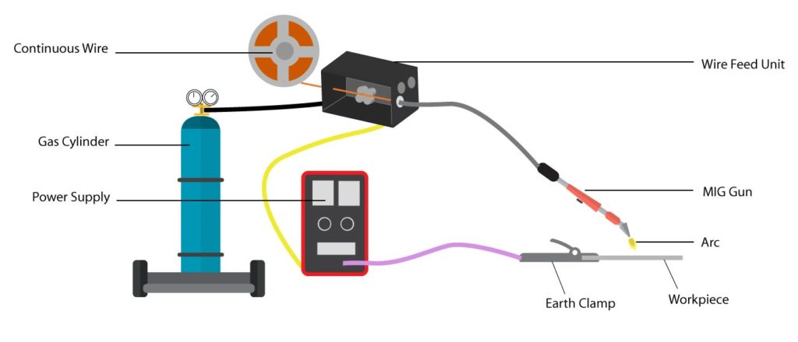
Along with the wire electrode, a shielding gas feeds through the welding gun, which shields the process from contaminants in the air. The process can be semi-automatic or automatic. A constant voltage, direct current power source is most commonly used with GMAW, but constant current systems, as well as alternating current, can be used.

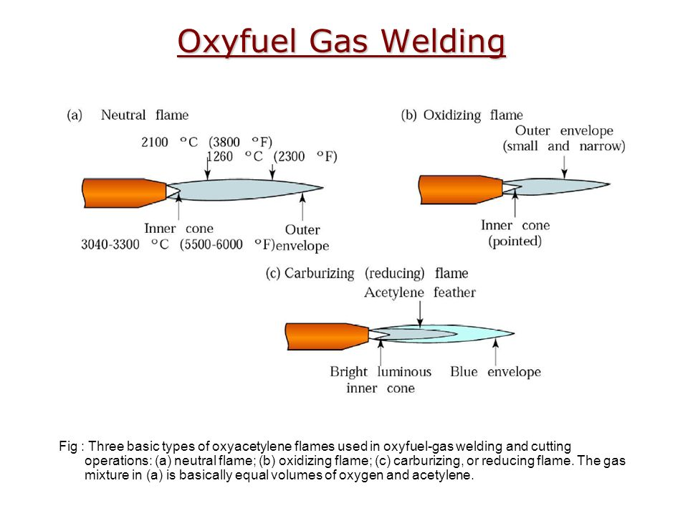
What is a flame?
Flames are formed when a fuel gas, like acetylene, reacts with a support gas such as oxygen. This reaction creates a lot of heat and light, which we see as a flame. An oxygen acetylene flame can create temperatures over 3200°C. The temperature of oxy-acetylene flames depends on the acetylene and oxygen mixture. The ratio of the gases creates different types of flames.
Oxy Acetylene Welding Flame Types
Setting the Correct Flame for Gas Welding Operations

Welding Practical Skills

Complete the following welding assessment
Instructions:
Cut 6 x 100mm x 3mm thick strips of mild steel and complete the following weld safely and efficiently using the correct settings and flames types-

- Fusion weld butt joint without filler rod

- Fusion Weld with mild steel filler rod

- Braze Weld

Completed …

Comments:…………………………………………………………………………………………………………………………………………………………………………………………………………………………………………………………………………………………………………………………………………………………………………………………………………………………………………………………………………………………………………………………………………………………………………………………………………………………………………………………………………………………………………………………………………………………………………...

Materials Technology Project Evaluation.

This term you have been given the task of producing a project that you have designed. As part of this project you have learnt new skills and worked with materials and tools that have allowed you to complete your project.
The last step in this project is to reflect on what you have done and evaluate the project you have completed.

- Describe the project and provide a list of tools and processes that you had to work through in making this project.
______________________________________________________________________________________________________________________________________________________________________________________________________________________________________________________________________________________________________________________________________________________________________________________________________________________________________________________________________________________________________________________________________________________________________________________________________________________________________________________________________________________________________________________________________________________________________________________________________________________________________________________________________

- Some of the steps in this project are simple and others difficult, what did you find easy and which process did you find most difficult?
__________________________________________________________________________________________________________________________________________________________________________________________________________________________________________________________________________________________________________________________________________________________________________________________________________________________________________________________________________________________________________

- Describe your design and explain why you chose the design you completed.
____________________________________________________________________________________________________________________________________________________________________________________________________________________________________________________________________________________________________________________________________________________________________________________________________________________________________

- If you had the opportunity to start this project again what would you change and why?
__________________________________________________________________________________________________________________________________________________________________________________________________________________________________________________________________________________________________________________________________________________________________________________________________________________________________________________________________________________________________________

Heritage College Design and Technology
Make a Mug
Learning Intention
To introduce new skills in using Inventor 2016 and create opportunities for design thinking. The following is a guide and students are encouraged to produce their own version of the mug to suit their individual personalities and needs.

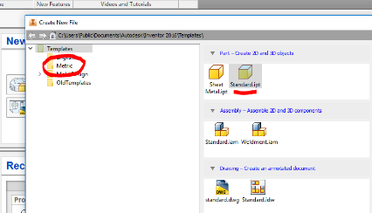
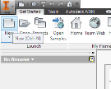
Step 1. Open Inventor 2016 and click on New and ensure that Metric is selected then click on Standard mm. ipt

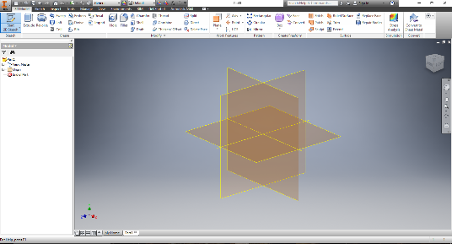
Step 2. Your drawing space will appear. In the left hand top corner click on Start 2D sketch and a drop down will appear select Start 2D sketch. Once you have selected this you will see a set of Planes appear.
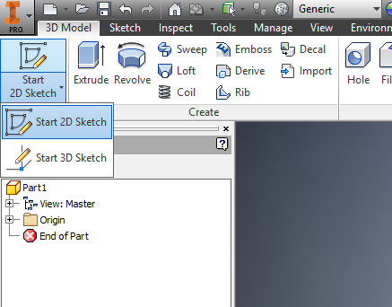

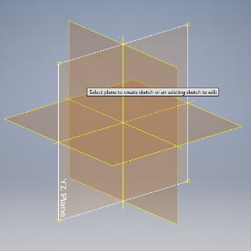
Step 3. Select the YZ Plane.

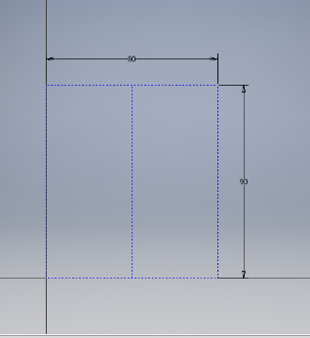
Step 4. Select the Rectangle tool and draw a rectangle 90mm high by 80mm wide. This will be a guide for your mugs size, select the Line tool and draw a vertical line down the centre, you will notice the cursor will turn green and snap to the centre of the horizontal line making it easy to create this line. Turn OFF the Construction Line.

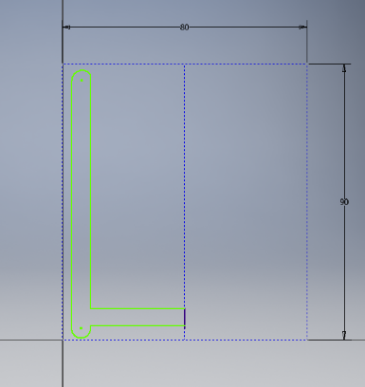
Step 5. Using the drawing skills that you have previously learnt draw a profile for your mug. This should resemble a mug that has been cut in half on one side of the line. As this diagram shows.

Step 6. Click Finish Sketch and the 3D Ribbon will appear giving options for working in 3D. Select Revolve.
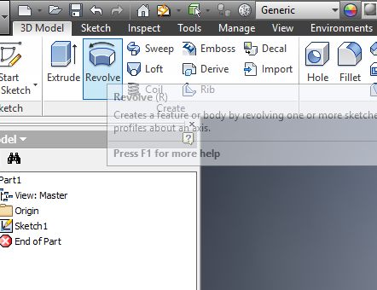
Select your profile, the same as when extruding.
Now select the axis which is the centre line making sure that the word Full appears in the box as shown.

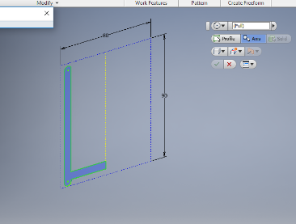

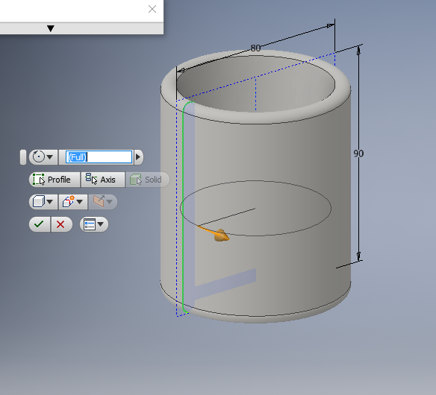
Step 7. The rotation should now appear and your mug is almost complete.

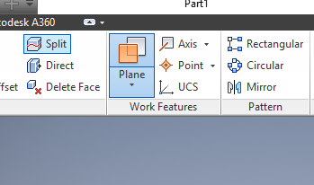
Step 8. The mug now needs a handle and this is where you design a feature that looks right for your intended use.
Select the Plane icon from the ribbon in 3D mode.

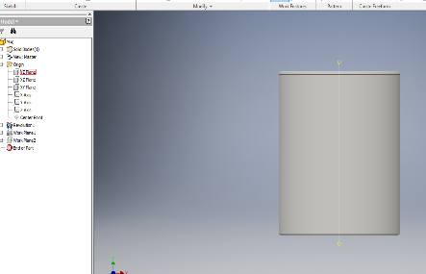
Select the YZ Plane and you will note the plane is in the centre of your mug.
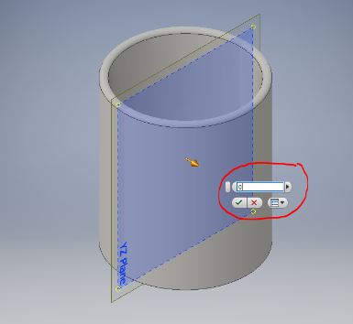

Place your cursor over the corner after adjusting the view and drag the circle on the corner of the plane forward or back Type in 0 into the measurement and the plane will remain centred.

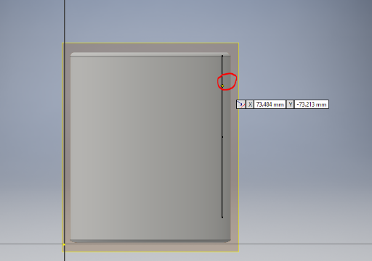
Step 9. Now select sketch and 2D Sketch and click on the Plane
Draw your handle profile making sure it meets the inner wall of your mug as shown

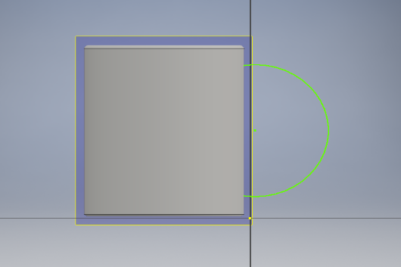
Use the Line and Arc tools to draw the handle shape.
The shape is up to your imagination, don’t make it too complex!

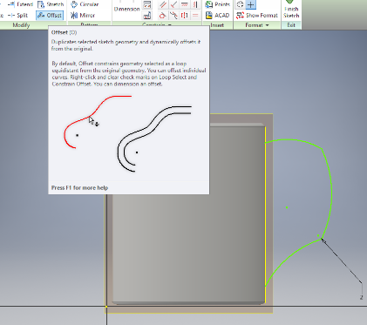
Step 10. The Offset tool is now used to create an exact copy of the line by an amount that we can choose.

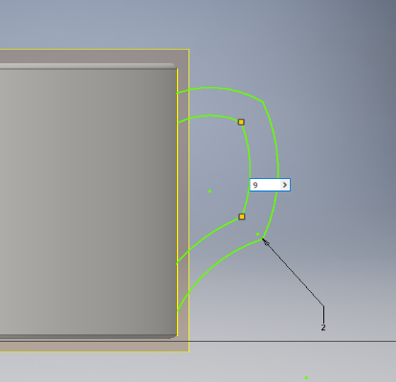
In the case shown we are choosing to offset 9mm inside of the first line.

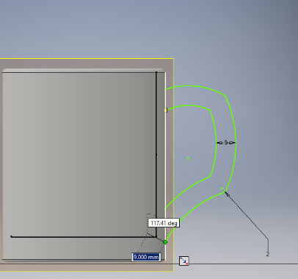
You must join the ends of these lines together to allow the next step which is to extrude the handle.
Click Finish Sketch

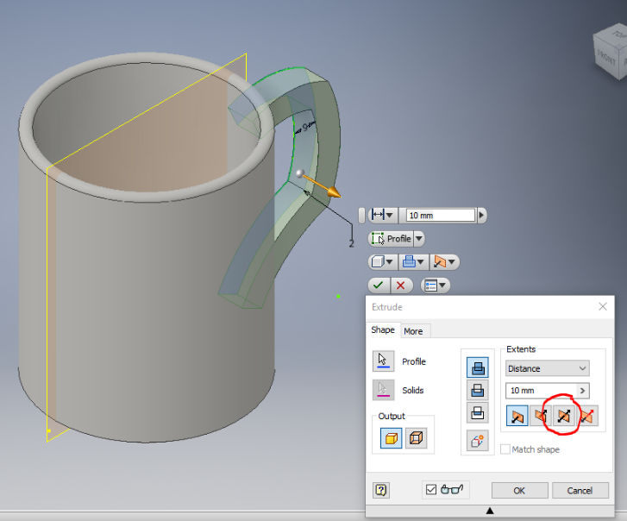
Step 11. We now Extrude the handle but we must use Symmetrical extrude. The way we do this is to select the icon as shown. The extrusion here is 10mm you may choose differently.

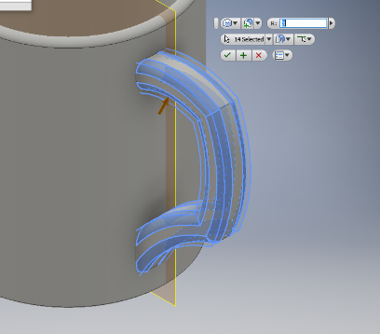
Step 12. The final touches are to Fillet or Chamfer the sharp edges on the handle and colour your mug.
If you are really clever you can use the decal command to apply an image to your mug.
If you have come this far you will be able to work it out using inventor help and the tutorials.

Heritage College Design and Technology

Computer Aided Design
Saving a file as an STL ready for 3D Printing

After completing a part in Autodesk inventor or any other CAD software package it is necessary to save it in the correct format for drawing printing or any other manufacturing process.
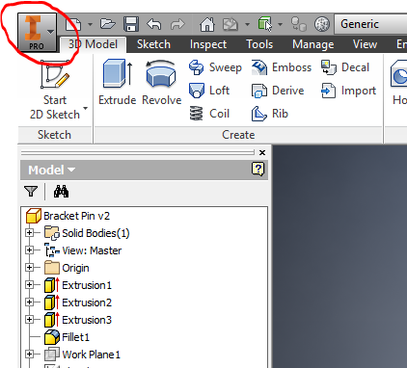

Step 1. Move your cursor to the top left and click on the I Pro Icon. Select Save As but click on the small arrow as shown to open Save Options.

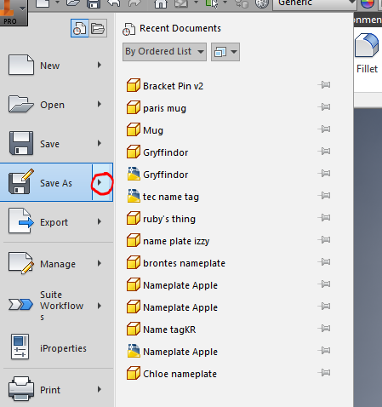

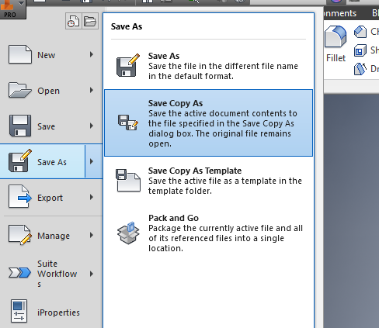

Step 2. Select Save Copy As

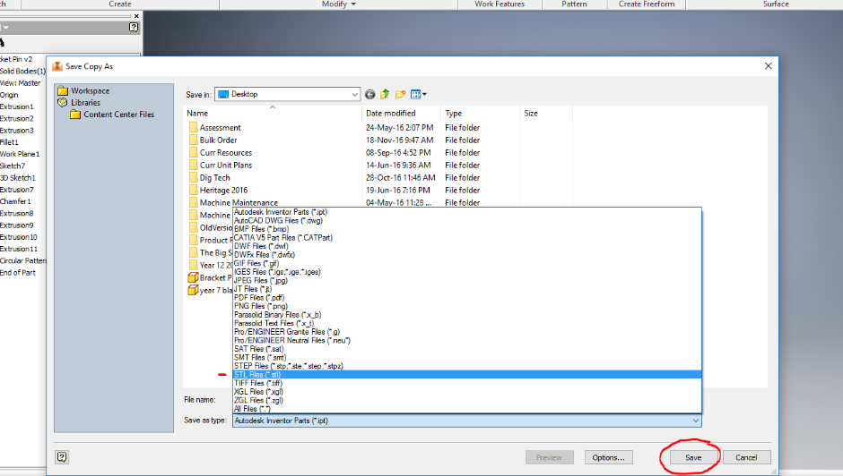
Step 3. Select the drive where you wish to save the file and ensure that you select. STL or stereolithographic file. Your file will now become recognisable by the 3D printer software.

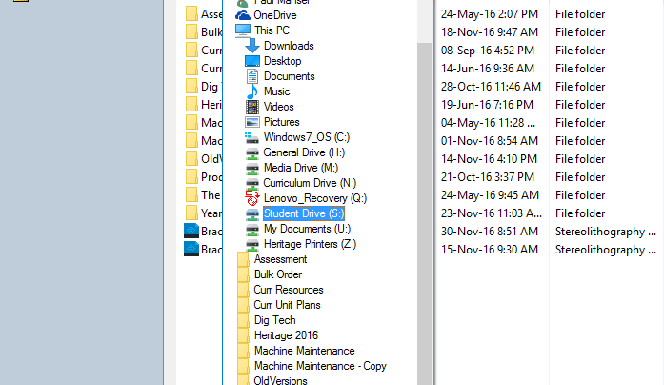

The drive for saving your work which can be accessed by the teacher is the Student ‘S’ drive.

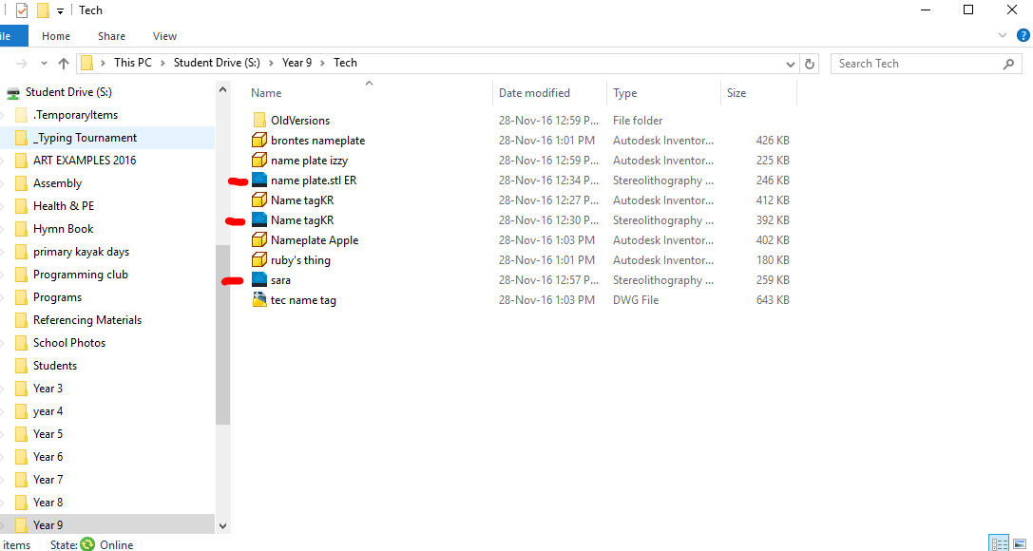

Step 4. If you have saved this file correctly, you will notice the icon has changed and the file type will show a Stereolithography file.

You are now ready to print, make sure your .stl is saved in the S drive so the teacher can access it.

Materials Technology Project Evaluation.

This term you have been given the task of producing a project that you have designed. As part of this project you have learnt new skills and worked with materials and tools that have allowed you to complete your project.
The last step in this project is to reflect on what you have done and evaluate the project you have completed.

- Describe the project and provide a list of tools and processes that you had to work through in making this project.
______________________________________________________________________________________________________________________________________________________________________________________________________________________________________________________________________________________________________________________________________________________________________________________________________________________________________________________________________________________________________________________________________________________________________________________________________________________________________________________________________________________________________________________________________________________________________________________________________________________________________________________________________

- Some of the steps in this project are simple and others difficult, what did you find easy and which process did you find most difficult?
_____________________________________________________________________________________________________________________________________________________________________________________________________________________________________________________________________________________________________________________________________________________________________________________________________________________________________________________________________________________

- Describe your design and explain why you chose the design you completed.
____________________________________________________________________________________________________________________________________________________________________________________________________________________________________________________________________________________________________________________________________________________________________________________________________________________________________

- If you had the opportunity to start this project again what would you change and why?
_____________________________________________________________________________________________________________________________________________________________________________________________________________________________________________________________________________________________________________________________________________________________________________________________________________________________________________________________________________________

