YEAR 10 DESIGN & TECHNOLOGY:
THE ENVIRONMENT, TECHNOLOGY AND SUSTAINABILITY

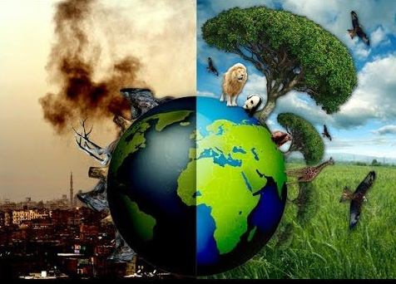

Learning Intention: To address the need to cover the Australian Curriculum content and to raise awareness of our responsibilities to care for our planet as members of society and believers in God’s work as creator.

Task

Step 1: Research an issue related to our use of technology and its impact on the environment and society. Produce a discussion paper that addresses the following points in relation to your chosen issue:
Successful submissions will include supporting data shown in graphical or pictorial form.

- What is the issue? (Material or process)
- What effect does it have on the environment?
- How does it affect people and society?
- Possible solutions
- Personal responsibility, what can I/we do to help .

Maximum Word Count 1000

Resources: Power School Learning (Haiku) Year 10 Technology and its environmental impacts ppt

