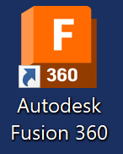
Year 8 Fusion Tutorial : Mood Light Project
Step 1 : Open Fusion
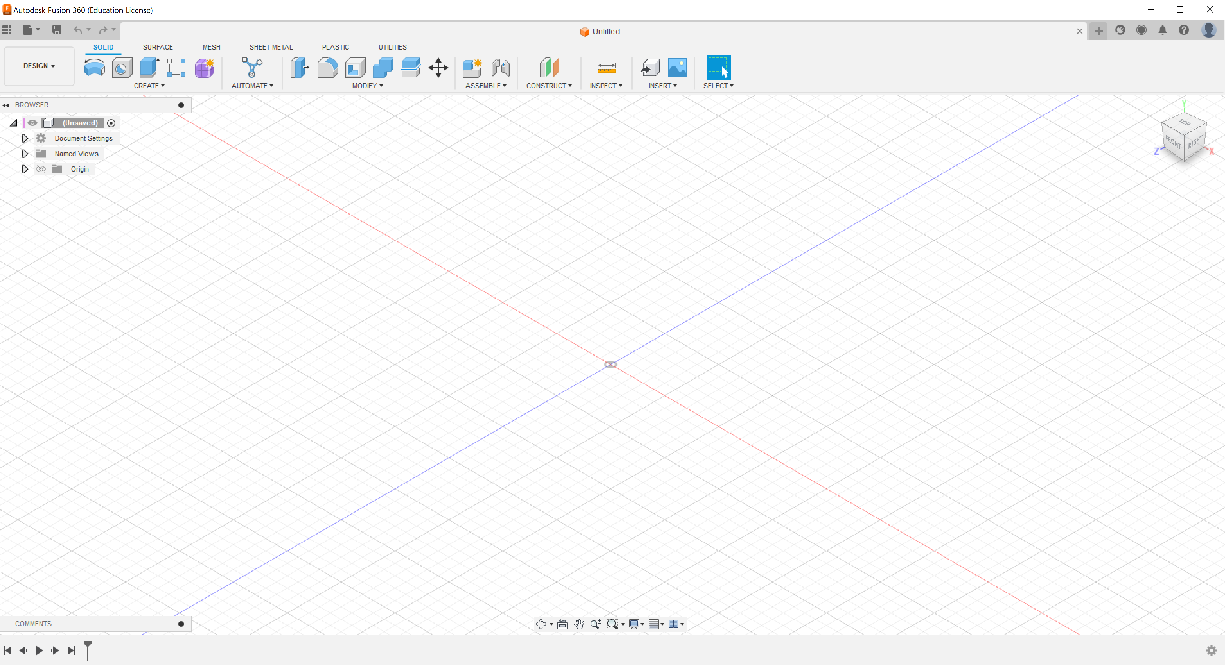
Once Fusion is open show your Data Panel, this panel provides tools that help you organise your workflow.
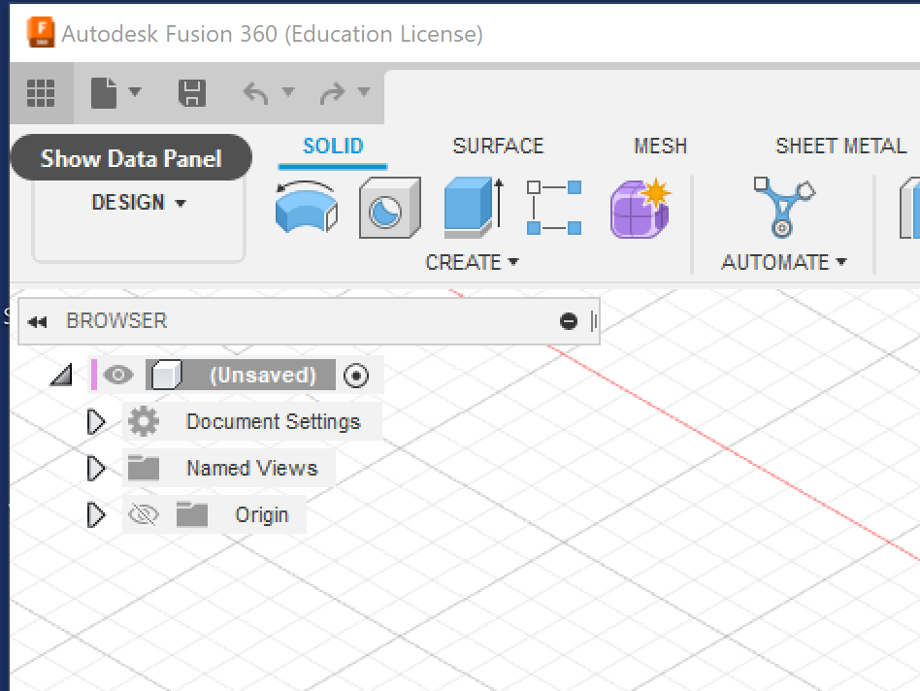

Create a New Project, Call it Mood Light or similar.
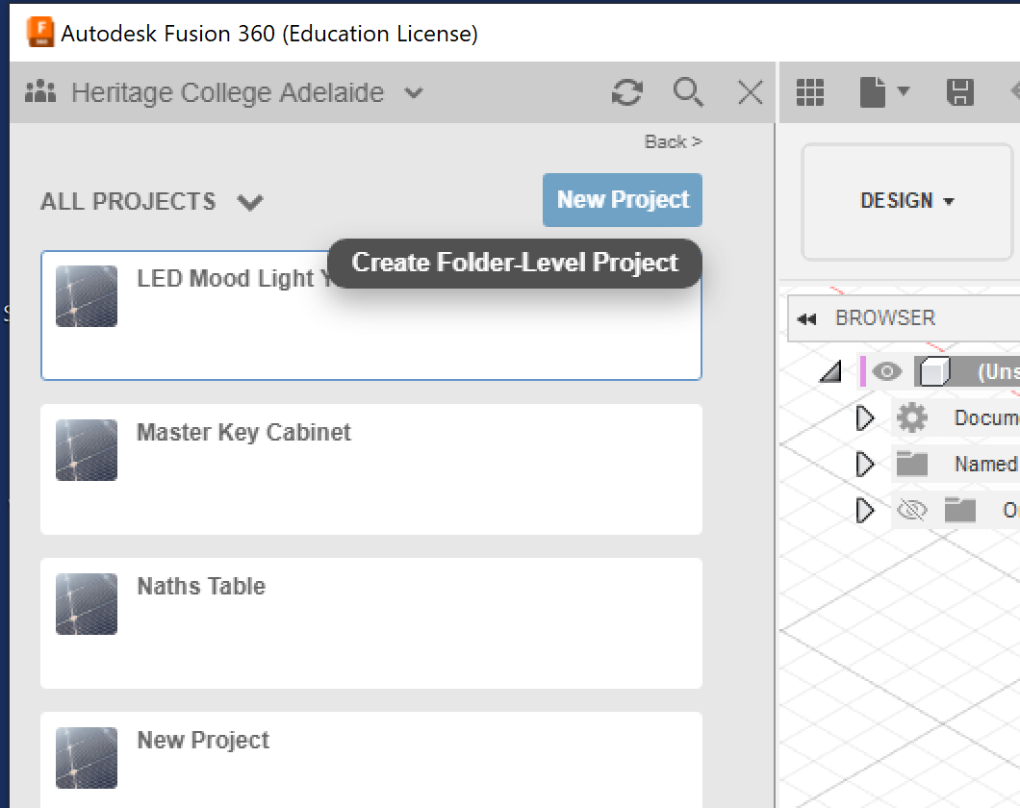
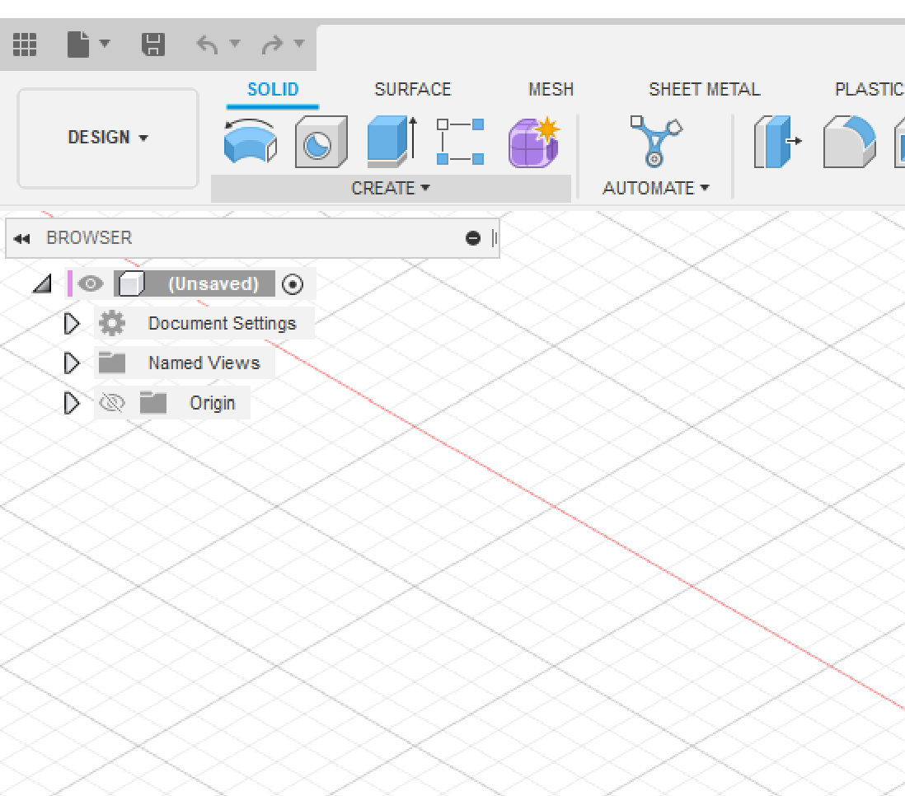
Step 2: Click on the drop down for the Create tools.

Click on Create Sketch
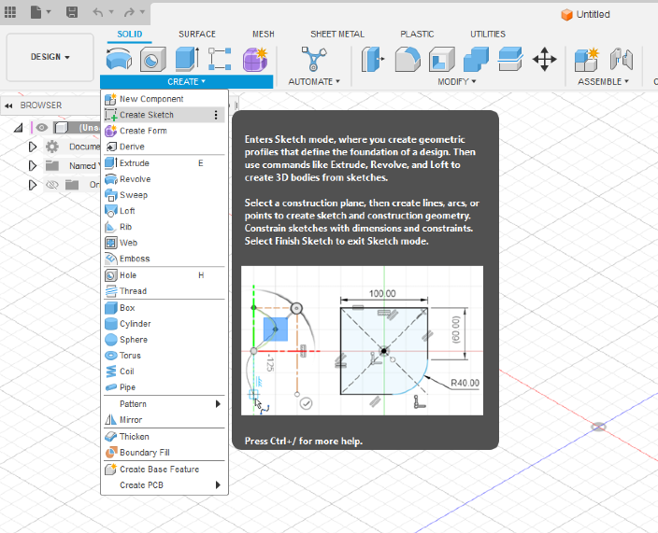
Step 3: Choose a Plane
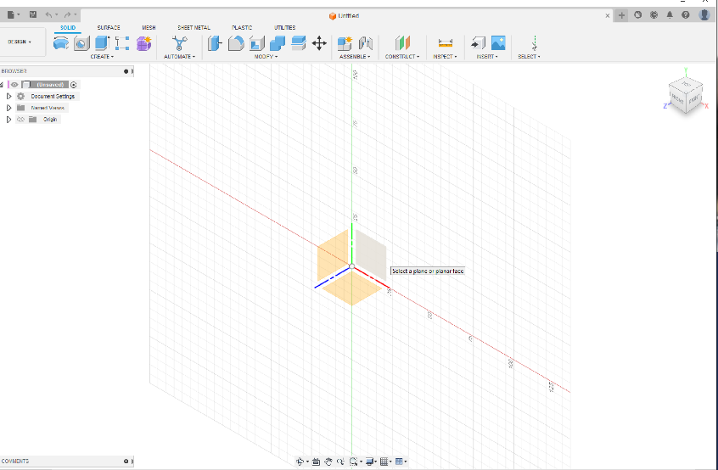
This plane represents the Front of our design

The Drawing space will now change to the Front Plane
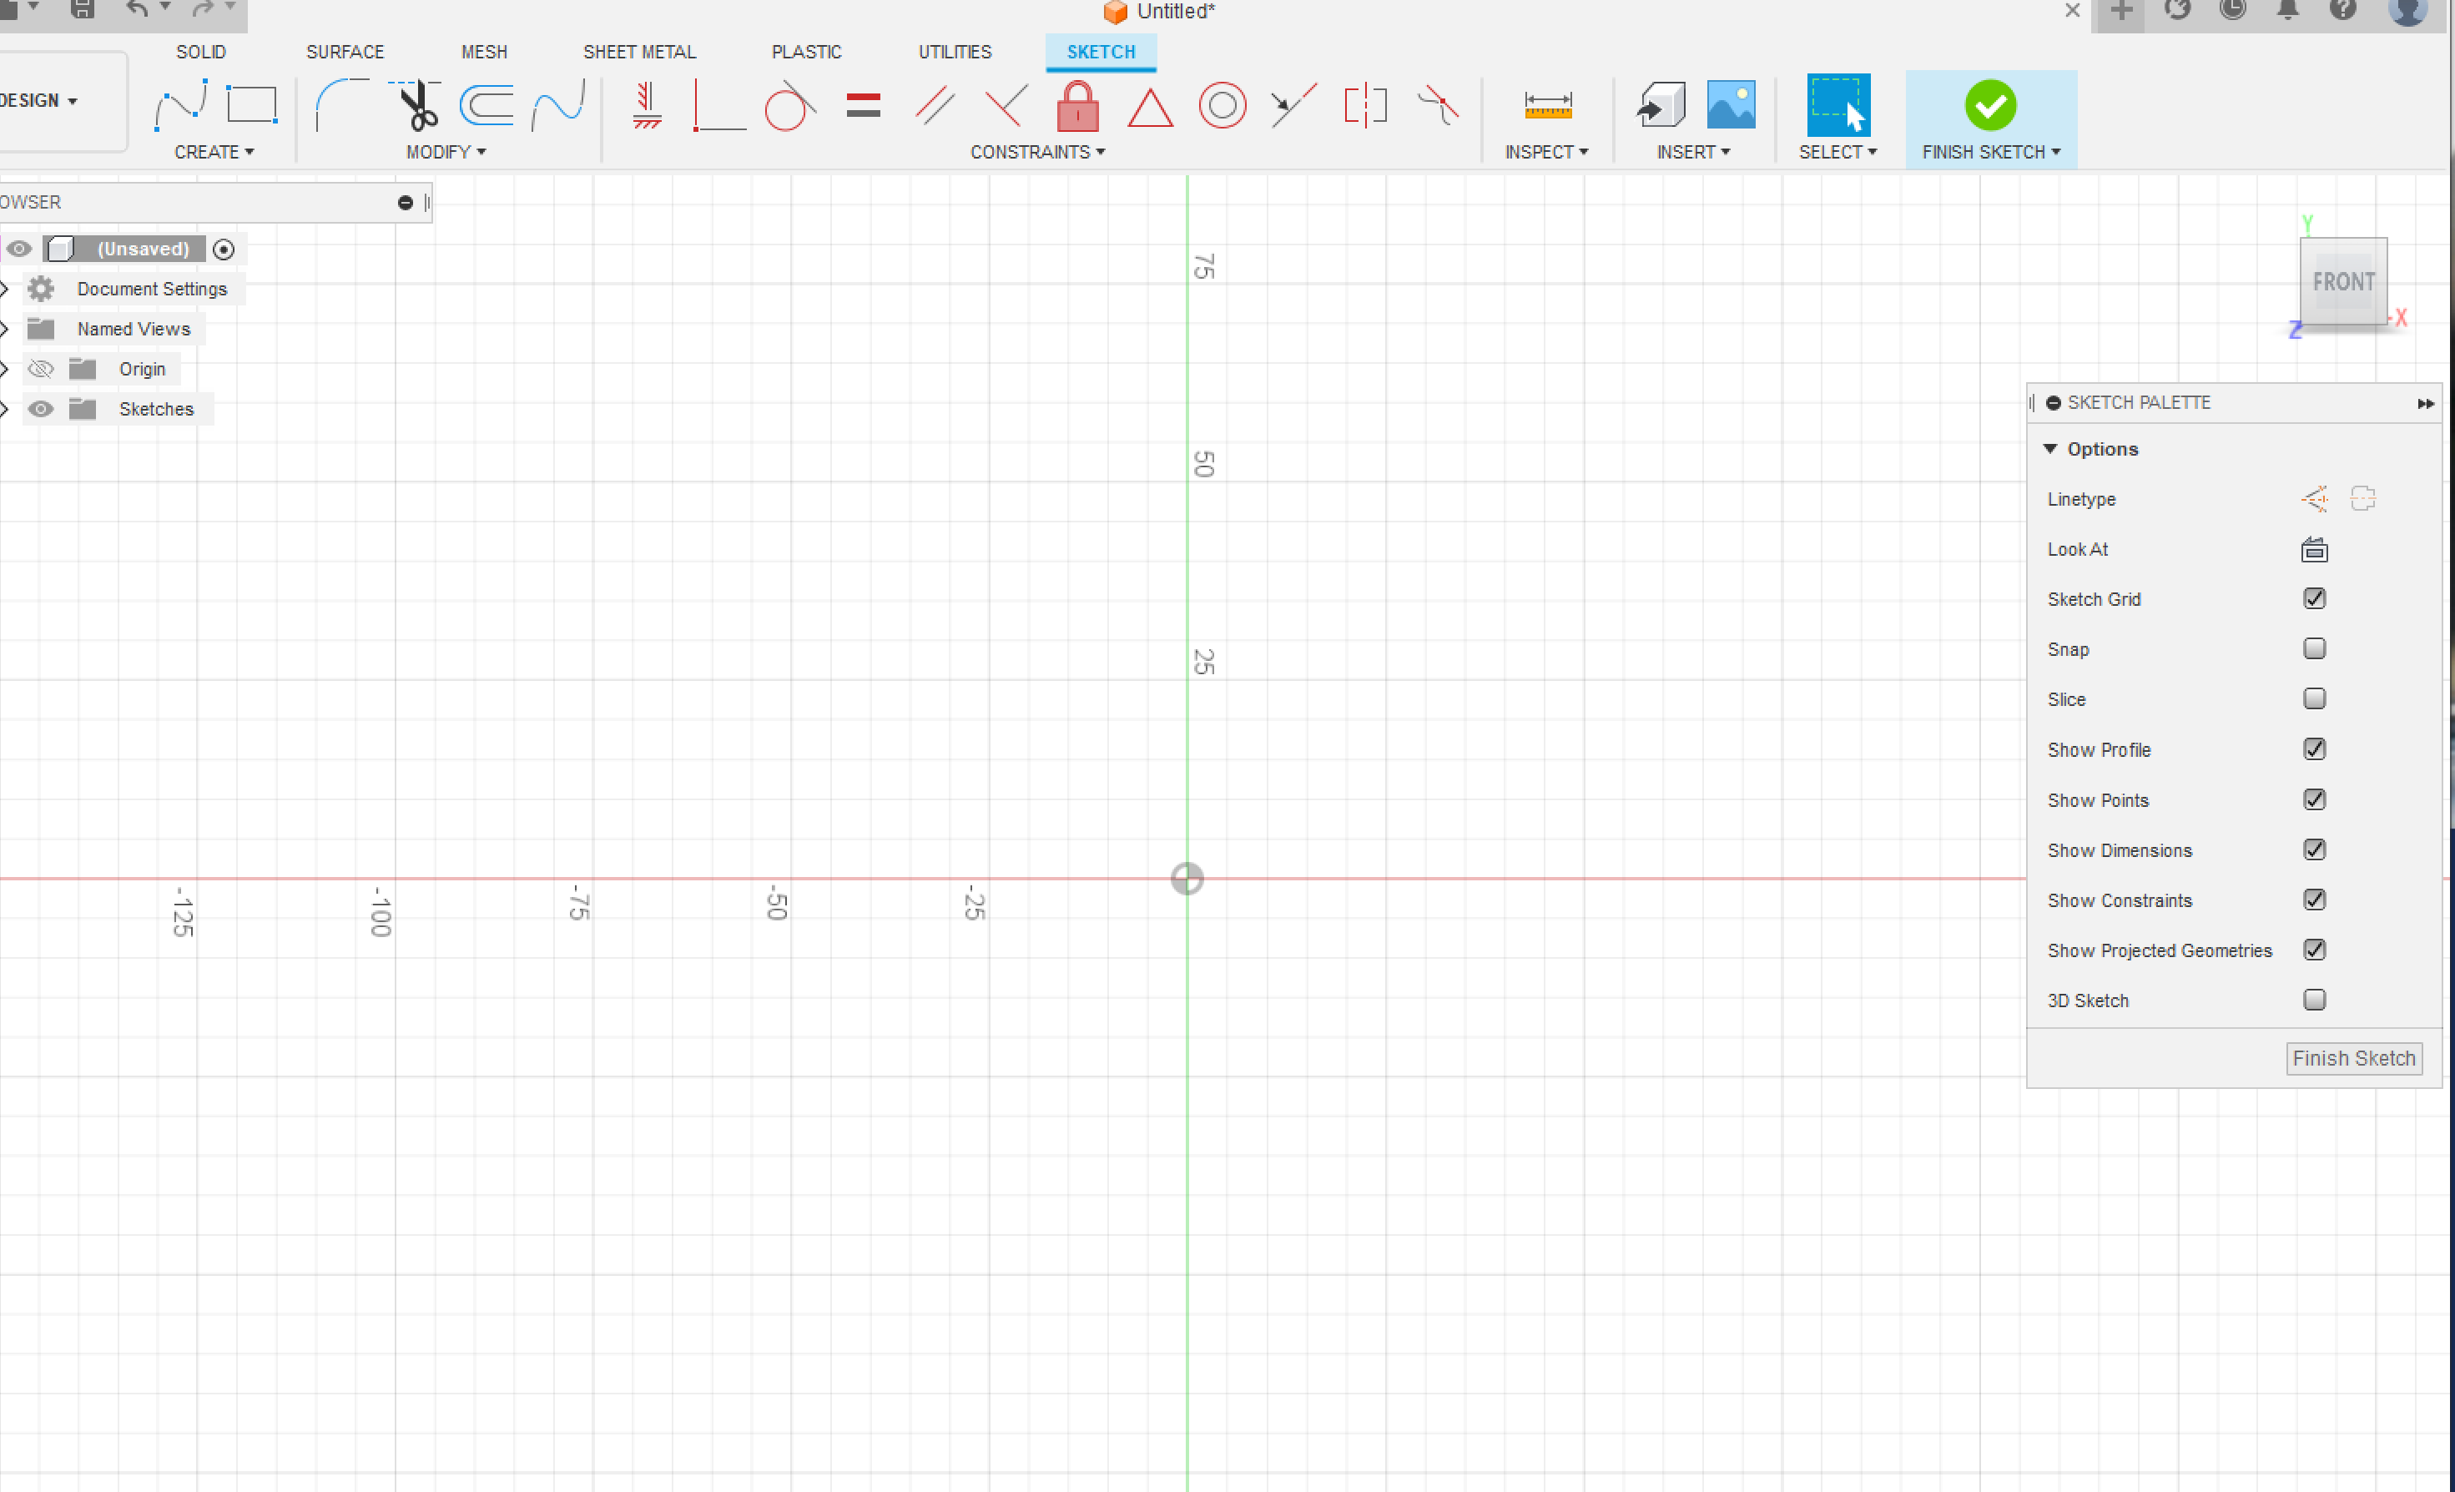

Step 4: Select the 2 point Rectangle Tool
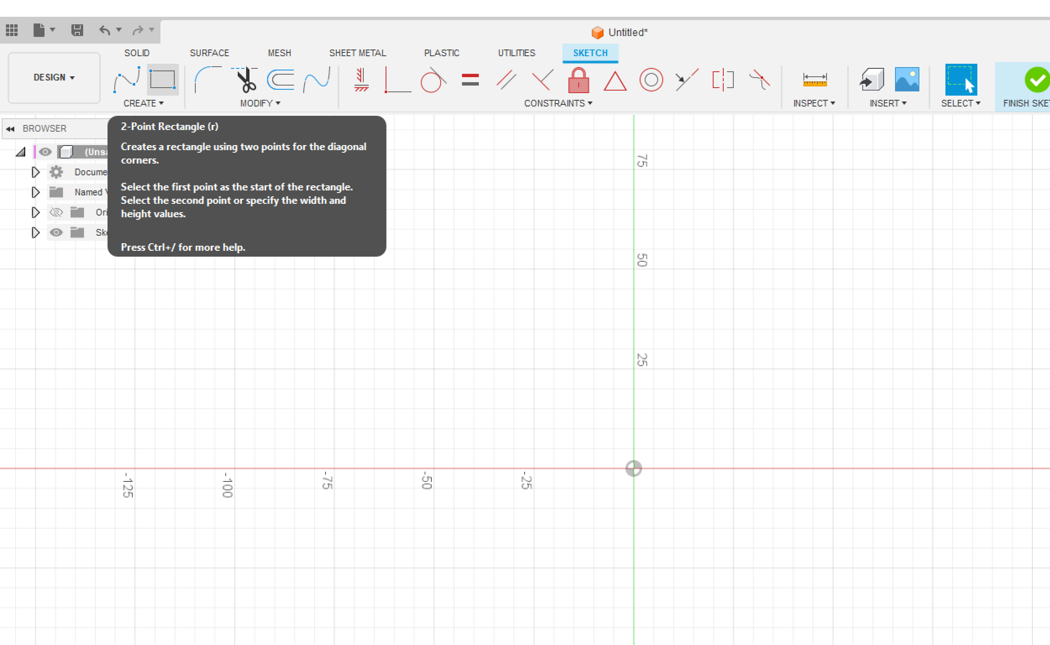

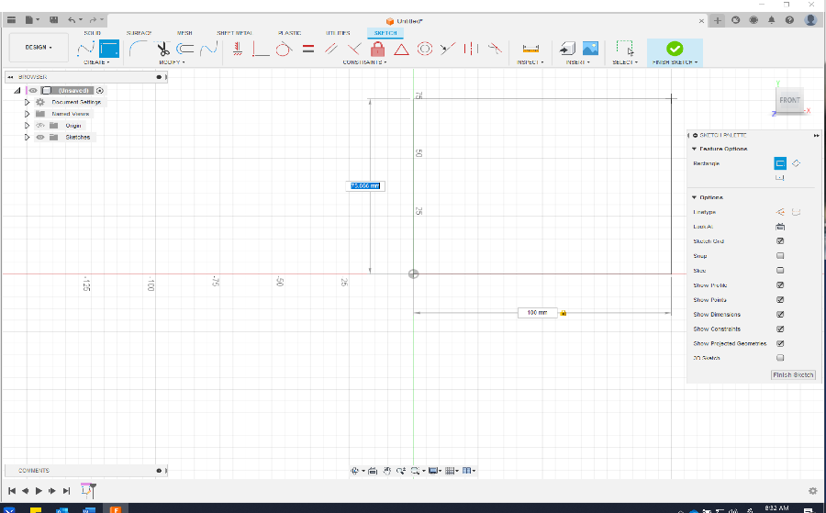
Place the Rectangle start point at the centre of your space and drag up and to the right ( DO NOT LEFT Click) Let go of your mouse and type 100mm in the bottom box hit the TAB button and type 140 in the highlighted box. This action has dimensioned your rectangle.

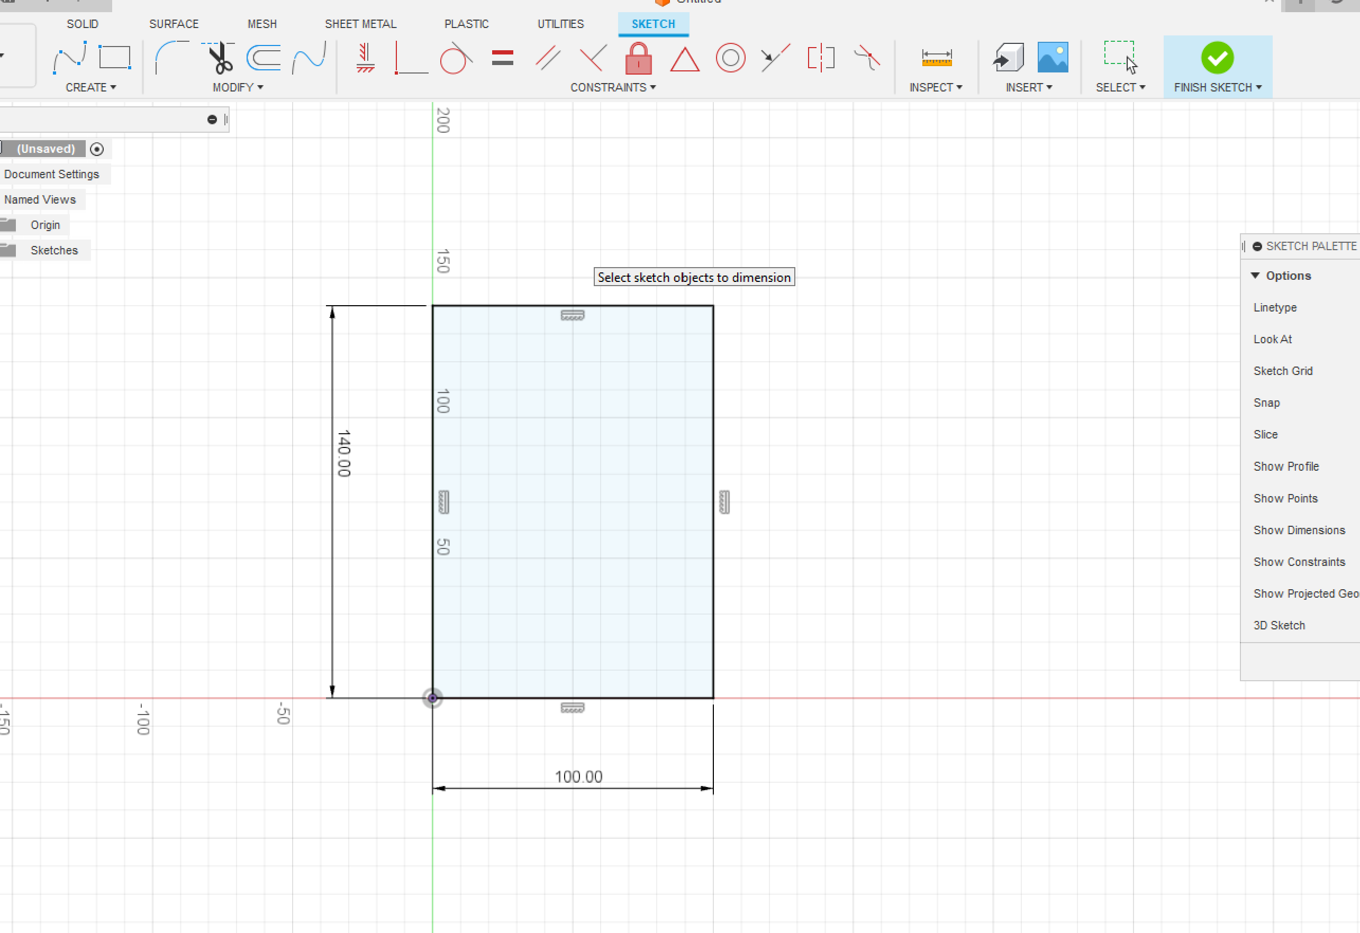
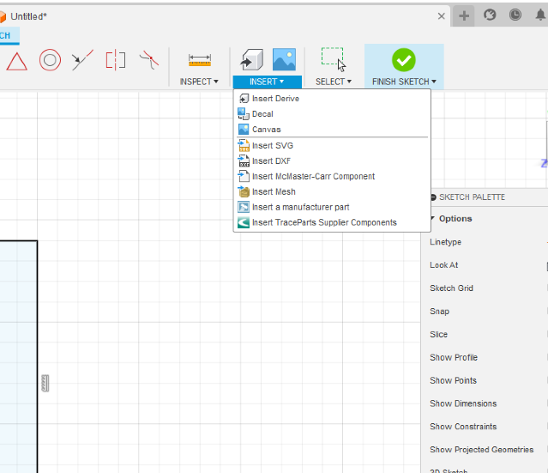
Step 5: Placing an Image into our Drawing Space.
Select the Insert drop down and click on CANVAS, this is how we place an image file into our drawing. Images need to be placed on a PLANE

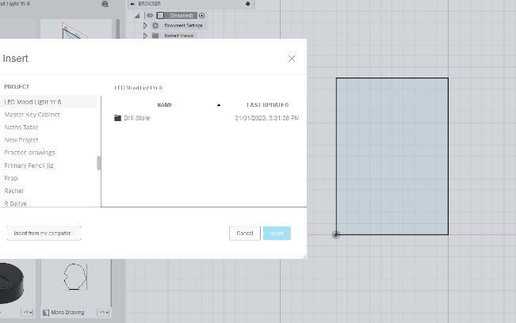
Find the image file you have saved in .jpg, .png format and open the image. It will appear in the drawing space.

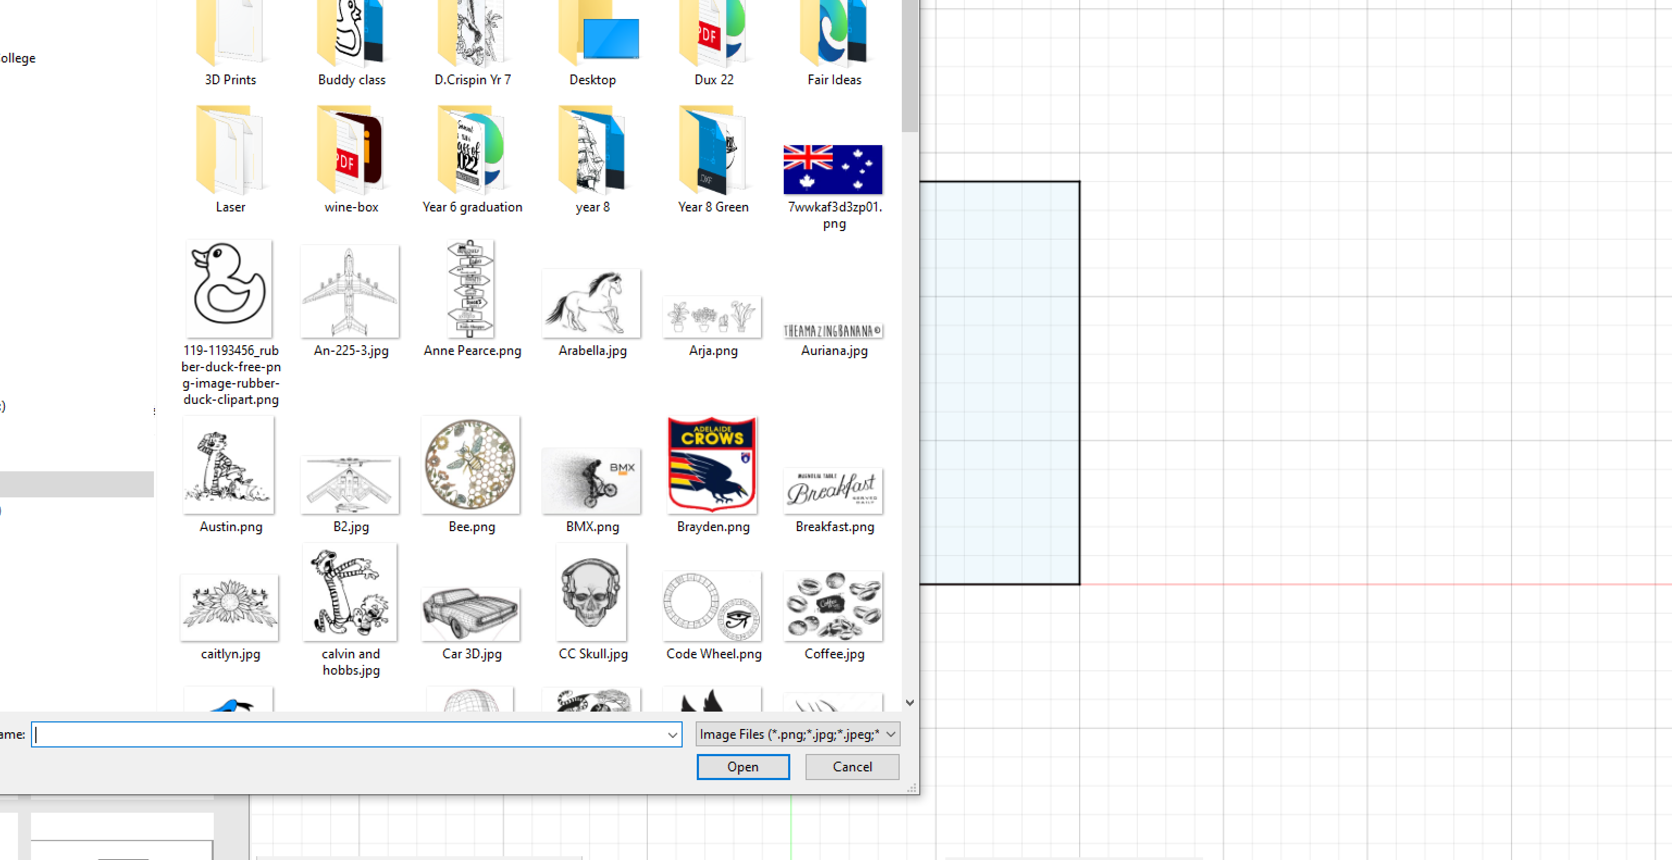
Click on the PLANE and your image will place itself in the drawing.
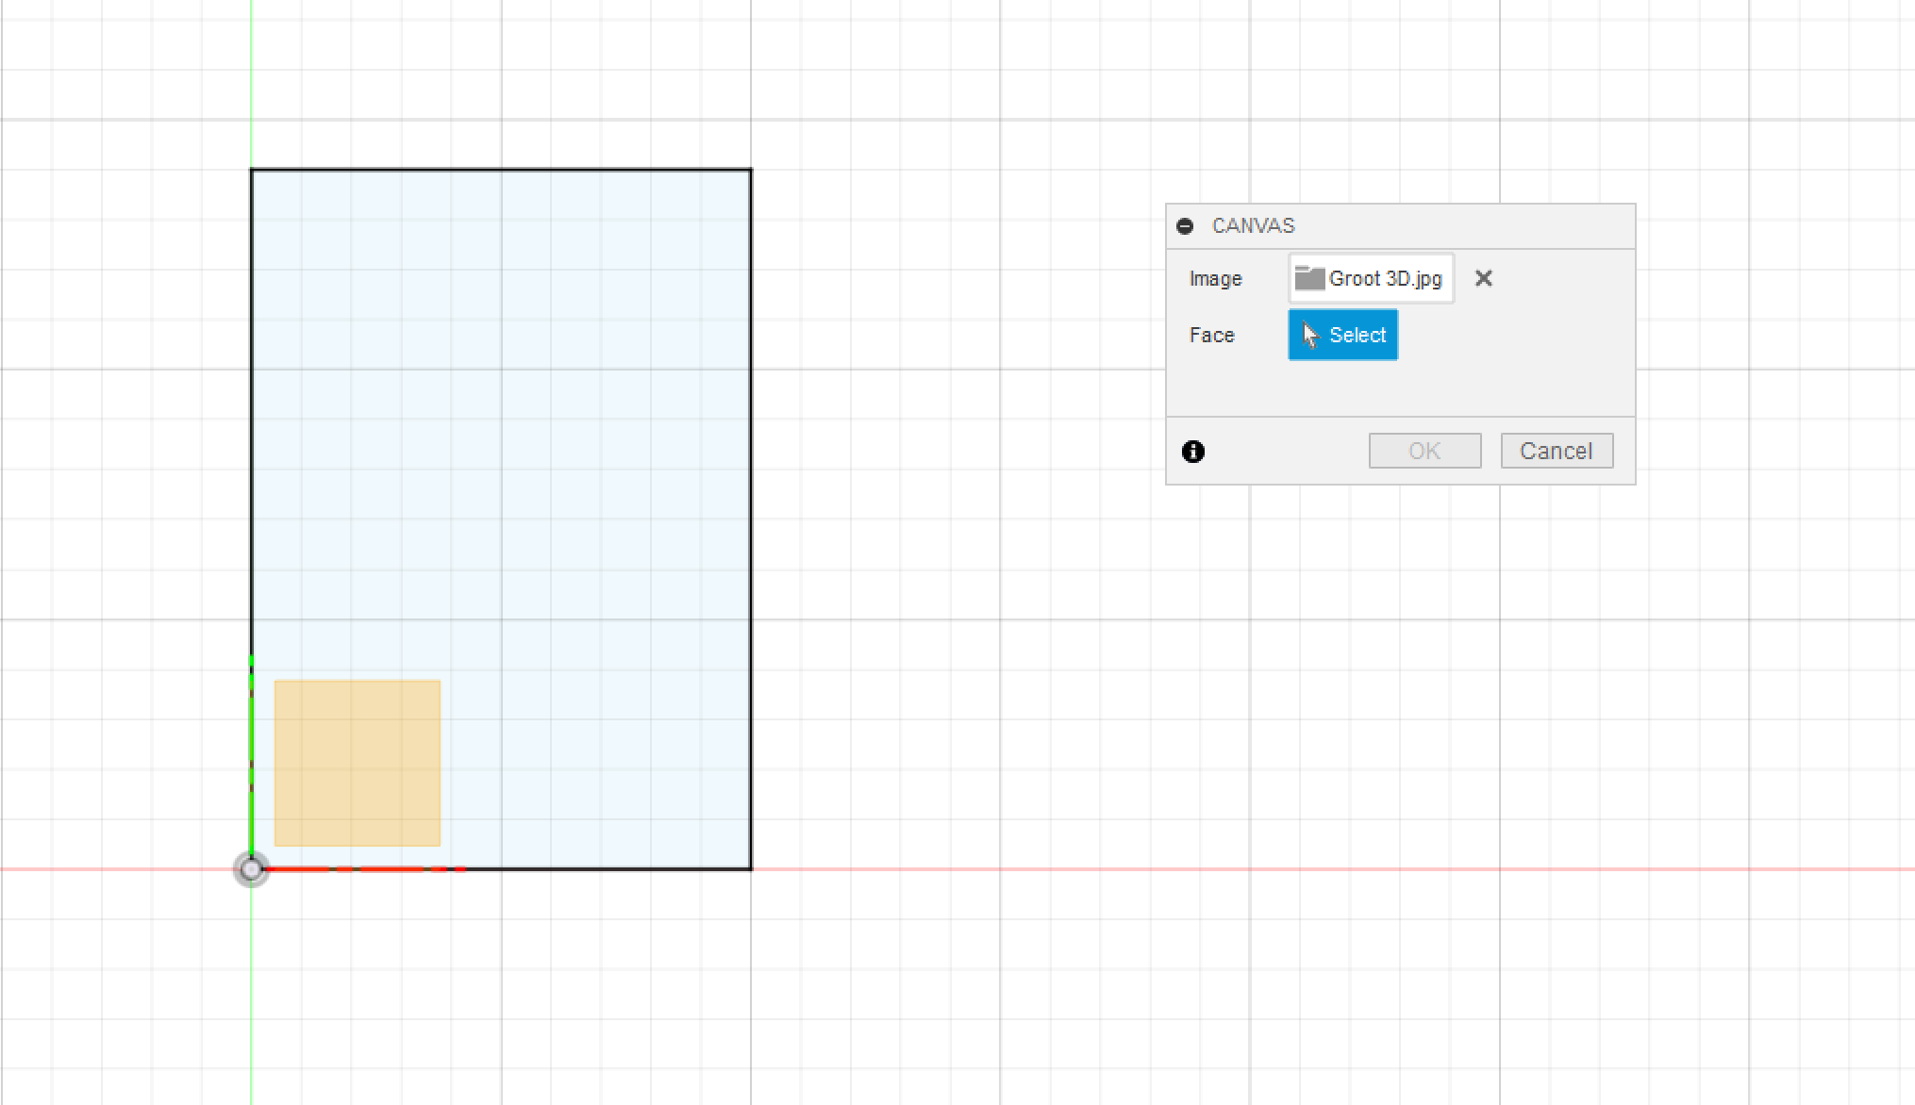

Step 6: Sizing and locating the image.
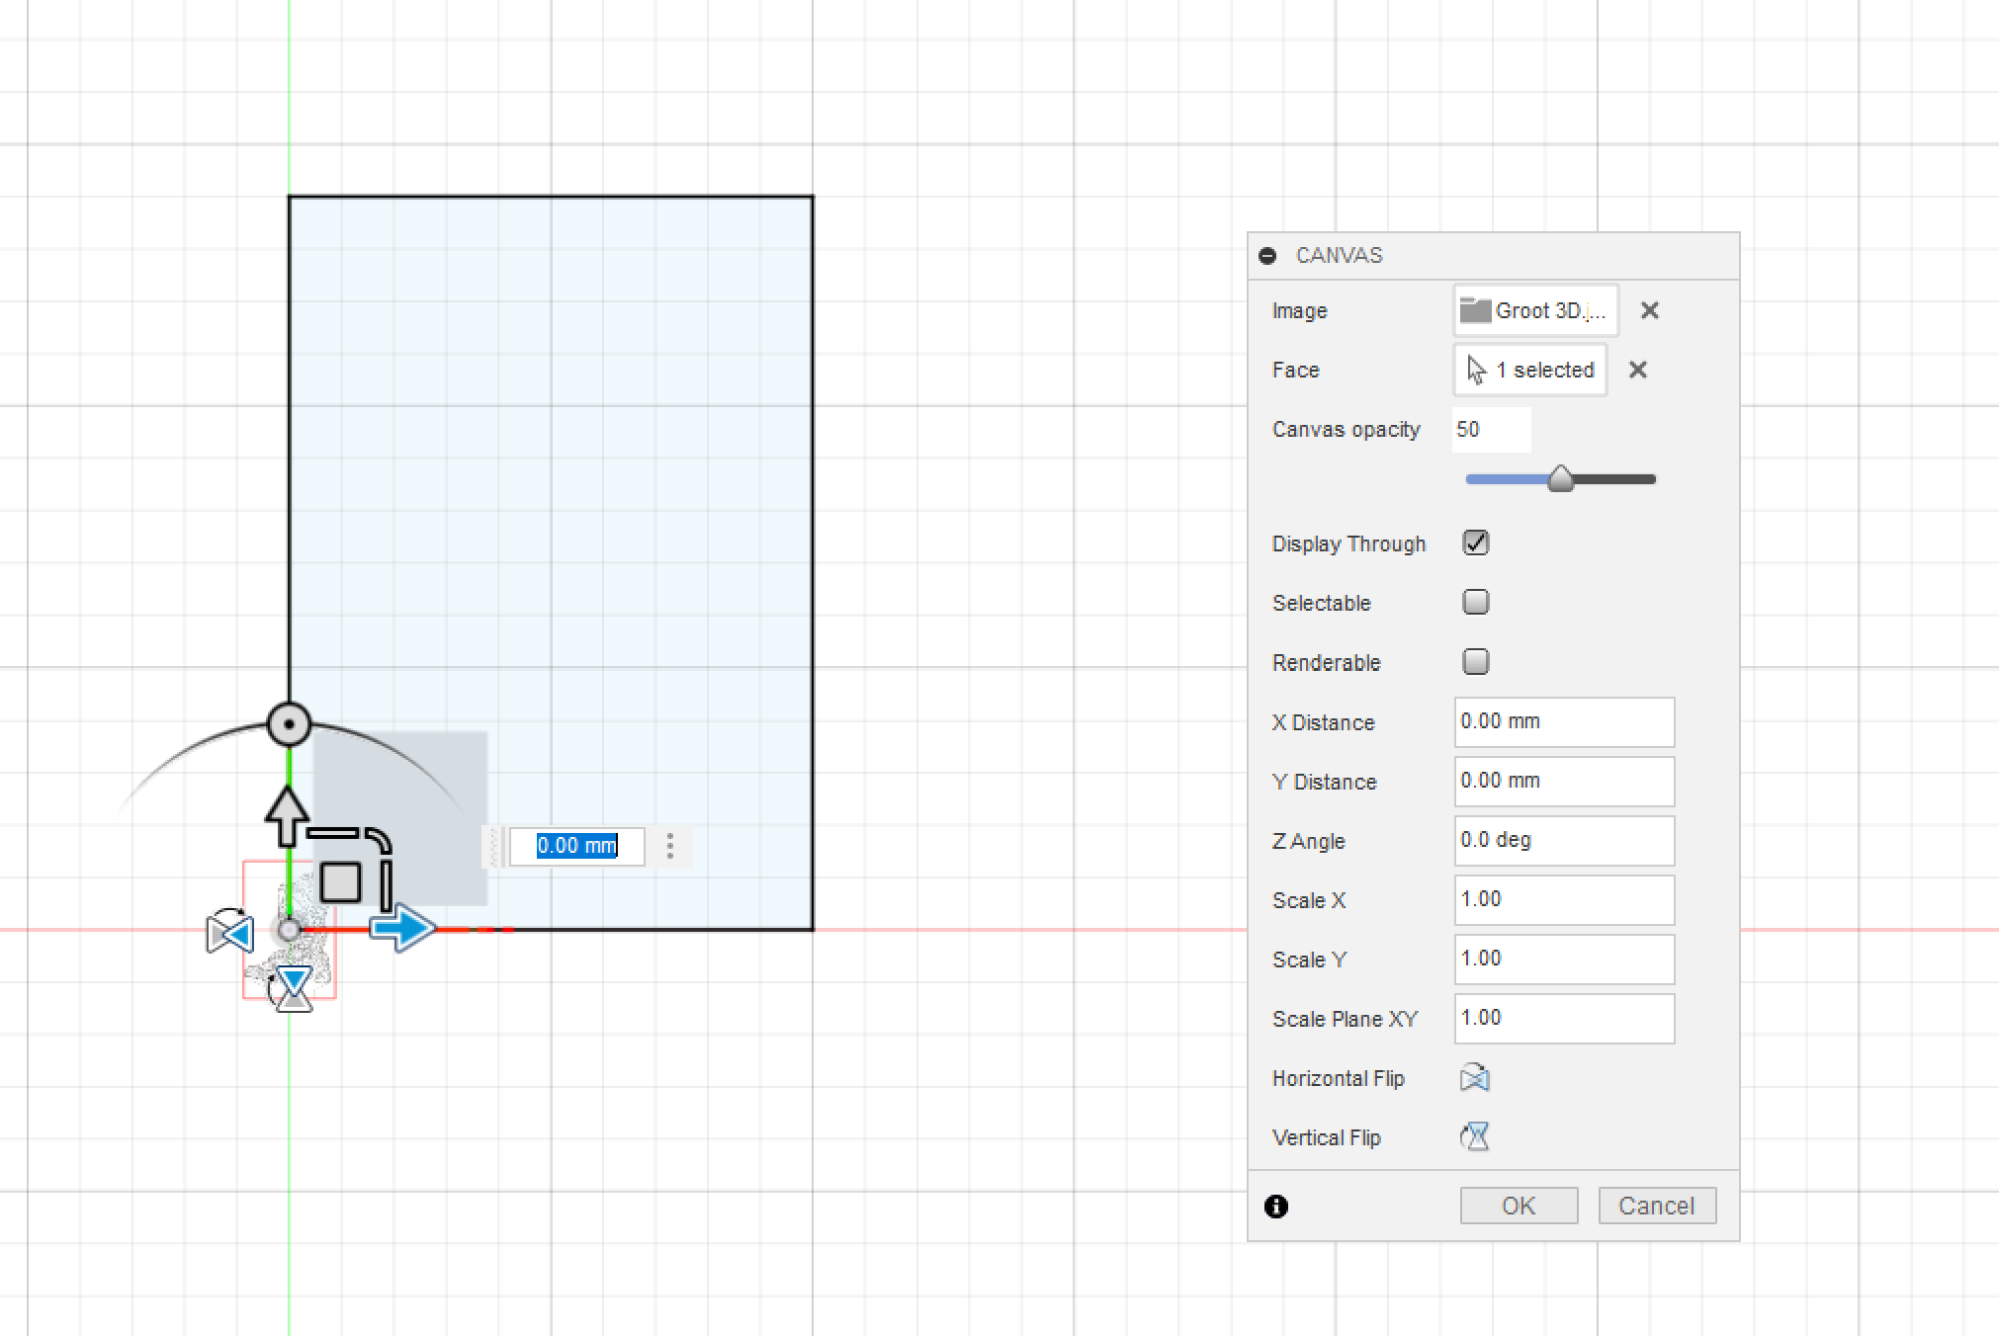
Use the provided handles to drag the image to size and move the image into the 140x100 rectangle
MOVE
SIZE

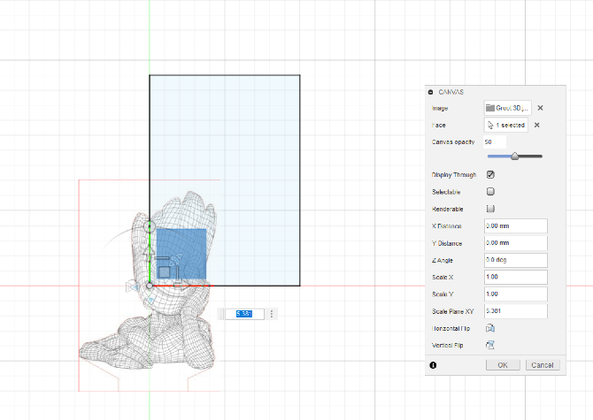

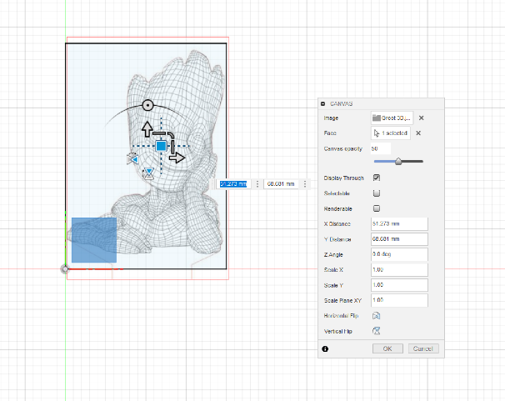
Once the size is set drag the image into the frame and the image is now ready to be used as a guide for our acrylic plastic shape.

Step 7: Creating the Acrylic shape
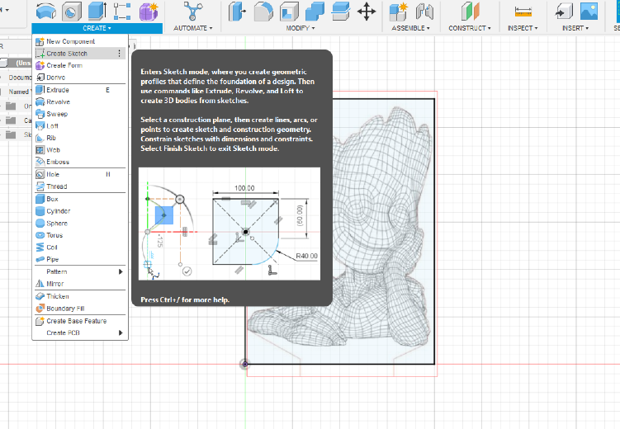
Open the CREATE drop down and select CREATE SKETCH and select the front PLANE again.
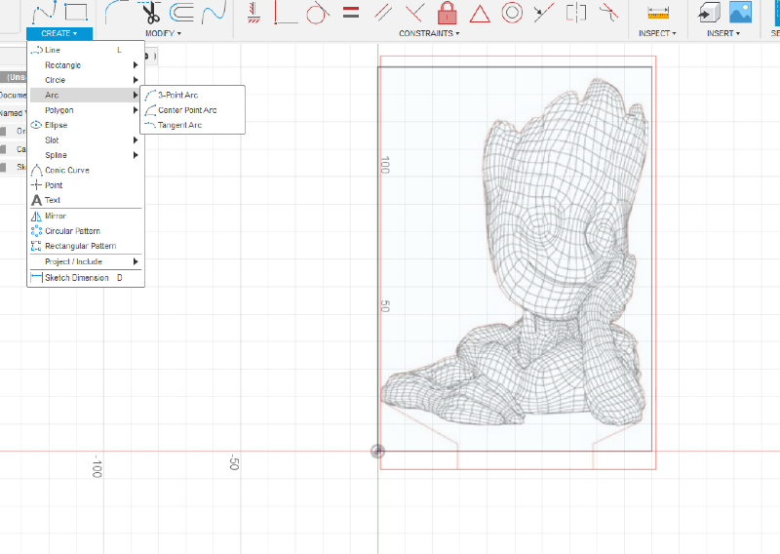
Use the appropriate tools for your design to trace the shape that you have chosen, it can follow the shape closely or be a basic shape. The design is up to you.

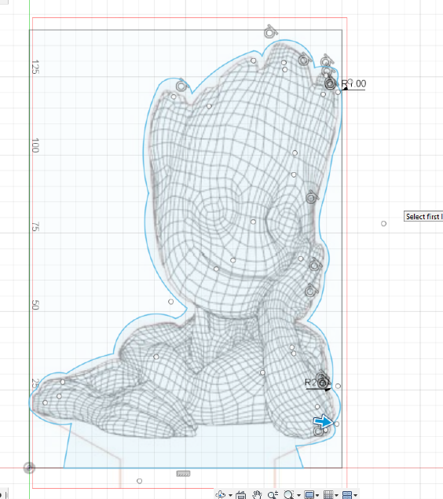
The Groot shape used the ARC Tool and includes the area of the shape which connects to the base.

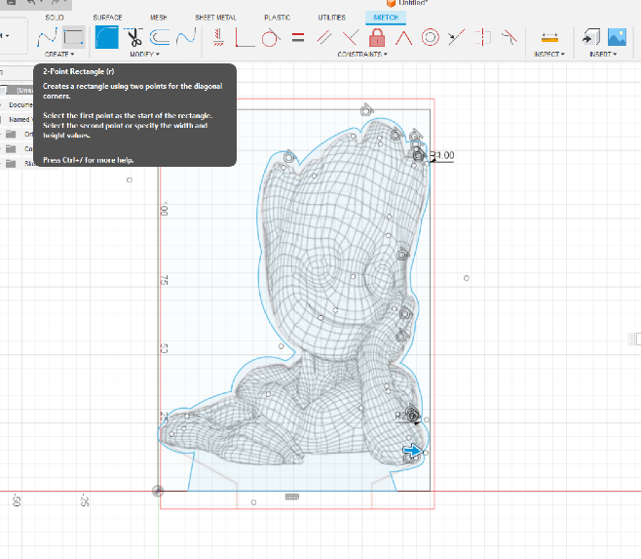
In order for the light to work a connection between the shape and the base containing the light source is required.
To enable this connection 2 rectangles will be drawn.
1x 100mm x 3mm
1x 90mm x 3mm

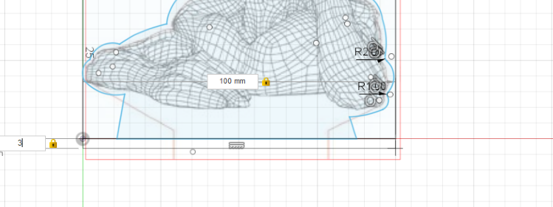
- 100mm x 3mm
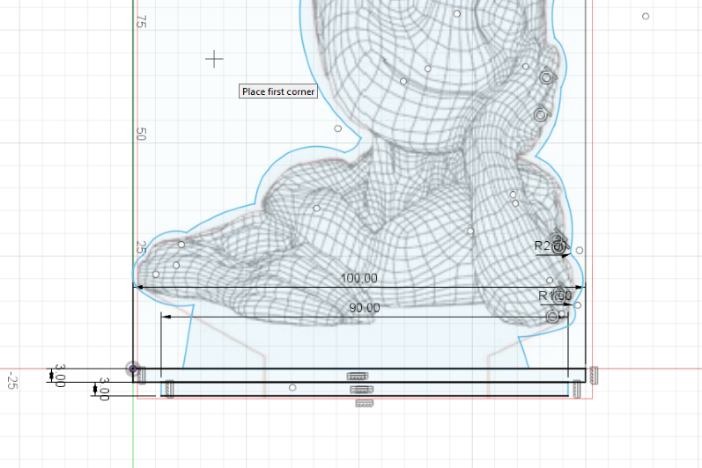
- 90mm x 3mm

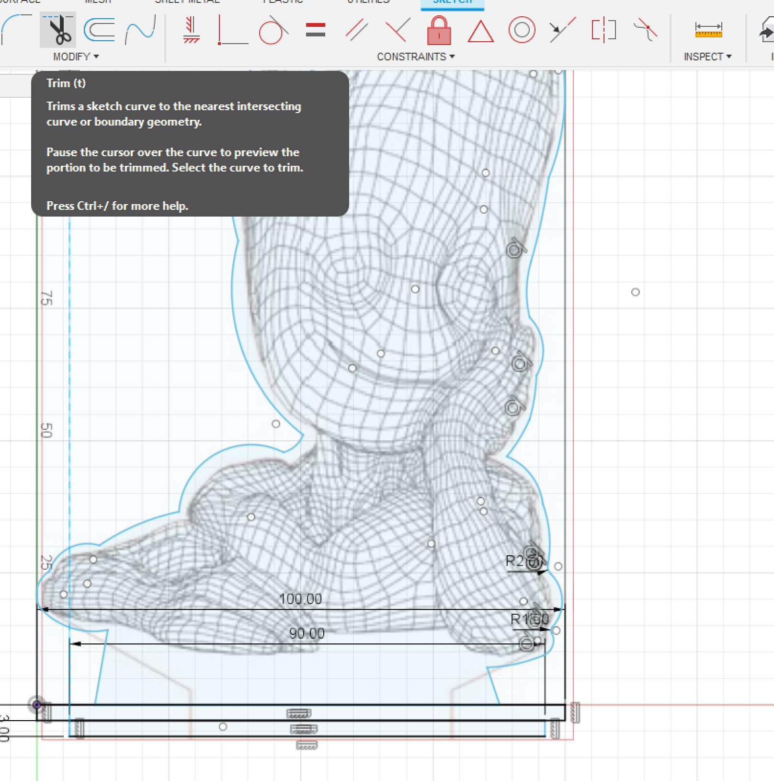Once both rectangles are drawn as shown we need to remove unnecessary lines using the TRIM tool, which looks like a pair of scissors.
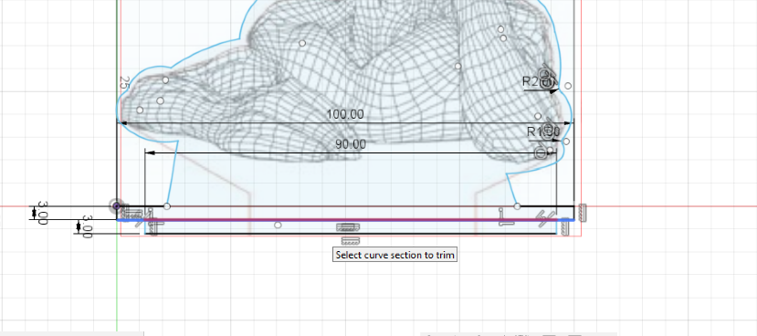
Select the tool and click on the lines shown to remove them from the drawing.
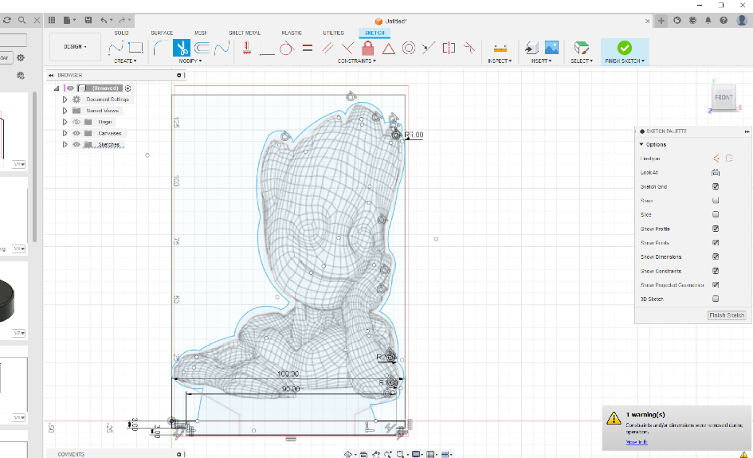
Your shape is now complete. To finish this section we will remove the first SKETCH which we used to place our image canvas.

Step 8 Remove the original 140mm x 100mm Rectangle.
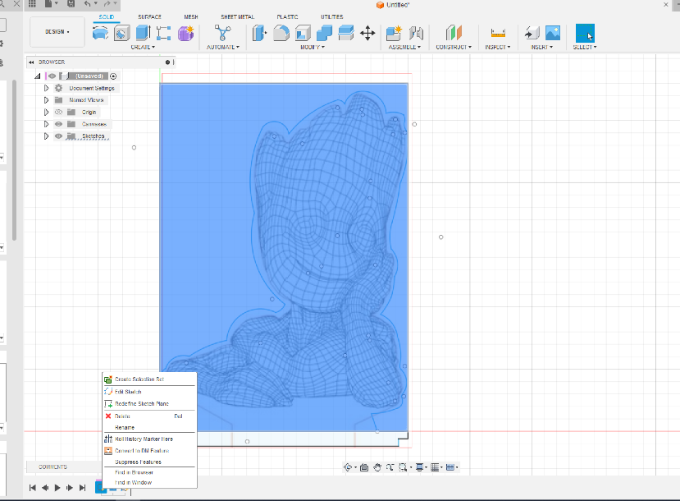
Right Click on the first SKETCH icon in the history bar at the bottom of our drawing and DELETE the SKETCH

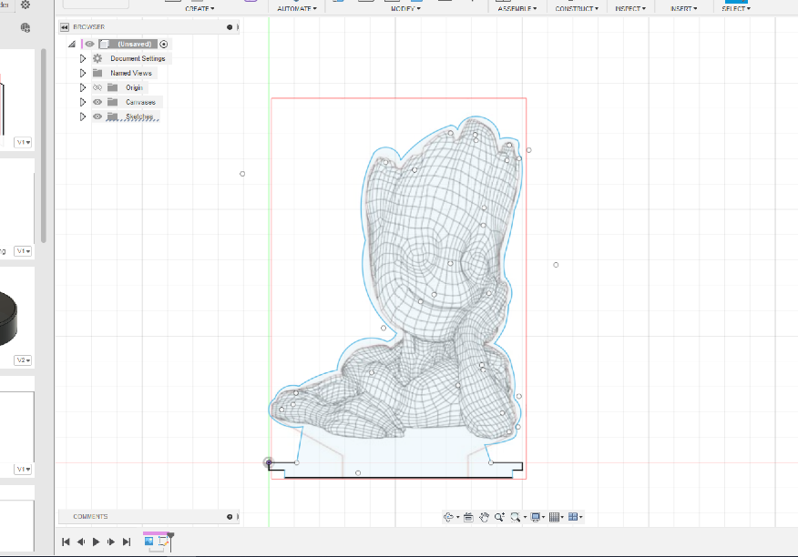
Congratulations, you have now completed the 2D sketch for your acrylic shape.

Step 9: Extrude and create a .DXF file for the laser cutter.
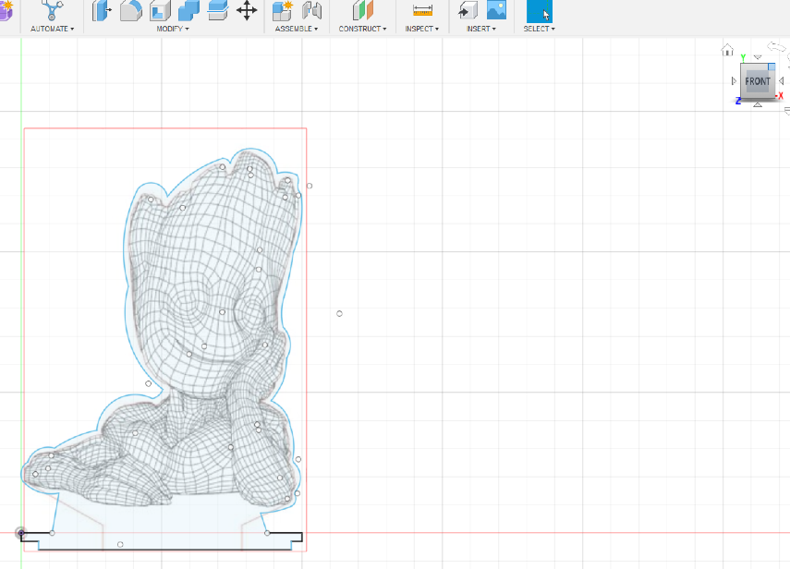

Click on the corner of the NAVIGATION cube to turn the image. This will make it easier to extrude the shape.

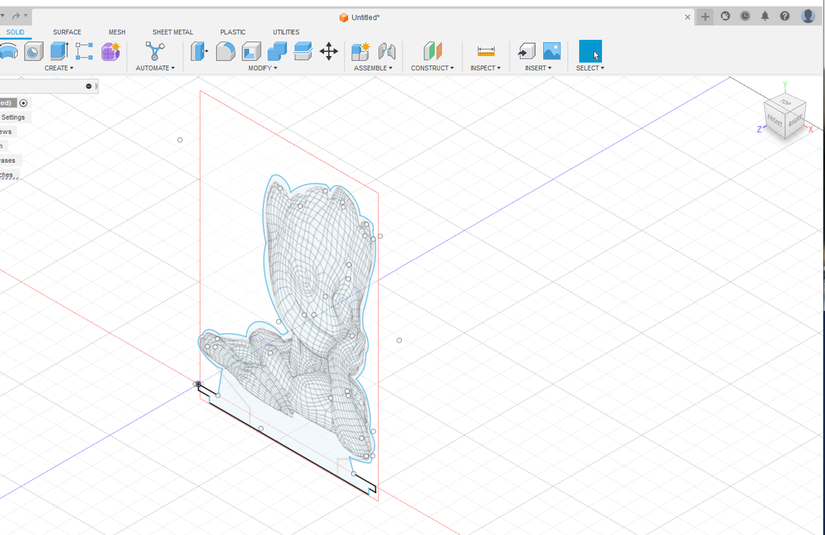
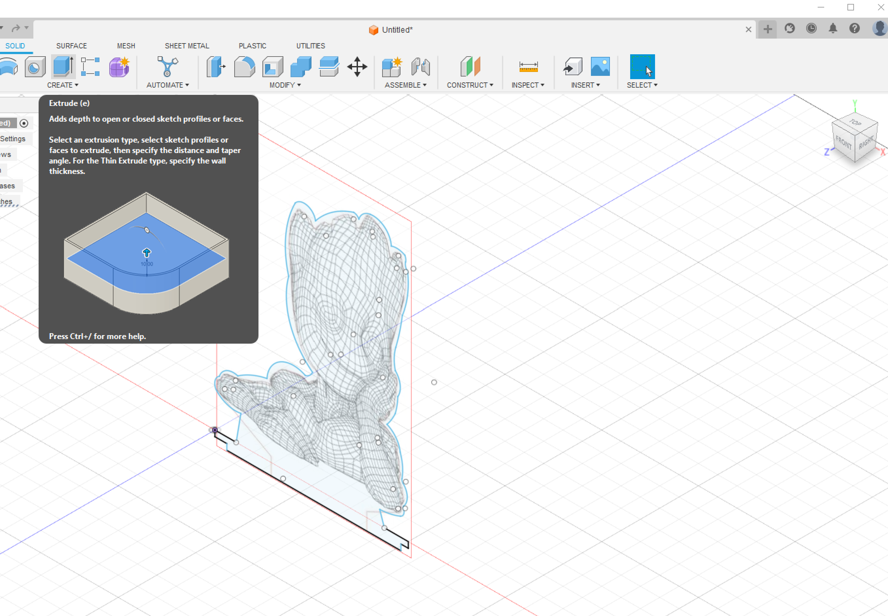

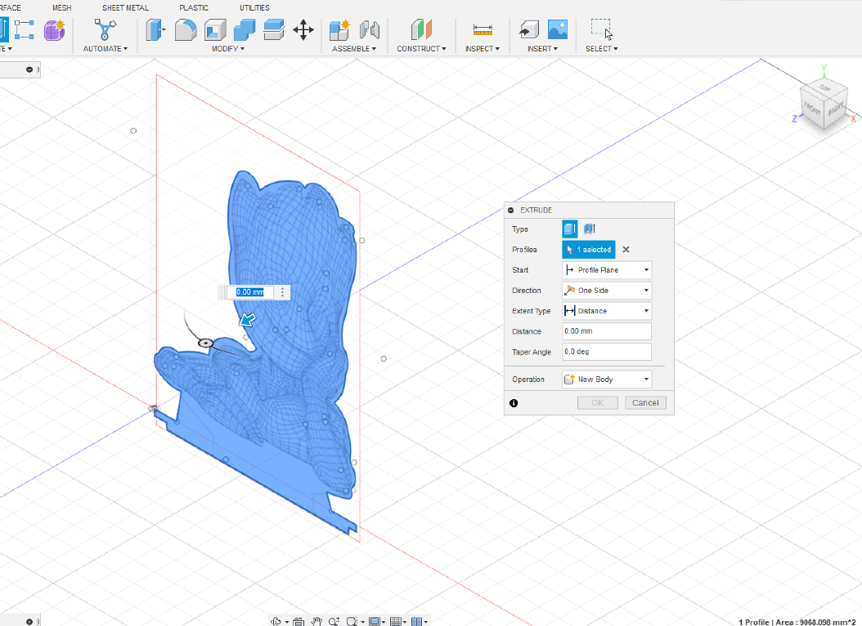
When the EXTRUDE tool is selected you will see the EXTRUDE options appear.
Type 3mm into the box and click OK the shape will now become a 3D object.
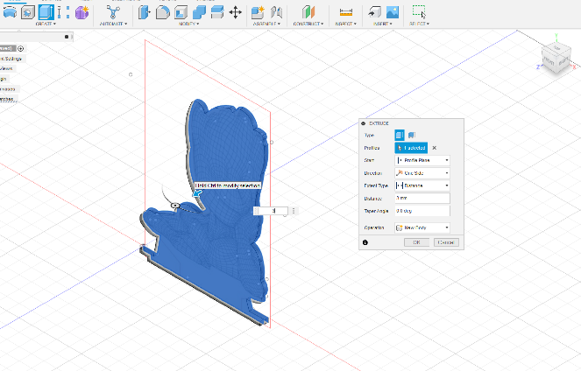

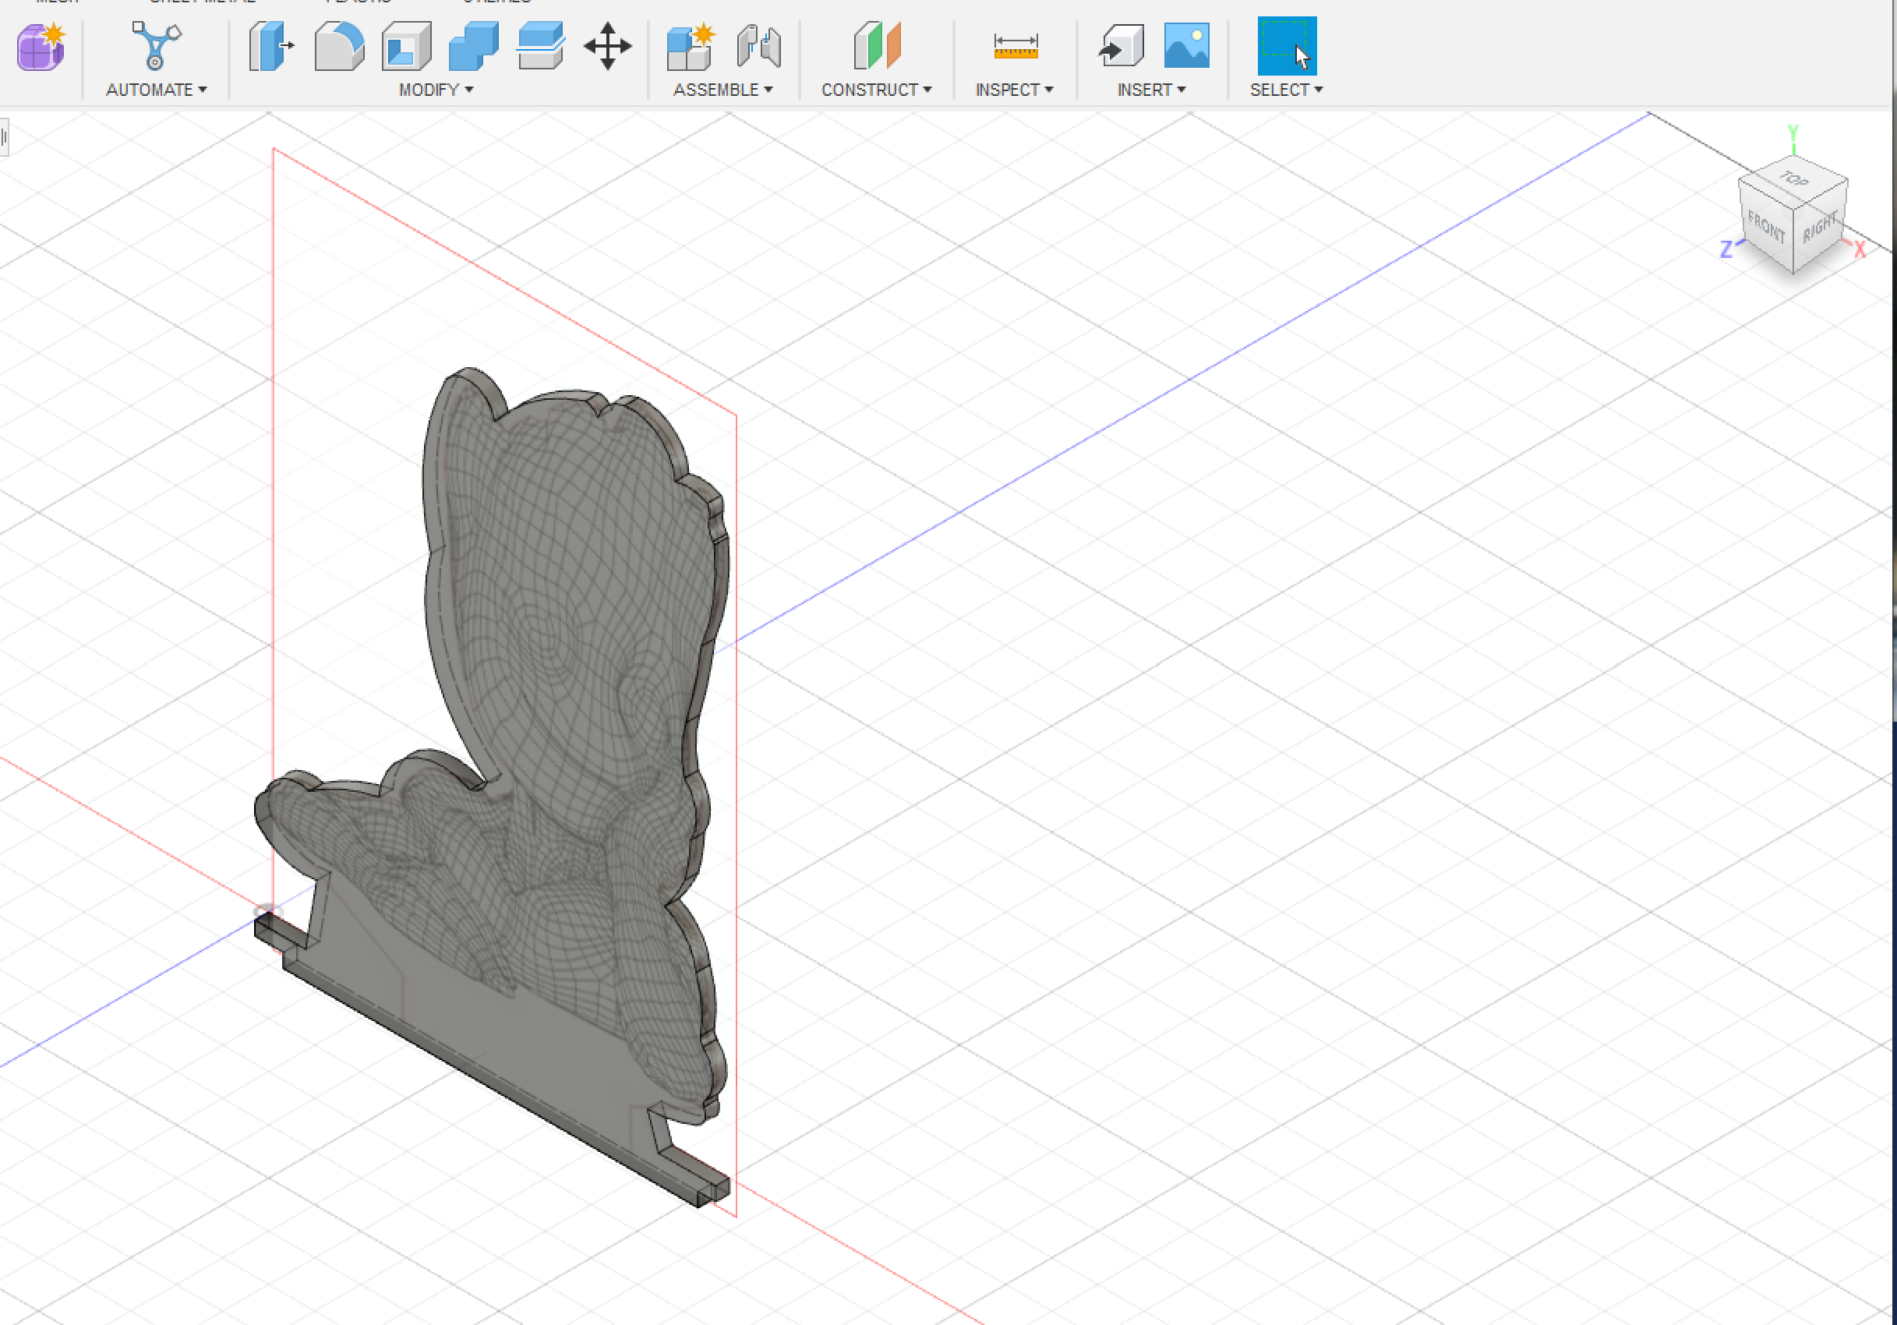

Step 10: Saving, Drawing and Exporting the .DXF File.
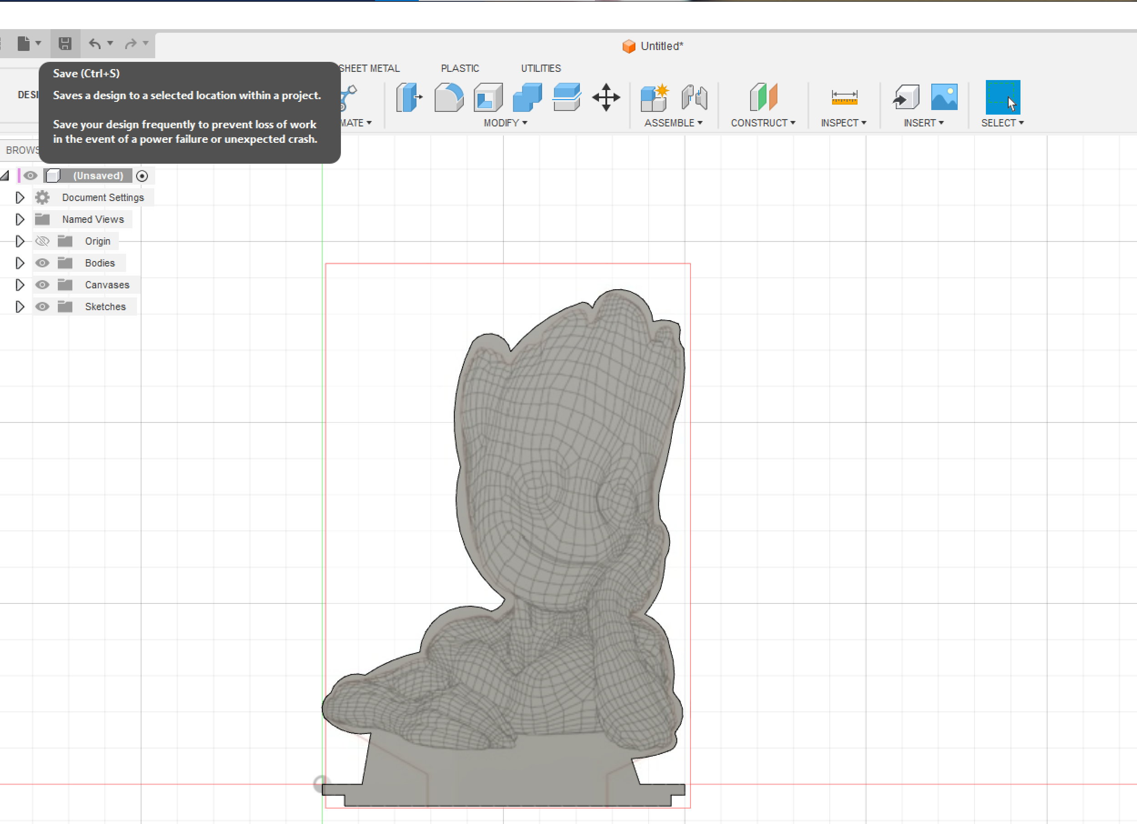

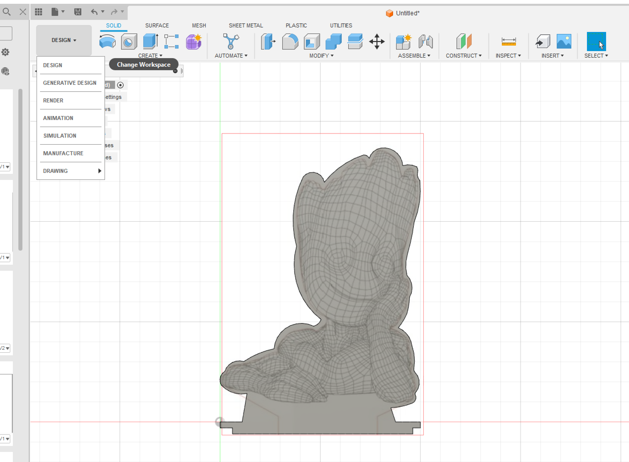

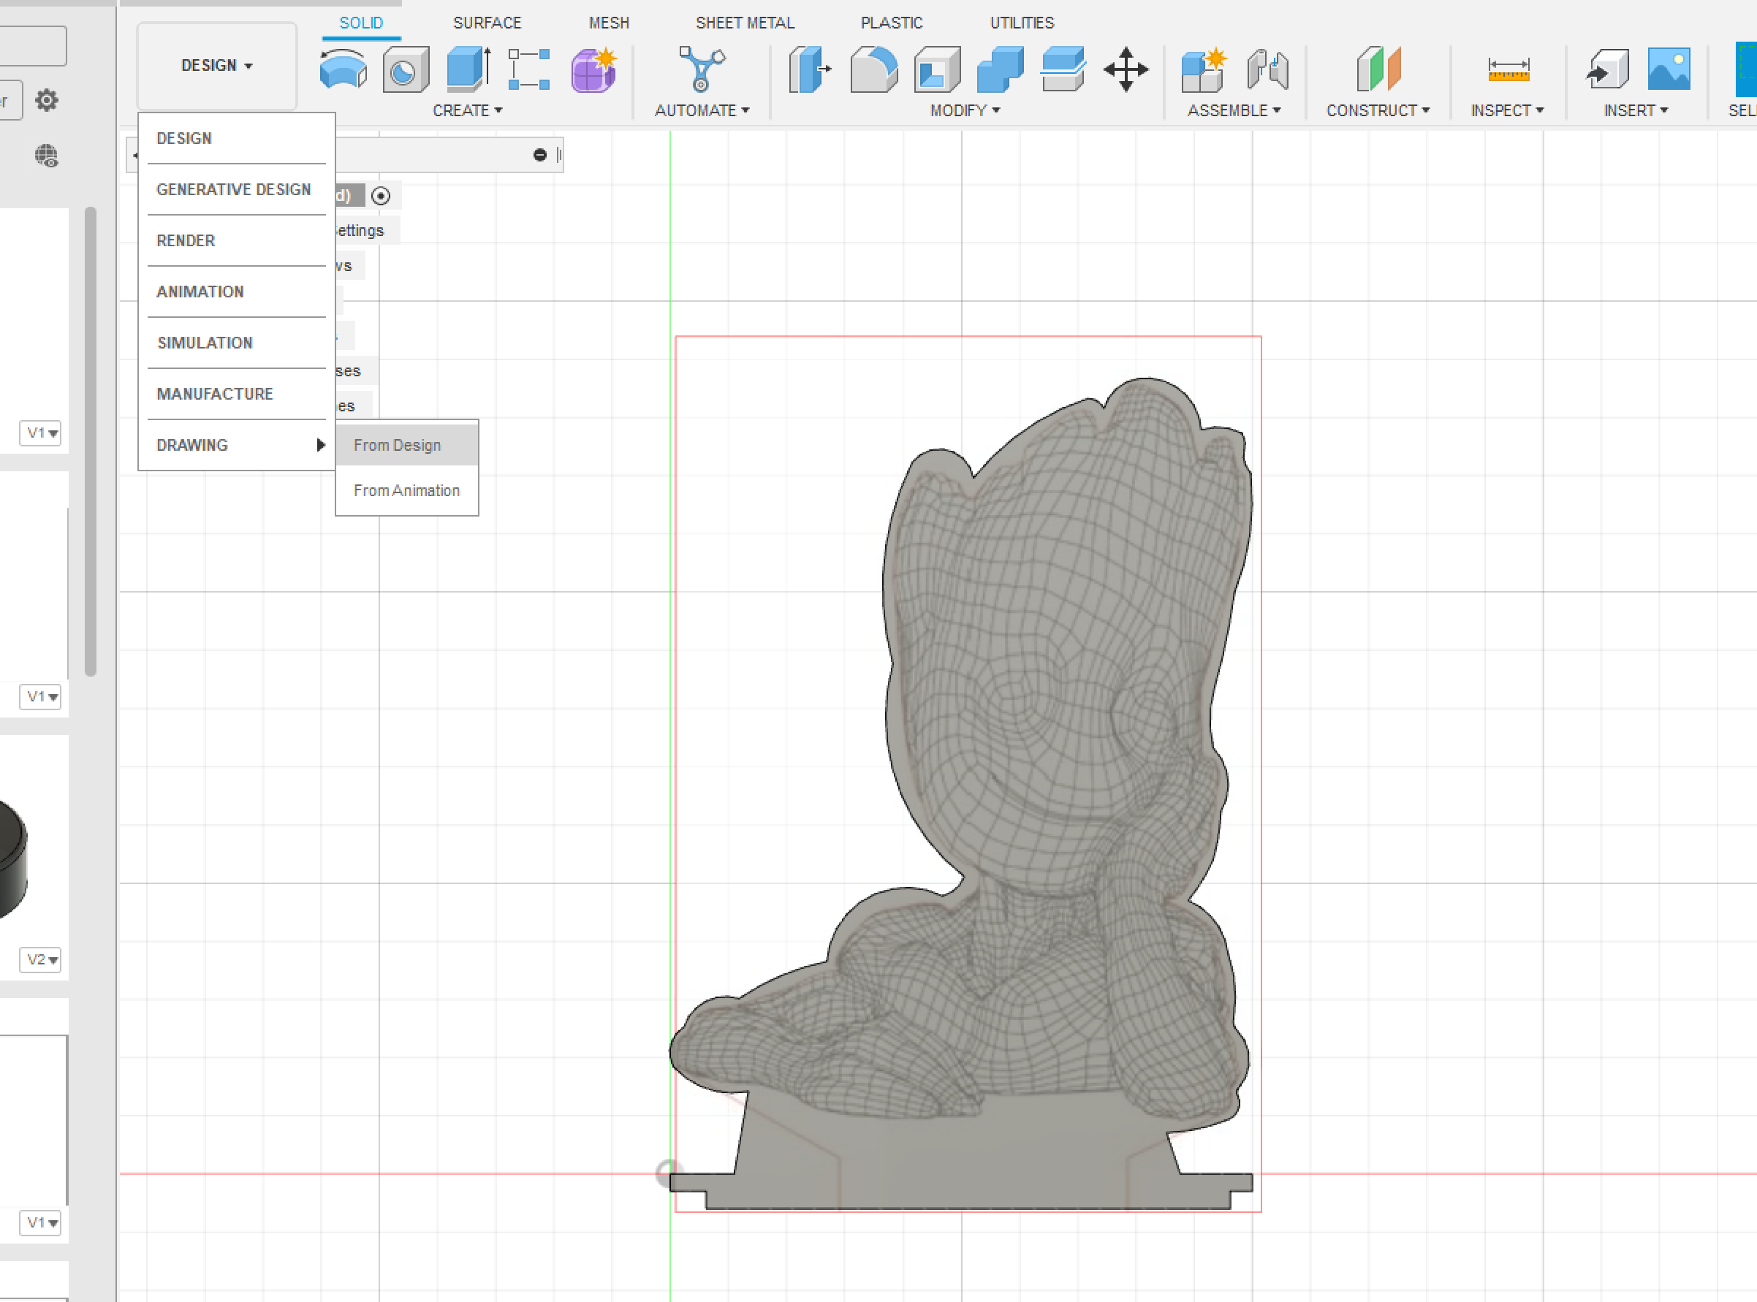
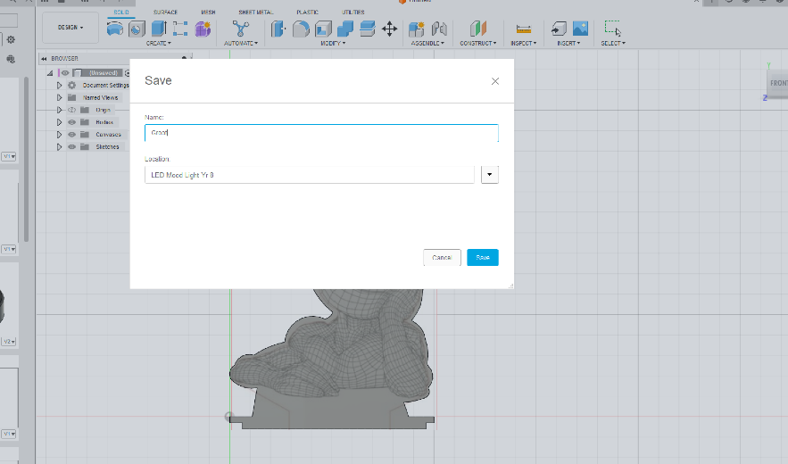
Ensure that you SAVE your work using a descriptive name….DO NOT CALL IT A THING !!!
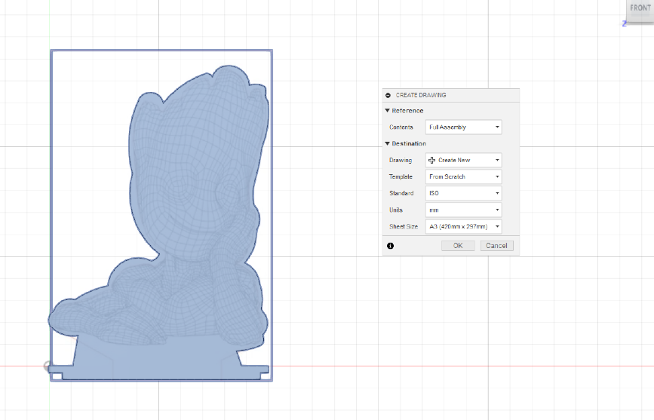
The DRAWING options box will appear, just select OK

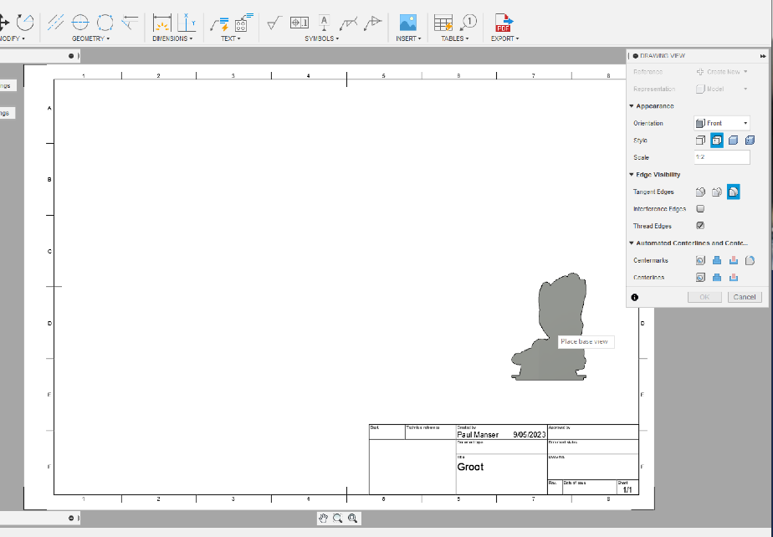
SCALE your work by typing 1:1 in the SCALE section and click OK
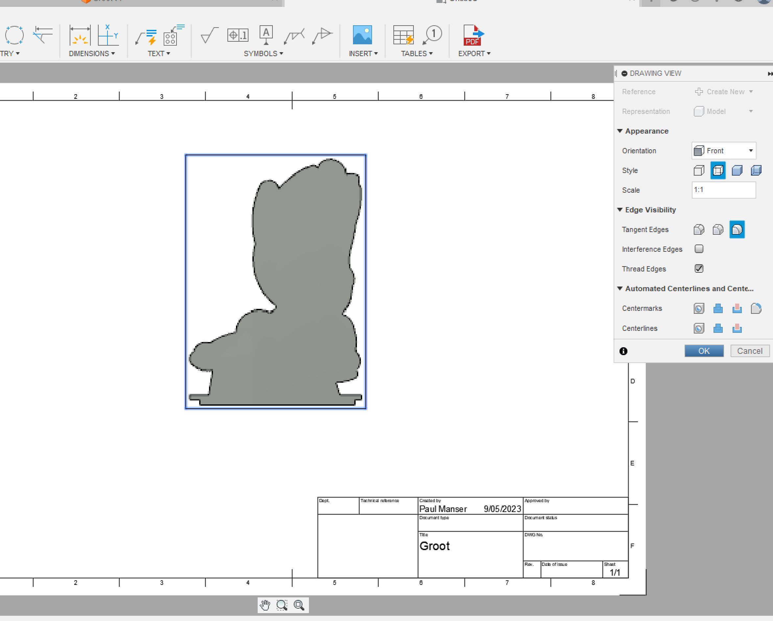

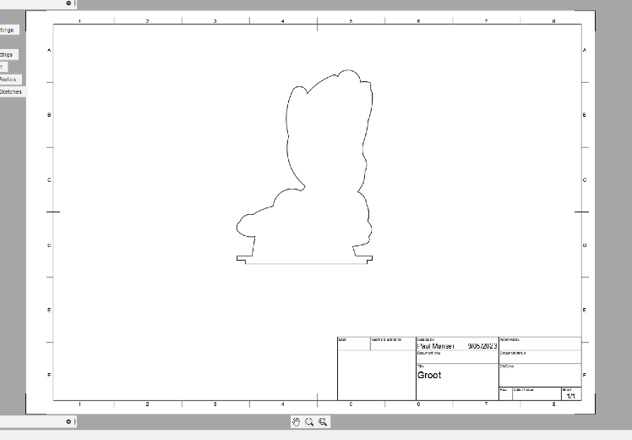
The DRAWING sheet will show an outline of the shape you have drawn. We now need to delete everything on the sheet except the shape.

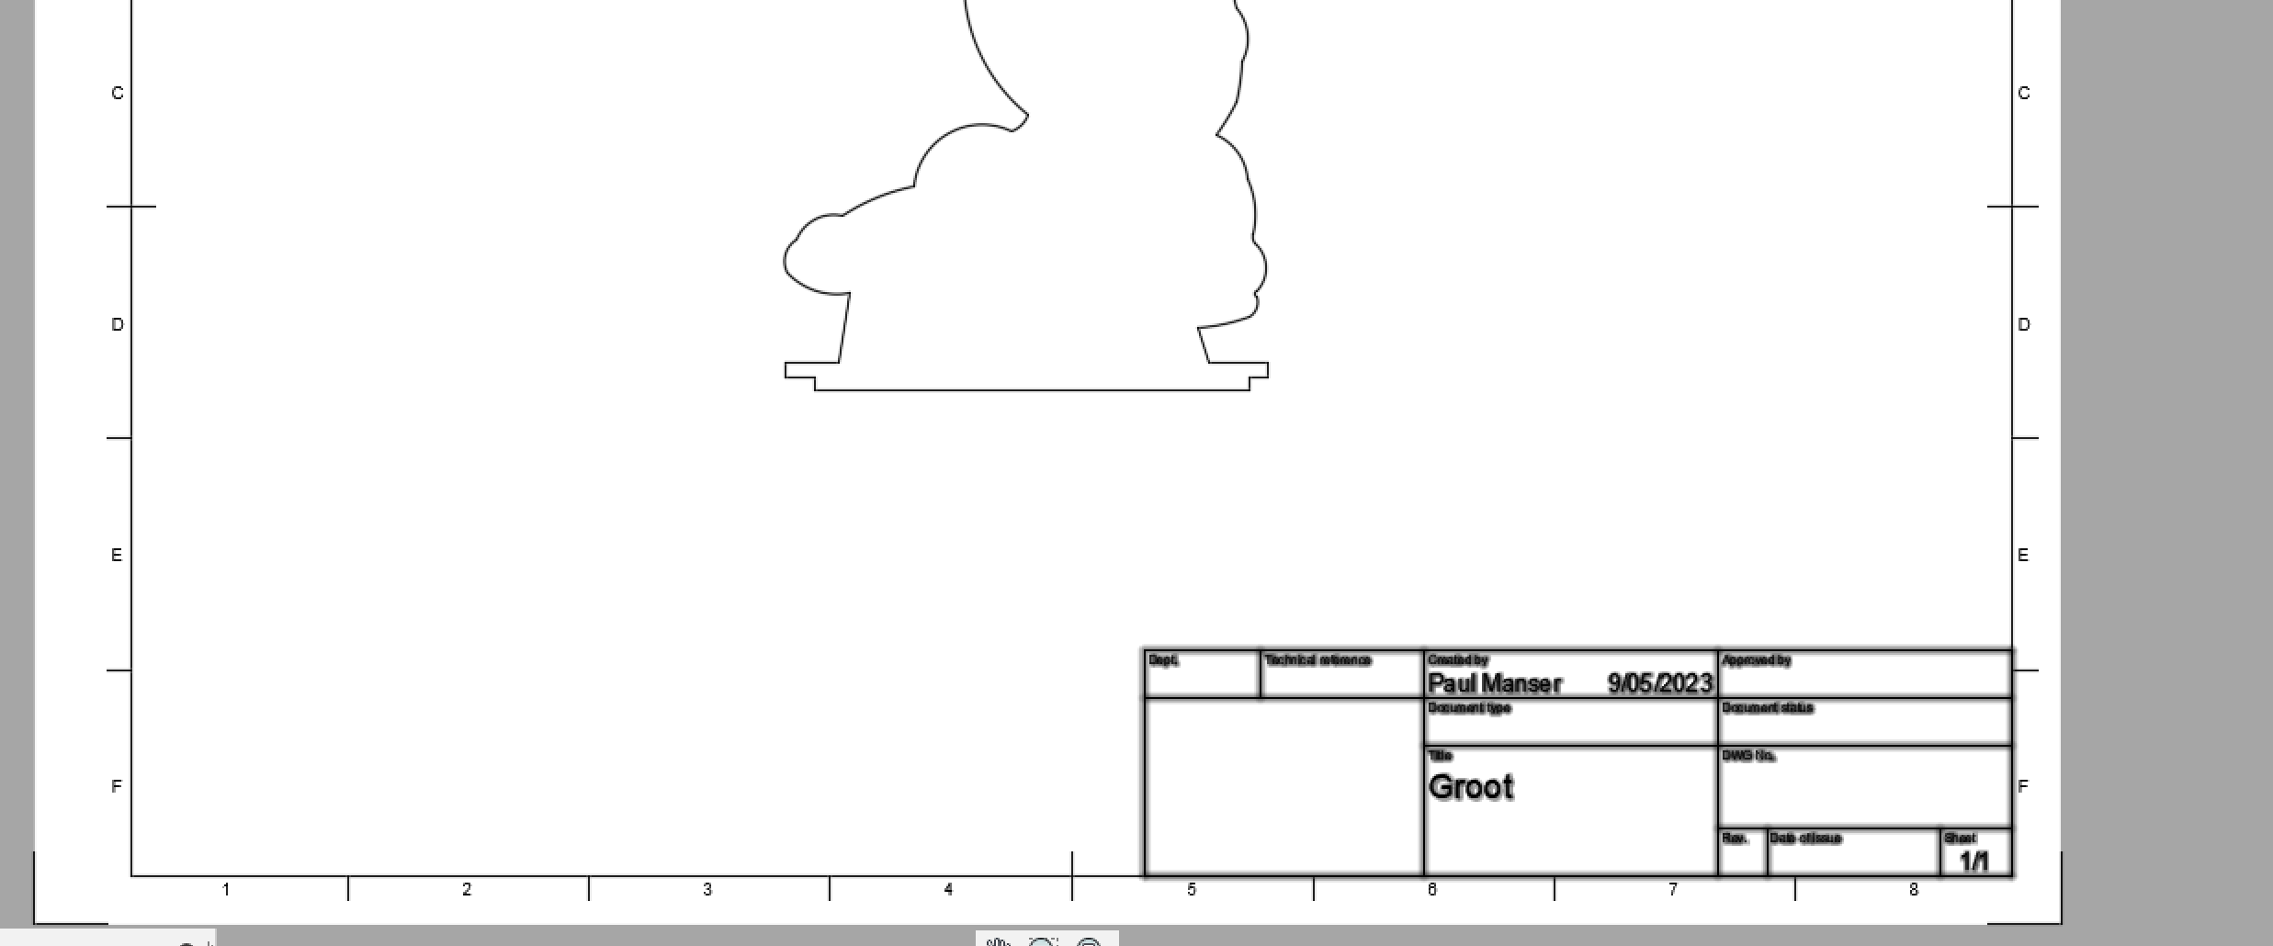 Click and use the DELETE command to remove the TEXT box and BORDER
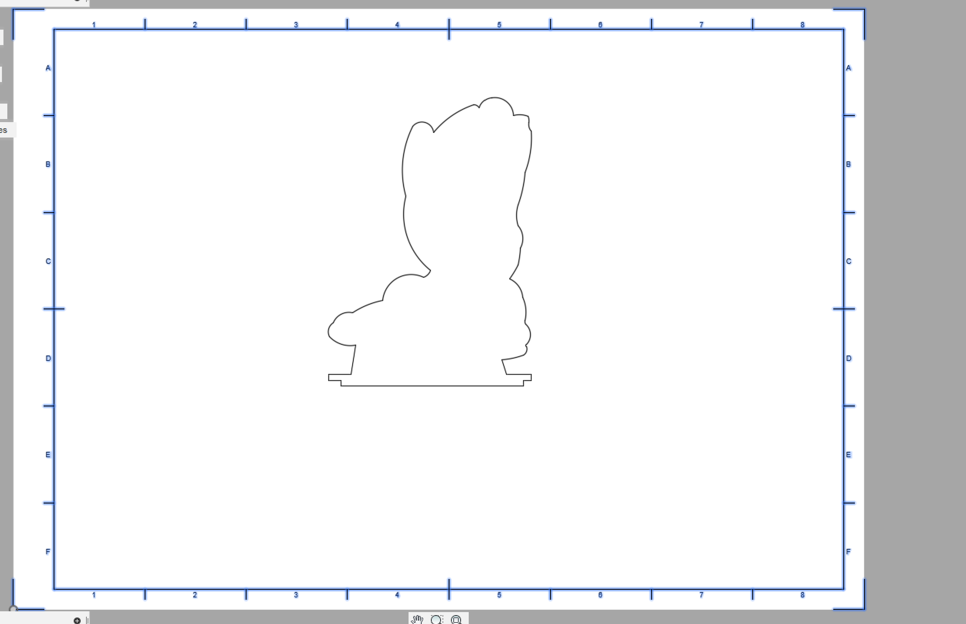
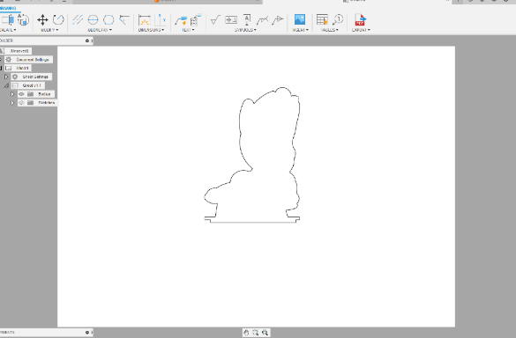
Open the EXPORT tab and choose the .DXF file.
SAVE the file into your U Drive and Email it to the teacher with your image ready for the laser cutter.

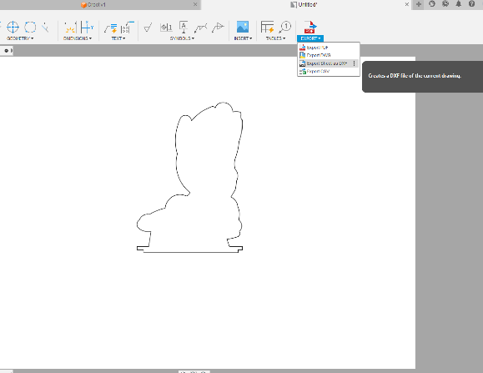
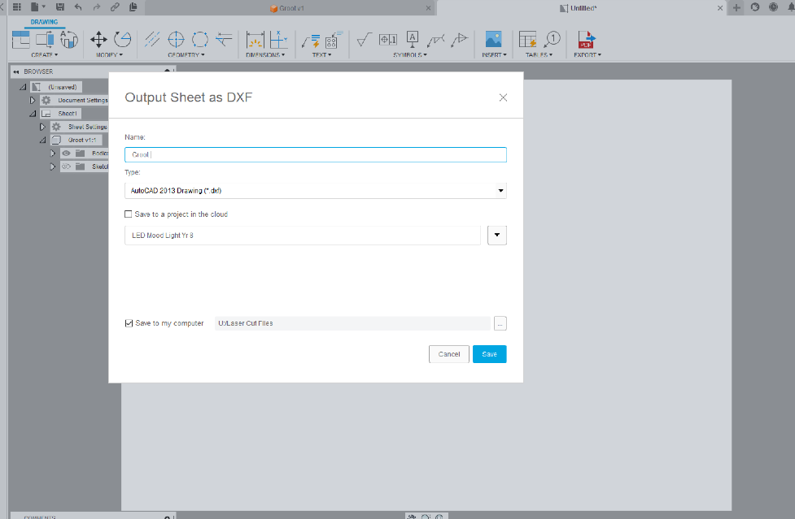

Your task is now complete.

