DESIGN & TECHNOLOGY
Mood Light Project

Year 8 Systems /Materials
Task
This project combines the use of traditional materials and techniques with contemporary design and production methods.
In this task you will design and produce an acrylic plastic mood light design which will then be mounted to a polished timber base containing some electronic components that will light the acrylic shape from underneath.
The following steps are required to achieve the finished product.
- Sketch 3 possible design ideas for the acrylic plastic section of the mood light.
- Manufacture the base from a piece of radiata pine 30 x 30mm x 120mm long.
- Laser cut the 3mm wide slot required for your acrylic light.
- Assemble the electronic components (LED strip, battery holder, switch)
- Fit electronics to base.
- Laser cut acrylic shape to match the base and slot for light transmission.
- Fit together and test.
- Evaluate your design.
Computer programs that can be used to create your design include Adobe Illustrator, Inventor and Fusion
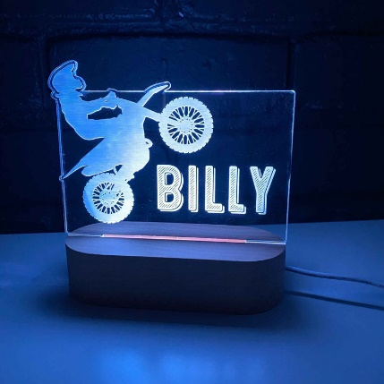
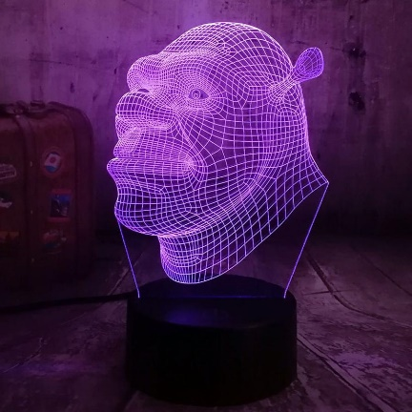
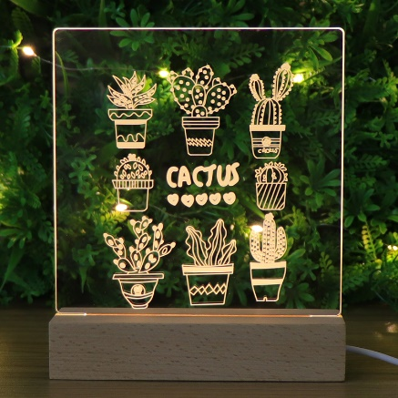

Project timeline : 3 weeks or 6 double lessons.

Materials Required
Base - 30x30mm Radiata Pine approx. 120-140mm long
Design - Clear acrylic 140x120mm
Circuit - 9v Battery snap (you will supply a 9v battery)
Toggle Switch
LED light strip
Red / Black wire
The Lighting Circuit
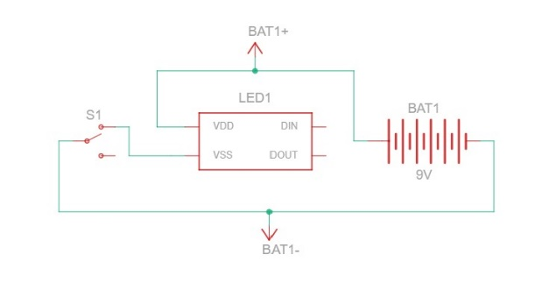
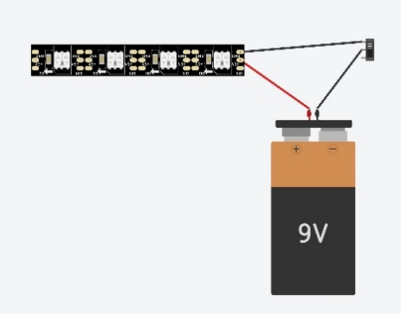
Circuit schematic diagram
Circuit Components Picture

Steps
- Design a shape for your light using Fusion 360 or Inventor that meets the specifications required.
- Save a copy of this shape as a .dxf file.
- Remember to include a 90mm x 10mm tab at the bottom of the design.
- Import your shape into Illustrator as a PDF using the export PDF function in Fusion.
- Once you have your shape use Adobe illustrator to create your picture and text
- Send your finished design to the Laser cutter.
- Hollow out a square opening using the mortising machine as per the teacher’s demonstration and finish with a sharp chisel.
- Drill a 6mm hole in the base to accommodate the toggle switch.
- Laser cut a slot in the top of the block 90mm x 3mm to accept the acrylic
- Use a soldering iron to join the circuit components as per the diagram.
- Test your circuit.
- Assemble
- Create a base for your mood light to sit on or in.
- Evaluate your Design

