**DESIGN & TECHNOLOGY**

**YEAR 10 BLUETOOTH SPEAKER DESIGN PROJECT**

**Learning Intention**

This task is designed to develop an understanding of product design which utilises electronic componentry to meet a desired outcome. The designed product will maximise the quality of sound and user experience through the application of design thinking.

**Task**

Design and make a speaker enclosure which will suit the componentry provided. This enclosure will allow the user to use the speaker and enhance the sound produced by the speakers used.

You will be supplied with the following components:

1 x Bluetooth enabled amplifier board with 2x 5W output.

2 x 5W 8Ω Speakers

These components will allow you to create a working Bluetooth speaker that will link with a mobile device.

Improvements can be made to the speaker by adding better quality speakers and circuitry which can provide extra functionality at your cost.

On completion and testing of your speaker you will complete an evaluation of the completed product.

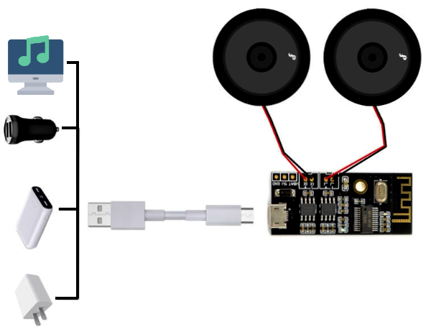**TASK STEPS**

1. Understand the componentry available and how these will impact your design and intended use.
2. Use the Design Process Document to record your design thinking and planning.
3. Utilise the tools and equipment available in the workshop to create a suitable solution.
4. Test your design.
5. Evaluate the finished product.

*\*All required documents are available on Haiku and Teams.*