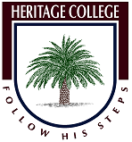
HERITAGE COLLEGE DESIGN & TECHNOLOGY
LASER CUTTERS – THE BASICS

What is a laser cutter?
A laser cutter is essentially a powerful laser beam that is produced inside a machine. It consists of a sequence of mirrors which direct the laser beam onto the material to be cut. As the laser beam strikes the material it cuts it by using an intense heat which vaporises the material, leaving a polished face. Then motors move the mirrors to adjust the cutting position while the laser supply remains stationary. This maximises movement speed and enables the laser cutter to cut straight lines and smooth contours. The power setting can also be reduced so that the laser beam doesn’t cut completely through the material, enabling engraving. Laser cutting is suitable for cutting plastics, woods, paper, card, cork, foam board, fabric and many other materials. Laser cutting can also be done on metal and glass but a more expensive laser is needed for these materials.
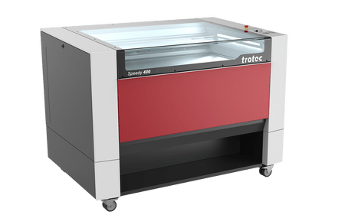
- What laser cutter does the school have?
- Heritage Adelaide’s laser cutter is from Trotec. Click here to view the Trotec laser systems website
- How can I create my design on the laser cutter?
- In order to cut or engrave a design on the laser cutter it must first be drawn on a vectored based software program such as Corel draw or illustrator. The design needs to be drawn as a vector file.

What is a vector file?
There are two basic types of graphic files: Images and Vectors. Images are constructed from a series of pixels, or tiny squares. Vector images however have no pixels. They are displayed or printed by using mathematical positioning. A vector image breaks down into a mathematical formula and contains messages like, draw a rectangle, this size and at this place on the page. A vector image looks like an illustration. Vector files are usually considerably smaller than an image file of the same image, since there is less information required to achieve the same results.

How does a vector file get printed on the laser cutter?
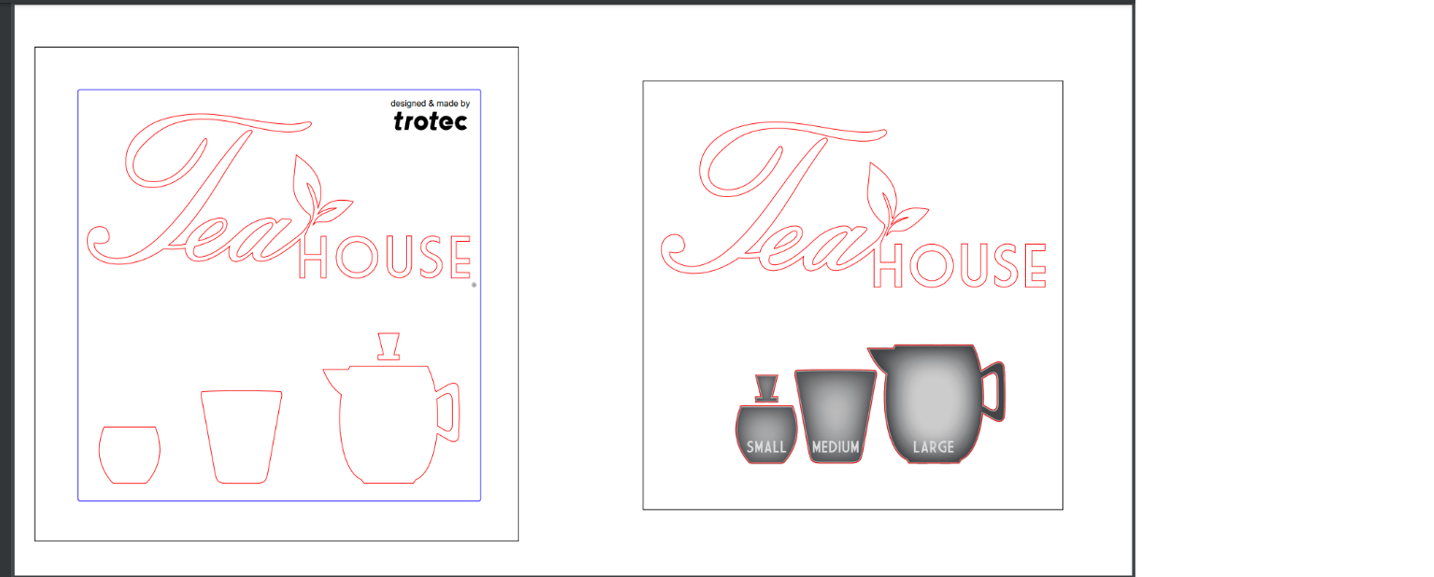
Once a vectored design has been made in Adobe Illustrator you can print it to the laser printer by simply pressing print. You will then need to choose your laser settings. These setting determine how much power you need to use to cut though the material and these setting are taken from the machines material power settings table. The right setting is essential as if the power is too low it will not cut through the material. If the power is too high it will then cut though the bed of the laser cutter. Once the settings are correct you press print. The vectored points are converted by the laser cutter into printing points and the file is cut out of the required material.

Questions
1). The laser cutter is essentially what?
2.) How is the laser beam directed to the material?
3.) How does the laser cutter cut material?
4.) What do you change on the laser cutter to make it engrave or cut?
5.) What materials are suitable for the laser cutter?
6.) How can you create your design on the laser cutter?
7.) What is a vector file?
8.) How does a vector file get printed on the laser cutter?

