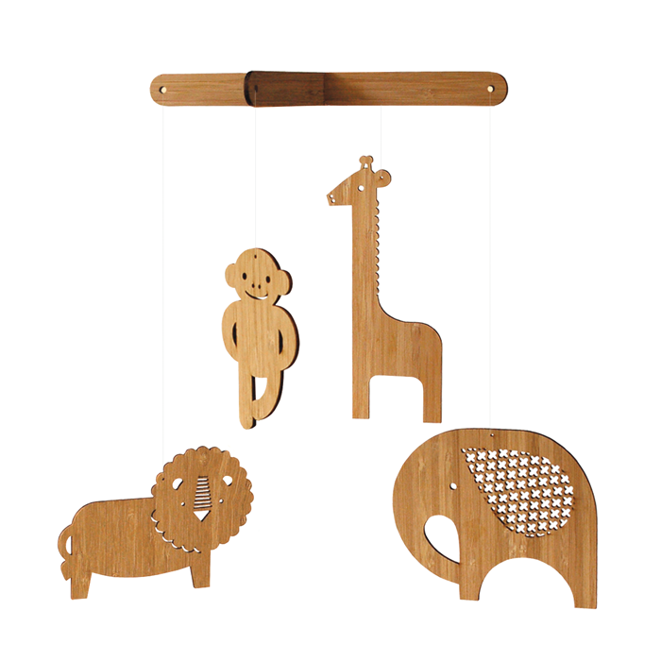
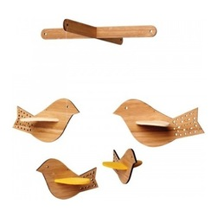

YEAR 9 Design and Technology
Systems and Control Products
Heritage College Adelaide
Contemporary Design & Fabrication

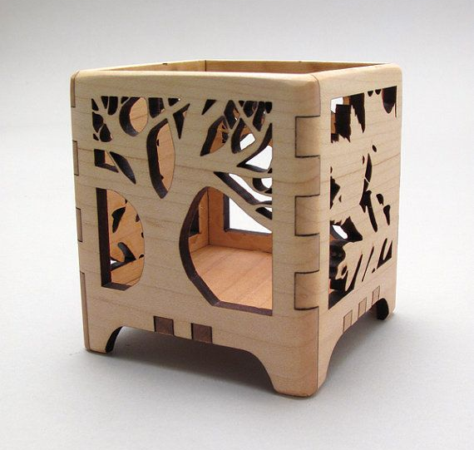
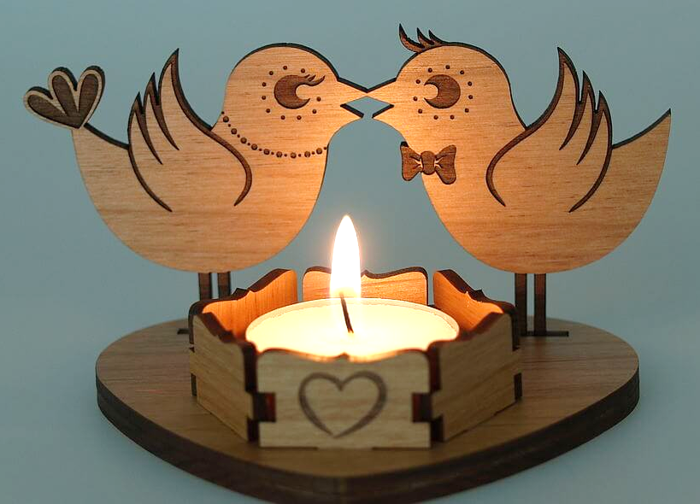

TASK:
You are to produce either a laser cut Decorative LED lamp or Decorative mobile that will suit your home Décor. It should be individual in its design and feature interlocking components, whilst still being functional and aesthetically pleasing. Your Final Design must be modelled in Fusion 360 and the use of the Laser cutter must be a major part of its production technique.

STEP 1: INVESTIGATE
- Investigate 4 existing laser cut examples of products similar to what you intend to make. Include images and comment on:
- What makes the chosen product appealing to you?
- Why do you think it would be appropriate for your home?
- What or how will the product be modified to suit the laser cutter?
- Think of the design elements and comment on how the Material, Shape, Form, Contrast, Pattern or Scale suits your specific needs and makes it a successful design.
Constraints
- Laser Cut Product is to be manufactured using 3mm Plywood and/or 3mm Acrylic.
- The maximum size of your overall project parts should fit on an A3 sheet.
- It must be made predominantly using the Laser Cutting equipment.

STEP 2: DESIGN
- Idea Generation:
After investigating existing examples of like products, you are to sketch at least 5 annotated conceptual design ideas of your product.

- Final Design:
One of these designs will be selected and refined for your final product. You must produce a final hand drawn sketch that is dimensioned and annotated.

Your Final Design is to be communicated using Autodesk Inventor and should include .ipts, an .iam and an .idw. Your .idw will be the final design you use to produce your product and should contain ALL details relevant to your project.

- Converting file to PDF for exporting
Once your design is complete as an .idw you will have to delete everything on the drawing except for lines and details that are to be cut or etched using the laser cutter. This includes deleting all borders, title blocks, annotations and dimensions. Save this as a different .idw file.
Next you will have to export this file as a PDF/DXF. This will be used in the Production stage.

NB: All lines must be converted to cut and etch lines in Inventor prior to exporting document. Cut lines need to be set to red with a line weight of 0.00mm and etch lines set to black with desired line weight set.

STEP 3: PRODUCE
Production Steps
- You will now have to open the laptop next to the Laser Cutter and login using the Generic login. You will have to put your PDF design file onto a USB and insert this into the laptop.
- Open Trotec Ruby software and select new design. Next select Import design and bring your project file into Ruby. Setup your overall size and create job.
- At this stage save your file again as to not lose it.
- You will now undertake the fabrication stage under close supervision of your teacher. Details of this step will again be available in a print out next to the laptop.

STEP 4: EVALUATE
- Write a 300-400 word paragraph evaluating the following points:
  - Does your finished product meet your design brief outcomes?
  - Discuss any problems you had during the process of designing and making your product.
  - If you could go back to the beginning would you make any changes to your design?
  - Did you find any elements of the process difficult?
  - Did you enjoy this project and did you learn any new skills?
Performance Standards for this Task
Final Grade
Criteria | Assessment Area | High achievement | Good achievement | Satisfactory achievement | Low achievement
Technological Processes | Generate, develop, communicate, test, evaluate  and communicate design ideas, plans and processes for identified needs and audiences using technologies and collaborative techniques | A+/A/A- | B+/B/B- | C+/C/C- | D+/D/D-
 | ■ Suitable, existing products were analysed in relation to specific product outcomes   Annotated sketches have been produced that communicate the progression of your project design.   The product was evaluated against the design brief criteria and the major strengths and weaknesses were discussed with correct use of technical language. | ◻ Excellent  ◻ Excellent  ◻ Excellent | ◻ Good  ◻ Good  ◻ Good | ◻ Satisfactory  ◻ Satisfactory  ◻ Satisfactory | ◻ Partial Understanding  ◻ Was partial or incomplete  ◻ Was partial or incomplete
 | Competently and safely use a range of materials, components, tools and techniques when designing, and project managing production of designed solutions for technologies contexts. | A+/A/A- | B+/B/B- | C+/C/C- | D+/D/D-
 | ■ Project management and effective use of class time to complete the product within the required timeline.   Development of completed Project undertaken successfully and independently.   CAD Inventor drawing of their final project design has been correctly drawn and includes all relevant details including change in line colour/weight. Files changed successfully from an iam to an idw and a PDF. | ◻ Excellent  ◻ High level of Skill and independence displayed  ◻ High standard of design drawings | ◻ Good  ◻ Good level of Skill and independence displayed  ◻ Good standard of design drawings | ◻ Satisfactory  ◻ Satisfactory / some help needed  ◻ Satisfactory quality and independence | ◻ Partial Understanding  ◻ Required a great deal of support  ◻ Was partial or incomplete

