YEAR 8 DESIGN & TECHNOLOGY

Design
Deliver
Ideas
Empathize
Iterate
Draw

Prototype
Define
Ideate
Sketch
Communicate
Problem

Task
Why the question?
Usually, you are making a product that is set by specification and constraint in your D&T lessons, but this project is about you designing your own product. This product while being a “free” choice will have some constraints. The steps for your project are set out below and represent the process which is used by designers and entrepreneurs who develop products or systems for industry.
To succeed in this task, you will do the following and have evidence of each step in a document or PowerPoint.
Step 1: Use the Design Process Guide attached to help you work through the development steps for your product.
The following constraints will apply to your design:
- Must utilise materials and skills that you can access here in the Technology centre.
- Is able to fit in a box no larger than .4M³ or 400mm x 400mm x 400mm.
- Utilises at least one joining technique other than glue.
Step 2: Justify your design before production begins by presenting your Design to the teacher.
Step 3: Make your product by the end of Week 4 Term 4.
Step 4: Evaluate your product against your initial design idea.

The Design Process
OR
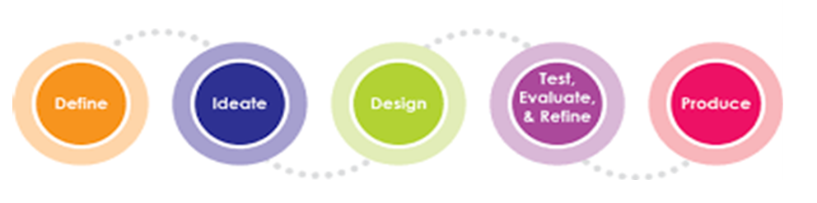
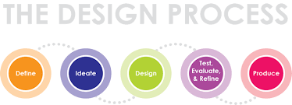

Name: …………………………………………… Class:………………
The Need – Problem (Something that requires a designed solution think about the end user)

Design Brief (A short statement that guides the designer providing specifications and constraints)

Possible Solutions (looking at existing products that may meet the need)
Positives

Negatives

IMAGE HERE

Positives

Negatives

IMAGE HERE

IMAGE HERE
Positives

Negatives

Feedback Results: Teacher and Peer comments on the above solutions
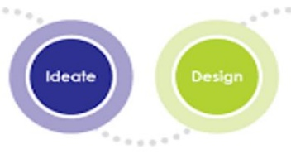
Conclusion: What I have learnt from considering these ideas.

The Solution
Intention

Investigate the How to?
Specifications (what maximum/minimum size, colours etc)

Joining Methods (wood joints/fixings/glues)

Materials (What will it be made of)

Finishes (Paint/varnish/coatings)

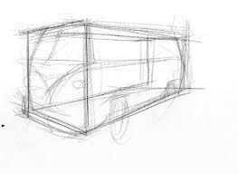
Drawings and Prototypes
Sketches (Hand drawn rough/communicate your ideas)

Working Drawings?
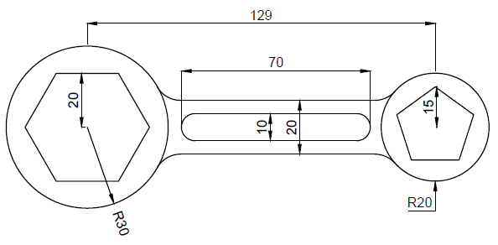
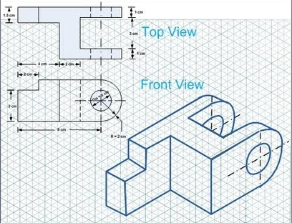
These are drawings which include all the detail required to produce the product designed. Information will include all dimensions and annotations providing explanations of features not shown. Computer Aided Design drawings are the best way to produce drawings but they could also be scaled manual technical drawings using the correct standards. The test for your drawings should be the ability for anyone to take your drawing and produce the product to the specifications given.
Lathe spanner: hardened 10mm thick steel.

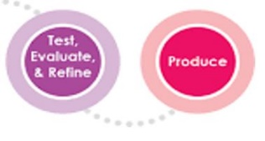

Production and Modifications
The making process is part of the design process as you test, prototype and refine your ideas. During this process you may need to revisit the planning and drawing steps to refine and modify the product. A record should be kept as evidence of your thinking and problem solving. Its useful to take images of your progress.

Criteria for Success (What will success look like?)
Considerations | Constraints

Evaluation
This is the time to reflect on your product and the process and consider the following questions. Use an electronic document if you choose to expand on the evaluation.
The most rewarding step in this project was..
Did the completed project meet the design brief and your Criteria for Success?
Describe the project, what was produced?
What changes would be made to the process and product if you were to repeat this project?
The most challenging steps were..

