Worksheet: Gas and MIG Welding - Safety and Procedures

Name: ______________________
Date: ______________________
Class: ______________________

Instructions: Answer the following questions and complete the activities related to Oxy Acetylene gas and MIG welding. ( You should download this from Haiku andsave your own copy.)

Part 1: Safety Measures
List three important safety measures that should be followed when Oxy Acetylene welding.

a. __________________________________________________________

b. __________________________________________________________

c. __________________________________________________________

Name the 3 types of flames shown below and provide the reason for their use in welding:
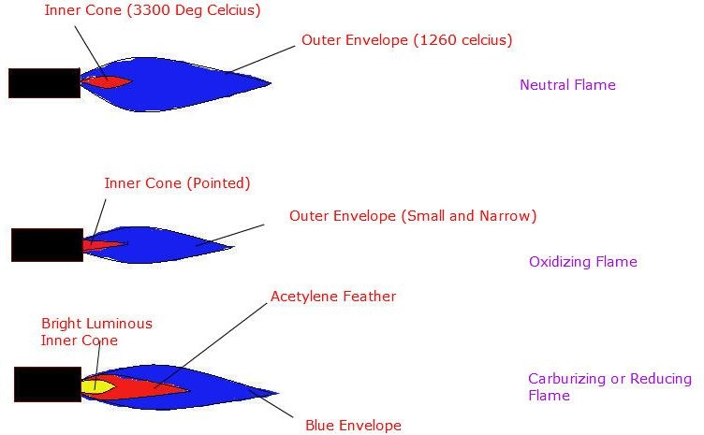
Name:
Use :
Name the three main Oxy welding practices used in our workshop:

- ……………………………………………………………….

- ……………………………………………………………….

- ………………………………………………………………..

List three important safety measures that should be followed when MIG and Arc welding.

a. __________________________________________________________

b. __________________________________________________________

c. __________________________________________________________

Explain why it's essential to wear protective gear when welding.

What is the purpose of a welding helmet or face shield?

Why is it important to have good ventilation in the welding area?

List three common gases used in welding and briefly explain their purposes.

a. __________________________________________________________

b. __________________________________________________________

c. __________________________________________________________

Part 2: Start-Up and Shutdown Procedures (Note SOPS contain this information)

Describe the steps involved in starting up a gas welding torch.

Explain the procedure for shutting down a gas welding torch safely.

List the steps for starting up a MIG welding machine.

Outline the steps for properly shutting down a MIG welding machine.

Part 3: Activity

Safety Poster Design: Design a safety poster that illustrates at least five important safety rules and practices when using a welding machine. Be creative and include images and captions to make it easy to understand.
(You can use a separate sheet of paper for your poster.)

Part 4: Reflection

Why is it crucial to follow safety procedures and protocols when working with welding equipment?

Explain the importance of proper start-up and shutdown procedures in welding.

