Lolly Dispenser
Basic Mechanisms
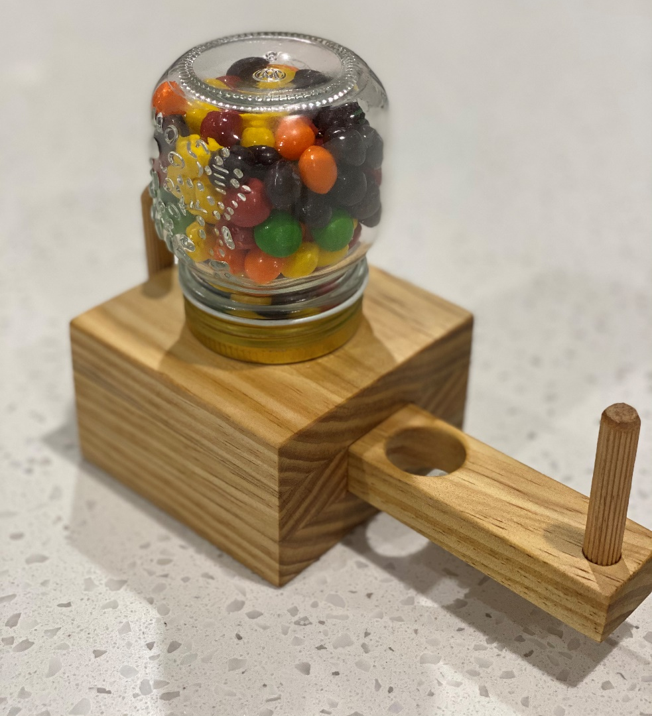

The History of the Gumball Machine

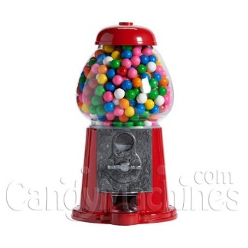
1898 - The Late 19th Century
We have all enjoyed an occasional gumball from a nearby gumball machine for our entire lives. As you might guess, these novelties haven't been around forever. While vending machines or vending kiosks have been around for centuries, the traditional gumball machine as we know it got it's start in the late 19th century.
Expert Mary Bellis, in an article written about the origin of the gumball machine, states: "In 1888, the Thomas Adams Gum Company introduced the very first vending machines to the United States. The machines were installed on the elevated subway platforms in New York City and sold Tutti-Fruiti gum. In 1897, the Pulver Manufacturing Company added animated figures to its gum machines as an added attraction. The round candy coated gumball and gumball vending machines were introduced in 1907."

Ford Gum - Carousel Gumball Machines
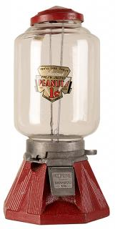
Founded in 1934, the Ford Gum and Machine Company of Akron, New York was another early manufacturer of gum for gumball machines in the U.S. The classic Carousel Gumball Machine and the Old Columbia Coin Machine are still around today. True to its original form, the look of the classic Carousel Gumball Machine hasn't changed since it was introduced.

Northwestern Vending Machines
Founded in 1909, Northwestern Corporation started with kitchen matches and eventually came out with the Northwestern Model 33 in 1933 (naming for the year which it came out) and eventually the Model 60 and Model 80, both of which are still sold today.

1990's - Giant Gumball Machines
Standing almost 7 feet tall and 42 inches wide, they are magical to look at and see over 20,000 Gumballs! These monsters are still around today and continue to evolve with the times, vending more than just gumballs. We've manufactured these to vend cupcakes, tennis balls, golf balls, lacrosse balls, toy capsules and much more.

Vending and Gumball Machines of Today
The vending machines of today have evolved in some regards and stayed true to their roots at their core. Most gumball machines today still work using a mechanical mechanism and require no electricity. However, you won’t find many 1 penny machines out today unless it's a novelty item. The basic mechanics of the machines function just as they did with the very first gumball machines. Today, the machines are made to vend a variety of items such as gumballs, nuts, candy, toy capsules, and much more.

Questions
- Who introduced the very first vending machines to the United States?
_________________________________________________________

- When were the round candy-coated gumball and gumball vending machines Introduce?

_________________________________________________________

- What is a Mechanism?

________________________________________________________________________
- What type of mechanism is used in gumball machines?

_________________________________________________________

- In the last paragraph what are 3 of the listed items that are in machines today?

________________________________________________________________________

- Ford Gum was the manufacture for gum in what country?

_________________________________________________________

- Animated figures added ______________ to gumball machines.

- Northwestern Vending Machines are still sold today, what models are still sold?

_________________________________________________________

- How many gumballs can a giant gumball machine hold?

_________________________________________________________

Sugar in our Food

How much sugar should we consume each day? _______________
Who is that recommendation from? ________________________________
Can you find the average Australian sugar intake? _______________
What are the health risks associated with excessive sugar consumption? __________________________________________________________________________________
______________________________________________________________________________________________________________________________________________________________________________________________________________________________________________________
Look at skittles. Find a packet (or an image) and look at the nutrition table. If you consume 100g of skittles, how many grams of sugar have you consumed?
__________________________________________________________________________________
What are some alternatives for sweets like skittles that contain less sugar?
______________________________________________________________________________________________________________________________________________________________________________________________________________________________________________________
Research three other lollies, drinks or treats and compare their sugar to skittles.

Summarise the information you have researched and the findings you have discovered.
______________________________________________________________________________________________________________________________________________________________________________________________________________________________________________________

____________________________________________________________________________________________________________________________________________________________________

Lolly Dispenser – Folio

Research and Investigating:
As part of this project, you will have to create a collection tray for your candy dispenser. Sketch two ideas of collection trays you could make. You can make the collection tray from acrylic, timber or create on Fusion 360 and 3D print your collection tray.

1. | 2.

Sketch 1 – List the material used, and explain if this design would be suitable/not suitable
________________________________________________________________________________________________________________________________________________________________________________________________
Sketch 2 – List the material used, and explain if this design would be suitable/not suitable
________________________________________________________________________________________________________________________________________________________________________________________________________________________________

As the timber will be touching food you will eat, it is important to use a food safe oil. Research some potential options and list them below.

Design Drawing:
Hand sketch and/or attach a CAD drawing of your final collection tray design.
Include the overall dimensions of your design (height, width, depth)
Include the material used.

Planning:
Some issues that I may have with my design are:
__________________________________________________________________________________________________________________________________________________________________________________________________________________________________________________________________________________
Producing:
In a 5-step process. List with some detail what steps you took to produce your candy dispenser. Include tools and equipment that you used.
STEP | TOOLS | PROCESSES
Example:  Measuring and Marking | Steel Ruler, Pencil and Square | The first step is to measure the length of the pieces and square a line around the timber to cut the pieces to length.

Evaluating:
This term you have been given the task of producing a candy dispenser with aspects you have designed. As part of this project, you have learnt new skills and worked with materials and tools that have allowed you to complete your project.
The last step in this project is to reflect on what you have done and evaluate the project you have completed.

- Some of the steps in this project are simple and others difficult, what did you find easy and which process did you find most difficult?
__________________________________________________________________________________________________________________________________________________________________________________________________________________________________________________________________________________________________________________________________________________________________________________________________________________________________________________________________________________________________________

- Describe your collection tray design and explain why you chose this design
____________________________________________________________________________________________________________________________________________________________________________________________________________________________________________________________________________________________________________________________________________________________________________________________________________________________________

- If you had the opportunity to start this project again, what would you change and why?
__________________________________________________________________________________________________________________________________________________________________________________________________________________________________________________________________________________________________________________________________________________________________________________________________________________________________________________________________________________________________________

YEAR 8 Design and Technology Rubric : Lolly Dispenser
 |  |  |  | Name
Strand | Assessment Criteria | High achievement | Good achievement | Satisfactory achievement |  | Low achievement
Processes & Production Skills | Select and justify choices of materials, components, tools, equipment and techniques to effectively and safely make designed solutions (ACTDEP037) | A+ / A / A- | B+ / B / B- | C+ / C / C- |  | D+ / D / D-
 | n Safe Work practices followed.  n Technical skills – Measure, mark and Cut to Size  n Technical skills – Fit and Finish  nProject Management (Working Effectively)  n Tray Design Suitable for Purpose | ¨ Excellent  ¨ Excellent  ¨ Excellent  ¨ Excellent  ¨ Excellent | ¨ Good  ¨ Good  ¨ Good  ¨ Good  ¨ Good | ¨ Satisfactory  ¨ Satisfactory  ¨ Satisfactory  ¨ Satisfactory  ¨ Satisfactory |  | ¨ Partial Understanding  ¨ Partial Understanding  ¨ Partial Understanding  ¨ Partial Understanding  ¨ Partial Understanding
Knowledge & Understanding | Develop design criteria collaboratively including sustainability to evaluate design ideas, processes and solutions  AC9TDE8P04
 | n Evaluate the completed Product | ¨ Excellent | ¨ Good | ¨ Satisfactory |  | ¨Partial Understanding

Grade

