Design & Technology
HERITAGE

Sling Puck
GAME

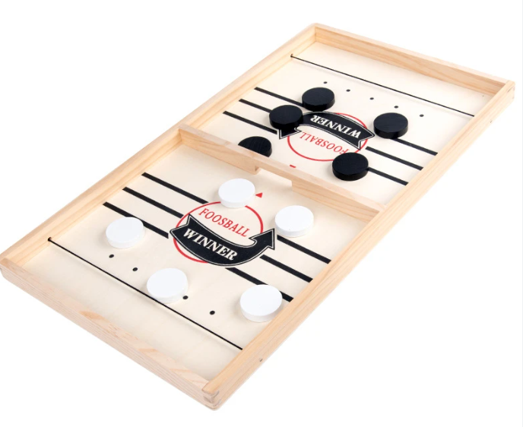

Origins of the game.
Sling Puck is a version of a traditional French game called Table a l elastique. The French would play the game using a wooden board with cat gut being used for the elastic which would need to be kept moist during play to keep the gut from becoming slack.

The Task
Your task will be to create your own Pucket board and pucks. This project will involve the use of hand tools and the laser cutter to create the finished product. Your board can feature your own personalised design and play area markings which can be laser engraved.
Materials cutting list
Components | Number | Material | Dimensions
Playing Surface board | 1 | 3mm Plywood | 500mm x 260mm
Board Sides | 2 | 12mm solid pine | 500mm x 50mm
Board Ends | 2 | 12mm solid pine | 260mm x 50mm
Centre board | 1 | 12mm solid pine | 250mm x 50mm
Elastic | 2 | Supplied Elastic | 400mm

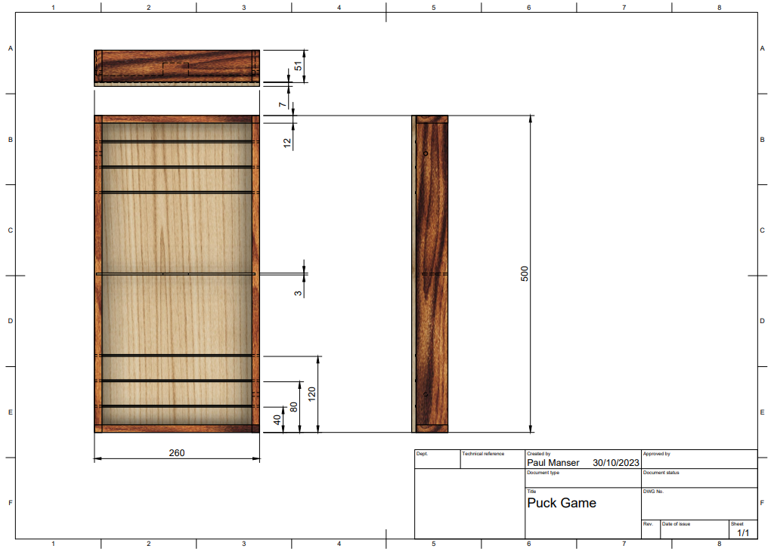

Task Steps
- Cut the base board for the playing surface using the laser cutter. At this point we can cut the board to size, etch designs and playing guides.
You can create your own designs or use an image form the internet.
2. Cut 2x long sides 625mm long from solid radiata pine sized to 50mm x 12mm.
3. Cut 2x short ends 300mm long from solid radiata pine sized to 50mm x 12mm.
4. Cut 1x middle at 310mm long from solid radiata pine 50mm x 12mm
5. Mark out and cut an opening in the centre of the middle piece 50mm long x 20mm deep. Use a tenon/band saw and chisel to remove the waste and smooth with abrasive if needed.
6. In the centre of each long piece (500mm) mark a stopped housing joint as demonstrated. This joint should 50mm long from the bottom edge and 3mm wide to accept the middle section of the board.
7. Finish the board in your chosen finish.
8. Complete the evaluation.
9. Present your product and evaluation for marking.

