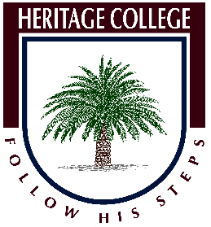
Design and Technology Timber Knowledge

(Create a word document and answer each point)

- Timber is the world’s most valuable building resource. Why is this true?
……………………………………………………………………………………………………………………………………………………………………………………………………………………………………………………………………………………………………………………………………………………………………………………………………………………………………………………………………………………………………………………………………………………………...
- The name of the timber used in schools and in construction most commonly is called…………………………………………………………

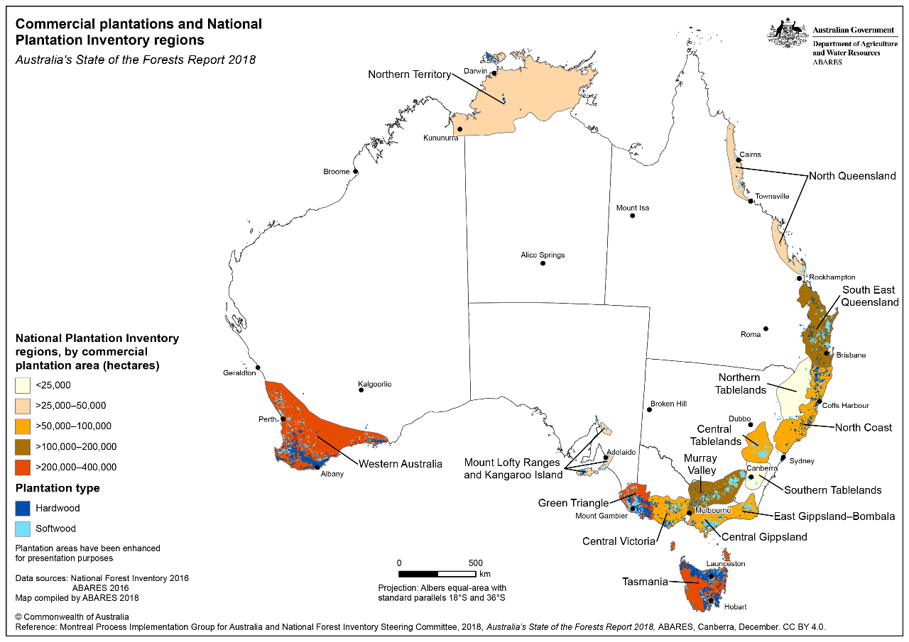
- In the Australia and Pacific region most of our softwood timber is grown in plantations which are most common in ………………………………………….

- You are working on your project and find that you are short of wood. Can you go outside and cut a branch off a tree and use it for your project, why?
…………………………………………………………………………………………………………………………………………………………………………………………………………………………………………………………………………………………………………………………………………………………………………………………………………………………………………………………………….
- Timber is classified into 2 main types or groups, what are they?
1)……………………………………….
2)……………………………………….

5. Name 4 varieties of timber commonly used in Australia:
1)…………………………………………….
2)……………………………………………
3)……………………………………………
4)…………………………………………….

The Timber Industry

- When people talk about sustainable forestry, what are they referring to?
____________________________________________________________________________________________________________________________________________________________________________________________________________________________________________________________________________

- What are the main differences between sustainable forestry and unregulated logging practices that are seen in areas of the world such as Borneo and Sumatra?
_______________________________________________________________________________________________________________________________________________________________________________________________________________________________________________________________________________________________________________________________________________

- Describe some of the environmental impacts of poor forestry practices and deforestation. Include some images to illustrate your answer.
_______________________________________________________________________________________________________________________________________________________________________________________________________________________________________________________________________________________________________________________________________________

- Find a map showing the location of Australian forests managed by the Forestry Industry.

- There are 2 groups of timber commonly used in the building and furnishing industry. What are these 2 groups called?

- Can timber be recycled? If so, describe the process and name a product that is made from recycled timber.

- Find an image of a timber product that appeals to you, insert the image into your document and explain what it that you like about it

- List 5 tools that are commonly used in woodworking insert an image and describe its purpose.
_________________________________________________________________________________________________________________________________________________________________________________________________________________________________________________________________________________________________________________________________________________________

- Hand your assignment in with your name and a footer showing the filename and path.

