|  |  |  |
| --- | --- | --- |
|  | **Heritage College Adelaide** | |
| **Design and Technology Year**  **Minecraft Sustainable Community Design** | |
| **Australian Curriculum Outcomes** | **Weighting** |
| **Curriculum Outcomes:**   * Design and produce creative solutions to identified needs or opportunities. * Investigate and apply design processes to develop innovative solutions. * Evaluate the effectiveness of design solutions against specified criteria. * Use digital technologies to communicate design ideas and processes. | | **15%** |

**Design Challenge Brief**

**Task:** Work in groups of 2 -3 students with the goal being to design and build a Minecraft community that is powered entirely by renewable and sustainable energy sources.

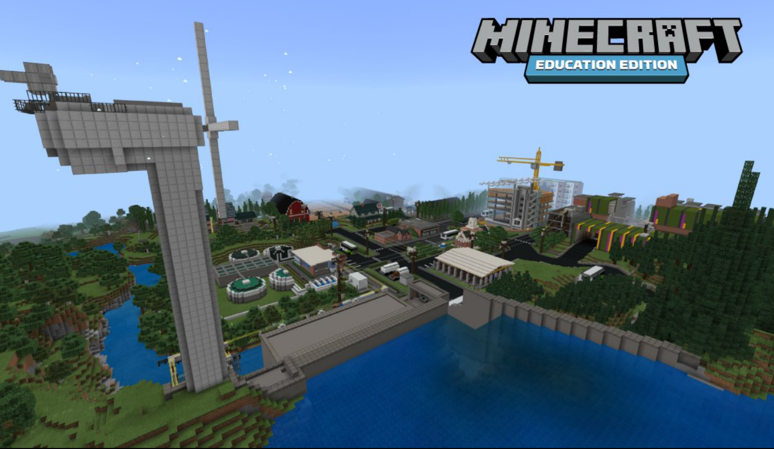**Context:** Imagine your Minecraft world is facing an energy crisis due to the depletion of fossil fuels. Your community must transition to renewable energy sources to ensure a sustainable future.

**Design Process**

1. **Research:** Students research different renewable energy sources (solar, wind, hydro, biomass) and their potential applications in a Minecraft environment.
2. **Brainstorming:** Students brainstorm ideas for their renewable energy community. Consider factors like energy storage, distribution, and the integration of renewable energy into buildings and infrastructure.
3. **Design:** Students create detailed designs of their community, focusing on the placement and efficiency of renewable energy systems. Use Minecraft's creative mode to experiment with different layouts and technologies.
4. **Construction:** Students build their community in Minecraft's survival mode, facing the challenges of resource management and energy production.
5. **Evaluation:** Students evaluate their community's energy efficiency and sustainability by measuring energy output and consumption.

**Assessment Criteria**

* **Design process:** Evidence of research, brainstorming, and design development.
* **Creativity and innovation:** Original and imaginative solutions to the design challenge.
* **Renewable energy integration:** Effective use of renewable energy sources to power the community.
* **Energy efficiency:** Minimisation of energy consumption through efficient design and technology.
* **Communication:** Clear and effective presentation of the design and its outcomes. *( Use Screen grabs* ***windows/shift/S*** *to record your progress)*

**Extension Activities**

* **Energy storage:** Students explore different methods of energy storage (batteries, pumped hydro) and implement them in their community.
* **Energy distribution:** Students design and build an efficient energy distribution network to supply power to all buildings.
* **Economic impact:** Students analyse the economic benefits of a renewable energy community.

By focusing on renewable energy, students will gain a deeper understanding of sustainable energy practices and technologies and their importance for the future.

**Evaluate your finished Product**

1. Describe the project and provide a list of tools and processes that you had to work through in making this project.

________________________________________________________________________________________________________________________________________________________________________________________________________________________________________________________________________________________________________________________________________________________________________________________________________________________________________________

1. Some of the steps in this project are simple and others difficult, what did you find easy and which process did you find most difficult?

________________________________________________________________________________________________________________________________________________________________________________________________________________________________________________________________________________________________________________________________________________________________________________________________________________________________________________

1. Describe your design and explain why you chose the design you completed.

________________________________________________________________________________________________________________________________________________________________________________________________________________________________________________________________________________________________

1. If you had the opportunity to start this project again, what would you change and why?

________________________________________________________________________________________________________________________________________________________________________________________________________________________________________________________________________________________________________________________________________________________________________

