Stage 2 GENERAL MathematicS
Assessment Type 1: Skills and Applications Tasks
TOPIC 2: MODELLING WITH MATRICES
Purpose
To demonstrate your ability to:
- understand mathematical concepts and relationships from within Topic 2: Modelling with Matrices
- select and apply mathematical techniques and algorithms to find solutions to problems
- interpret results, draw conclusions, and consider the reasonableness of solutions in context
- communicate mathematically and present mathematical information.

This assessment allows you to show your skills in understanding and appropriate use of the mathematical concepts, process, and strategies in the following:
- Subtopic 1.1: Application of matrices to network problems
- Subtopic 1.2: Application of matrices to transition problems

Assessment Conditions
This is a supervised assessment.
This task is conducted in a 90 minute lesson.
Assessment Design Criteria

Concepts and Techniques
CT 1 Knowledge and understanding of concepts and relationships.
CT 2 Selection and application of mathematical techniques and algorithms to find solutions to problems in a variety of contexts.
CT 4 Use of electronic technology to find solutions to mathematical problems.

Reasoning and Communication
RC 1 Interpretation of mathematical results.
RC 2 Drawing conclusions from mathematical results with an understanding of their reasonableness and limitations.
RC 3 Use of appropriate notations representations and terminology.
RC 4 Communication of mathematical ideas and reasoning to develop logical arguments.

TOPIC 2: MODELLING WITH MATRICES
QUESTION 1:

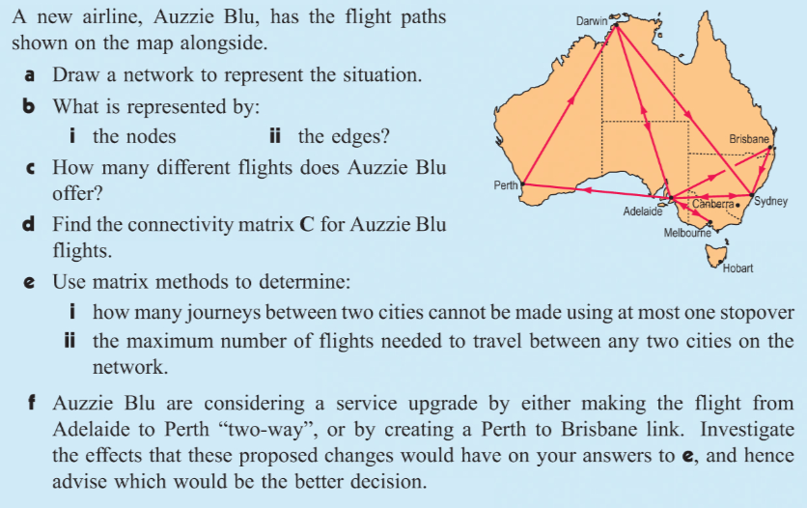

QUESTION 2:

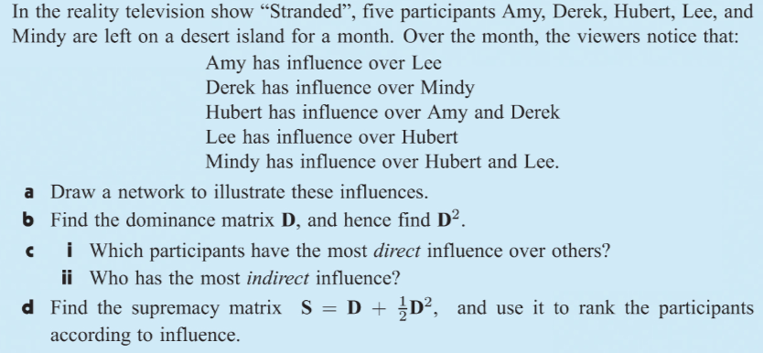

QUESTION 3:
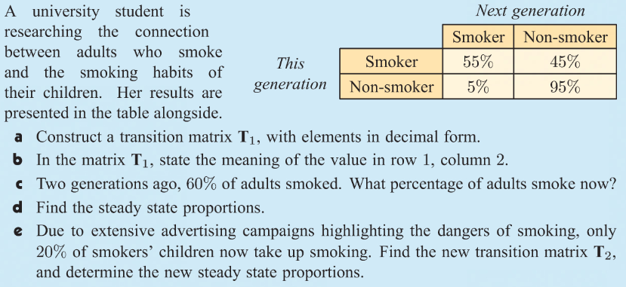
QUESTION 4:
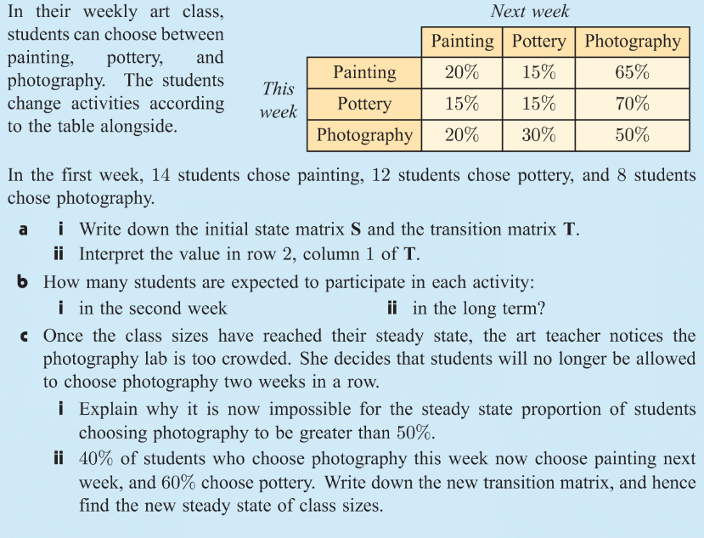
Performance Standards for Stage 2 General Mathematics
 | Concepts and Techniques | Reasoning and Communication
A | Comprehensive knowledge and understanding of concepts and relationships.  Highly effective selection and application of mathematical techniques and algorithms to find efficient and accurate solutions to routine and complex problems in a variety of contexts.  Successful development and application of mathematical models to find concise and accurate solutions.  Appropriate and effective use of electronic technology to find accurate solutions to routine and complex problems. | Comprehensive interpretation of mathematical results in the context of the problem. Drawing logical conclusions from mathematical results, with a comprehensive understanding of their reasonableness and limitations.  Proficient and accurate use of appropriate mathematical notation, representations, and terminology.  Highly effective communication of mathematical ideas and reasoning to develop logical and concise arguments.  Formation and testing of appropriate predictions, using sound mathematical evidence.
B | Some depth of knowledge and understanding of concepts and relationships.  Mostly effective selection and application of mathematical techniques and algorithms to find mostly accurate solutions to routine and some complex problems in a variety of contexts.  Attempted development and successful application of mathematical models to find mostly accurate solutions.  Mostly appropriate and effective use of electronic technology to find mostly accurate solutions to routine and some complex problems. | Mostly appropriate interpretation of mathematical results in the context of the problem. Drawing mostly logical conclusions from mathematical results, with some depth of understanding of their reasonableness and limitations.  Mostly accurate use of appropriate mathematical notation, representations, and terminology.  Mostly effective communication of mathematical ideas and reasoning to develop mostly logical arguments.  Formation and testing of mostly appropriate predictions, using some mathematical evidence.
C | Generally competent knowledge and understanding of concepts and relationships.  Generally effective selection and application of mathematical techniques and algorithms to find mostly accurate solutions to routine problems in different contexts.  Application of mathematical models to find generally accurate solutions.  Generally appropriate and effective use of electronic technology to find mostly accurate solutions to routine problems. | Generally appropriate interpretation of mathematical results in the context of the problem. Drawing some logical conclusions from mathematical results, with some understanding of their reasonableness and limitations.  Generally appropriate use of mathematical notation, representations, and terminology, with reasonable accuracy.  Generally effective communication of mathematical ideas and reasoning to develop some logical arguments.  Formation of an appropriate prediction and some attempt to test it using mathematical evidence.
D | Basic knowledge and some understanding of concepts and relationships.  Some selection and application of mathematical techniques and algorithms to find some accurate solutions to routine problems in context.  Some application of mathematical models to find some accurate or partially accurate solutions.  Some appropriate use of electronic technology to find some accurate solutions to routine problems. | Some interpretation of mathematical results. Drawing some conclusions from mathematical results, with some awareness of their reasonableness.  Some appropriate use of mathematical notation, representations, and terminology, with some accuracy.  Some communication of mathematical ideas, with attempted reasoning and/or arguments.  Attempted formation of a prediction with limited attempt to test it using mathematical evidence.
E | Limited knowledge or understanding of concepts and relationships.  Attempted selection and limited application of mathematical techniques or algorithms, with limited accuracy in solving routine problems.  Attempted application of mathematical models, with limited accuracy.  Attempted use of electronic technology, with limited accuracy in solving routine problems. | Limited interpretation of mathematical results. Limited understanding of the meaning of mathematical results, their reasonableness or limitations.  Limited use of appropriate mathematical notation, representations, or terminology, with limited accuracy.  Attempted communication of mathematical ideas, with limited reasoning.  Limited attempt to form or test a prediction.

