Year 12 General Mathematics - Loans
8C.6 Question 1 – calculations
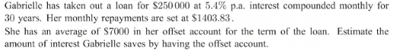
Question Section | Formula and calculations | Answer
- Step 1 – find the time taken to reduce the loan  $250,000 - $7000 (Offset account) = $243,000 | N =0  I = 5.4  PV = 243000  PMT = -1403.83  FV = 0  P/Y = 12  C/Y = 12 | N = 336 or 28 years  This is the number of payments calculated to pay off this loan amount less the offset amount of $7000.
- Find the future value (FV) of the loan after 28 years. | N =336  I = 5.4  PV = 243000  PMT = -1403.83  FV = 0  P/Y = 12  C/Y = 12 | FV = $223
- Final calculations | So Gabrielle will need to pay $7000 - $223 = $6777  With the offset Gabrielle will pay:  $1403.83 x 336 + $6777 = $478,463.88  Without the offset she will pay:  $1403.83 x 360 = $505,378.80  $505,378.80 - $478,463.88 = $26,914.92 savings

