Year 12 General Mathematics – 8E - Interest only and sinking funds
8E Question 2 – calculations
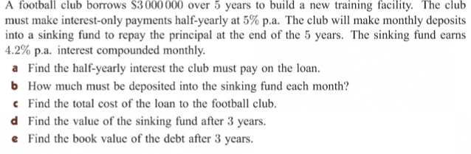
Question Section | Formula and calculations | Answer
- Find the half-yearly interest the club must pay on the loan. | I = P x I x n  I = 3,000,000 x .05 x ½ | I = $75,000 interest payments every six months
- How much must be deposited into a sinking fund each month? | N =5 x 12 = 60  I = 4.2  PV = 0  PMT = 0  FV = 3,000,000  P/Y = 12  C/Y = 12 | PMT = -$45,020.74  $45,020.74 must be put into the sinking fund each month to off principal.
- Find the total cost of the loan to the football club. | Interest = $75,000 x 10 payment = $750,000  Principal = $45020.74 x 60 payments = $2,701,244.40  Total loan cost -= $750,000 + $2,701,244.40 = $3,451,244.40
- Find the value of the sinking fund after 3 years. | N =3 x 12 = 36  I = 4.2  PV = 0  PMT = 45020.74  FV = 0  P/Y = 12  C/Y = 12 | FV = $1,724,071.79
- Find the book value of the debt after 3 years | Debt = $3,000,000  Sinking Fund value after 3 years = $1,724,071.79  Book value = $3,000,000 - $1,724,071.79 =  $1,275,928.21

