Year 12 General Mathematics – Discrete Models
12B.4 Question 2 – Non-square matrices
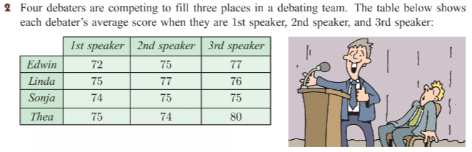
Question Section | Answer
A Team of debaters will be selected to maximise the team’s score.  - Explain why we can be certain Linda will be selected. | Linda has the second highest average scores, and therefore we are always going to pick Linda ahead of others that have lesser scores.
- State the maximum value in the table. | The maximum value in the table is 80.
- Write down the matrix that the Hungarian algorithm must be applied to, including any dummy rows and columns.  What to do:  - As there are four speakers (rows), so we add a dummy column as the fourth speaker.  - Use the maximum value of 80 take other values from the maximum. | 1st Speaker 2nd Speaker 3rd Speaker 4th Speaker  Edwin 72 75 77 0  Linda 75 77 76 0  Sonja 74 75 75 0  Thea 75 74 80 0  1st Speaker 2nd Speaker 3rd Speaker 4th Speaker  Edwin 8 5 3 0  Linda 5 3 4 0  Sonja 6 5 5 0  Thea 5 6 0 0
- Determine who should be assigned to each of the speaking positions.  What to do:  - Apply the Hungarian algorithm:  - Step 1 – the matrix remains unchanged as the minimum value for each row is 0.  - Step 2 – remove the minimum column value.  - Step 3 – 3 horizontal lines only so we move to step 4  - Step 4 – take the smallest value in the table (1) from the values not covered by the lines, and add the smallest value to the values that are covered by two lines. We now have four lines.  - Step 5 – Apply the patter to the original matrix, and starting with Sonja who only has one zero go through a process of deduction to determine who is on the debating team and who is not.  - Which debater will miss out on a position in the team? | 1st Speaker 2nd Speaker 3rd Speaker 4th Speaker  Edwin 8 5 3 0  Linda 5 3 4 0  Sonja 6 5 5 0  Thea 5 6 0 0  -5 -3 -0 -0  1st Speaker 2nd Speaker 3rd Speaker 4th Speaker  Edwin 3 2 3 0  Linda 0 0 4 0  Sonja 1 2 5 0  Thea 0 3 0 0  1st Speaker 2nd Speaker 3rd Speaker 4th Speaker  Edwin 2 1 2 0  Linda 0 0 4 0  Sonja 0 1 4 0  Thea 0 3 0 0  1st Speaker 2nd Speaker 3rd Speaker 4th Speaker  Edwin 72 75 77 0  Linda 75 77 76 0  Sonja 74 75 75 0  Thea 75 74 80 0  Sonja is 1st Speaker  Linda is 2nd Speaker  Thea is 3rd Speaker  Edwin misses out.

