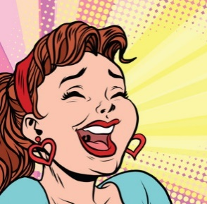
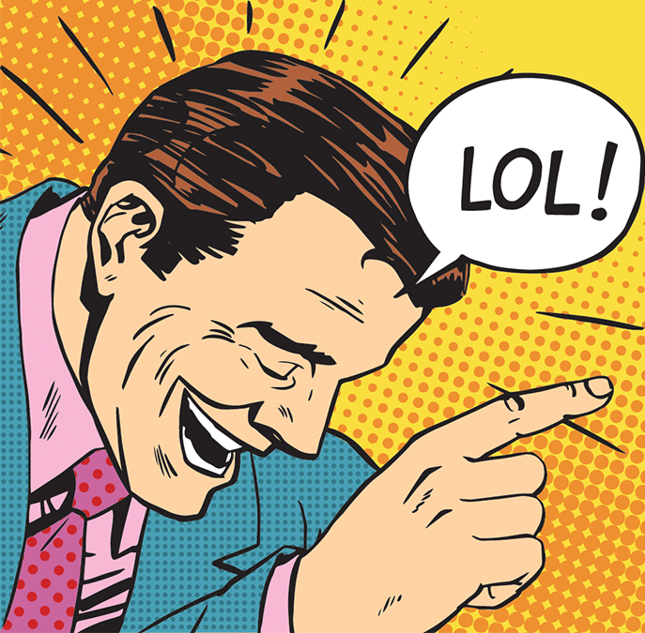
Parody

What is a parody?
A parody is a creative work that copies or imitates something else in order to mock (tease, poke fun at) the original work. Parodies can imitate a story, song, poem, or another creative work and can be found in art, literature, music, animation, internet videos, gaming, and film. A parody is also called a pastiche, a spoof, a lampoon, a satire, a take-off, or a send-up amongst many other names. Parodies normally mock something that is well-known or famous. The joke works best when audience recognises what is being made fun of.

The main purpose of a parody is to make fun of something, but parodies can also be used to make a point or a comment about the original work, in a subtle way. By exaggerating some of the flaws, plot holes, or weak characters in a story, it can point out that the original is not very well written. By exaggerating a flowery or elaborate writing style, a parody could show that the author is self-important or pompous. By exaggerating some of the pretentious or outdated ideas and themes, the author of the parody might be commenting on the attitudes of the author, or of society generally during the time when the original was written.

Parody vs Comedy
Not all comedy is parody, but the two are linked and share a lot of similarities. In order to be a parody, it must be an imitation of something specific. To check whether it’s a comedy or a parody, see if you can recognise an original story, incident, artwork, or film style that is being mocked or mimicked.

Features of a parody
Imitation - the original story should be clearly recognisable. The parody should have a similar plot, similar or the same characters, similar style or wording, some key phrases the same, and a title that is similar or swapped.
Exaggeration – taking themes, ideas or plot points from the original to extremes to make them sound ridiculous
Humour - main point of a parody is to be funny! Silliness and jokes keep the audience entertained & makes it memorable
Moral or lesson – make a point, show what’s wrong with the original, why it’s silly
Caricatures – characters that are exaggerated to create a silly or funny effect. Can exaggerate their physical appearance, behaviour, or personality traits. Often used to point out flaws or weaknesses, and helps the reader picture them vividly and remember them
Wordplay and puns – playing with the double meanings of words or phrases. Deliberately using mixed metaphors, incorrect spelling, or homophones in a funny way.
Plot twist – a surprise ending. Subverts expectations – does the opposite of what the reader expects. E.g. supposed ‘hero’ turns out to be the villain, reader knows something the character’s don’t, new information at the end proves mystery isn’t solved after all.

