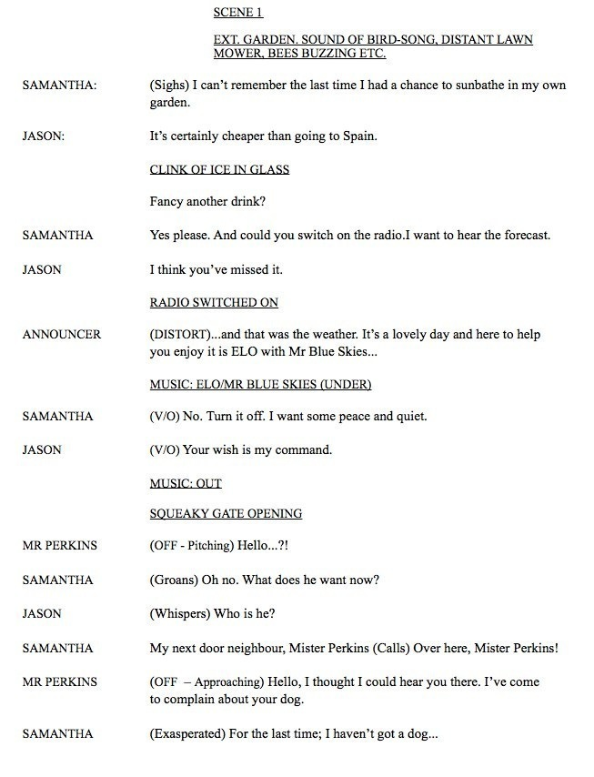

Writing a Script
ORIENTATION
Most scripts begin with a line telling the reader where the scene is set. They might use the abbreviations (EXT.) or (INT.) (exterior or interior, outside or inside) and describe the location. For an audio script, sound effects are often used to help set the scene in the listener’s mind as there is no visual to show them.
FX
This abbreviation stands for sound effects. Sound effect technicians (or ‘foley artists’) work in a studio to create sounds that mimic the tinkle of ice in a glass, a squeaky gate, footsteps etc.
DISTORT
If one of your characters is speaking on the phone, through a loudspeaker system or over the radio, it’s useful to distort their voice to remind the listener where the words are coming from.
MUSIC
If there’s a specific piece of music you want to use, label it to distinguish it from other sound effects. If the music will be talked over by the character, you could write ‘under’ or ‘V/O’ (voice-over) to indicate this.
OFF-STAGE
‘Off’ or ‘off-stage’ indicates the character is some distance away. In a theatre production, they would say this from offstage. In an audio recording, the voice actor might turn away from the microphone to make it sound as if they’re far away.
Setting the scene
It’s important to establish the setting of a play or film – when and where the events are taking place. If the listener is confused about these details, they won’t be able to follow what’s going on. In audio play, (unlike in a film) the audience can’t see any visual information, so the setting needs to be established a different way. You could have a character say out loud: “well, here I am standing at the railway station” but people don’t really talk like that, so it sounds false. Another option could be to have a narrator say “It’s 1946. Noon. The train station is busy and bustling”. A better way of establishing location is through sound effects. The sound of train doors slamming, engine noises, station announcements, etc, indicates to the audience, quickly and without words, that the scene is set in a train station.
In the example script, the garden scene is set with appropriate background noises (birds, a lawn mower) and this message is reinforced by the first line of dialogue:
“I can’t remember the last time I had a chance to sunbathe in my own garden.”
This line quite clearly tells the listener where the character is and what they’re doing, but it sounds a bit more natural than the railway dialogue. The line also delivers three other items of information: it’s daytime, and probably summer if it’s hot and sunny enough to sunbake. These facts may not be that important to the story, but they help the listener paint a mental picture of the scene. The line also gives some information about the speaker. She has a property with a garden, and she seems to have a busy life with few opportunities to relax.
Introduce your characters
Once the scene is set, establish who’s in it. In the example, the second line is spoken by Jason. It’s a throwaway line of little importance but it lets the listener know he’s there. If Jason didn’t introduce himself and didn’t speak a word until Mister Perkins arrived, anyone listening would be startled by his sudden appearance. If a new character enters a scene halfway through, make the other characters say something about them to introduce them to the audience and let them know they are there.
Directions
In the example, the line: “Oh no. What does he want now?” could be delivered a few different ways – she could shout it angrily or say it laughingly. Because the line is ambiguous it needs a direction (in this case ‘groans’) so the actress knows how it should be spoken. An example of an unambiguous line would be:
NIGEL: (angrily) Jasper, I’m furious with you! You shot my dog, burnt down my house and murdered my entire family!
In this case the direction ‘angrily’ is unnecessary. But it doesn’t hurt to include directions anyway for the actors’ benefit.
‘Pitching’ indicates the actor should pitch their voice up (as if asking a question) or down (as if denying something).
Writing for your actors
If you’re writing a script for a single person, keep that in mind as you’re writing and don’t include impossible feats like talking over yourself. Sudden shifts between characters can also be difficult. If your script involves an old Scottish woman, a schoolteacher, a child, and a roaring Sergeant Major all speaking in quick succession, things could get tricky. One way of avoiding vocal gymnastics is to paraphrase the dialogue or deliver some information by a narrator.

