Set 2: Poem and recruitment posters

Text 1: What Every Soldier Should Know, by Brian Turner
To yield force to is an act of necessity, not of will;
it is at best an act of prudence.
—Jean-Jacques Rousseau
If you hear gunfire on a Thursday afternoon,
it could be for a wedding, or it could be for you.

Always enter a home with your right foot;
the left is for cemeteries and unclean places.

O-guf! Tera armeek is rarely useful.
It means Stop! Or I’ll shoot.

Sabah el khair is effective.
It means Good morning.

Inshallah means Allah be willing.
Listen well when it is spoken.

You will hear the RPG coming for you.
Not so the roadside bomb.

There are bombs under the overpasses,
in trashpiles, in bricks, in cars.

There are shopping carts with clothes soaked
in foogas, a sticky gel of homemade napalm.

Parachute bombs and artillery shells
sewn into the carcasses of dead farm animals.

Graffiti sprayed onto the overpasses:
I will kell you, American.

Men wearing vests rigged with explosives
walk up, raise their arms and say Inshallah.

There are men who earn eighty dollars
to attack you, five thousand to kill.

Small children who will play with you,
old men with their talk, women who offer chai—

and any one of them
may dance over your body tomorrow.

Questions for Text 1: What Every Soldier Should Know
- An ‘epigraph’ is a short quotation at the beginning of a poem. What do you think the epigraph at the beginning of this poem means?
- What is the significance of the Arabic words used in the poem?
- What are the cultural aspects that soldiers in Iraq should be aware of?
- What are the dangers that they face every day?
- What is the significance of the last 2 couplets?
- How does the title fit with the content of the poem?

Text 2: Australian Defence Force Recruitment Poster
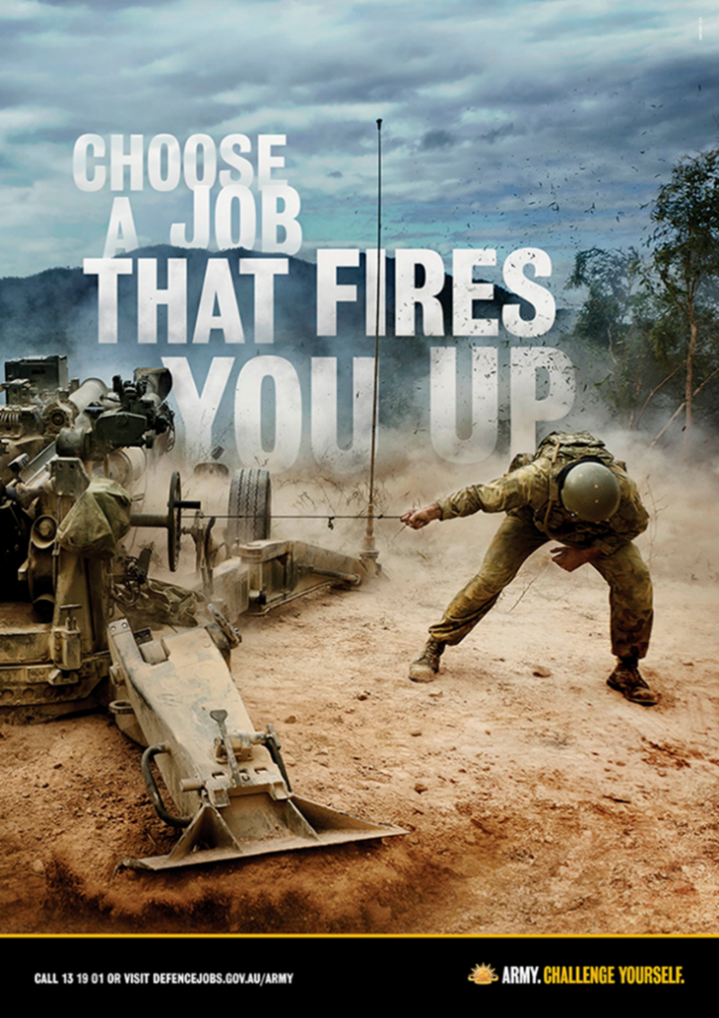

(Source: DefenceJobs.com.au)
Questions for Text 2: Recruitment Poster
- Explain the play on words used in the ‘body copy’ (text on the poster).
- How does the image add to the message of the ad?
- Who is the target audience for the ad?
- How does the image reflect the slogan for the army?
Text 3: Australian Defence Force Recruitment Poster
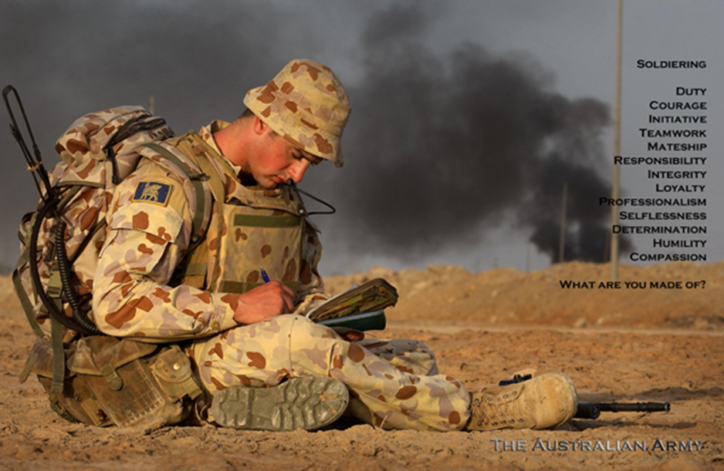
(Source: DefenceJobs.com.au)
Questions for Text 3: Recruitment Poster
- This advertisement was created with the input of Australian soldiers. What qualities do they identify as important?
- What is the purpose of the question at the bottom of the list?
- Why do you think they have chosen this image for the ad?
- How is this ad different to Text 2?

Text 4: Australian Defence Force Recruitment Posters
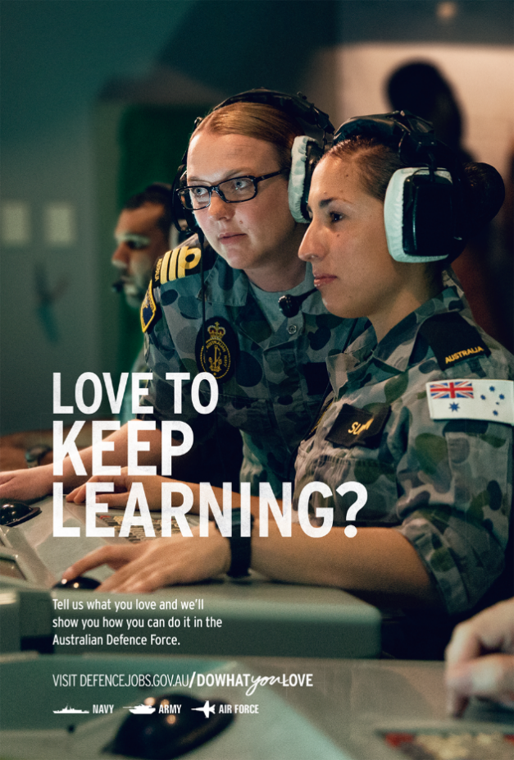
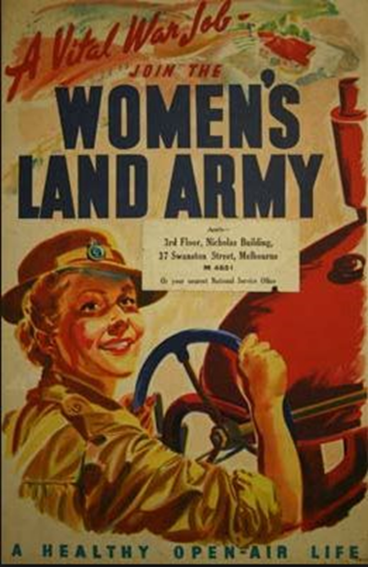

(Source: Australian War Memorial) (Source: DefenceJobs.com.au)
Questions for Text 4: Australian Defence Force Recruitment Posters
- The first advertisement in Text 4 comes from World War II. What positive language is used to encourage women to join up?
- How does the image reinforce the ad’s message?
- Who is the target audience of the second ad in Text 4?
- How does the ‘body copy’ (text on the page) attract the reader’s attention?
- How does the image reinforce the ad’s message?
- How does this ad show that times have changed?

Set 2: Questions for Evaluation
- All of these texts highlight different experiences of conflict. How have the authors used visual and language features to present their ideas, evaluate the experience (directly or indirectly) and engage or challenge the audience?
- Compare the perspective of the texts. How have the authors used written or visual elements to show their point of view? Are they trying to influence/persuade the audience? How do they want the readers/viewers to feel or act?
- EVALUATE the texts. Which is most effective at getting the message across, and why? Use persuasive & evaluative language to justify your answer.

