Set 5: Speech & Statement
Text 1: Former Prime Minister Kevin Rudd’s apology to the Stolen Generations
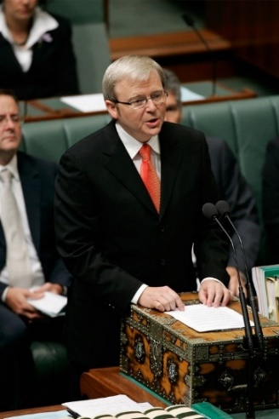
‘Mr Speaker, I move: that today we honour the Indigenous peoples of this land, the oldest continuing cultures in human history. We reflect on their past mistreatment. We reflect in particular on the mistreatment of those who were Stolen Generations – this blemished chapter in our nation's history. The time has now come for the nation to turn a new page in Australia's history by righting the wrongs of the past and so moving forward with confidence to the future.
We apologise for the laws and policies of successive Parliaments and governments that have inflicted profound grief, suffering, and loss on these our fellow Australians. We apologise especially for the removal of Aboriginal and Torres Strait Islander children from their families, their communities, and their country. For the pain, suffering and hurt of these Stolen Generations, their descendants and for their families left behind, we say sorry. To the mothers and the fathers, the brothers and the sisters, for the breaking up of families and communities, we say sorry. And for the indignity and degradation thus inflicted on a proud people and a proud culture, we say sorry.
We the Parliament of Australia respectfully request that this apology be received in the spirit in which it is offered as part of the healing of the nation. For the future, we take heart; resolving that this new page in the history of our great continent can now be written. We today take this first step by acknowledging the past and laying claim to a future that embraces all Australians. A future where this Parliament resolves that the injustices of the past must never, never happen again. A future where we harness the determination of all Australians, Indigenous and non-Indigenous, to close the gap that lies between us in life expectancy, educational achievement, and economic opportunity. A future where we embrace the possibility of new solutions to enduring problems where old approaches have failed. A future based on mutual respect, mutual resolve, and mutual responsibility. A future where all Australians, whatever their origins, are truly equal partners, with equal opportunities and with an equal stake in shaping the next chapter in the history of this great country, Australia.
There comes a time in the history of nations when their peoples must become fully reconciled to their past if they are to go forward with confidence to embrace their future. Our nation, Australia, has reached such a time.’
Questions for Text 1:
- Explain the purpose of this speech.
- Who is the intended audience?
- What fact about Indigenous Australians is recognised in the opening? Why is this done?
- What perspective is argued in the paragraph starting ‘The time has now come …’?
- How does the speech present the extent of the suffering which Indigenous Australians experienced under government laws and policies?
- What is the significance of the repetition of the word ‘we’ at various point in the speech? Who are ‘we’? In the speech what do ‘we’ do?
- What is the implication of the term ‘first step’? How do the next 2 paragraphs add to this term?
Text 2: Uluru statement
https://ulurustatement.org/the-statement (Link includes audio of the statement being read out by Professor Megan Davis, member of the Referendum Council)
We, gathered at the 2017 National Constitutional Convention, coming from all points of the southern sky, make this statement from the heart:
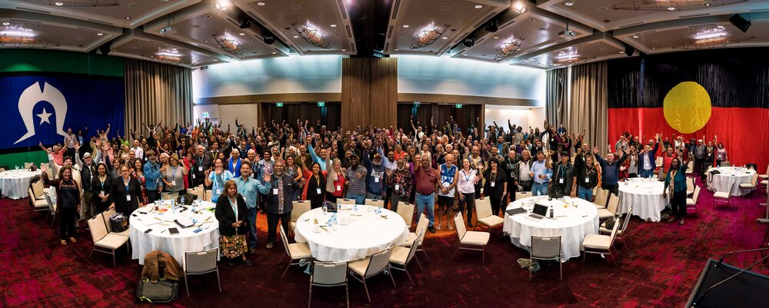
‘Our Aboriginal and Torres Strait Islander tribes were the first sovereign Nations of the Australian continent and its adjacent islands and possessed it under our own laws and customs. This our ancestors did, according to the reckoning of our culture, from the Creation, according to the common law from ‘time immemorial’, and according to science more than 60,000 years ago.
This sovereignty is a spiritual notion: the ancestral tie between the land, or ‘mother nature’, and the Aboriginal and Torres Strait Islander peoples who were born therefrom, remain attached thereto, and must one day return thither to be united with our ancestors. This link is the basis of the ownership of the soil, or better, of sovereignty. It has never been ceded or extinguished and co-exists with the sovereignty of the Crown.
How could it be otherwise? That peoples possessed a land for sixty millennia and this sacred link disappears from world history in merely the last two hundred years? With substantive constitutional change and structural reform, we believe this ancient sovereignty can shine through as a fuller expression of Australia’s nationhood.
Proportionally, we are the most incarcerated people on the planet. We are not an innately criminal people. Our children are aliened from their families at unprecedented rates. This cannot be because we have no love for them. And our youth languish in detention in obscene numbers. They should be our hope for the future. These dimensions of our crisis tell plainly the structural nature of our problem. This is the torment of our powerlessness.
We seek constitutional reforms to empower our people and take a rightful place in our own country. When we have power over our destiny our children will flourish. They will walk in two worlds and their culture will be a gift to their country. We call for the establishment of a First Nations Voice enshrined in the Constitution.
Makarrata is the culmination of our agenda: the coming together after a struggle. It captures our aspirations for a fair and truthful relationship with the people of Australia and a better future for our children based on justice and self-determination.
We seek a Makarrata Commission to supervise a process of agreement-making between governments and First Nations and truth-telling about our history.
In 1967 we were counted, in 2017 we seek to be heard. We leave base camp and start our trek across this vast country. We invite you to walk with us in a movement of the Australian people for a better future.’
Questions for Text 2:
- What is the purpose of the speech?
- Who is the target audience for the speech?
- What is the statement from the heart calling for?
- What does ‘sovereignty’ mean?
- What is the purpose of the rhetorical questions: How could it be otherwise? That peoples
possessed a land for sixty millennia and this sacred link disappears from world history in merely the last 200 years?
- What particular problems are faced by First Nations’ people?
- What is the effect of the inclusive language used in the speech?
- What metaphor is used for the journey the First Nations’ people are undertaking? What is the effect of this on the audience?

Set 5: Questions for Evaluation
- Both of these speeches talk about a better future for the First Nations People. How have the authors used language features to present their ideas, evaluate the experience (directly or indirectly) and engage or challenge the audience?
- Compare the perspective of the two texts. How have the authors used written or visual elements to show their point of view? Are they trying to influence/persuade the audience? How do they want the readers/viewers to feel or act?
- EVALUATE the two texts. Which is more effective at getting the message across, and why? Use persuasive & evaluative language to justify your answer.

