Set 3: Advertisement & blog article
Text 1: Blog article: 7 of the funniest things people have done while stuck at home due to the coronavirus, by Gabbi Shaw – April 30, 2020
There are lots of things you can do while social distancing, like cleaning your house, catching up on work, or learning a new skill. Or you could go for the laughs and share your exploits on the internet.
After over a month of social distancing, some people are starting to run out of shows to binge, skills to learn, and chores to do. What we could all use is a good laugh.
These comedians, social media stars, and families have all resorted to some hilarious ways to keep themselves entertained during the coronavirus pandemic.
Scooting along. A Joy Story Photography
Keep scrolling for 7 of funniest and most heart-warming things that have happened while we're all stuck at home.
In Stockport, England, two teddy bears are bringing their neighbors joy with their antics.
Ted and Ed are two teddy bears that reside in the English city of Stockport. Every day, their neighbors are treated to various scenes of their lives, from camping to mowing the lawn, to relaxing with a spa day.
Ted and Ed. @themoorbears
The Moor Bears, as they're also called, have their very own Instagram and Facebook pages to help the rest of the world keep up with their shenanigans during the coronavirus pandemic.
"Both Ted and Ed were adopted from Costco after we found them causing a mess on the marmalade aisle and they have been living with us ever since," their owners told Insider. "All our neighbors have been very supportive of the bears' daily activities and have come to tell us how wonderful it is to see families and people turning on to our street beaming with a smile at the sight of the bears' daily activities."
A group of friends in Texas decided to have a photo shoot in their wedding dresses, because why not?
The photographer, Elyssa Seibel, told Insider that the idea stemmed from a group chat in which one of her friends and neighbors decided to have a “fancy night" and try on her wedding dress. That sparked an idea to get as many of her neighbors as possible to don their wedding dresses and have a socially distant photo shoot on their block.
A block party photo shoot. A Joy Story Photography
The friends popped bottles of champagne, took scooters for a ride, and chilled out on lawn chairs, all while wearing their fanciest dresses — and amusing their other neighbors.
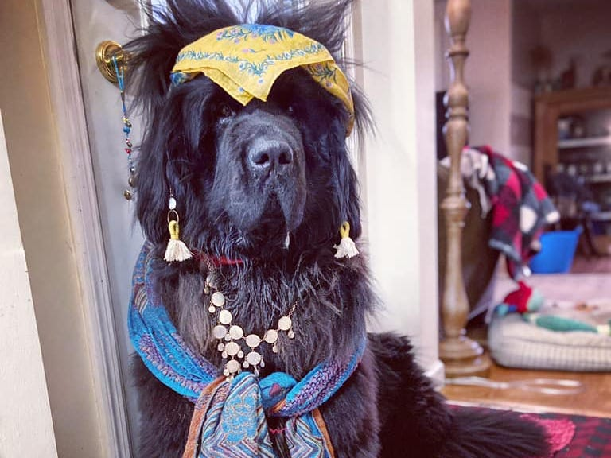
Hank the Newfoundland is taking this time to switch up his "fur styles," much to the delight of his online friends.
Hank channeling a fortune-teller. Hannah Heil
Hank's two owners have taken to dressing him up in different styles every day and sharing images of his costumes online. The production value of these photos can't be beat — just look at Hank's accessories as he channels a tarot card reader.
Everything they've been using has come from their house, like pieces of cardboard, jewelry, and other props. Luckily for Hank, he loves his makeovers. "If you know big dogs, they just think, 'Oh, this is fun. Go ahead, you know my style.' He just he thinks it's great — it's a head massage," said Hank's owner, Hannah.
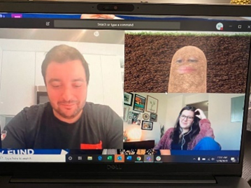
The peak of quarantine humor? A boss accidentally turning on the potato filter during a call and being unable to change it.
The spud in question. Rachele Clegg
Maybe our standards for humor are steadily decreasing as we remain isolated — or maybe this is just hilarious. Lizet Ocampo, the national political director for the progressive advocacy group People for the American Way, was holding a weekly Monday morning check-in with her colleagues over Microsoft Teams when she accidentally turned on a potato filter — and was unable to change it back.
"We started flipping on our cameras and Lizet popped up as a potato in the soil. We all laughed uncontrollably because all you could see were her eyes and mouth. The meeting was about a half hour, but I guarantee we spent 10 minutes cackling," Ocampo's colleague Rachele Clegg told Insider.
In order to avoid a fight about who got the last Dorito, Chuck McCarthy created a paper-mache chip, so he could eat the final snack in secret.
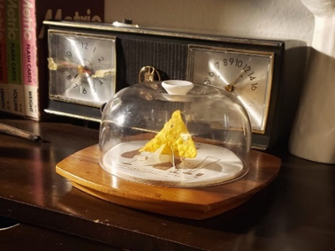
In normal times, it wouldn't be a big deal — but in the time of COVID-19, one can't just simply go out and buy more chips. That fact, coupled with an inordinate amount of free time, led McCarthy to spend hours making a fake chip, so he could secretly eat the real one without telling his girlfriend.
The chip in question. Chuck McCarthy
"As an artist and as an actor, I try not to look at anything as a waste of time. I mean, it wasn't a waste of time, I got to eat the last Dorito and she still hasn't noticed," he told Insider.

This dad is recreating Starbucks, the movie theater, and McDonald's for his daughter inside their home — and no detail is left out.
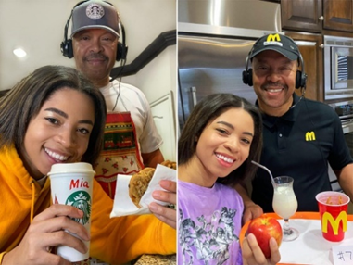
TikTok star Mia Finney has been sharing her father's hilarious efforts on the app, showing her dad playing every role necessary to make her experience as authentic as possible. For the movie theater, that means making her popcorn, dressing up as a movie theater attendant, checking her ticket, and even putting numbers on their seats — a full commitment.
Mia and her dad's recreations. Mia Finney
Another recreation was a drive-thru Starbucks, using a NutriBullet, a Wii steering wheel, a head set, and some printed Starbucks logos. The resemblance is uncanny.
"It's terrible what's going on with COVID-19 right now. But with any terrible situation, there's always a silver lining, and that is that I get to spend more time with Mia," her father told Insider.
Need something to do? How about creating a restaurant for squirrels?
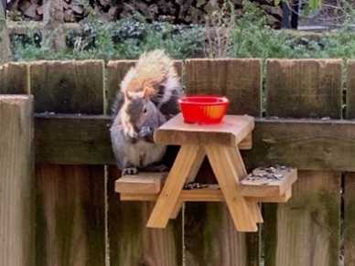
After losing his job, Rick Kalinowski decided to dedicate his time to building adorable mini-picnic benches for the squirrels around his home. What else would you do with your free time?
Chez Squirrel. Rick Kalinowski
The tiny picnic tables made people chuckle after images were shared online, but Kalinowski's had the last laugh. He's managed to turn it into a successful business. He created an Etsy store, SquirrellyTreasureCo, which received 400 orders in the first 24 hours.

Questions for Text 1: Blog Article by Gabbi Shaw
- What is the purpose of the article?
- How is the article structured?
- What language features have been incorporated into the article to engage the reader?
- How do the images add to the article?
- Is there a particular target audience for this article?

Text 2: Amazon Advertisement
Watch the advertisement, found here: https://www.adsoftheworld.com/media/film/amazon_the_show_must_go_on
(Source: Ads of the World)

Questions for Text 2: Amazon Advertisement
- How does the opening sequence establish the girl’s dream?
- What problem interrupts this?
- How does the structure of the ad position you to empathise with her?
- How do the other characters react to her sadness?
- What is the peak moment of the ad?
- How does the soundtrack add to the impact on the audience?

Set 3: Questions for Evaluation
- What issue is explored in different ways by the two authors?
- How have the authors used visual, cinematic and language features to present their ideas, evaluate the experience (directly or indirectly), and engage or challenge the audience?
- Compare the perspective of the two texts. How have the authors used written or visual elements to show their point of view? Are they trying to influence/persuade the audience? How do they want the readers/viewers to feel or act?
- EVALUATE the two texts. Which is more effective at getting the message across, and why? Use persuasive & evaluative language to justify your answer.

