PRACTICE EXAM – Year 9 English Semester 1 2023

SECTION ONE: VOCABULARY & SENTENCES

1. Choleric
A. Corrosive; acidic
B. Irritable or bad-tempered
C. To feel sorry for; pitiful
D. cheerful and light-hearted

2. Analogy
A. Light; weightless
B. An envelope
C. Mystical incantations
D. A comparison between two things

3. Akimbo
A. A division or crack
B. Illness or weakness due to old age
C. Hands on hips
D. Doing harm in subtle ways

4. Brigand
A. To edit out any unacceptable elements
B. A bandit, someone who lives by stealing
C. A style of art that intends to confuse
D. To place objects in a specific configuration

5. Insipid
A. Very hot and dry
B. A noticeable difference
C. To sparkle or perform brilliantly
D. Boring, bland, no flavour or interest

6. Magnanimous
A. A remedy for all diseases or problems; a cure-all
B. Amusing in an odd way
C. A group of people who go around with someone famous or important
D. Generous or forgiving

7. Elegy
A. Contemptuous boldness
B. A poem or speech for someone who has died
C. Submissive behaviour
D. A person who mocks politicians

8. Ostentatious
A. An agreement to meet
B. To weigh down or burden
C. One who asks humbly
D. Showy, flashy

9. Profligate
A. A factory where cars are processed
B. Wild, lacking restraint
C. Strong criticism or disapproval
D. A type of plastic that replaces glass

10. Fecund
A. A secret agreement
B. Extraordinarily thin
C. Fertile or productive
D. A state of perplexity or bewilderment

11. Manifest
A. A raucous gathering
B. A public declaration of intentions
C. To influence or control
D. To make clear or obvious by signs or actions; to show

12. Venerable
A. Wild; untamed, unable to be stopped
B. Deserving respect because of great age
C. Active during the day
D. Crafty; marked by skill in deception

13. Countenance
A. At a loss as to what to say or do; perplexed
B. To flood or overwhelm
C. Solitary; alone
D. Face or expression

14. Obliquely
A. Unmistakably; definitely B. Not in a straightforward manner; indirectly
C. Casually; calmly
D. Irresponsibly

15. Allay
A. Skilled at specific trade
B. Able to move around from place to place
C. To subdue or reduce
D. Having a harmful effect in a subtle or gradual way

16. Deposition
A. To praise highly
B. Unclear or difficult to explain; vague
C. Applying for a position
D. A statement made in court under oath

17. Derisive
A. Lacking flavour; weak or tasteless
B. Trying to impress with wealth or status
C. Mocking
D. Designed to intentionally destruct

18. Nuance
A. Bad habits or faults
B. A subtle difference
C. Tolerance of delays or mistakes
D. Living through someone else

19. Epigram
A. To beg or plead
B. Expulsion from one’s country of origin
C. Behaviour; the manner in which one conducts oneself
D. A witty saying

20. Curate
A. Discontented; irritable
B. Absolutely trustworthy or able to be depended upon
C. To select and organise items for display
D. Impossible to stop or prevent

21. Remonstrance
A. Strange; bizarre
B. To break or wrench apart with force
C. A complaint; a strong protest or criticism
D. Truth; accuracy

22. Nascent
A. Just coming into existence or recently appeared
B. To act irritably
C. To formally remember and show respect
D. To credit to a person or a cause; to attribute

23. Quail
A. To surrender; to cease resisting
B. A thorough explanation of a complicated idea
C. A large amount; more than enough
D. To tremble in fear; to cower

24. Writhe
A. To twist in pain or discomfort
B. Widespread; everywhere
C. Cheerful in a bad situation
D. Spending a lot of money wastefully

25. Feign
A. Easy to see; abundantly clear
B. The face, countenance, or appearance of a person
C. To pretend or fake
D. Showing strong, forceful feeling; passionate

26. Fatuous
A. Obese; overweight
B. Silly and pointless; foolish
C. Inciting others to overthrow an authority
D. A vigorous outpouring of many things at once

27. Subversive
A. Inflammatory; causing fires or arguments
B. Slow and clumsy because of great weight
C. Overly concerned with unimportant details
D. Working against a system trying to destroy it from within

28. Mein
A. To skip about or frolic
B. The fluid held inside the spleen
C. Appearance or manner
D. To be abundant or plentiful in number

29. Confound
A. Clothing
B. To consider in speech or writing
C. To confuse or surprise
D. Contempt for something seen as unworthy

30. Furtive
A. Trying not to be noticed or seen; sneaky
B. To make more certain
C. Not needed or useful; unnecessary
D. To work together with others

/30
1. Name the type of sentence:

- The surface of the liquid began to undulate slightly when I moved the glass.
Type of sentence: __________________________________
- Ben decided to purge his wardrobe of any clothes that were too small.
Type of sentence: __________________________________ /2
2. Circle the VERBS in these sentences:
- My chess partner was a worthy foe, but I defeated him in the end.
- Although John is a voracious reader, he doesn't like graphic novels.
/2
3. Circle the SUBJECT in these sentences:
- If food gets lodged between your teeth, you should use dental floss to remove it.
- Jennifer can sometimes act rather imperious at school.
/2

4. In the sentences below:
- Circle any coordinating conjunctions
- Underline any subordinating conjunctions.

- You can tell she is a chef because she notices every single flavour in the meal.

- Smoking is a disgusting habit and it causes irreversible damage to healthy lungs.

- That penguin looks very suspicious so I’m going to report him to Crime Stoppers.

- My dog was not interested when I offered him some broccoli.

/4
2. Write two simple sentences:

/2

3. Write two compound sentences:

/2
4. Write two complex sentences:

- /2

END OF SECTION ONE /46

SECTION TWO: POETRY & SYMBOLISM

1. Briefly describe the structure & features of the following poetry types.

a) Sonnet: ________________________________________________________________________________________________________________________________________________________________________________________________
_______________________________________________________________/2
b) Villanelle:
________________________________________________________________________________________________________________________________
_______________________________________________________________________________________________________________________________/2
c) Psalm:
________________________________________________________________________________________________________________________________
_______________________________________________________________________________________________________________________________/2
d) Free verse:
________________________________________________________________________________________________________________________________________________________________________________________________
_______________________________________________________________/2
e) Ballad:
________________________________________________________________________________________________________________________________________________________________________________________________
_______________________________________________________________/2

2. Read the poem below and label 5 DIFFERENT poetic devices (i.e. two similes do not count as two devices).
/5

War

I didn’t ask to fight this war
A battle that I never seem to win
Each new attack creates a scar
Another trigger clicks, the sky goes dark
And now I can’t find air to breathe
I stumble in a suffocating smog
Now gasping, choking, panicking
I don’t know why it’s happening

The war is wretched, weary work
A grave to dig with blunt and broken spades
A heavy weight around my neck
A tightened iron band around my lungs
The simple things are now too hard
To eat, to speak, to take another step
It’s like I’m trapped inside a pit
I don’t know why I’m fighting it

The war consumes all other thoughts
Like creatures caged, I only see the bars
While others wander, laughing, free
I witness joy but cannot touch or feel
The war is always whispering
Cruel words are poison, and they never stop
Give up, you’ve lost, it’s your fault now
I’d ask for help but don’t know how

From outside, others think it’s fine
From where they sit it doesn’t look so bad
Perhaps I’m doing something wrong
I am invisible, the mirror’s blank
They cannot hear my silent screams
I run towards a light I cannot see
Why am I lost? I know this place
I don’t know how to stop the chase

Please grab my hand and don’t let go
You’re here; it helps more than you’ll ever know
The battle’s calmer when you stay
I can survive this war for one more day

- What do you think the war symbolises in this poem? __________________________________________________________________________________________________________________________________________________________/1

- Explain why you think so – what clues did you use to determine what it might symbolise?

_______________________________________________________________________________________________________________________________________________________________________________________________________________________________________________________________/2

- What do you think is the meaning or message of this poem?
________________________________________________________________________________________________________________________________________________________________________________________________
_______________________________________________________________/1

- What is the tone or mood of this poem?
_______________________________________________________________/1

- Choose three of the devices you labelled and explain what effect they have on the audience.

Device | Effect
1.

2.

3.

/3
3. In the table below, write a brief definition of the following poetic terms:

Term | Meaning
Symbolism
Tone & mood
Enjambment
Parallelism
Refrain
Caesura
Diction
Imagery
Stanza
Persona

/10

4. What is the difference between assonance and consonance?
________________________________________________________________________________________________________________________________
_______________________________________________________________/2

Use the information in the box below to help you work out the meter for questions 6 and 8.

Feet:
Trochee (DAH-da) e.g. TROphy
iamb (da-DAH) e.g. inDEED
Spondee (DAH-DAH) e.g. TV
Dactyl (DAH-da-da) e.g. CERtainly
Anapest (da-da-DAH) e.g. interrupt

(Trochaic, iambic, dactylic, anapestic, spondaic)

one foot = monometer
two feet = dimeter
three feet = trimeter
four feet = tetrameter
five feet = pentameter
six feet = hexameter
seven feet = heptameter
eight feet = octameter

Example:
If there are three IAMBS (three ‘da-DAH’s) per line, the meter would be iambic trimeter. Remember, it does not have to be exact – you are looking for the general/overall pattern

5. In the verse below, underline or highlight the stressed (emphasised) syllables.

HINT: Make sure you only underline the SYLLABLE that should be emphasised, not the entire word. The first line has been done as an example.

Of that forbidden tree, whose mortal taste
Brought death into the world, and all our woe,
With loss of Eden, till one greater man
Restore us, and regain the blissful seat,
That shepherd, who first taught the chosen seed
/4
6. What is the meter of the verse in question 5?
________________________________________________________________
________________________________________________________________
/2

7. In the verse below, underline or highlight the stressed syllables.

It is missing me not how I’m stretched on your grave,
With no purpose, nor mission my mourning could save,
Still I rise every day and assume my routine,
Of repentance for sins of mine yet to be seen.
/4
8. What is the meter of the verse in question 7?
_______________________________________________________________/2

END OF SECTION TWO /47

SECTION THREE: DESCRIPTIVE & EVALUATIVE LANGUAGE

1. In the table below, list 3 of the key features of descriptive writing and give an example.

Feature | Example
a)

b)

c)

/6

2. Write a short description of the image below using some of the techniques you identified.
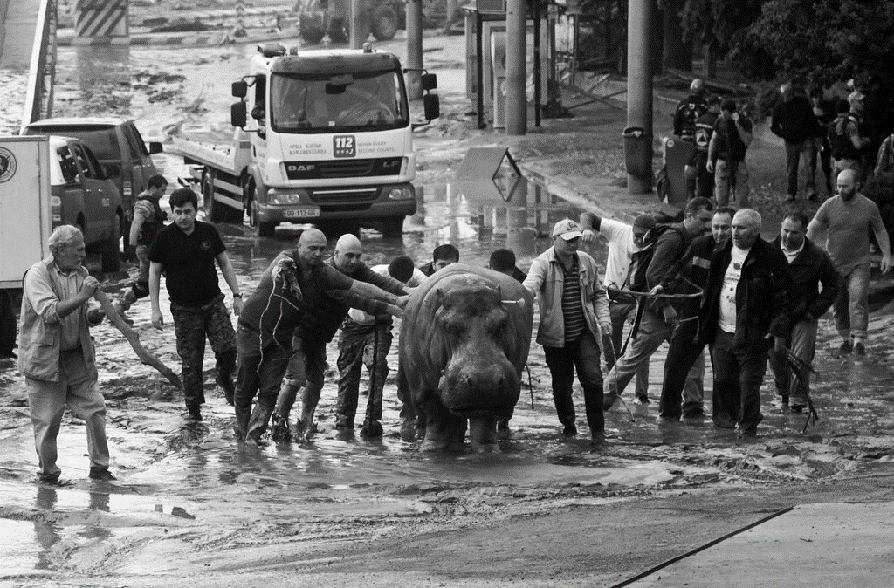

_______________________________________________________________________________________________________________________________________________________________________________________________________________________________________________________________________________________________________________________________________________________________________________________________________________________________________________________________________________________________________________________________________________________________________________________________________________________________________________________________________________________________________________________________________________________________________________________________/6

4. In the table below, list the three main tools used in evaluative language and give an example.
/6
Tool | Example
a)

b)

c)

5. Give an example of…
a) a comparative adjective: __________________________
b) a superlative adjective: ____________________________
c) an implicit judgment: __________________________________________________________
d) a mild judgment: ______________________________________________________________
/4

6. Write an evaluation of the two texts below using the techniques you identified:
Text 1: Poem Text 2: Political Cartoon
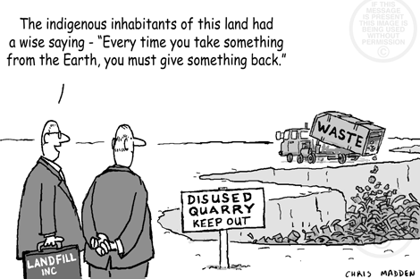
“My Country” by Oscar Krahnvohl

I love a sunburnt country,
A land of open drains
Mid-urban sprawl expanded
For cost-accounting gains;
Broad, busy bulldozed acres
Once wastes of fern and trees
Now rapidly enriching
Investors overseas.

A nature-loving country
Beneath whose golden wattles
The creek is fringed with newspapers
And lined with broken bottles.
I love her massive chimneys,
Production’s, profit’s pride,
Interminably pouring,
Pollution high and wide.

Evaluate the two texts here: _______________________________________________________________________________________________________________________________________________________________________________________________________________________________________________________________________________________________________________________________________________________________________________________________________________________________________________________________________________________________________________________________________________________________________________________________________________________________________________________________________________________________________________________________/5

END OF SECTION THREE /47
SECTION FOUR: MULAN & ESSAY WRITING

1. In the table below, list four similarities or differences in the way Chinese culture is portrayed in Disney’s cartoon Mulan (1998) and the live action Mulan (2020). For each, explain how it relates to Chinese culture.

Difference or similarity | What aspect/s of Chinese culture does this relate to?
1.

2.

3.

4.

/8

2. What should the introduction paragraph of an essay contain?
________________________________________________________________________________________________________________________________
_______________________________________________________________________________________________________________________________/2
3. What does PEEL stand for in an essay paragraph?

________________________________________________________________________________________________________________________________
________________________________________________________________________________________________________________________________
_______________________________________________________________________________________________________________________________/4

4. What should the conclusion paragraph of an essay contain?
________________________________________________________________________________________________________________________________________________________________________________________________
________________________________________________________________________________________________________________________________
/2

5. The following sentences contain mistakes in academic language. Re-write them beneath in formal language appropriate for an essay.

(The first one has been done as an example)

- The 1st difference is that Mulan doesn’t start as a teen, she’s only like 8 at the start of the movie.

The first difference is that Mulan does not start as an adolescent. She is aged around eight at the beginning of the film.

- The witch has super awesome powers and can turn into a hawk and stuff, but she still can’t get the main villain guy and the 10 Rohran tribes to respect her.

_______________________________________________________________________________

_______________________________________________________________________________

_____________________________________________________________________________/2

- I think the cartoon’s more entertaining. In my opinion the newer one’s more like a war epic or something. This doesn’t seem as interesting to me.

_______________________________________________________________________________

_______________________________________________________________________________

_____________________________________________________________________________/2

- The 2rd reason is that they don’t even really explain how chi works and that’s why people don’t get it.

_______________________________________________________________________________

_______________________________________________________________________________

_____________________________________________________________________________/2

6. Rephrase the following sentences, making them sound more academic by nominalising the verbs.

- After the two disruptive students were separated, they produced better work.

_______________________________________________________________________________

_______________________________________________________________________________

_____________________________________________________________________________/1

- The leaflets will be distributed around the neighbourhood to advertise my lawnmowing business.

_______________________________________________________________________________

_______________________________________________________________________________

_____________________________________________________________________________/1

END OF SECTION FOUR /23

TOTAL MARKS: /177

